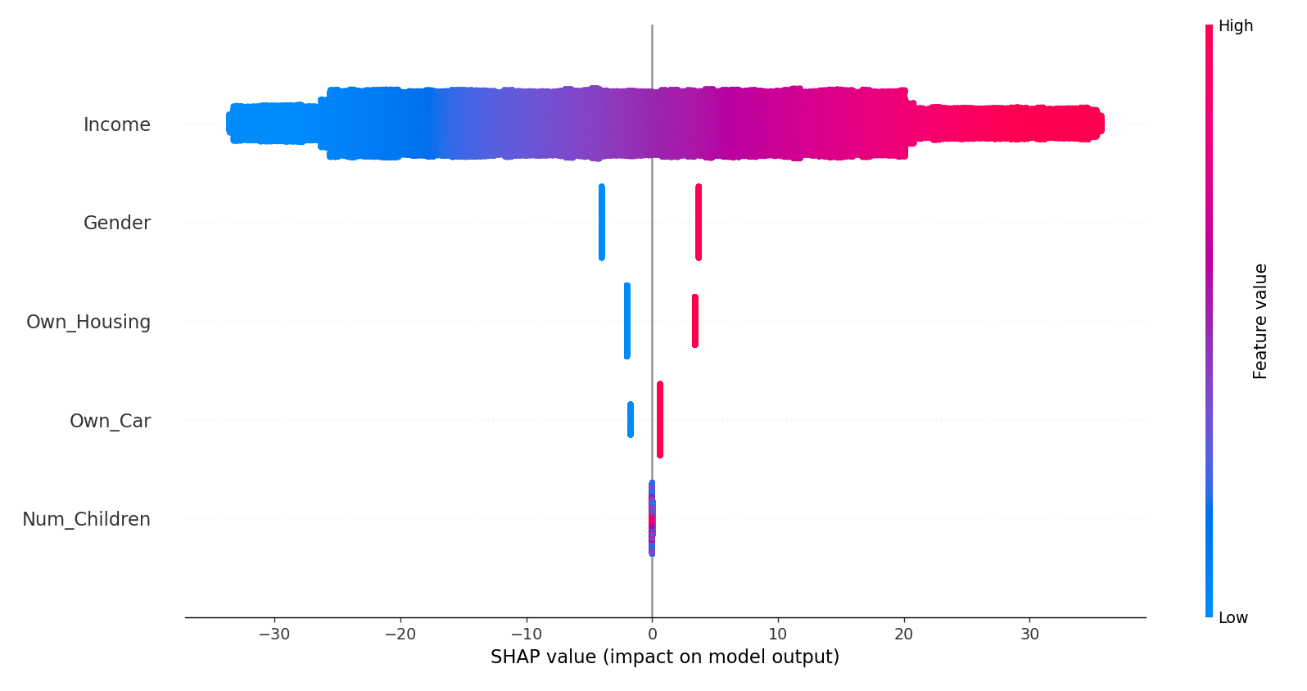

Evaluation Results:

performance: {'accuracy': 0.97293, 'precision': 0.9656836043887636, 'recall': 0.9641580773812607, 'f1_score': 0.9649202379255382}

Variance of Numerical Features:

Num_Children: 1.9882564969649696

Income: 528038693.06598526

Fairness Metrics:

Attribute: Gender

Statistical Parity: {'Female': 0.19481689013408046, 'Male': 0.5760143913651808}

Equal Opportunity (TPR): {'Female': 0.9267466912896276, 'Male': 0.9767901063498112}

Equalized Odds (TPR): {'Female': 0.9267466912896276, 'Male': 0.9767901063498112}

Equalized Odds (FPR): {'Female': 0.01745270119086095, 'Male': 0.02934366583187639}

Attribute: Own_Car

Statistical Parity: {'No': 0.28986960882647944, 'Yes': 0.4263518333571123}

Equal Opportunity (TPR): {'No': 0.9482007792803118, 'Yes': 0.9688169164882227}

Equalized Odds (TPR): {'No': 0.9482007792803118, 'Yes': 0.9688169164882227}

Equalized Odds (FPR): {'No': 0.018693353474320242, 'Yes': 0.023058554300781055}

Attribute: Own_Housing

Statistical Parity: {'No': 0.3184452036441586, 'Yes': 0.48495830023828435}

Equal Opportunity (TPR): {'No': 0.9551548288733505, 'Yes': 0.9728984841525035}

Equalized Odds (TPR): {'No': 0.9551548288733505, 'Yes': 0.9728984841525035}

Equalized Odds (FPR): {'No': 0.020815413727851367, 'Yes': 0.023000724812756706}

Attribute: Income_Category

Statistical Parity: {'High': 0.7328428576860195, 'Medium': 8.439174648719355e-05}

Equal Opportunity (TPR): {'High': 0.9705414635418025, 'Medium': 0.00392156862745098}

Equalized Odds (TPR): {'High': 0.9705414635418025, 'Medium': 0.00392156862745098}

Equalized Odds (FPR): {'High': 0.09267710454258232, 'Medium': 6.363617079948243e-05}

Subgroup Accuracy by Sensitive Attribute:

Attribute: Gender

Male: 0.9741954827103738

Female: 0.9716629977986793

Attribute: Own_Car

Yes: 0.9734769581966044

No: 0.9716482781678368

Attribute: Own_Housing

Yes: 0.9750049642573471

No: 0.9715300107181136

Attribute: Income_Category

High: 0.9534238241891944

Medium: 0.9945778302881978