|  |  |  |  |  |  |  |
| --- | --- | --- | --- | --- | --- | --- |
| **Practicum Final Exam – Odd Semester Year 2022/2023** | | | | | | |
| **Subject** | | | **COMP6799001 - Database Technology** | | |  |
| **Class** | **:** | **B701 | BP01** | | **Start Date** | **: 19 January 2023** |
| **Lecturer** | **:** | **D4458 - Diana, S.Kom., M.T.I.**  **D6659 - Eko Setyo Purwanto, S.Pd., M.Kom.** | | **Start Time** | **: 11.20** |
| **End Date** | **: 19 January 2023** |
| **End Time** | **: 13.00** |

**PERATURAN UJIAN:**

*Exam Regulations:*

* Mahasiswa tidak diperbolehkan berdiskusi dan/atau bekerja sama dengan peserta ujian lainnya

*Student is not allowed to discuss and/or work together with other exam participants*

* Mahasiswa tidak diperbolehkan untuk membuka dan menyalin dari **BUKU** atau **CATATAN**, **VIDEO** dari pengajar (recording kelas, VBL, Youtube, dsb) dan **REFERENSI** lainnya

*Student isn't allowed to open and copy from any resources such as notes, videos (class recording, VBL, Youtube, etc) and other references*

* Mahasiswa tidak diperbolehkan membuka dan menyalin jawaban dari internet (google, stackoverflow, dsb)

*Student isn't allowed to open and copy answer from the internet (google, stackoverflow, etc)*

* Asisten **BERHAK** memberi nilai 0 **(NOL)** bagi peserta ujian yang melakukan segala bentuk kecurangan

*Assistant is able to give 0 (ZERO) score for exam participant who does any cheating actions*

* Kumpulkan jawaban tepat pada waktunya, apabila terlambat mengumpulkan maka jawaban tidak akan dikoreksi dan nilai mahasiswa adalah 0

*Submit the answer on time, if not, then the answer will not be checked, and the students will receive 0 (ZERO)*

* Bila Anda tidak membaca peraturan ini, maka aanda dianggap telah membaca dan menyetujuinya

*If you have missed to read these regulations, so you are considered to have read and agreed on it*

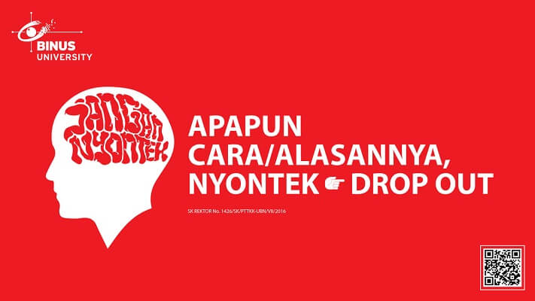

**SOFTWARE YANG DIGUNAKAN:**

*Software will be used:*

* XAMPP 8.0.7

**FILE YANG DIKUMPULKAN:**

*File must be collected:*

* SQL

**PERHATIAN!**

*Attention!*

* Bagi yang mengerjakan tidak sesuai dengan soal, maka akan diberikan nilai **NOL (0)**

*For those who do not work in accordance with the exam case will be marked as* ***ZERO (0)***

* Bagi yang mengerjakan tidak sesuai dengan software dan versi yang telah ditetapkan, maka akan tetap dikoreksi dengan software dan versi yang telah ditetapkan

*For those who do not work in accordance with the software and specific version will be corrected by the predefined software and version*

* Kompres semua jawaban yang akan diunggah. Pastikan format pengumpulan nama file dan ekstensi sesuai dengan format berikut: **[NIM]-[NAMA].zip**

*Compress all file that will be uploaded. Make sure the format for collecting file name and extension according to the following format:* ***[NIM]-[NAME].zip***

**Soal**

*Case*

**KCinema**

**KCinema** is one of the most famous cinemas in town, known for its treatment and service. The cinema handles a lot of transactions each day and it needs a database to manage all the transactions. **KCinema’s** CEO hired you as a database administrator to maintain the database.

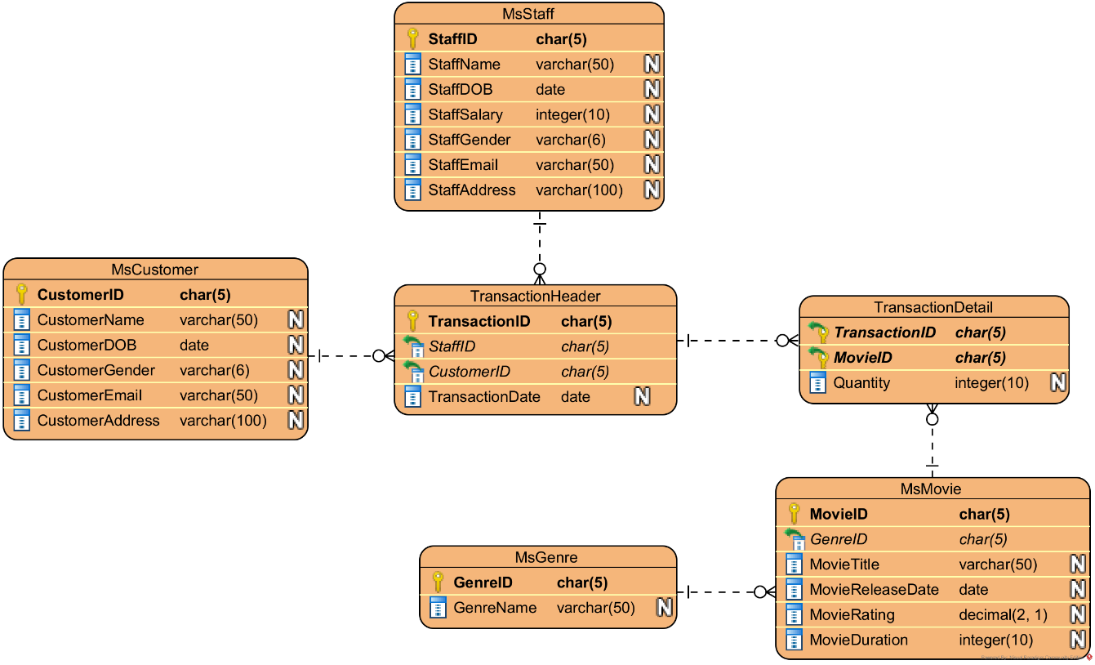

**Figure 1. ERD**

**Notes**

* Open **create+insert.sql** file (attached with the case), then **execute** the file on **MySQL.**
* Please **include the number of the question** in your answer SQL file.

1. **Import** and **use** the database **using SQL query**.
2. Display **TransactionID, StaffID, StaffName, and StaffSalary** for every transaction that was handled by a staff whose **name starts with** **‘Ama’**.

**(LIKE)**

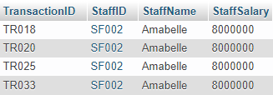

1. Display **Name** (obtained from **CustomerName** in **uppercase format**), **Gender** (obtained from **CustomerGender**), and **Day** (obtained from the **day of** **CustomerDOB**) for every **Customer** that was **born after or in 1998**. Then, combine it with **Name** (obtained from **StaffName** in **uppercase format**), **Gender** (obtained from **StaffGender**), and **Day** (obtained from the **day of StaffDOB**) for every Staff that was **born after or in 1998**.

**(UNION, UPPER, DAY)**

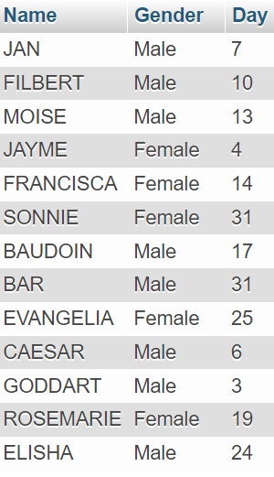

1. Display **Name** (obtained from **CustomerName** in **lowercase format**), **Gender** (obtained from **CustomerGender** in **lowercase** **format**), **Email** (obtained from **CustomerEmail**), **Address** (obtained from **CustomerAddress**), and **Date** (obtained from **TransactionDate**) for every **transaction** which **occurred in 2021** and done by customer whose **email** contains **‘wordpress’.** Then, combine it with **Name** (obtained from **StaffName** in **lowercase format**), **Gender** (obtained from **StaffGender** in **lowercase** **format**), **Email** (obtained from **CustomerEmail**), **Address** (obtained from **StaffAddress**), and **Date** (obtained from **TransactionDate**) for every **transaction** which **occurred in 2021** and handled by staff whose **email** contains **‘amazon’.**

**(LOWER, YEAR, LOCATE, UNION)**

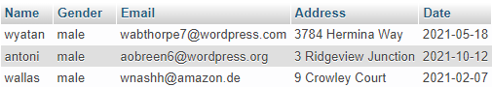

1. **Add** a constraint called **‘CHK_Salary’** for **MsStaff** to validate that every **StaffSalary** inserted is **at least 4000000**.

**(ALTER TABLE, ADD CONSTRAINT, CHECK)**

1. **Update StaffSalary** from **MsStaff** by **adding 2000000 to StaffSalary** for every Staff whose born **after 1995** and their **address** contains ‘**Circle**’word.

**(YEAR, LIKE)**

**Before**

**After**

1. Display **TransactionCode** (obtained by **replacing** ‘**TR**’ with ‘**Transasction** ’ in **TransactionID**), **StaffName, MovieTitle, MovieRating,** and **Quantity** for every transaction which **MovieRating** is **greater than 9** and every Staff whose **email** contains **‘.com’.**

**(POSITION, REPLACE)**

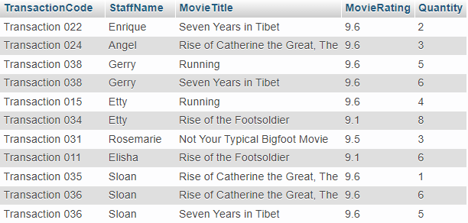

1. Display **MovieID, MovieTitle, GenreName, Release Month** (obtained from the **month name** of **MovieReleaseDate**), and **MovieRating.** Then, **sort** the result by **MovieRating** from **largest** to **smallest.**

**(MONTHNAME, ORDER BY)**

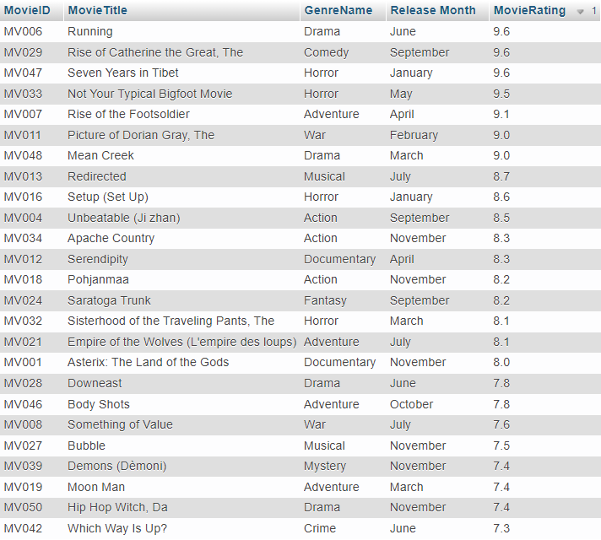

1. **Create a view** named ‘**TransactionView**’ to display **TransactionID, ‘3D ID’** (obtained from **MovieID** **ends with** ‘ **3D**’), **Quantity,** and **TransactionDate** (obtained from **TransactionDate** in **‘mon dd, yyyy’ format**).

**(CONCAT, DATE_FORMAT)**

1. **Create a view** named ‘**CustomerView**’ to display **CustomerName, Domain** (obtained from **extracting the domain** of **CustomerEmail**), **MaxRefundDate** (obtained from **adding** **3** **months** to the **TransactionDate**), and **MovieTitle**.

**(SUBSTRING, ADDDATE, POSITION)**

