UNIVERSITY OF CAPE COAST

COLLEGE OF AGRICULTURE AND NATURAL SCIENCES

SCHOOL OF PHYSICAL SCIENCES

DEPARTMENT OF COMPUTER SCIENCE AND INFORMATION TECHNOLOGY

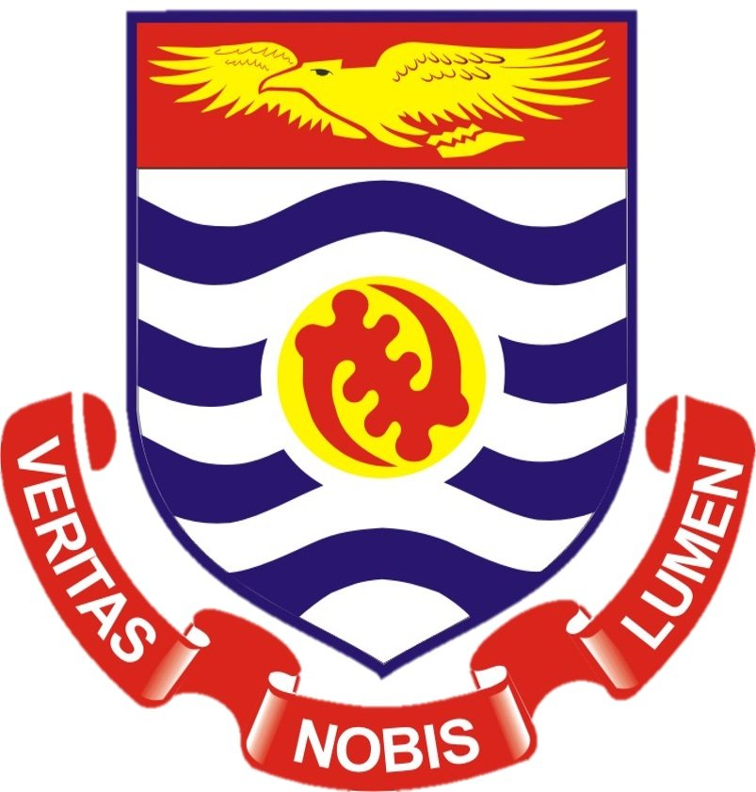

INF 40: INTRODUCTION TO INTELLIGENT SYSTEMS

PROJECT GROUP 5

NAME: AYAMBA IMORO SUMAILA

INDEX NUMBER: PS/ITC/20/0182

Project 5: Smart Campus Navigation System

Problem: New students and visitors often find it challenging to navigate large campus areas.

Solution: Develop a smart navigation system that provides real-time guidance and information about campus facilities using computer vision and location services.

Note: Develop a model of the project. Do a detail write up on the process, tools and how it can developed into a function system.

### Solution Overview

The proposed solution involves the development of a Smart Campus Navigation System tailored specifically for the University of Cape Coast. This system will leverage computer vision and location-based services to assist users in navigating the campus efficiently. It will include real-time guidance, detailed facility information, and user-friendly interfaces.

### User Interface (UI): Mobile Application (iOS/Android) and Web Application

User Interface (UI) refers to the means by which a user interacts with a system. In this project, the UI will consist of two main components: a mobile application and a web application.

#### Mobile Application (iOS/Android)

The mobile application will be designed to run on both iOS and Android devices. This app will be the primary tool for users to interact with the Smart Campus Navigation System while on the go.

Key Features:

1. Real-Time Navigation:
   * The app will provide turn-by-turn navigation to help users find their way around the UCC campus. This will include both outdoor and indoor navigation.
2. Augmented Reality (AR) Integration:
   * Users can use their phone’s camera to view real-time navigation paths and information about buildings overlaid on the real world through AR technology.
3. Facility Information:
   * Users can access detailed information about campus facilities such as lecture halls, libraries, cafeterias, and administrative offices. This can include operating hours, available services, and contact information.
4. Search and Filter:
   * The app will allow users to search for specific locations or facilities and apply filters to narrow down their search results based on categories such as departments or services.
5. Notifications and Alerts:
   * Users will receive notifications about important events, campus news, and alerts about navigation issues like construction zones or closed paths.
6. Personalization:
   * The app can be personalized based on user preferences, such as frequently visited places or specific routes.

Technology Stack:

* React Native: A popular framework for building cross-platform mobile apps, allowing the development of a single codebase that runs on both iOS and Android.
* ARKit (iOS) and ARCore (Android): Tools for implementing AR capabilities, enabling the app to overlay digital information on the real world.

#### Web Application

Overview: The web application will be accessible from any web browser, providing an alternative interface for users who prefer to interact with the system on a desktop or laptop.

Key Features:

1. Interactive Campus Map:
   * An interactive map of the UCC campus that users can explore to find buildings, routes, and other facilities.
2. Facility Information:
   * Similar to the mobile app, users can access detailed information about campus facilities through the web application.
3. Search and Filter:
   * Users can search for specific locations or facilities and apply filters to refine their search results.
4. User Account Management:
   * Users can create and manage their accounts, customize their preferences, and view their navigation history.
5. Notifications and Alerts:
   * Users will receive notifications about important campus events and alerts regarding navigation.
6. Responsive Design:
   * The web application will be designed to be responsive, ensuring it works well on various screen sizes and devices.

Technology Stack:

* React: A widely used JavaScript library for building user interfaces, enabling the development of a fast and interactive web application.
* Node.js and Express.js: Backend technologies for handling server-side logic and database interactions.

### Summary

The User Interface (UI) components for the Smart Campus Navigation System include a mobile application and a web application, both designed to provide an intuitive and efficient way for users to navigate the UCC campus. The mobile app, built with React Native, will offer real-time navigation, AR integration, and facility information on iOS and Android devices. The web application, built with React, will provide similar functionality in a desktop-friendly format, ensuring users can access the system from any device with ease.

1. Backend Services:
   * Server to handle requests
   * Database for storing campus maps, facility information, and user data
2. Computer Vision Module:
   * Image recognition for identifying buildings and landmarks
   * Augmented Reality (AR) for overlaying navigation paths on the real world
3. Location Services:
   * GPS for outdoor navigation
   * Indoor Positioning System (IPS) for indoor navigation (e.g., Bluetooth beacons, WiFi triangulation)
4. Data Sources:
   * Campus maps and facility information
   * Real-time user location data

#### 2. Tools and Technologies

Frontend:

* React Native for cross-platform mobile app development
* React for web application development
* ARKit/ARCore for augmented reality capabilities

Backend:

* Node.js with Express.js for server-side development
* MongoDB for the database
* Firebase for real-time database and authentication

Computer Vision:

* OpenCV for image recognition and processing
* TensorFlow Lite for running machine learning models on mobile devices

Location Services:

* Google Maps API for outdoor navigation
* IndoorAtlas for indoor positioning

#### 3. Development Process

Step 1: Requirement Analysis

* Identify user needs and system requirements
* Gather UCC campus maps and facility information
* Determine the necessary hardware for IPS (Bluetooth beacons, etc.)

Step 2: Design

* Design the user interface (wireframes, mockups)
* Design the system architecture (components, data flow)
* Plan the database schema

Step 3: Implementation

* Develop the frontend application (React Native and React)
* Set up the backend server and database (Node.js, Express.js, MongoDB)
* Implement computer vision functionalities (OpenCV, TensorFlow Lite)
* Integrate AR capabilities (ARKit/ARCore)
* Implement location services (Google Maps API, IndoorAtlas)

Step 4: Testing

* Perform unit testing for individual components
* Conduct integration testing for the entire system
* Perform user acceptance testing (UAT) with a group of new students and visitors

Step 5: Deployment

* Deploy the backend server on a cloud platform (e.g., AWS, Heroku)
* Publish the mobile app on app stores (Google Play Store, Apple App Store)
* Launch the web application

Step 6: Maintenance and Updates

* Monitor system performance and user feedback
* Fix bugs and update the system as needed
* Add new features based on user feedback and technological advancements

#### 4. Functionality and User Experience

User Onboarding:

* Simple and intuitive sign-up and login process
* Personalize the experience based on user preferences (e.g., faculty, interests)

Real-Time Navigation:

* Provide real-time directions using GPS and IPS
* Use AR to overlay navigation paths and information on the real world

Facility Information:

* Provide detailed information about UCC campus facilities (e.g., lecture halls, libraries, cafeterias)
* Allow users to search and filter facilities based on categories

Notifications and Alerts:

* Notify users about important events and announcements
* Provide alerts for potential navigation issues (e.g., construction zones, closed paths)

#### 5. Implementation Details for UCC

Campus Map and Facility Information:

* Gather detailed maps of the UCC campus, including all buildings, lecture halls, libraries, cafeterias, dormitories, and administrative offices.
* Create a database to store this information, ensuring it is regularly updated.

Outdoor Navigation:

* Utilize the Google Maps API to provide GPS-based navigation for outdoor areas of the campus.
* Develop an algorithm to optimize navigation paths, taking into account factors such as distance, accessibility, and user preferences.

Indoor Navigation:

* Implement an Indoor Positioning System (IPS) using Bluetooth beacons and WiFi triangulation to provide accurate indoor navigation.
* Place beacons strategically throughout buildings to ensure comprehensive coverage.

Computer Vision and AR Integration:

* Develop a computer vision module using OpenCV and TensorFlow Lite to recognize buildings and landmarks from images captured by the user’s device.
* Use ARKit/ARCore to overlay navigation paths and facility information on the real world, enhancing the user’s navigation experience.

User Interface Design:

* Design an intuitive and user-friendly interface for both the mobile and web applications.
* Include features such as search functionality, filters, and personalized recommendations.

high-level architecture diagram of the Smart Campus Navigation System. I'll create a UML deployment diagram that shows the different components and their interactions.

Let's break down the components as follows:

1. Mobile Application (iOS/Android)
2. Web Application
3. Backend Server
4. Database
5. Computer Vision Module
6. Location Services
7. AR Module

Here's a high-level architecture diagram of the Smart Campus Navigation System:

* Mobile Application (iOS/Android): This component is where users interact with the system on their mobile devices.
* Web Application: This component allows users to access the system from any web browser.
* Backend Server: The central server handles requests from the mobile and web applications, processes data, and coordinates other components.
* Database: Stores campus maps, facility information, user data, and other relevant information.
* Computer Vision Module: Processes images to identify buildings and landmarks on the campus.
* Location Services: Provides real-time location tracking for navigation, both outdoor (using GPS) and indoor (using Bluetooth beacons, WiFi triangulation).
* AR Module: Adds augmented reality features to the mobile application, overlaying navigation paths and information on the real world.

Arrows indicate the flow of data between the components, showing how they interact to provide a seamless navigation experience.

### Conclusion

The Smart Campus Navigation System for the University of Cape Coast aims to enhance the campus experience for new students and visitors by providing real-time navigation and facility information through an intuitive and user-friendly application. By leveraging computer vision, augmented reality, and location-based services, the system will ensure efficient and accurate navigation, ultimately improving user satisfaction and campus accessibility. This project will serve as a model for other educational institutions looking to implement similar systems.