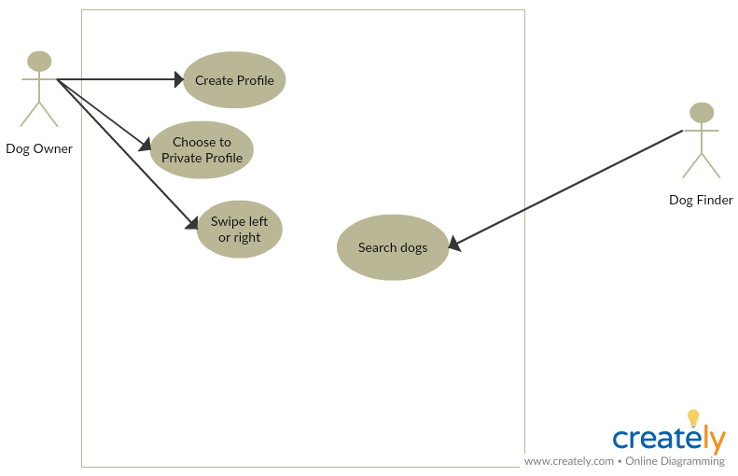

Allen Ferriols’ Edit:

Connect “Dog Finder” actor to “Create Profile” use case by adding arrow

Add “BorkBork” as Title for the app name