**Software Requirements Specification**

For

**A Comparative Study and Analysis of Different Optimized Indexing Algorithms**

**3rd November 2023**

Prepared by

|  |  |  |
| --- | --- | --- |
| **Specialization** | **SAP ID** | **Name** |
| BIG DATA | 500096926 | ANVI GOEL |
| BIG DATA | 500096946 | AYAN SAR |



Department of Informatics

School Of Computer Science

UNIVERSITY OF PETROLEUM & ENERGY STUDIES,

DEHRADUN- 248007. Uttarakhand

Table of Contents

|  |  |  |
| --- | --- | --- |
| **Topic** | | **Page No** |
| Table of Content | | 2 |
| 1 | Introduction | 3 |
|  | 1.1 Purpose of the Project | 3 |
|  | 1.2 Target Beneficiary | 3 |
|  | 1.3 Project Scope | 3 |
| 2 | Project Description | 3-6 |
|  | 2.1 Reference Algorithm | 3 |
|  | 2.2 Data/ Data Structure | 3 |
|  | 2.3 SWOT Analysis | 4 |
|  | 2.4 Project Features | 4 |
|  | 2.5 User Classes and Characteristics | 4 |
|  | 2.6 Design and Implementation Constraints | 4-5 |
|  | 2.7 Design diagrams | 5 |
|  | 2.8 Assumption and Dependencies | 5-6 |
| 3 | System Requirements | 6 |
|  | 3.1 User Interface | 6 |
|  | 3.2 Software Interface | 6 |
|  | 3.3 Database Interface | 6 |
|  | 3.4 Protocols | 6 |
| 4 | Non-functional Requirements | 7-8 |
|  | 4.1 Performance requirements | 7-8 |
|  | 4.2 Security requirements | 8 |
|  | 4.3 Software Quality Attributes | 8 |
| Appendix A: Analysis Model | | 9 |

1. **INTRODUCTION**
   1. **Purpose of the Project**

The purpose of this research project, "A Comparative Study and Analysis of Different Optimized Indexing Algorithms" is to provide valuable insights and comprehensive information on the performance, strengths, and weaknesses of various optimized indexing algorithms used in database management systems.

**1.2 Target Beneficiary**

The primary beneficiaries of this research project are database administrators, software developers, data analysts, organizations, and the research community. Database administrators and software developers will gain valuable insights for optimizing database performance. Data analysts will benefit from enhanced data query efficiency for analytics and warehousing.

**1.3 Project Scope**

The project scope encompasses a comprehensive evaluation of five key indexing algorithms: B-tree, B+ tree, Hashmap indexing, Bitmap indexing, and Inverted Indexing. It involves performance assessments under various workloads, data distributions, and query types, measuring query response times, storage requirements, and update operations. Real-world use cases will be integrated to provide practical insights for algorithm selection.

1. **PROJECT DESCRIPTION**

**2.1 Reference Algorithm**

A reference algorithm, in the context of database management and indexing, is a benchmark or baseline algorithm against which other indexing methods are compared and evaluated. It serves as a standard for assessing the performance and efficiency of various indexing techniques. The reference algorithm typically represents a well-established and widely recognized method, often chosen for its proven effectiveness and stability. By comparing other algorithms to the reference algorithm, researchers and practitioners can gauge the relative strengths and weaknesses of new or alternative indexing approaches, enabling them to make informed decisions when selecting the most appropriate method for their specific database and data retrieval requirements.

**2.2 Characteristics of Data**

The data used for a comparative study and analysis of different optimized indexing algorithms should possess several key characteristics to ensure the validity and reliability of the research. Firstly, the data should be comprehensive and diverse, encompassing a wide range of datasets or scenarios to facilitate a robust comparison. It should also be well-organized and structured, allowing for easy retrieval and processing of information. Additionally, the data should be representative of real-world scenarios and incorporate realistic parameters to ensure the relevance of the study's findings. The data should also be accurate and up-to-date, minimizing errors and maintaining the currency of the analysis. Finally, proper documentation and metadata should accompany the data to enable transparency and reproducibility of the study, fostering trust and credibility in the research results.

**2.3 SWOT Analysis**

Strengths (S):

Optimized indexing algorithms such as B+ trees and R* trees [1] and [2], excel in providing efficient data retrieval and query performance, making them suitable for applications with high-speed requirements.

Bitmap indexing techniques [3] stand out for their space-efficient storage of high-dimensional data. Reducing storage overhead.

Weaknesses (W):

Some indexing algorithms, like trie-based indexing [4] may have limited applicability and might not be suitable for all data types of access patterns.

While adaptive indexing using machine learning [5] holds promise, its implementation and maintenance can be complex and resource-intensive, potentially posing challenges.

Opportunities (O):

The growing volume of data and advancements in machine learning present opportunities to further enhance indexing algorithms for improved scalability and predictive indexing.

Threats (T):

This field of indexing algorithms is subject to rapid technological changes, and algorithms that are efficient today may become obsolete in the face of emerging technologies and paradigms.

The diversity of indexing algorithms and the constant pursuit of efficiency can create a competitive landscape, making it challenging for a single algorithm to dominate the field.

**2.4 Project Features**

For my minor project, we aim to develop A Comparative Study and Analysis of Different Optimized Indexing Algorithms. The key features will include User Authentication, Data Ingestion, Data Processing, Data Storage, Integration, Security, and Performance Optimization optimizing data retrieval performance, and ensuring efficient data management in the dynamic landscape of the data-driven world.

**2.5 User Classes and Characteristics**

**End Users:** Non-technical, diverse in age and background, seeking user-friendly interfaces, looking for efficiency and ease of use.

**Administrators:** Technical proficiency, responsible for system maintenance, require access to advanced settings, prioritize system stability and security.

**Managers:** Decision-makers, need access to high-level reports and analytics, prioritize data visualization and insights, and may not be highly technical.

**Developers:** Highly technical, responsible for customizations and integrations, require access to APIs and developer documentation.

**Customers/Clients:** External users, diverse in needs and expectations, prioritize self-service options, and may require secure access to their data.

**2.6 Design and Implementation Constraints**

Design and implementation constraints are limitations and requirements that impact the development of a project. These constraints encompass technological, budgetary, regulatory, environmental, and usability factors. They influence decisions regarding technology choices, budget allocation, project timelines, compliance with regulations, and considerations for system scalability, performance, and security. Recognizing and addressing these constraints is essential for effective project planning and risk management, ensuring that the project aligns with the available resources, budget, and compliance requirements while delivering a system that meets the needs of its users and stakeholders.

**2.7 Design diagrams**

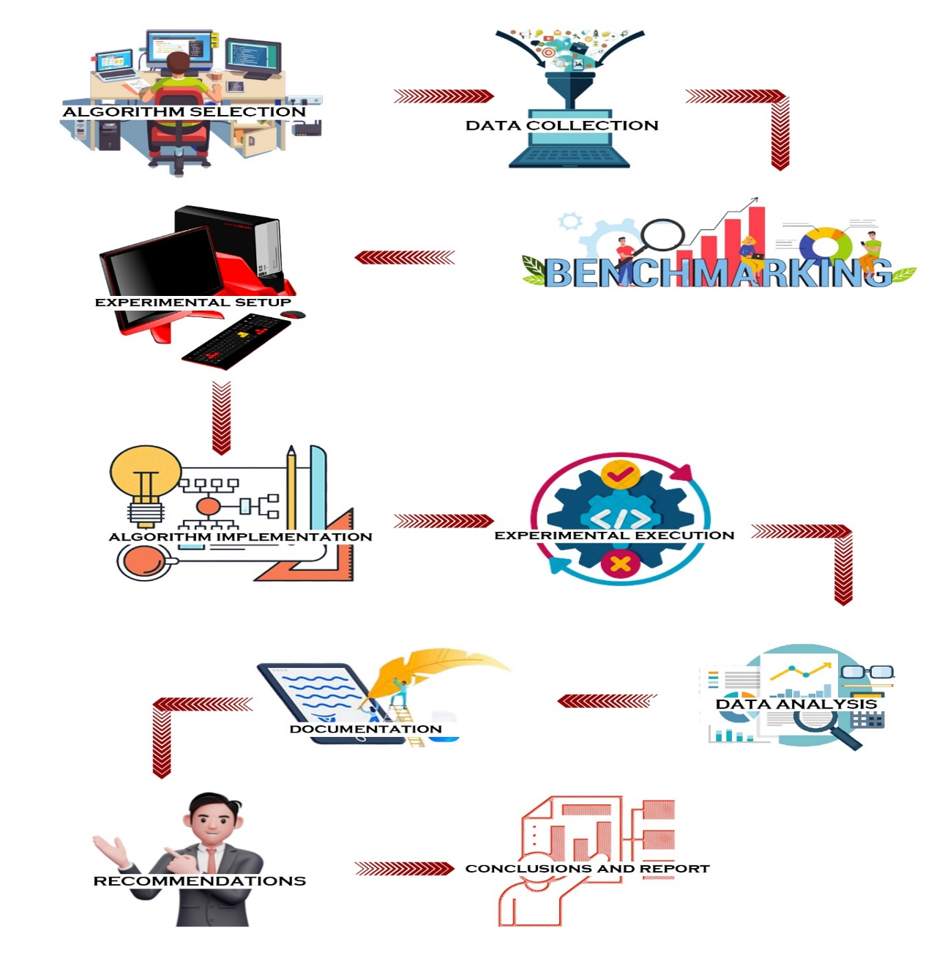

**2.8 Assumption and Dependencies**

Assumptions:

* Assumption of stable internet connectivity for remote work.
* Assumption of third-party API availability for integration.
* Assumption of consistent user feedback and collaboration.
* Assumption of adherence to project budget constraints.

Dependencies:

* Data processing depends on successful data ingestion.
* Task B is dependent on the completion of Task A.
* User training is dependent on system development completion.
* Project launch depends on stakeholder approval and deployment readiness.

1. **SYSTEM REQUIREMENTS**

**3.1 User Interface**

The user interface for the research project, "A Comparative Study and Analysis of Different Optimized Indexing Algorithms," should offer a user-centric design to enhance the experience of researchers and analysts involved. This interface should provide intuitive navigation, enabling users to input research parameters, select algorithms, initiate queries, and visualize results with ease. An interactive dashboard or control panel can assist in managing the research workflow, displaying relevant statistics, and configuring algorithm parameters.

**3.2 Software Interface**

In the research project, "A Comparative Study and Analysis of Different Optimized Indexing Algorithms," the software interface plays a crucial role in facilitating interactions between researchers and the algorithms under examination. The interface should include a user-friendly front end, enabling researchers to input parameters, initiate queries, and visualize results.

**3.3 Database Interface**

The database interface for the research project, "A Comparative Study and Analysis of Different Optimized Indexing Algorithms," is pivotal in managing and accessing research data efficiently. It should provide a user-friendly front-end for researchers to input and manage data, query databases, and retrieve results. Behind the scenes, a well-designed backend interface should be capable of seamlessly interfacing with diverse database management systems.

**3.4 Protocols**

Data Collection Protocol: Guidelines for consistent dataset acquisition.

Experimental Design: Methodology and research design.

Performance Metrics: Metrics to measure algorithm efficiency.

Data Preprocessing: Steps for accurate data preparation.

Error Tracking and Anomaly Handling: Procedures for data anomalies.

Result Validation: Protocol for ensuring research integrity.

Benchmark Definition: Criteria for algorithmic assessment.

Reporting Protocol: Guidelines for disseminating findings.

Documentation and Version Control: Ensuring research reproducibility.

1. **NON-FUNCTIONAL REQUIREMENTS**

**4.1 Performance requirements**

In the research project "A Comparative Study and Analysis of Different Optimized Indexing Algorithms," robust performance requirements are essential for achieving the project's objectives. The performance of the research should be characterized by efficient data retrieval and analysis. Key performance requirements include optimizing query response times, ensuring scalability to accommodate large datasets, minimizing storage overhead, and providing swift data updates. The research should also address the adaptability of indexing algorithms to varying workloads and data distributions. These requirements aim to enable researchers to draw meaningful conclusions from their analysis while efficiently managing data, making the research process both timely and effective.

**4.2 Security requirements**

In the context of the research project, "A Comparative Study and Analysis of Different Optimized Indexing Algorithms," stringent security requirements are paramount to safeguard the integrity, confidentiality, and ethical considerations surrounding research data and findings. To ensure the security of the project, data encryption protocols should be implemented to protect sensitive research data both at rest and during transmission. Access control mechanisms, including role-based access and two-factor authentication, are vital to limit access to authorized personnel only, thereby mitigating unauthorized access risks. Detailed audit trails should be maintained to monitor activities within the research environment, facilitating the identification of potential security breaches. Compliance with data privacy regulations, such as GDPR or HIPAA, is essential depending on the data involved. Regular security assessments and incident response planning are fundamental in identifying and addressing vulnerabilities and responding effectively to security incidents.

**4.3 Software Quality Attributes**

For my minor project on "A Comparative Study and Analysis of Different Optimized Indexing Algorithms," I'm focusing on several crucial software quality attributes to ensure the success of the project:

Reliability: The system must consistently provide accurate results, as incorrect diagnoses could have serious consequences.

Performance: Real-time detection requires high processing speed, and the software should be optimized to handle a large volume of data quickly.

Accuracy: The neural network's algorithms need to be precise in recognizing heart disease patterns.

Security: Ensuring patient data privacy and protecting the system from cyber threats is paramount.

Usability: The user interface should be intuitive, making it accessible to medical professionals with varying technical backgrounds.

Scalability: The software should adapt to different hospital environments and accommodate future data growth.

Maintainability: Regular updates, bug fixes, and model enhancements must be easy to implement.

These attributes will be central to the success of our project, ultimately saving lives and benefiting healthcare professionals.

**APPENDIX A: PERTINENT ANALYSIS MODEL**

