University of Messina



Bachelor of Data Analysis
ACADEMIC YEAR - 2024/2025
(Report)

Subject: System Security Student: Ayan Ali
Supervisor: Prof: Massimo Villari Matricola: 552070

Introduction
This report explains the security features I implemented in my simulated cryptocurrency trading platform. I will walk you through each security measure one by one, showing you how I implemented and how they work and why they're important.

Table of Contents

- Password Security
- Two-Factor Authentication (OTP)
- Session Management
- RSA Encryption for Transfers
- Input Validation
- SQL Injection Prevention
- Summary

1. Password Security

What I Did
When users register on my platform, I do not store their passwords as plain text. Instead, I use a hashing to convert passwords into a scrambled version that can't be reversed.

How It Works
When a user creates an account, I take their password and run it through PHP's password_hash() function. This uses bcrypt which is a secure way to scramble passwords. Here's what happens:
- User enters password: MyPassword123
- System converts it to a long-scrambled string
- This scrambled version is stored in the database

Why This Matters
- Even if someone hacks the database, they can't see the actual passwords
- Bcrypt is slow by design - this makes it very hard for attackers to guess passwords by trying millions of combinations
- Each password gets a unique "salt", even if two users have the same password, they'll have different hashes

Registration Page
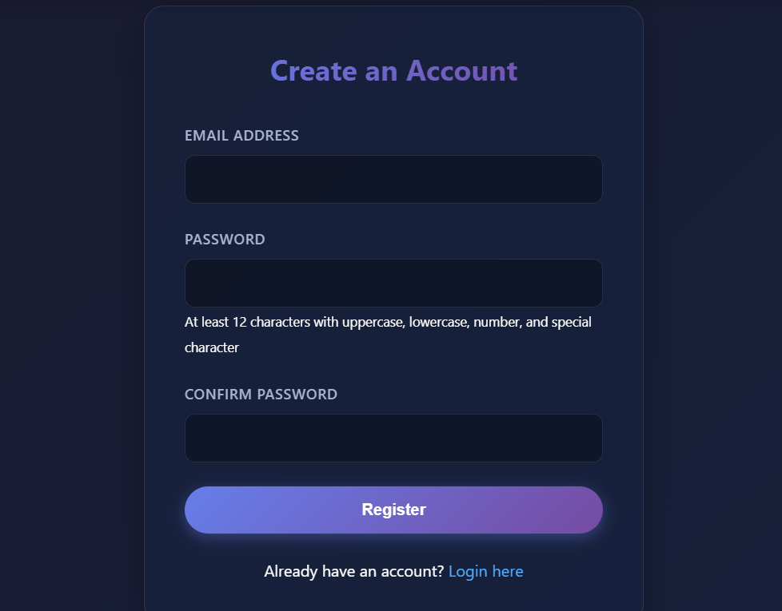
The password they enter gets hashed before being stored.

Login Process
When users log in, the system compares the entered password with the stored hash using password_verify(). This is secure because it prevents timing attacks.

2. Two-Factor Authentication (OTP)

What I Did
I added an extra layer of security beyond just passwords. After users enter their password, they also need to enter a 6-digit code that gets sent to their email.

How It Works
Here's the step-by-step process:
- User enters email and password on the login page
- System checks if credentials are correct
- If correct, system generates a random 6-digit code (like 123456)
- Code is sent to user's email using PHPMailer
- Code is stored in the server session with a 50-second expiration
- User enters the code they received
- System verifies the code matches and hasn't expired
- User is logged in only if everything checks out

Why This Matters
- Even if someone steals your password, they still need access to your email to log in
- The code expires quickly (50 seconds) so old codes can't be reused
- Codes are random - you can't predict what the next code will be

OTP Verification Page
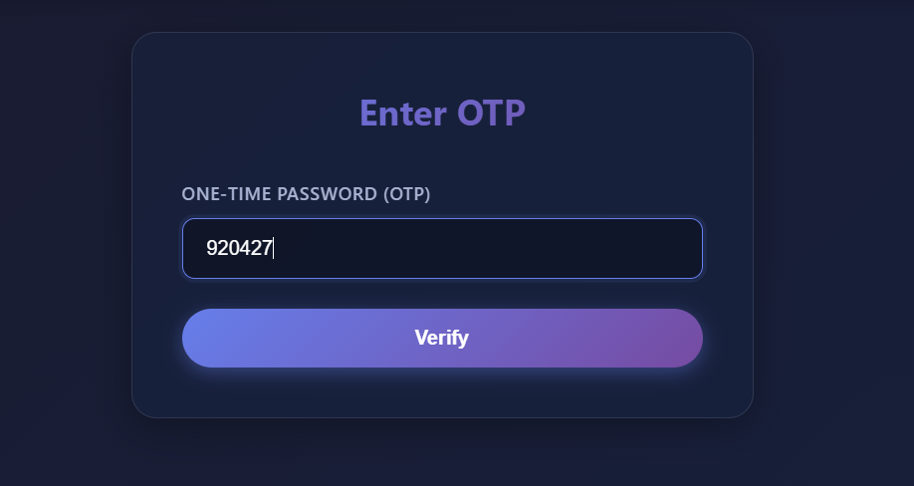
After entering their password, users see this page where they enter the 6-digit code from their email.

3. Session Management

What I Did

Once a user is logged in, I need to remember who they are as they navigate through the website. I do this using "sessions", a way to store information on the server that's linked to each user.

How It Works
- When user logs in, the system creates a session
- A unique session ID is stored in the user's browser (as a cookie)
- User information (like their user ID) is stored on the server
- Every time the user visits a page, the system checks if they have a valid session
- If no valid session, the user is redirected to the login page
- When user logs out, the session is destroyed

Why This Matters
- Users don't have to log in on every page - the session remembers them
- Sessions are stored on the server - users can't tamper with them
- Sessions expire when the browser closes or user logs out
- Protected pages check for sessions - you can't access your dashboard without being logged in

Dashboard Access
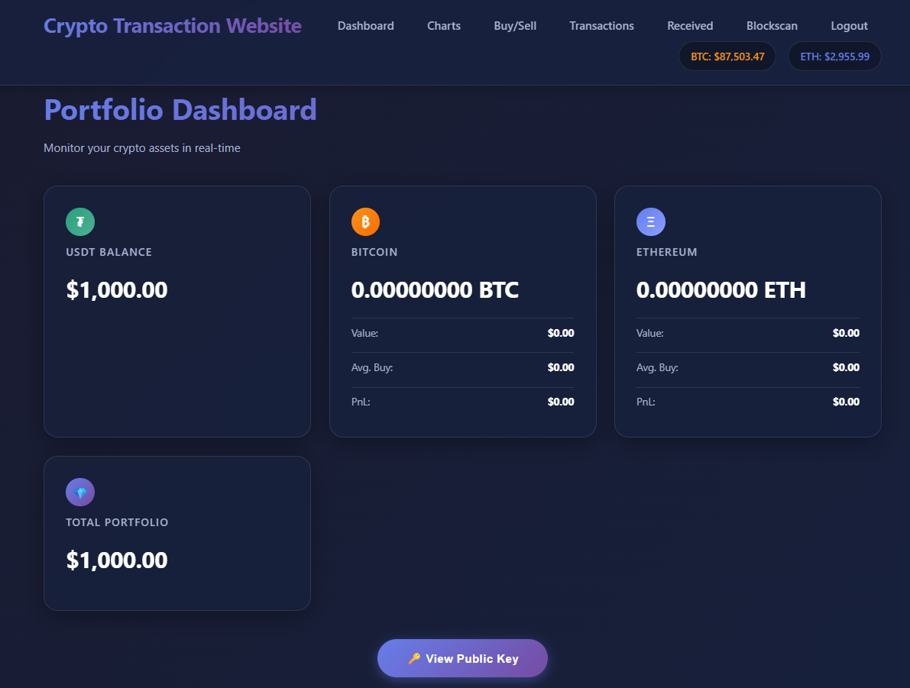
This dashboard is protected, you can only see it if you have a valid session (are logged in).

4. RSA Encryption for Transfers

What I Did
When users want to send cryptocurrency to each other, I encrypt the transfer data so that only the intended recipient can read it. I use something called RSA encryption, which is a type of "public-key cryptography."

How It Works
This is a bit more complex, but here's the simple explanation:
Each user gets a pair of keys when they register:
- - A public key (like a mailbox - anyone can put mail in it)
- - A private key (like the mailbox key - only the owner has it)
When sending a transfer:
- - The sender encrypts the transfer data using the recipient's public key
- - Only the recipient can decrypt it using their private key
- - The sender also signs the data with their private key to prove they sent it
When receiving a transfer:
- - The recipient uses their private key to decrypt the data
- - The system verifies the sender's signature to make sure it's authentic
- - The cryptocurrency is added to the recipient's balance

Why This Matters
- Only the recipient can read the transfer - even if someone intercepts it, they can't decrypt it
- The signature proves who sent it - the sender can't deny sending it later
- Data is encrypted before storage - even database administrators can't see the transfer details

Transfer Interface
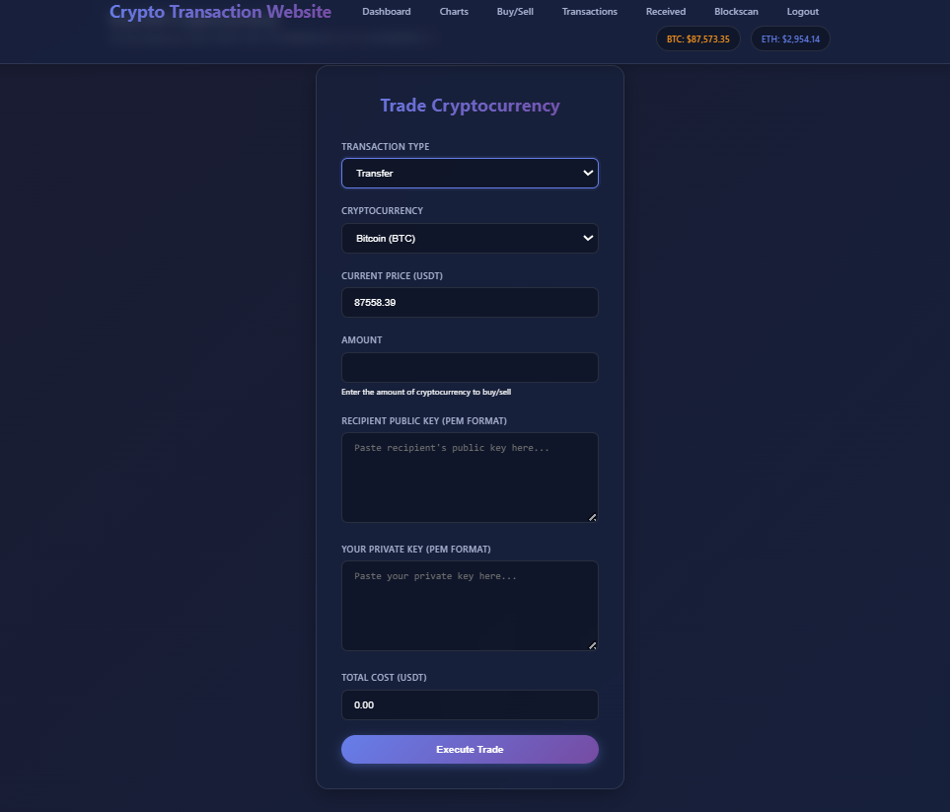
This is where users initiate transfers. They need to provide the recipient's public key and their own private key to sign the transaction.

Received Transfers
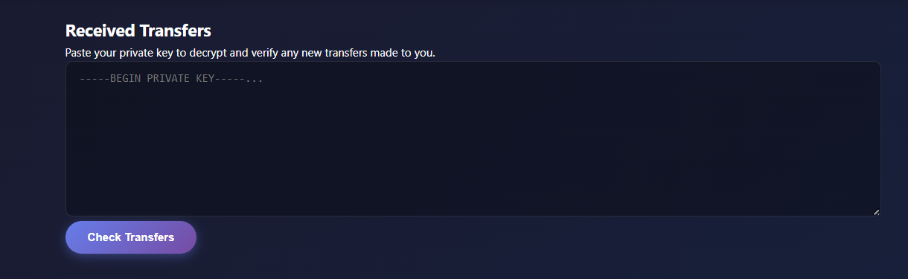
Users can see transfers sent to them here. They need their private key to decrypt and claim the transfers.

Technical Details
- Key Size: 2048 bits (very secure)
- Encryption Algorithm: RSA with OAEP padding
- Signature Algorithm: SHA-256 with RSA
- Private keys are stored securely in a directory on the server

5. Input Validation

What I Did
I check and clean all data that users enter the system before using it. This prevents malicious code from being executed.

How It Works
Every time a user submits a form, I run the data through a sanitization function:

- Remove extra spaces from the beginning and end
- Remove backslashes that might be used for escaping
- Convert special characters like < and > to safe versions
- Check the data type - make sure numbers are numbers
- Validate format - check that emails look like emails

Example

If a user tries to enter: <script>alert('hack')</script> as their name, the system converts it to: &lt;script&gt;alert('hack')&lt;/script&gt; which is safe and won't execute.

Why This Matters
- Prevents XSS attacks - malicious scripts can't run in other users' browsers
- Ensures data integrity - only valid data gets stored
- Protects other users - bad data can't harm the system or other users

Buy/Sell Interface
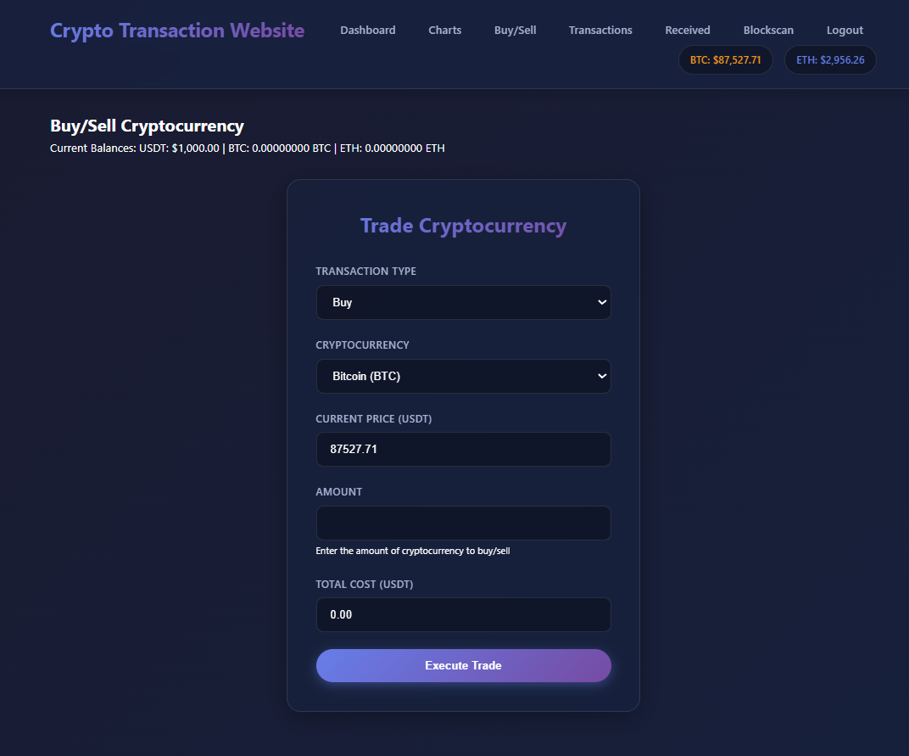
All inputs on this page are validated before processing. The system checks that amounts are positive numbers, coins are valid types, and prices are reasonable.

6. SQL Injection Prevention

What I Did
I use "prepared statements" for all database queries. This separates the SQL code from the user data, making it impossible for users to inject malicious SQL commands.

How It Works
Instead of building SQL queries by combining strings (which is dangerous), I use placeholders:

Why This Matters
- Prevents SQL injection attacks - users can't manipulate database queries
- Protects user data - attackers can't access or delete data they shouldn't
- Maintains data integrity - the database structure can't be modified by users

Transaction History
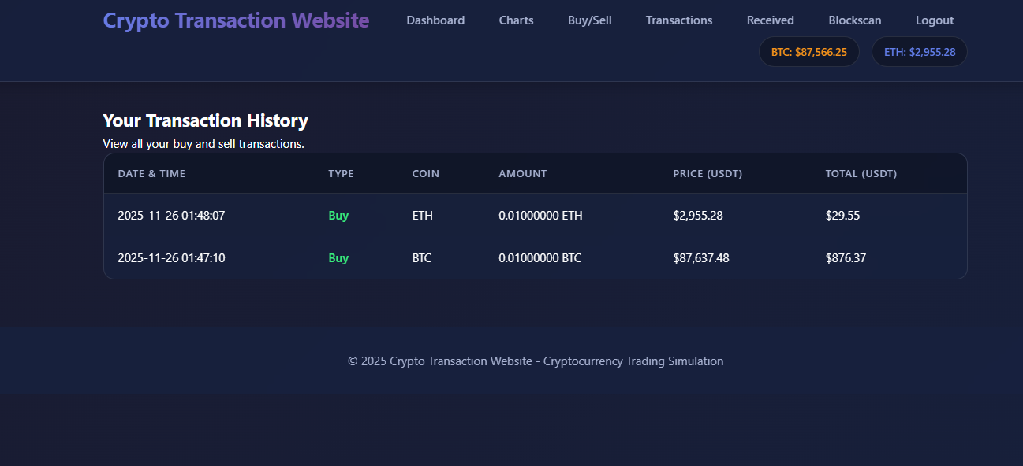
All the data shown here is retrieved using prepared statements, ensuring that user input can't be used to manipulate the queries.

Summary

Security Features Overview
I've implemented multiple layers of security to protect the platform:

- Password Security
- - Passwords are hashed using bcrypt
- - Never stored in plain text
- - Secure verification process

- Two-Factor Authentication
- - Email-based OTP system
- - Time-limited codes
- - Extra layer beyond passwords

- Session Management
- - Secure session handling
- - Automatic expiration
- - Protected page access

- RSA Encryption
- - 2048-bit key pairs
- - Encrypted transfers
- - Digital signatures

- Input Validation
- - All inputs sanitized
- - XSS prevention
- - Data type checking

- SQL Injection Prevention
- - Prepared statements for all queries
- - Parameter binding
- - Safe database operations

Why Multiple Layers Matter
I didn't rely on just one security measure. Instead, I used multiple layers because:
- If one layer fails, others still protect the system
- Different attacks require different defences
- Defence in depth is a security best practice

What I Learned
Through this project, I learned that:
- Security is not optional - it must be built in from the start
- Simple measures like input validation can prevent many attacks
- Cryptography is powerful but must be used correctly
- User education is important - users need to understand how to keep their keys safe

Future Improvements
If I were to continue developing this project, I would:
- Use cryptographically secure random number generation for OTPs
- Add rate limiting to prevent brute force attacks
- Implement HTTPS for all communications
- Add account lockout after failed login attempts
- Regular security audits and testing

Conclusion
This project gave me hands-on experience with implementing security measures in a web application. I learned how to protect user data, secure communications, and prevent common attacks. While the implementation is suitable for an academic project, I understand that production systems would require additional security measures and regular updates.
The most important lesson is that security is an ongoing process, not something you do once and forget. As new threats emerge, security measures must evolve to counter them.

