Machine Learning Engineer – Assessment

Spotter.AI

Muhammad Ayan BUTT
Ayanbutt1013@gmail.com

Dataset Preprocessing and Preparation (data_prepare.py)
The dataset (train-test.csv) was first processed and prepared before any model development:
- Loaded the dataset containing 48,000 freight records
- Non-predictive features/ columns were removed from the dataset
  - load_id
  - pickup
  - delivery
- Date feature was converted into following numerical features:
  - date_month
  - date_weekday
- Two additional features were created as a result of feature engineering:
  - delta_lat = delivery_lat − pickup_lat
  - delta_lon = delivery_lon − pickup_lon
- Missing n/a values were filled using mean (in case of numeric) and mode (in case of categorical)
- One-hot encoding was applied to “equipment”
- Standardized numerical features using StandardScaler.
- Applied a “log1p transformation” to the target variable (posted_rate) before training.
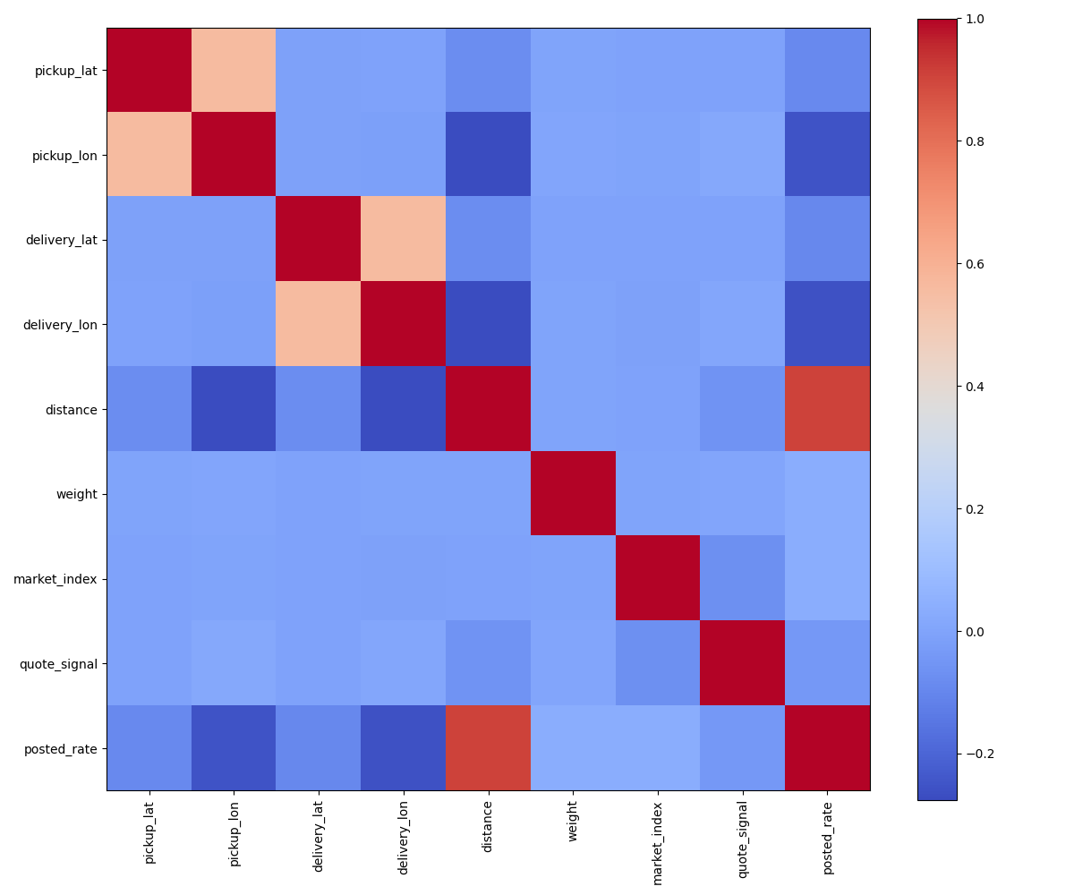
Figure 1: Correlation Heatmap
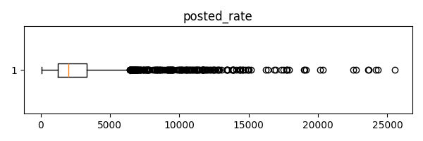
Figure 2: Boxplot of posted_rate

Train/ Testing Split (data_prepare.py)
The dataset (test-train.csv) was divided into:
- 80% Training
- 20% Testing
using a random train-validation split.
Table 1: Test/ Train Split
Dataset | Samples
Training | 37,861
Testing | 9,466

Training Strategy (model.py)
The neural network was trained using:
- Huber Loss
- Adam optimizer
- ReduceLROnPlateau learning-rate scheduler
- Early Stopping
- Best model checkpoint restoration

Model Network (model.py)
The architecture is given as:
- Three hidden layers (128, 64, 32) were used with ReLU, batch normalization, and dropout (0.2).
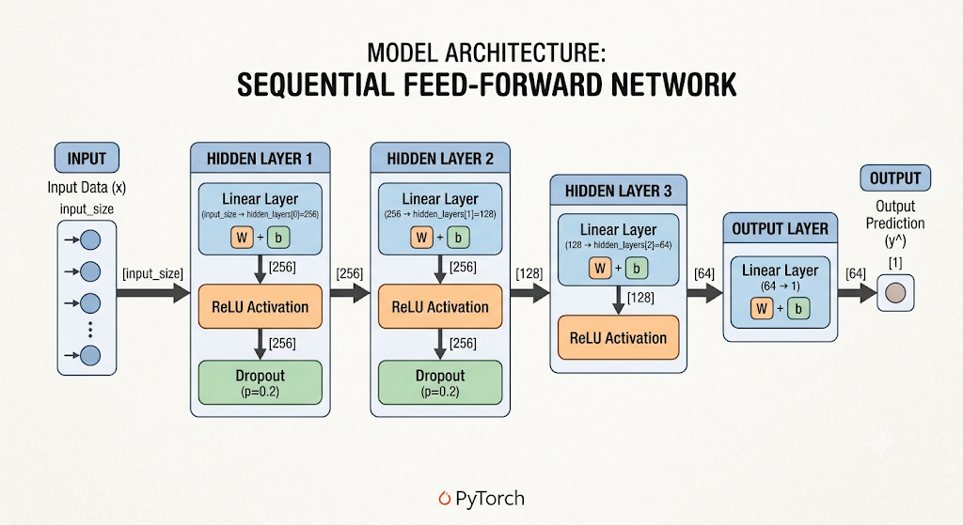
Figure 3: Model Architecture

Model Testing Performance Metrics
Model performance metrics are given as:
Table 2: Model Performance Metrics
Metric | Value
Loss | 0.0104
RMSE | 529.54
MAE | 105.46
R² | 0.8689

December 2025 Prediction Chart
The supplied score.py script was used to validate both submission files and generate the required prediction chart.
The chart below shows the predicted freight rate for a fixed shipment:
- Pickup: Lexington
- Delivery: Fort Wayne
- Distance: 360 miles
- Equipment: Dry Van
- Weight: 32,000 lb
Only the shipment date changes from December 1–31, 2025.
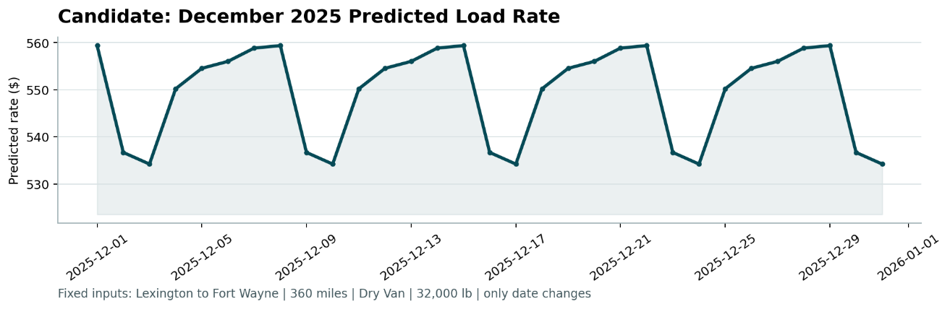
Figure 4: December 2025 Chart

Observations
- The model achieved an R² score of 0.8689 on the validation set, indicating good predictive capability.
- Feature engineering using geographical coordinate differences (delta_lat, delta_lon) improved prediction accuracy.
- Applying a logarithmic transformation to the target variable stabilized training and reduced prediction error.
- Early stopping and adaptive learning rate scheduling improved model generalization.

