GRADE 9 CISCE
INTERNAL ASSESSMENT – FIRST TERM
COMPUTER APPLICATIONS PROJECT
Academic Year: 2026–2027
Program – 1 :-
Question - Write a program to initialise fractional numbers 7.6,3.2,6.4. Print the sum and product of the numbers.
Program –
public class Program_1
{
public static void main(String args[])
{
float number_1 = 7.6f;
float number_2 = 3.2f;
float number_3 = 6.4f;
//This is the first program
System.out.println("The first number is : " + number_1);
System.out.println("The second number is : " + number_2);
System.out.println("The third number is : " + number_3);
float sum = number_1 + number_2 + number_3;
float product = number_1 * number_2 * number_3;
System.out.println("The sum of the numbers - " + number_1 + " , " + number_2 + " & " + number_3 + " is " + sum);
System.out.println("The product of the numbers - " + number_1 + " , " + number_2 + " & " + number_3 + " is " + product);
}
}
Output –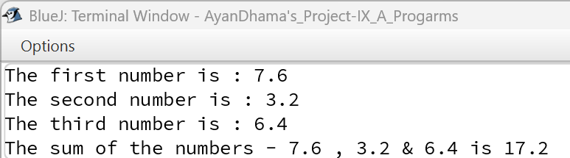
V·D·T (VARIABLE DESCRIPTION TABLE) --
VARIABLE NAME | VARIABLE TYPE | DESCRIPTION
number_1 | Float | Stores the value 7.6
number_2 | Float | Stores the value 3.2
number_3 | Float | Stores the value 6.4
sum | Float | Stores the sum of all three numbers
product | Float | Stores the product of all three numbers

Program – 2 :-
Question - Write a program to print the quotient and remainder of integer 187 by integer 13
Program –
public class Program_2
{
public static void main(String args[])
{
int a = 187;
int b = 13;
int quotient, remainder;
//This is the second program
quotient = a / b;
remainder = a % b;
System.out.println("Dividend = " + a);
System.out.println("Divisor = " + b);
System.out.println("Quotient = " + quotient);
System.out.println("Remainder = " + remainder);
}
}
Output –
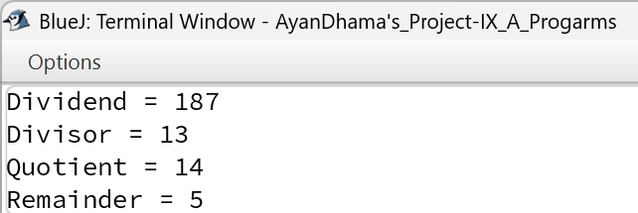
V·D·T (VARIABLE DESCRIPTION TABLE) --
VARIABLE NAME | VARIABLE TYPE | DESCRIPTION
a | Int | Stores the dividend value 187
b | Int | Stores the divisor value 13
quotient | Int | Stores the result of division (a / b)
remainder | Int | Stores the remainder of division (a % b)

Program – 3:-
Question - Write a program to assign integers a, b, c with values 3, 6, 9. Perform, the operations and print the results of the operations: S = (a + b + c)/2 and V = (a² + b²)/c³
Program –
public class Program_3
{
public static void main(String args[])
{
int a = 3;
int b = 6;
int c = 9;
//This is the third program
double S = (a + b + c) / 2.0;
double V = (Math.pow(a, 2) + Math.pow(b, 2)) / Math.pow(c, 3);
System.out.println("Value of a : " + a);
System.out.println("Value of b : " + b);
System.out.println("Value of c : " + c);
System.out.println("Result of S = (a + b + c) / 2 : " + S);
System.out.println("Result of V = (a^2 + b^2) / c^3 : " + V);
}
}
Output –
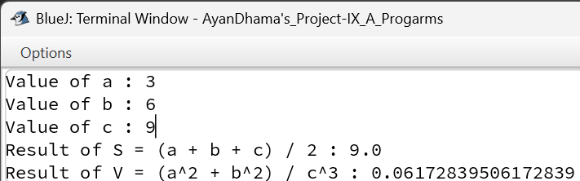
V·D·T (VARIABLE DESCRIPTION TABLE) --
VARIABLE NAME | VARIABLE TYPE | DESCRIPTION
a | Int | Stores the integer value 3
b | Int | Stores the integer value 6
c | Int | Stores the integer value 9
S | Double | Stores the calculated result of S
V | Double | Stores the calculated result of V

Program – 4 :-
Question - Write a program to accept Principal amount(P), rate of interest (R) and Time (T) through parameterized method. Calculate and print the Simple Interest.
Program –
public class Program_4
{
public static void main (double P, double R, double T)
{
double SI = (P * R * T) / 100.0;
//This is the fourth program
System.out.println("Principal Amount = " + P);
System.out.println("Rate of Interest = " + R);
System.out.println("Time Period = " + T);
System.out.println("Simple Interest = " + SI);
}
}
Output –
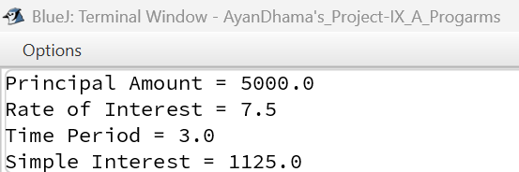
V·D·T (VARIABLE DESCRIPTION TABLE) --
VARIABLE NAME | VARIABLE TYPE | DESCRIPTION
P | Double | Accepts principal amount as parameter
R | Double | Accepts rate of interest as parameter
T | Double | Accepts time period as parameter
SI | Double | Stores the calculated simple interest

Program – 5 :-
Question - Write a program to accept values for variables a and b through parameterized method. Swap their values using third variable. Display the values after swapping.
Program –
public class Program_5
{
public static void main (int a, int b)
{
System.out.println("Values before swapping: a = " + a + ", b = " + b);
int temp = a;
a = b;
b = temp;
System.out.println("Values after swapping: a = " + a + ", b = " + b);
}
}
Output –
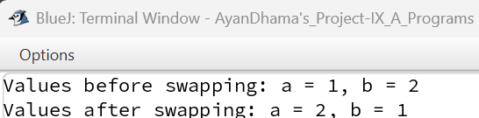
V·D·T (VARIABLE DESCRIPTION TABLE) --
VARIABLE NAME | VARIABLE TYPE | DESCRIPTION
a | Int | Accepts first integer value as parameter
b | Int | Accepts second integer value as parameter
temp | Int | Temporary variable used to swap values

Program – 6 :-
Question - Write a program to initialize a three-digit number of a long integer type. Print the sum and product of first and last digits of that number.
Program –
public class Program_6
{
public static void main(String args[])
{
long num = 845L;
long firstDigit = num / 100;
long lastDigit = num % 10;
long sum = firstDigit + lastDigit;
long product = firstDigit * lastDigit;
System.out.println("Given three-digit number = " + num);
System.out.println("First digit = " + firstDigit);
System.out.println("Last digit = " + lastDigit);
System.out.println("Sum of first and last digit = " + sum);
System.out.println("Product of first and last digit = " + product);
}
}
Output –
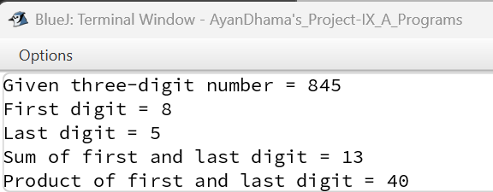
V·D·T (VARIABLE DESCRIPTION TABLE) --
VARIABLE NAME | VARIABLE TYPE | DESCRIPTION
num | Long | Stores the given three-digit long integer
firstDigit | Long | Stores the extracted first digit of the number
lastDigit | Long | Stores the extracted last digit of the number
sum | Long | Stores the sum of first and last digits
product | Long | Stores the product of first and last digits

Program – 7 :-
Question - Create a class Student_Info to input (Scanner method) marks in English, Maths, Physics, Chemistry, Biology, Computer Applications. Print the marks obtained in all the subjects, total marks and percentage. (Assume that the maximum mark in each subject is 100).
Program –
import java.util.Scanner;
public class Student_Info
{
public static void main(String args[])
{
Scanner sc = new Scanner(System.in);
System.out.print("Enter marks in English: ");
double eng = sc.nextDouble();
System.out.print("Enter marks in Maths: ");
double math = sc.nextDouble();
System.out.print("Enter marks in Physics: ");
double phy = sc.nextDouble();
System.out.print("Enter marks in Chemistry: ");
double chem = sc.nextDouble();
System.out.print("Enter marks in Biology: ");
double bio = sc.nextDouble();
System.out.print("Enter marks in Computer Applications: ");
double comp = sc.nextDouble();
double total = eng + math + phy + chem + bio + comp;
double percentage = (total / 600.0) * 100.0;
System.out.println("\n--- MARKS DETAILS ---");
System.out.println("English: " + eng);
System.out.println("Maths: " + math);
System.out.println("Physics: " + phy);
System.out.println("Chemistry: " + chem);
System.out.println("Biology: " + bio);
System.out.println("Computer Applications: " + comp);
System.out.println("Total Marks Obtained: " + total + " / 600");
System.out.println("Percentage: " + percentage + "%");
}
}
Output –
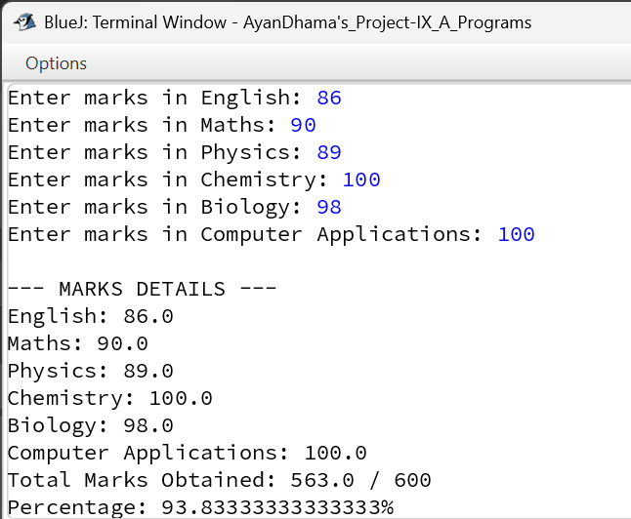
V·D·T (VARIABLE DESCRIPTION TABLE) --
VARIABLE NAME | VARIABLE TYPE | DESCRIPTION
sc | Scanner | Scanner object to accept input from console
eng | Double | Stores marks obtained in English
math | Double | Stores marks obtained in Maths
phy | Double | Stores marks obtained in Physics
chem | Double | Stores marks obtained in Chemistry
bio | Double | Stores marks obtained in Biology
comp | Double | Stores marks obtained in Computer Applications
total | Double | Stores total marks obtained across all 6 subjects
percentage | Double | Stores calculated percentage

Program – 8 :-
Question - Write a program to input three sides of a triangle (Scanner method). Print the area of the triangle using the given formula Area=√s(s − a)(s − b)(s − c). The class name is Triangle.
Program –
import java.util.Scanner;
public class Triangle
{
public static void main(String args[])
{
Scanner sc = new Scanner(System.in);
System.out.print("Enter side a: ");
double a = sc.nextDouble();
System.out.print("Enter side b: ");
double b = sc.nextDouble();
System.out.print("Enter side c: ");
double c = sc.nextDouble();
double s = (a + b + c) / 2.0;
double area = Math.sqrt(s * (s - a) * (s - b) * (s - c));
System.out.println("Side a = " + a);
System.out.println("Side b = " + b);
System.out.println("Side c = " + c);
System.out.println("Semi-perimeter (s) = " + s);
System.out.println("Area of Triangle = " + area);
}
}
Output –
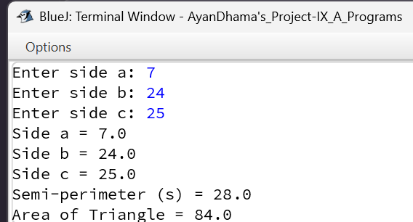
V·D·T (VARIABLE DESCRIPTION TABLE) --
VARIABLE NAME | VARIABLE TYPE | DESCRIPTION
sc | Scanner | Scanner object to accept user input
a | Double | Stores length of first side
b | Double | Stores length of second side
c | Double | Stores length of third side
s | Double | Stores calculated semi-perimeter
area | Double | Stores calculated area using Heron's formula

Program – 9 :-
Question - Write a program to which inputs two integers num1, num2 and operator, that contains an arithmetic operator (‘+’, ‘-‘, ‘/’ or ‘*’) only. Perform and print the corresponding operation on n1 and n2 on the basis of the operator using the switch-case or user’s choice statement.
Program –
import java.util.*;
public class calculator
{
public static void main(String args [])
{
Scanner sc = new Scanner(System.in);
System.out.println("---------------------------------------------------------------------------------------------------------------------------------------------------------");
System.out.println("┃ !!!Welcome to CALCULATOR !!! ┃");
System.out.println("---------------------------------------------------------------------------------------------------------------------------------------------------------");
System.out.println("");
System.out.println("");
System.out.println("");
System.out.println("---------------------------------------------------------------------------------------------------------------------------------------------------------");
System.out.print("Please Enter Your First Number :- ");
double n1 = sc.nextDouble();
System.out.println("---------------------------------------------------------------------------------------------------------------------------------------------------------");
System.out.print("Please Enter Your Second Number :- ");
double n2 = sc.nextDouble();
System.out.println("---------------------------------------------------------------------------------------------------------------------------------------------------------");
System.out.println("Please Enter Your Type Of Method Based On The Below Options :-");
System.out.println("---------------------------------------------------------------------------------------------------------------------------------------------------------");
System.out.println("1. Addition - Code = P001aaa1");
System.out.println("---------------------------------------------------------------------------------------------------------------------------------------------------------");

System.out.println("---------------------------------------------------------------------------------------------------------------------------------------------------------");
System.out.println("2. Subtraction - Code = P001aaa2");
System.out.println("---------------------------------------------------------------------------------------------------------------------------------------------------------");

System.out.println("---------------------------------------------------------------------------------------------------------------------------------------------------------");
System.out.println("3. Division - Code = P001aaa3");
System.out.println("---------------------------------------------------------------------------------------------------------------------------------------------------------");

System.out.println("---------------------------------------------------------------------------------------------------------------------------------------------------------");
System.out.println("4. Multipication - Code = P001aaa4");
System.out.println("---------------------------------------------------------------------------------------------------------------------------------------------------------");
System.out.print("Input code :- ");
String c = sc.next();
System.out.println("---------------------------------------------------------------------------------------------------------------------------------------------------------");
if (c.equals("P001aaa1"))
{
double addition = n1+n2;
System.out.println("The Addition result of " + n1 + " " +"+" + n2 + " is : "+ addition);
System.out.println("---------------------------------------------------------------------------------------------------------------------------------------------------------");
}
else if (c.equals("P001aaa2"))
{
if (n1>=n2)
{
double subtraction_1 = n1-n2;
System.out.println("The Subtraction result of " + n1 + " " +"-" + n2 + " is : "+ subtraction_1);
System.out.println("---------------------------------------------------------------------------------------------------------------------------------------------------------");
}
else
{
double subtraction_2 = n2-n1;
System.out.println("The Subtraction result of " + n2 + " " +"-" + n1 + " is : "+ subtraction_2);
System.out.println("---------------------------------------------------------------------------------------------------------------------------------------------------------");
}
}
else if (c.equals("P001aaa3"))
{
double Division = (double) n1 / n2;
System.out.println("The Division result of " + n1 + " " +"/" + n2 + " is : "+ Division);
System.out.println("---------------------------------------------------------------------------------------------------------------------------------------------------------");
}
else if (c.equals("P001aaa4"))
{
double Multiplication = n1 * n2;
System.out.println("The Multipication result of " + n1 + " " +"*" + n2 + " is : "+ Multiplication);
System.out.println("---------------------------------------------------------------------------------------------------------------------------------------------------------");
}
else
{
System.out.println("Error 101 : You Have Entered The Wrong Code For The Type Of Arithmetic Method. Please Enter A Valid Code And Try Again.");
System.out.println("---------------------------------------------------------------------------------------------------------------------------------------------------------");
}
System.out.println("Note : The Subtraction Result Will Not Appear As A Negative Value Because Of The Current Capabilities Of Our System.");
System.out.println("---------------------------------------------------------------------------------------------------------------------------------------------------------");
System.out.println("Please Also Note That The Code You Will Have To Rerun If You To Redo A Equation");
System.out.println("---------------------------------------------------------------------------------------------------------------------------------------------------------");
System.out.println("");
System.out.println("");
System.out.println("");
System.out.println("---------------------------------------------------------------------------------------------------------------------------------------------------------");
System.out.println("┃ !!! THANK YOU !!! ┃");
System.out.println("---------------------------------------------------------------------------------------------------------------------------------------------------------");
System.out.println("");
System.out.println("");
System.out.println("");
System.out.println("---------------------------------------------------------------------------------------------------------------------------------------------------------");
System.out.println("┃ !!! SEE YOU LATER!!! ┃");
System.out.println("---------------------------------------------------------------------------------------------------------------------------------------------------------");
}
}
Output –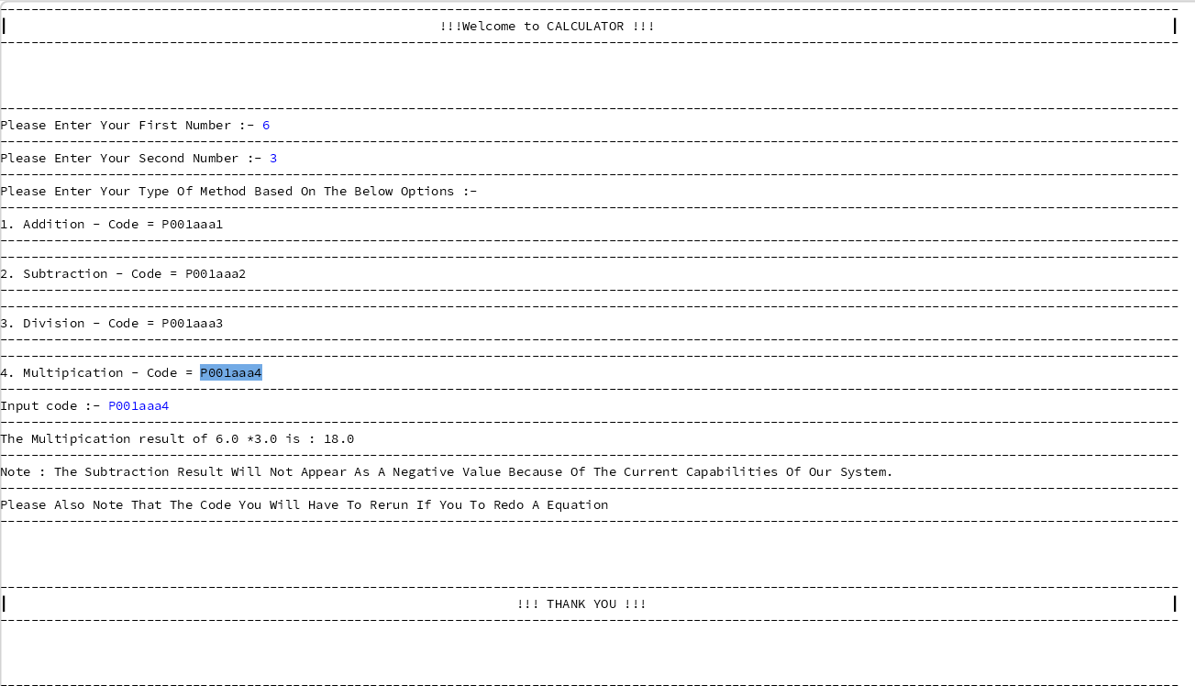
V·D·T (VARIABLE DESCRIPTION TABLE) --
VARIABLE NAME | VARIABLE TYPE | DESCRIPTION
sc | Scanner | Scanner object to accept input from standard input
n1 | Double | Stores the first input number entered by the user
n2 | Double | Stores the second input number entered by the user
c | String | Stores the unique operational code string entered by the user
addition | Double | Stores the sum of n1 and n2
subtraction_1 | Double | Stores result of (n1 - n2) when n1 >= n2
subtraction_2 | Double | Stores result of (n2 - n1) when n2 > n1
Division | Double | Stores the division quotient of n1 / n2
Multiplication | Double | Stores the multiplication product of n1 * n2

Program – 10:-
Question - An XYZ mall has announced the festive discounts on the purchase of items based on the total cost of items. Write a program to input the name of the customer, total cost of purchase, type of the purchase (H for Home Appliances and F for Furniture) using Scanner class. Compute and display the amount to be paid by the customer after availing the discount.
Program –
import java.util.Scanner;
public class Program_10
{
public static void main(String args[])
{
Scanner sc = new Scanner(System.in);
System.out.print("Enter Customer Name: ");
String name = sc.nextLine();
System.out.print("Enter Cost of Purchase: ");
double cost = sc.nextDouble();
System.out.print("Enter Purchase Type (H for Home Appliances, F for Furniture): ");
char type = sc.next().toUpperCase().charAt(0);
double discountPercent = 0.0;
if (cost < 25000)
{
discountPercent = (type == 'H') ? 5.0 : 7.0;
}
else if (cost >= 25001 && cost <= 30000)
{
discountPercent = (type == 'H') ? 7.0 : 10.0;
}
else if (cost >= 30001 && cost <= 45000)
{
discountPercent = (type == 'H') ? 10.0 : 13.0;
}
else if (cost >= 45001)
{
discountPercent = (type == 'H') ? 14.0 : 16.0;
}
double discountAmount = (cost * discountPercent) / 100.0;
double netAmount = cost - discountAmount;
System.out.println("\nName\t\tCost of the Purchase\tDiscount (in Rs)\tNet Amount(in Rs.)");
System.out.println(name + "\t" + cost + "\t\t\t" + discountAmount + "\t\t" + netAmount);
}
}
Output –
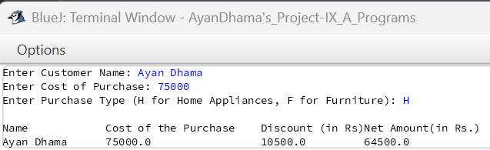
V·D·T (VARIABLE DESCRIPTION TABLE) --
VARIABLE NAME | VARIABLE TYPE | DESCRIPTION
sc | Scanner | Scanner object to accept user input
name | String | Stores customer name
cost | Double | Stores total cost of purchase
type | Char | Stores purchase category ('H' or 'F')
discountPercent | Double | Stores applicable discount percentage rate
discountAmount | Double | Stores calculated discount value in rupees
netAmount | Double | Stores final amount payable after discount

