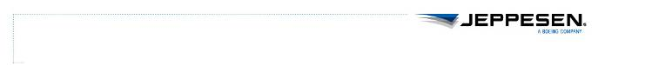**The SAS CMS Project**

**Functional Reference Manual**

*Common functionality Jeppesen CMS*

*Document Type: Functional Reference*

*Document Status: Final FAT*

*Version: 1.21*

*Last Changed: 2013-02-26*

Table of Contents

[1 Creating activities/ground duties 6](#_Toc338314616)

[1.1 Activity code/Task code 6](#_Toc338314617)

[1.2 Personal Activity 6](#_Toc338314618)

[1.3 Create Ground Duty 6](#_Toc338314619)

[1.4 Activating cancelled ground duties 7](#_Toc338314620)

[1.5 Changing properties of a ground duty 7](#_Toc338314621)

[2 Wave forms 8](#_Toc338314622)

[2.1 Input Field 8](#_Toc338314623)

[2.2 Pick-list 8](#_Toc338314624)

[2.3 Combined Input Field and Pick-list 8](#_Toc338314625)

[2.4 Calendar 8](#_Toc338314626)

[3 Crew Info 9](#_Toc338314627)

[3.1 User Interface 9](#_Toc338314628)

[3.2 Navigation 14](#_Toc338314629)

[3.3 Data Tabs 15](#_Toc338314630)

[4 Crew Accounts 27](#_Toc338314631)

[4.1 User Interface 27](#_Toc338314632)

[4.2 Crew account balance 30](#_Toc338314633)

[4.3 Online Transactions 31](#_Toc338314634)

[5 Crew Block Hours 33](#_Toc338314635)

[5.1 User Interface 33](#_Toc338314636)

[5.2 Data Modification 36](#_Toc338314637)

[6 Crew Training 40](#_Toc338314638)

[6.1 User Interface 40](#_Toc338314639)

[6.2 Navigation 41](#_Toc338314640)

[6.3 Data 42](#_Toc338314641)

[7 Hotel Reservations 44](#_Toc338314642)

[7.1 Basic process of booking a hotel 44](#_Toc338314643)

[7.2 Reservation/Forecast generation 45](#_Toc338314644)

[7.3 Forecast Reports 45](#_Toc338314645)

[7.4 Reservation Reports 46](#_Toc338314646)

[7.5 Performed Reports 48](#_Toc338314647)

[7.6 Process 48](#_Toc338314648)

[7.7 Database Administration 50](#_Toc338314649)

[7.8 Storage of reports 51](#_Toc338314650)

[8 Transport Reservation 53](#_Toc338314651)

[8.1 Reports 53](#_Toc338314652)

[8.2 Process 56](#_Toc338314653)

[8.3 Database Administration 58](#_Toc338314654)

[8.4 Storage of Reports 59](#_Toc338314655)

[9 Crew Annotations 60](#_Toc338314656)

[9.1 Manage Annotations 60](#_Toc338314657)

[9.2 Set Annotation on Marked Crew 60](#_Toc338314658)

[9.3 Information Window 61](#_Toc338314659)

[10 Crew Audit Trail 62](#_Toc338314660)

[11 Leg Audit Trail 65](#_Toc338314661)

[12 Planning Area 67](#_Toc338314662)

[12.1 Manual Trip Area Attribute 67](#_Toc338314663)

[12.2 User Interface 67](#_Toc338314664)

[13 Table Editor 69](#_Toc338314665)

[13.1 Filtering 69](#_Toc338314666)

[13.2 Audit Trail 71](#_Toc338314667)

Change History

|  |  |  |  |
| --- | --- | --- | --- |
| Version | Author | Date | Description |
| 1 | Andreas Wohrm | 21-Jan-08 | Copied all functional reference guides into one for tracking and one for Common. |
| 2 | Andreas Wohrm | 24-Jan-08 | Added information or changed on, audit trail, crew annotations and crew training. |
| 3 | Erik Gustafsson | 6-Feb-08 | Updated documentation of Crew Training |
| 4 | Hugo Vazquez | 19-Feb-08 | Updated documentation of Transport and Hotel Reservation |
| 5 | Per Grönberg | 03-mar-08 | Updated Crew Info validations and Crew Accounts update baseline information |
| 6 | Per Grönberg | 20-Mar-08 | Updated validationnote for Crew info |
| 7 | Andres Salvador | 25-Mar-08 | Updated Crew and Leg Audit Trail |
| 8 | Per Grönberg | 02-Apr-08 | Crewinfo updated for maintrunk and beta3 |
| 9 | Per Grönberg | 04-Apr-08 | Crewinfo updated for main, removed beta3 chapter due to merge of main into beta3 |
| 9 | Per Grönberg | 04-Apr2008 | Readded beta3 chapter for Crewinfo due to checking in changes in main |
| 10 | Per Grönberg | 09-Apr-2008 | More updates to CI. Removed CI-beta3 chapter due to merge |
| 11 | Andres Salvador | 11-Apr-2008 | Updated Crew and Leg Audit Trail |
| 12 | Per Grönberg | 17-Apr-2008 | Updated Crew info with crew document-> ac\_qual |
| 13 | Per Grönberg | 05-Mar-2008 | Updated crewinfo, removed validation-statement no longer in form |
| 14 | Hugo Vazquez | 14-May-2008 | Updated Hotel and Transport: information about database administration. |
| 15 | F. Acosta | 19-May-2008 | Added information about Publish in PreStudio. |
| 16 | Per Grönberg | 09-Jun-2008 | Area attribute to trips chapter |
| 17 | Erik Gustafsson | 10-Jun-2008 | Updated Planning Area section and Crew Info: Qualifications (CR43 related). |
| 18 | Hugo Vazquez | 13-Jun-2008 | Updated Hotel and Transport: new considerations, process and layout |
| 19 | Erik Gustafsson | 17-Jun-2008 | Minor updates to Planning Area |
| 20 | Per Grönberg | 27-Jun-2008 | Entered how to Borrow crew in Crew Info. Separated crew accounts into U1 and U2 due to baseline development |
| 21 | Sten Larsson | 03-Jul-2008 | Removed two columns from Restriction tab in Crew Info |
| 22 | Hugo Vazquez | 04-Jul-2008 | Added Output File Manager to Hotel and Transport reservation |
| 23 | Sten Larsson | 07-Jul-2008 | Updated Crew Info section |
| 24 | Stefan Hansson | 13-Aug-2008 | Updated Crew Info section |
| 25 | Per Grönberg | 08-Sep-2008 | Updated Crew Accounts |
| 26 | Andreas Wohrm | 11-Sep-2008 | Added chapter on wave forms, deleted crew accounts U1 chapter |
| 27 | Stefan Hansson | 12-Sep-2008 | Inserted references to the Wave Forms chapter where applicable. |
| 28 | Johan Brännström | 12-Sep-2008 | Updated Crew block hours, Crew training, Hotel reservations and Transport reservations. |
| 29 | Andreas Wohrm | 19-Sep-08 | Added chapter on Create activity |
| 30 | Robert Tropp Larsen | 23-Sep-08 | WP NC 426 |
| 31 | Erik Gustafsson | 24-Sep-08 | Added Create Ground Duty and rearranged a bit |
| 32 | Erik Gustafsson | 24-Sep-08 | Changes proposed by TI |
| 1.0 | Andreas Wohrm | 06-Oct-08 | Final adjustments |
| 1.1 | Markus Kollind | 09-Oct-08 | Made some minor corrections |
| 1.2 | Per Grönberg | 03-Nov-08 | Updated create ground duty screenshot and merge change in old doc 0.33 |
| 1.3 | T. Rudolfsson | 19-Jan-09 | New snapshot for “Set Annotation on Marked Crew” (and probably more changes by others) |
| 1.4 | Per Grönberg | 06-Feb-2009 | Added info in period-filter in CI Audit Trail |
| 1.5 | Hugo Vazquez | 24-Mar-2009 | Changes to Hotel and transport |
| 1.6 | Thomas Rudolfsson | 20-Apr-2009 | Corrected navigation for Crew Training |
| 1.7 | F. Acosta | 05-May-2009 | Updated section about Crew Block Hours to reflect changes originating from RFI 51. |
| 1.8 | Andreas W | 20-May-09 | Added chapter Table tool |
| 1.9 | Christoffer S | 16-Jun-2009 | Added Table Editor information |
| 1.11 | Jonas Carlsson | 08-Dec-2009 | Removed section on Publish in PreStudio, since that is already in FunctionalReferencePreStudio.  Changed TOC to display only 2 levels instead of 3. Various minor changes, mostly cosmetic. |
| 1.12 | Per Grönberg | 08-Jan-2010 | Updated Crew accounts chapter with form messages |
| 1.13 | Erik Fjelkner | 08-Feb-2010 | Updated crew\_accounts view |
| 1.14 | Max Franklin | 18-Feb-2010 | Updated Crew accounts with Emp No field |
| 1.15 | Erik Fjelkner | 5-Mar-2010 | Updated Mismatch validation in crew info |
| 1.16 | Erik Fjelkner | 15-Apr-2010 | Updated Mismatch validation in crew info  JIRA-1756 |
| 1.17 | Göran Emretsson | 5-May-2010 | CR347 Added 2 qual to Crew Info/profile |
| 1.18 | Göran Emretsson | 7-Jun-2010 | CR367 Standalone profile form |
| 1.19 | Erik Arnström | 28-Jun-10 | Updated info on creating ground duties |
| 1.20 | Michael Lundell | 17-Oct-12 | Updated for CMS2. |
| 1.21 | S. Olsson | 26-Feb-13 | Minor update for CMS2. |

# Creating activities/ground duties

*Personal Activity* and *Create Ground Duty* uses similar CFH forms, for information about how to use the CFH form please look in Jeppesen help.

## Activity code/Task code

The activity code/task code field is checked against the activity\_set table; only codes found in the table can be used. When creating a personal activity it is possible to use a drop-down list with a predefined set of codes.

## Personal Activity

*Personal Activity* is called from the general menu in the crew window:

Assignment General > Create > Activities…

It should be used for activities where crew typically is off duty.

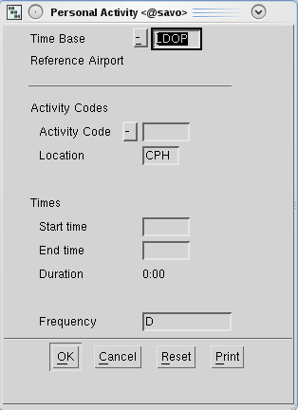

## Create Ground Duty

*Create Ground Duty* is called from the general menu in the trip window:

Trip General > Create Ground Duty

It should be used for activities where crew typically is on duty.

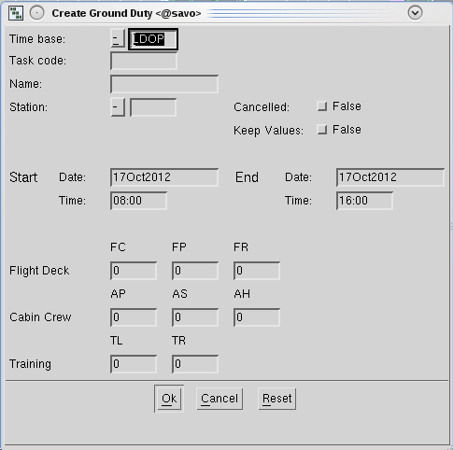

It will create trips for the date interval specified. If composed trips are needed, create the single objects and then move them together to complete the trips.

Entering 24Sep2008 00:00 to 26Sep2008 00:00 will create two full day ground duties.

## Activating cancelled ground duties

If ground duties are rolled out or fetched to a period where an appropriate leg set doesn’t exist, they will be cancelled/NOP. To activate them (create a leg set for them in the back ground), use the function *Activate Ground Duty*:

Trip General > Activate Marked Ground Duties

It will activate all marked ground duties in the window.

## Changing properties of a ground duty

It is possible to change properties of ground duties. Please note that this will affect all legs, trips, and rosters where the ground duty is used.

# Wave forms

Most of the common applications are based on wave forms and contains input fields, pick-lists, combined input fields and pick-lists, check boxes and calendar functions.



## Input Field

The input fields can be read-write or read-only. In insert mode the cursor is a vertical bar and in replace mode it is a box. You toggle between these modes using the insert key on the keyboard.

## Pick-list

Click the arrow to display the whole list of alternatives.

Enter one or several characters; this will display the list entries starting with the character(s). Press and hold Shift while stepping through the list using arrow up and arrow down.

## Combined Input Field and Pick-list

In this combined option you can either write your own text in the input field or choose from a predefined list by clicking the button.

## Calendar

Click the arrow to display the calendar. Select a date by clicking on it. Switch month by using the arrows in the upper part of the calendar.

# Crew Info

The purpose with the Crew Info application is to have a single application throughout the entire planning process for administrating and maintaining crew related data. The crew info form is access controlled.

## User Interface

*For general guidelines, see also: 2* Creating activities/ground duties*.*

The Crew Info form can be opened either via the launcher bar or by selecting the “Crew Info” option from the “Crew Object” menu in Studio. When opening the crew info form in the latter way, the form will display information regarding the selected crew member automatically. The figure below shows this scenario.

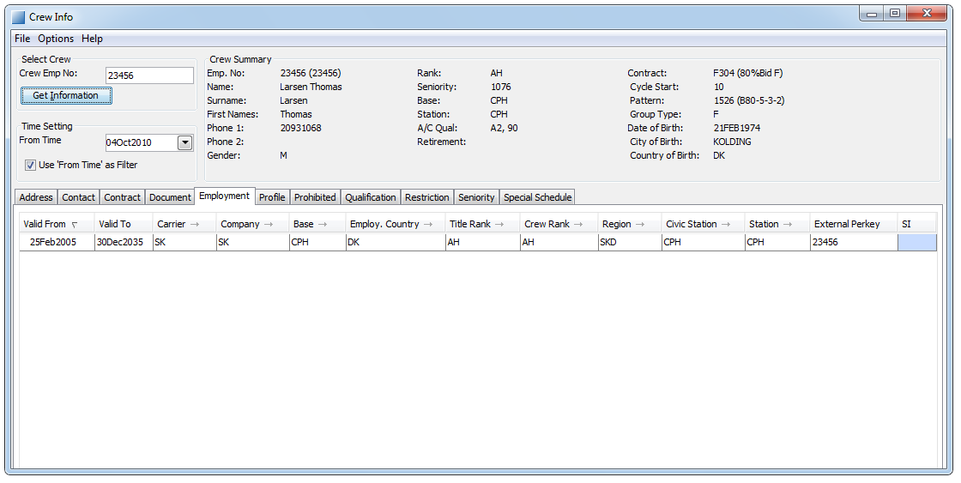

1. The crew info form for crew member Aadnoey. Had the form been opened via the launcher bar, it would not have contained any information.

### Crew Selection

The crew selection interface is located in the top left corner of the form. This interface can be used to change crew member without closing the form. In order to do this, the employee number of the new crew member is written into the text field labelled “Crew Emp No.” and either return or the button “Get Information” is pressed.

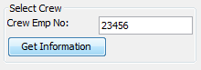

1. The Crew Selection interface.

**NOTE:** It is important to save before selecting a new crew, otherwise changes will be lost! (In case there are unsaved changes, a warning dialog will be shown, allowing the user to cancel the new selection.)

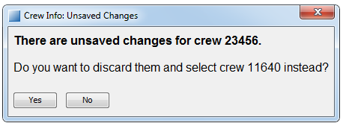

1. Warning dialog when selecting a new crew.

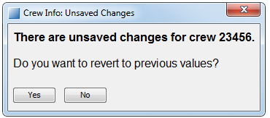

1. Warning dialog when re-selecting the same crew.

### Time Filtering

The “Time Setting” section contains a date labelled “From Time:” and a check-box labelled “Use ‘From Time’ as Filter”.

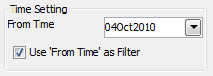

1. Time filtering data

Time filters affect all data which is time dependent – data which is valid only before the “Form Time” is not shown. Crew summary is not affected by time filtering – it always displays the data that is valid “now”.

### Crew Summary

The crew summary contains some of the most important information regarding the crew. If some data is missing the corresponding field in the crew summary will remain blank.

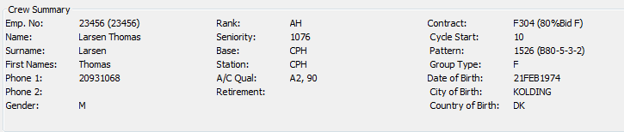

1. Crew Summary

Crew summary data is not affected by any filters and is updated when saving changes made for the crew or when getting information about another crew.

### Data

The data is displayed in tables placed under different tabs. Each tab contains one table and may or may not contain additional functionalities (such as buttons for modifying or filtering the data). For more information regarding the specific available data and the functionalities see the chapter 3.3 below.

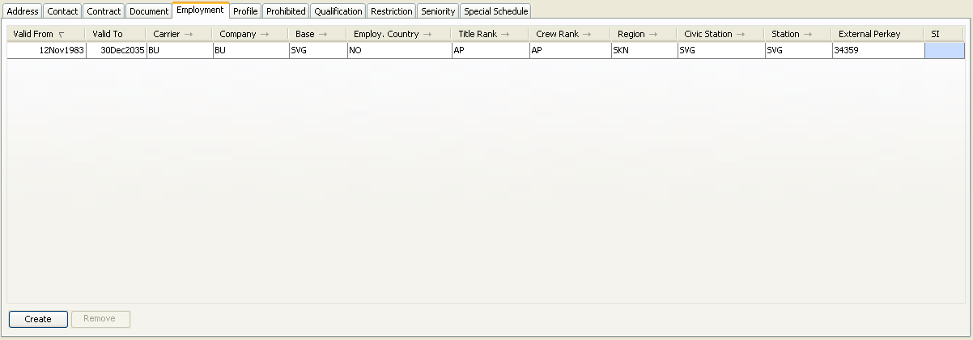

1. Data section

Data may be treated differently by the form depending on crew specifics such as employment country, rank etc.

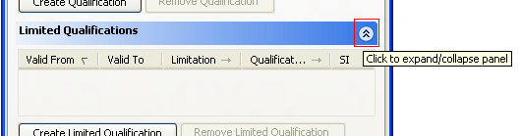

1. The redmarked icon expands/collapses table in view.

#### Sorting

The data presented in the table may be sorted by any of the columns. To change the data sorting press the column header on the desired column and the data will be sorted in an ascending manner. To sort the data descending press the column header again. An additional press on the column header will switch off the sorting.

#### Details

Some of the data tabs contain a “details” section. This section provides additional information about any selected row. If the details are needed for a specific row, clicking on it will update the details with the needed information.

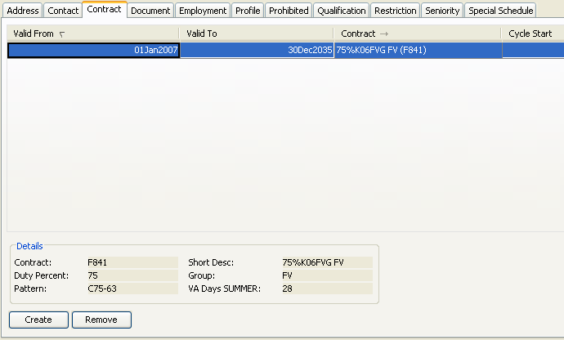

1. Data section with details

#### Modify Existing Data

Data can be modified by editing the data directly in the tables. Note that only users with write access are allowed to do this (see chapter regarding access rights).

#### Create New Data

New data can be created by pressing the “create” button on the corresponding tab.

If table contains ‘validfrom’, the time will be read from Time Setting component.

A new row which can be modified will appear in the table. Note that only users with write access are allowed to do this (see chapter regarding access rights).

#### Remove Existing Data

Data can be removed by selecting the desired row in the tab and pressing the “remove” button. Note that only users with write access are allowed to do this (see chapter regarding access rights).

### Save, Exit, Apply, and Close Buttons

The Save and Exit buttons are located at the bottom of the form and shall be used for saving modifications and/or exiting the form. Both functionalities contain some validation which is described in greater detail in the Navigation chapter below. When started from Studio, the buttons change names to Apply and Close. The reason is that nothing is saved to the database until saved in Studio.

### Refresh Button

The Refresh button is located at the bottom of the form and can be used to re-read the data for the currently selected crew. It provides the same functionality as described in section , except that the current crew id is used.

### Profile Button

The Profile button is located at the bottom of the form next to the Refresh Button and can be used to open a standalone Profile form.

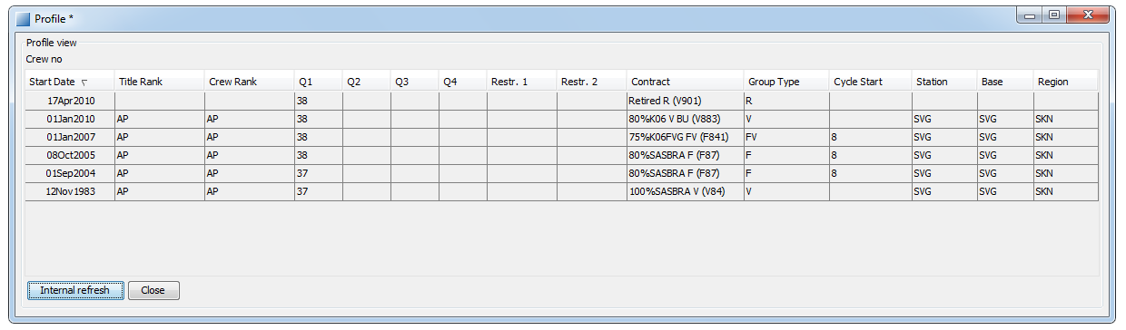

The standalone Profile Form is read-only and contains the same information as the Profile View, see chapter 3.3.6 Profile for detailed information.

|  |  |  |
| --- | --- | --- |
|  | Internal Refresh  Close | Synchronizes the Stand Alone Profile with the Crew Info form. I.e. changes of the selected crew, local changes in the Crew Info form and database refreshes  Closes the standalone Profile form |

### Status Bar

Below the Save and Exit buttons, there is a status bar. This provides feedback to the user when attempting to save. If an error occurs, the status bar will become red and an error description will be presented. In order to complete the action, the error must be corrected and the action repeated.

### Menus

A number of menu items are available at the top of the window.

|  |  |  |
| --- | --- | --- |
| **File** |  |  |
|  | Refresh | See 3.1.6 |
|  | Save/Apply | See 3.1.5 |
|  | Exit/Close | See 3.1.5 |
|  | Errors… | Certain errors in the stored data, detected when selecting a crew, can be shown via this menu entry. In case there are any such errors, this will be indicated in the status bar when the crew is selected. |
|  | Audit Trail… | An audit trail on changes made to crew info for this crew.  The audit trail option prompts following dialog:     1. Crew Info Audit trail period dialog   The default settings is this this month and three montsh back. The report will only show changes saved in this timespan. |
| **Options** |  |  |
|  | Edit list of available Employment Civic Station values… | Edit the values that are possible to select in the Employment tab. This is needed when adding a new base. |
|  | Edit list of available Employment Station values… | Edit the values that are possible to select in the Employment tab. This is needed when adding a new base. |
| **Help** |  |  |
|  | Help | This help |

## Navigation

### Short keys

There are a number of short keys available:

| Short Key | Description |
| --- | --- |
| F1 | Displays this help. |
| Alt+S  Alt+A | Saves all modifications in the form (when started from the launcher bar).  Applies all modifications in the form (when started from Studio). |
| Alt+E  Alt+C | Exits the application (when started from the launcher bar).  Closes the form (when started from Studio). |
| Tab Shift+Tab | Changes the focus to the next/previous element in the form. For tables: loops through the table-cells. Never switches the focus from the table. |
| Ctrl+Tab Shift+Ctrl+Tab | Changes the focus to the next/previous part of the form. May be used to switch from a table, or between data tabs. |
| Alt+I | Performs Crew Selection (see 3.1.1).  *Ignored if the Crew Emp No field is empty.* |
| Alt+R | Re-read crew data (see 3.1.6). |
| Alt+T | Creates a new row in the current Data Tab (see 3.3).  *Ignored if the current data tab is read-only.* |
| Alt+V | Removes selected (highlighted) rows in the current Data Tab (see 3.3).  *Ignored if the current data tab is read-only, or if no row is selected.* |
| Space | “Activates” the focused part of the form. |

### Saving Changes

To commit any changes made to the data, the “Save” (or “Apply”) button should be pressed. Complex validations are then made to the modified rows to ensure that they fulfil the requirements. Should the validation fail – one or more modifications being incorrect – the status bar will show the error message of the first error that occurred. If there were no errors the status bar will show “Save completed successfully”.

In case changes were made in several tabs, the data may be partially committed. The status bar message will indicate what has been committed.

If Crew Info was started from Studio, it is also necessary to save in Studio to save changes to the database.

During save, a busy icon will appear.

For more information on the validation made, see chapter on validation below.

### Exiting the Form

To exit the form the “Exit” (or “Close”) button should be pressed. If the data has been modified but not saved, a dialog will appear, informing that there are unsaved changes and requesting confirmation that the form should be closed anyway.

## Data Tabs

The data and the data-specific functionality are located under different tabs (see chapter 3.1 for a user interface description).

This chapter describes each of the tabs in greater detail.

### Address

The address tab contains the address data for the crew such as home addresses, temporary addresses and time-limited addresses.

#### Description

The address table consists of the following columns:

|  |  |
| --- | --- |
| Column | Description |
| Valid From | Start date of the validity period for the address. |
| Valid To | End date of the validity period for the address. |
| Street | The street name of the first address. |
| City | The city name of the first address. |
| State | The state name of the first address. |
| Postal Code | The postal code of the first address. |
| Country | The country code of the first address. |
| Second Street | The street name of the second address. |
| Second City | The city name of the second address. |
| Second State | The state name of the second address. |
| Second Postal Code | The postal code of the second address. |
| Second Country | The country code of the second address. |
| SI | Supplementary information. |

The crew information application is not the master of contact data and thus it is not possible for any user to modify it.

#### Validation

There is no validation on this data.

### Contact

The contact tab contains information on how to contact the crew such as telephone number, known e-mail addresses and so on. The data do not contain address information as this information is located in another tab (see chapter 3.3.1 regarding the Address tab)

#### Description

The contact table consists of the following columns:

|  |  |
| --- | --- |
| Column | Description |
| Type | The type of contact i.e. telephone number, mobile phone number, e-mail address, pager number and so on. |
| Location | A description of the expected location of the contact, i.e. home, work or similar. |
| Number | The contact number/address. |
| SI | Supplementary information. |

The crew information application is not the master of contact data and thus it is not possible for any user to modify it.

#### Validation

There is not validation on this data.

### Contract

The contract tab contains the various contracts that are available for the crew. Only one contract may be valid at a given time.

#### Description

The contract table consists of the following columns:

|  |  |  |
| --- | --- | --- |
| Column | Description | Value type |
| Valid From | Start date of the validity period for the contract. | Date (press the arrow for calendar). |
| Valid To | End date of the validity period for the contract. | Date (press the arrow for calendar). |
| Contract | A short description of the contract. | Any value from the list (press the arrow to see the list). |
| Cycle Start | The start day of a F-contract cycle. | A number. |
| End Reason | The reason the contract was ended. | Characters (max 200). |
| SI | Supplementary information. | Characters (max 200). |

In addition to the data view there is a detail section which provides additional information about the contract in the selected row. The following details are provided:

|  |  |
| --- | --- |
| Field | Description |
| Contract | The contract name of the selected row. |
| Duty Percent | The contract percentile. |
| Pattern | A reference to the pattern list. |
| Short Desc | A short description of the contract. |
| Group | An indicator of contract type: V or F. |
| VA Days SUMMER | The max number of vacation days in summer associated with contract. |

#### Validation

The following validations are performed:

* Only one contract may be valid at any given time.
* A contract’s type must be valid for the whole Valid From/To period of the contract.
* Cyclestart is validated to be not-null and 1 or larger for fixed group.
* Crew cannot have active contract without an employment, or employment without contract. All contracts are checked if any employment or contract is changed in crew information application.

**Note:** Only rows which have been modified via the crew information application are subject to the validity check, except for contract/employment validation.

### Document

The tab contains the various documents that the crew has and which may be of importance to SAS.

#### Description

The document table consists of the following columns:

|  |  |  |
| --- | --- | --- |
| Column | Description | Value type |
| Valid From | Start date of the validity period for the document. | Date (press the arrow for calendar). |
| Valid To | End date of the validity period for the document. | Date (press the arrow for calendar). |
| Document | The type of document. | Any value from the list (press the arrow to see the list). |
| Main Document Number | If the document type is dependant on another document, this document number is provided. | A number. |
| Document Number | The number of this document. | A number. |
| Aircraft Qual | Aircraft qual connected to, e.g. M8 | A 10 char string |
| Issuer | The authority that issued the document. | Characters (max 200). |
| SI | Supplementary information. | Characters (max 200). |

It is possible to filter the document view on the different document types. This is done via the document filter which needs to be enabled before any filtering takes place.

**Note:** For crew the last four digits of any “Licence” and “Medical” documents are replaced by “\*”. When creating a new such document it is possible to enter the digits which will be fully visible until the change is saved. An administrator can find the real value in the Table Editor.

#### Validation

The following validations are performed:

* The main document number for a “Visa” must be the same as one of the valid the passports’ number.
* Aircraft qual must not be over 10 chars long. The string is automatically converted to upper case.

**Note:** Only rows which have been modified via the crew information application are subject to the validity check.

### Employment

The employment tab contains information about the employment a crew has.

**NOTE:** If new employment row is created and overlaps existing employment row, the older row is ended the day before new row start and all values from last valid row are copied to newly created row.

#### Borrowed crew

In employment tab, it is possible to define if crew is lent to another region for a period of time. This is done by changing the region and possibly station.

The region will control which rule agreements crew follows and the station denotes from which airport the crew operates. In Tracking filtering, the crewmember will appear in both his region and country selection, e.g. Country = NO, Region = SKD will appear in both SKN and SKD.

Example:

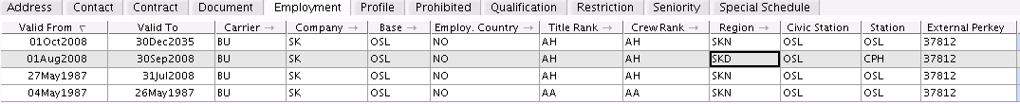

1. Crew flies for SKD out of CPH between 01Aug2008 and 30Sep2008

#### Description

The employment table consists of the following columns:

|  |  |  |
| --- | --- | --- |
| Column | Description | Value type |
| Valid From | Start date of the validity period for the employment. | Date (press the arrow for calendar). |
| Valid To | End date of the validity period for the employment. | Date (press the arrow for calendar). |
| Carrier | The carrier the crew works for. | Any value from the list (press the arrow to see the list). |
| Company | The employment company. | Any value from the list (press the arrow to see the list). |
| Base | The employment base. | Any value from the list (press the arrow to see the list). |
| Employ. Country | The employment country. | Any value from the list (press the arrow to see the list). |
| Title Rank | The rank the crew is employed as. | Any value from the list (press the arrow to see the list). |
| Crew Rank | The rank of the crew. | Any value from the list (press the arrow to see the list). |
| Region | The region the crew currently belongs to. | Any value from the list (press the arrow to see the list). |
| Civic Station | The civic station the crew is currently operating from. | Any five letter string |
| Station | The station the crew is currently operating from. | Any five letter string |
| External Perkey | The employment number of the crew. | A number. |
| SI | Supplementary information. | Characters (max 200). |

#### Validation

The following validations are performed:

* Only one employment may be valid at any given time.
* The main category for the title rank and crew rank must be the same (i.e. a cabin crew may not be employed in the cockpit).
* The base where the crew is employed must be within the country where the crew is employed.
* Crew must have at least one crew employment row.
* The fields 'Carrier', 'Company', 'Base', 'Country', 'Crewrank', 'Titlerank' and 'Region' may not be void.
* Crew cannot have active contract without an employment, or employment without contract. All contracts are checked if any employment or contract is changed in crew information application.

**Note:** Only rows which have been modified via the crew information application are subject to the validity check, except for contract/employment validation.

### Profile

This view gives an overview of overall planned training activities. The path of qualifications and trainings can be seen in tab. Local changes that not are saved/applied yet are shown in the Profile view.

**NOTE :** This view is read-only!

#### Description

It contains the followings information:

|  |  |
| --- | --- |
| Column | Description |
| Start Date | Start date of the property row |
| Title Rank | Tilte Rank from Crew Employment |
| Crew Rank | Crew Rank from Crew Employment |
| Q1, Q2, Q3, Q4 | Valid Qualifications |
| Restr.1, Restr.2 | Crew Restrictions |
| Contract | Crew Contract |
| Group Type | Contract Group Type |
| Cycle Start | Contract Cycle Start |
| Station | Station from Crew Employment |
| Base | Base from Crew Employment |

The view contains a print-button, this will open a pdf-report of the view in browser for printing. If view contains data-errors, the profile view will be empty and print-button disabled.

### Prohibited

In some cases it certain crew combinations are not allowed or unwanted. This may be personal requests from crew or other circumstances. To prevent certain crew from flying together, post can be created in the prohibited tab.

#### Description

The prohibited crew table consists of the following columns:

|  |  |  |
| --- | --- | --- |
| Column | Description | Value type |
| Valid From | Start date of the validity period for the prohibition. | Date (press the arrow for calendar). |
| Valid To | End date of the validity period for the prohibition. | Date (press the arrow for calendar). |
| Emp. No. | Employment number of the crew who is prohibited to fly with the crew displayed in the crew information application. | Any value from the list (press the arrow to see the list). |
| SI | Supplementary information. | Characters (max 200). |

In addition to the data view there is a detail section which provides additional information about the crew in the selected row. The following details are provided:

|  |  |
| --- | --- |
| Field | Description |
| Emp. No. | Employment number of crew, and crew id in brackets. |
| Name | Name of the crew. |

#### Validation

There is not validation on this data.

### Qualification

The qualification tab lists the crew’s various qualifications.

#### Description

The qualification tab contains three tables:

* **Crew Qualification**Regular qualifications
* **Limited Qualifications**Qualifications which are only valid on a specific (ac) qualification, e.g. INSTRUCTOR+TRI on A3.
* **Qualification Restrictions**Restrictions which are only valid on a specific (ac) qualification, e.g. NEW+ACTYPE on AL.

The Crew Qualification table consists of the following columns:

|  |  |  |
| --- | --- | --- |
| Column | Description | Value type |
| Valid From | Start date of the validity period for the qualification. | Date (press the arrow for calendar). |
| Valid To | End date of the validity period for the qualification. | Date (press the arrow for calendar). |
| Qualification | The type of qualification. | Any value from the list (press the arrow to see the list). |
| SI | Supplementary information | Characters (max 200). |

The Limited Qualifications table consists of the following columns:

|  |  |  |
| --- | --- | --- |
| Column | Description | Value type |
| Valid From | Start date of the validity period for the qualification. | Date (press the arrow for calendar). |
| Valid To | End date of the validity period for the qualification. | Date (press the arrow for calendar). |
| Limitation | The (ac) qualification for which the qualification applies. | Any value from the list (press the arrow to see the list). |
| Qualification | The type of qualification. | Any value from the list (press the arrow to see the list). |
| SI | Supplementary information | Characters (max 200). |

The Qualification Restrictions table consists of the following columns:

|  |  |  |
| --- | --- | --- |
| Column | Description | Value type |
| Valid From | Start date of the validity period for the qualification. | Date (press the arrow for calendar). |
| Valid To | End date of the validity period for the qualification. | Date (press the arrow for calendar). |
| Restriction | The type of restriction. | Any value from the list (press the arrow to see the list). |
| Qualification | The (ac) qualification for which the restriction applies. | Any value from the list (press the arrow to see the list). |
| SI | Supplementary information | Characters (max 200). |

It is possible to filter the qualification view on the different qualification types. This is done via the Qualification Filter which needs to be enabled before any filtering takes place. The filter value is applied on the Qualification column in the Crew Qualification and Qualification Restriction tables, and on the Limitation column in the Limited Qualifications table.

#### Validation

The following validations are performed:

* Flight crew may only have one aircraft qualification at any given time.
* Cabin crew may only have three aircraft qualifications at any given time.

**Note:** Only rows that have been modified via the crew information application are subject to the validity check.

### Restriction

The restriction tab lists contains information about restrictions a crew has, either generally or connected to a specific qualification.

#### Description

The restriction table consists of the following columns:

|  |  |  |
| --- | --- | --- |
| Column | Description | Value type |
| Valid From | Start date of the validity period for the restriction. | Date (press the arrow for calendar). |
| Valid To | End date of the validity period for the restriction. | Date (press the arrow for calendar). |
| Restriction | The type of restriction. | Any value from the list (press the arrow to see the list). |
| SI | Supplementary information | Characters (max 200). |

It is possible to filter the restriction view on the different restriction types. This is done via the restriction filter which needs to be enabled before any filtering takes place.

In addition to the data view there is a detail section which provides additional information about the restriction in the selected row. The following details are provided:

|  |  |
| --- | --- |
| Field | Description |
| Type | The restriction type. |
| Subtype | The restriction subtype. |
| Short Desc | A short description of the restriction. |
| Long Desc | A long description of the restriction. |
| SI | Supplementary information |

#### Validation

There is no validation on this data.

### Seniority

This tab lists the crew’s seniority value according to the different lists available in SAS.

#### Description

The qualification table consists of the following columns:

|  |  |  |
| --- | --- | --- |
| Column | Description | Value type |
| Valid From | Start date of the validity period for the seniority. | Date (press the arrow for calendar). |
| Valid To | End date of the validity period for the seniority. | Date (press the arrow for calendar). |
| Seniority List | The seniority list/group the seniority value belongs to. | Any value from the list (press the arrow to see the list). |
| Seniority | The seniority value. | An integer |
| SI | Supplementary information | Characters (max 200) |

It is possible to filter the seniority view on the different seniority list/groups. This is done via the Seniority Filter which needs to be enabled before any filtering takes place.

#### Validation

There is no validation on this data.

### Special Schedule

For various reasons certain activities or combinations of activities are undesirable for certain crew. In the special schedule tab it is possible to configure this.

#### Description

The special schedule table consists of the following columns:

|  |  |  |
| --- | --- | --- |
| Column | Description | Value type |
| Valid From | Start date of the validity period for the restriction. | Date (press the arrow for calendar). |
| Valid To | End date of the validity period for the restriction. | Date (press the arrow for calendar). |
| Type | The type of special schedule. This column has great affect on which other columns should contain values and how the columns should be interpreted. | Any value from the list (press the arrow to see the list). |
| Note | The field “Note” can be used to specify a forbidden destination (“ForbiddenDest”), but also a forbidden activity (“ForbiddenAct”). “ForbiddenAct” can take both a group code and a task code, depending on how broad or detailed the prohibition is to be. | A string (either an airport code or an activity code). |
| From  To | The fields "From” and "To" have different meaning depending on type:  For types "TimeOff", "CheckIn" and "CheckOut", the valid weekdays interval should be entered (e.g. "TimeOff every Friday" should be entered as 5, 5 and "CheckIn later than 07:00 every weekend" should be entered as 6, 7, 07:00).  For type "TripLength", the valid trip length interval should be entered (e.g. "Only 2 and 3 day trips allowed" should be entered as 2, 3).  For type “PartTime”, the part time percentage should be entered (without the ‘%’ in the “To” field. | See description. |
| Time | The field “Time” has different meaning depending on “Type”:  For types “CheckIn” and “CheckOut” the time is the time-of-day of the limit (e.g. check-in before a certain time of day and check-out after a certain time-of-day could be forbidden).  For types “MaxDuty” and “MaxBlh” the time is the maximum number of hours for duty and block hours, respectively. | See description. |

These columns only make sense in specific combinations depending on which type is set. The table below describes those combinations:

|  |  |  |  |  |  |  |
| --- | --- | --- | --- | --- | --- | --- |
| Type | Valid from | Valid to | Note | From | To | Time |
| ForbiddenDest | x | x | x | - | - | - |
| ForbiddenAct | x | x | x | - | - | - |
| ForbiddenAcFam | x | x | x | - | - | - |
| TripLength | x | x | - | x | x | - |
| TimeOff | x | x | - | x | x | - |
| CheckIn | x | x | - | x | x | x |
| CheckOut | x | x | - | x | x | x |
| MaxDuty | x | x | - | - | - | x |
| MaxLegs | x | x | - | - | x | - |
| MaxBlh | x | x | - | - | - | x |
| PartTime | x | x | - | - | x | - |
| HasChildren | x | x | - | - | - | - |

The columns which do not make sense for a specific type should be left empty.

#### Validation

* Field “Note” may not be void, is defaulted to ‘\*’ on row creation and is limted to 5 chars.
* The rows are validated according to the table above.

# Crew Accounts

The Crew Accounts GUI lets the user investigate the balance and postings on crew’s accounts. Vacation, F7, compensation days and bought days are considered crew accounts. All accounts are accessible through the same interface in studio.

In manpower, the leave history for accounts related to leave (VA, F7,…) are available as expanded view in leave view. Most of the postings on crew accounts are generated on-line (automatically from activities on the roster) and to change those postings the roster must be changed first. Other activities are created manually or by batch runs. The GUI lets a user make manual operations on accounts, such as payment or corrections.

## User Interface

This section describes the Studio application user interface to handle Crew Account.

*For general guidelines, see also: , .*

### View

The Crew Accounts form is presented in the figure below.

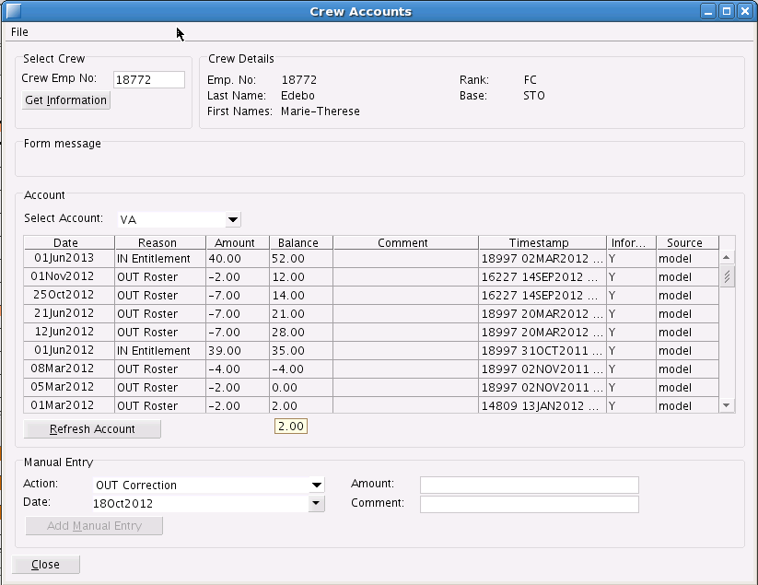

1. The Crew Account form for Crew 18772.

The upper left part is Select Crew. Enter an employment number or crew id and press Get Information to change crew. If no crew is found a message will be shown in Form message. Only crew in the loaded planning area can be selected.

The upper right part of the form is called Crew details. Here some static information about crew is visualized.

The second parts informs the user when the forms has updated the crew’s account information in the background. This will happen if, for example one removes an activity while form is open and then presses refresh.

The third part of the form is the account view. Here the user selects an account by using the drop-down combo-box. The combo-box lists all available accounts in the system. By selecting an account the list view below is updated with the most recent posting at the top. There is one row marking current baseline. All balance after this row is calculated using this baseline. If there have been changes before this baseline without recalculating of baseline, there might be discrepancies between balance before and after baseline.

LeaveAccountsGUI2a

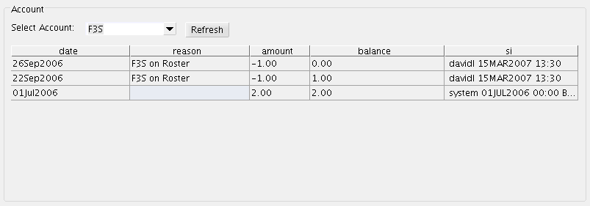

1. The crew roster on top and the resulting postings in the list. 1st of July crew earns two F3S days which are then rostered on the 22nd and 26th of September. Balance is zero on the 26th of September.

The third part of the view contains manual operations that a user can perform. The operations are different on different accounts. Some operations require you to enter a reason. All operations require that you set a valid date and an amount. If an amount is a decimal value, a decimal dot (.) shall be used as decimal delimiter. Only the administrator will have the possibility to correct existing postings. Users will have to correct posts by adding new correction posts.

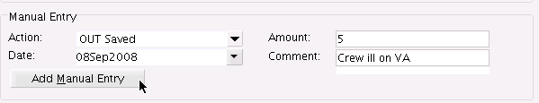

1. The manual entry field. The available actions changes depending on the selected account.

For example: Step-by-step for saving vacation:

1. Open crew account form and select VA account
2. Enter manual ‘OUT Saved’ action on given date with correct amount and comment, e.g. 5 days as above.
3. Press 'Add Manual Entry'

Result is:

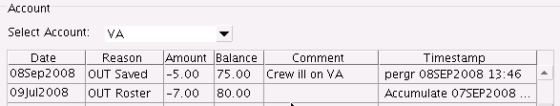

1. VA Account

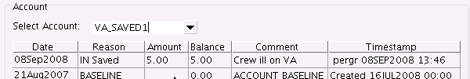

1. VA\_SAVED1 Account

To replace days from VA\_SAVED1 to VA, select VA\_SAVED1 account and use “OUT Unsaved” action when creating manual entry

If a manual entry will cause a negative balance on the selected account, at some point, a warning message is shown. The user can either choose to continue or cancel. A warning will also be shown if entry is before current baseline date.

An person with administrator-role can make the change before baseline, BUT the account balance after baseline will not be affected. For the change to take effect, administrator needs to recalculate account baselines. See chapter 4.2.2 below!

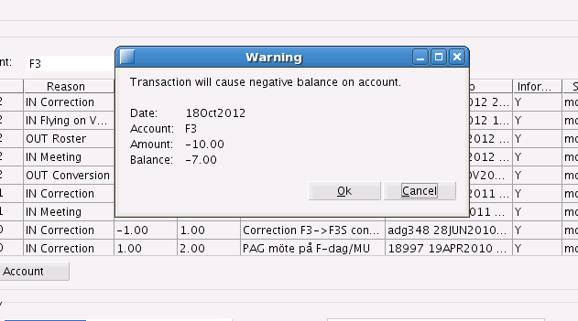

1. The warning message when an out payment will cause a negative balance on the F3 account.

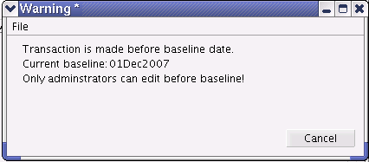

1. Warning if change is before baseline, an administrator can make the change.

### Updating the View

If the user makes changes to the roster in studio or updates the rosters from the database by doing a refresh of the plan the user needs to refresh the account view to get the latest information. This is done by pressing the refresh button next to the account select or by changing account.

### Saving Changes

Changes done to the account (added postings) are created in the currently opened plan. When studio is opening a plan it is kept in memory as scenario. The posting will not be saved to the database until the user presses the save button. At that time the posting is committed to the database and the balance are updated for other users connected to the same plan.

## Crew account balance

This section describes

### account\_entry

All crew account transactions are stored in the table account\_entry for fast access in balance calculations. This table is automatically updated by online-transactions Manual transactions are also stored in account\_entry, marked as manual. Manual entries will not be changed by automatic updates of table.

### Account Baseline

To increase performance the crew accounts are summed up and stored as baseline with regular interval. This gives a waypoint when loading data, thus one only needs to load data from the last baseline and forward. The baseline-date is chosen so that data before this date is considered safe, i.e. will never change. The date is moved forward by for example one month by nightly batch process.

An example:

Previous baseline for account VA was 10 on 20Oct2006, moving baseline forward one month would sum all transactions for VA in account\_entry between 20Oct2006 and 20Nov2006 and add the old baseline value (10) and write a new row in baseline table with date 20Nov2006.

If data before baseline needs change, the administrator can update and regenerate the baseline.

This is done by running the bin/accumulateBaseLine.sh script with arguments new\_date and “recalc”. Thus if it is necessary to make adjustments before baseline at e.g. 1Dec2007, do the changes and then run:

>bin/accumulateBaseLine.sh 01Dec2007 recalc

This will update the baseline 01Dec2007 with latest account\_entry information. Is is also possible to move baseline to an earlier date by running e.g.

>bin/accumulateBaseLine.sh 01Oct2007 recalc  
However, all info about previous baseline will be lost.

Running script without recalc-option and date equal to or earlier that current baseline will give an exception.

End-users studio applications uses a special baseline which is moved forward each month after roster release and recalculated daily by night job.

To manually update this run:

>bin/accumulateBaseLine.sh 1jan1986 recalc DAILY

### Calculation of Crew Account Balance

To calculated balance for a given date in an opened plan, the following method is used:

Last account baseline entry before plan start+

Transactions in account\_entry between last baseline date and opened plan start+

Opened roster from plan startdate until given date.

Balances after opened plan’s enddate is calculated by adding account\_entry transactions to the calculation above.

Baseline

account\_entry

Roster / Plan

account\_entry

Last baseline date

Plan startdate

Plan enddate

time

source

## Online Transactions

Online transactions are transactions created automatically by the system. The opposite are called manual transactions.

Online transactions are done *interactively,* i.e. when a user is working with the system or by night *batch jobs*.

### Interactive

There are two interactive updates of account\_entry, one in Studio applications and one in manpower application.

#### CMS (Studio)

The account\_entry table is updated for all crew accounts defined in account\_set when opening Crew Account view or pressing save. The table is updated with unbooked transactions in opened plan, i.e. newly added activities affecting crew accounts. Non-manual entries related to activities in account\_entry without matching activity are removed. The accounts are updated using ruleset-defined functions.

#### CMP (Manpower)

The account\_entry table is updated for the crew accounts handled by manpower (activities defined as leave in manpower user) when making any changes to the roster, opening leave view or pressing refresh. Manpower only effects online transactions, i.e. not transactions marked as manual. The manpower user also updates any transactions in opened plan not related to rostered activities, such as entitlement and transfer between saved vacation accounts.

### Batch Process

The batch process runs nightly and updates and accumulates baseline using CMS and Manpower functionality.

Each night the batch job updates the account\_entry for a period from last baseline date until month end plus 30 days. The update is identical to the one run when pressing save. This is to ensure the validity of the account\_entry table.

The manpower user nightly updates manpower handled accounts in the same way as during interactive running. The script opens one month in a time and performs necessary updates to the account\_entry table. The update includes matching against crew activities and adding transactions regarding entitlement incl. reduction, moving between buffers and accounts and moving saved vacation between the different saved accounts. After completion of the updates in CMS and CMP and if needed the baseline is moved forward as described above.

# Crew Block Hours

SAS maintains an electronic log book for all pilots, thereby relieving each pilot from keeping his/her own records. Civilian Aviation Authorities require that these records are up-to-date.

The purpose of the *Crew Block Hours* application (CBH) is to provide users with the ability to view and modify block hours and other quantities that are displayed in the Pilot’s Log (interface 32.3.9).

The quantities available are: *Block Hours, Loggable (*or *Reduced) Block Hours, Simulator Block Hours* and *Landings*.

Modifications are handled by adding manual correction entries. The previously accumulated data is not modified by CBH, a batch job handles this.

A typical use-case would be to transfer block hours from previous assignments for a newly recruited pilot.

## User Interface

*For general guidelines, see also: 2“*Wave forms*”.*

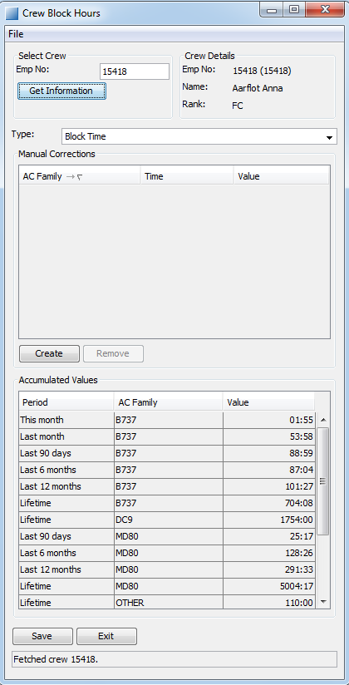

1. Crew Block Hours application.

The application may be started either from within Studio (“Crew object” -> “Crew Data” ->“Block Hours...” or from the Launcher (“Crew Block Hours” icon). If it is started from within Studio, the form will be populated with data for the currently selected crew; if it’s started from the Launcher, no information will be shown.

### File Menu and Short-Cut Keys

The “File” menu contains the following entries:

|  |  |  |
| --- | --- | --- |
| Entry | Short-Cut Key | Description |
| Create | Alt-T | See 5.2.1 Creating a New Row |
| Remove | Alt-V | See 5.2.3 Deleting a Row |
| Save Apply | Alt-S Alt-A | See 5.1.7 Apply and Close (Save and Exit) |
| Exit Close | Alt-E Alt-C | See 5.1.7 Apply and Close (Save and Exit) |

### Select Crew

*Select Crew* makes it possible to load data for another pilot. To load data, enter the employee number into the “Emp No” field and either press enter or the button “Get Information”.

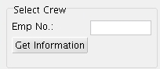

1. Select Crew

### Crew Details

*Crew Details* provides basic information about the current crew member.

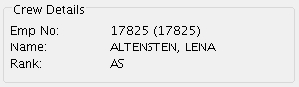

1. Crew Details

### Type

*Type*, allows the user to switch from *Block Hours* to another quantity, e.g. *Landings.*

*cbh_02*

1. Type

### Manual Corrections

*Manual Corrections* contains all manual corrections for the selected crew.

**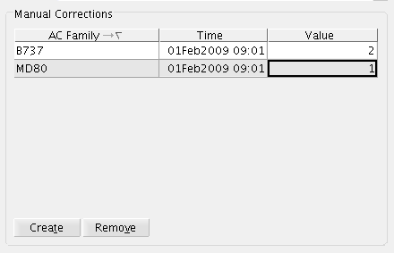**

1. Manual Corrections

**AC Family**: The aircraft family of the entry. The entries are sorted by this column at start-up.

**Time**: This column is a date/time column, which means that both date and time must be entered. The date has to be correct for the 90-days statistics to work, the time-of-day is not significant, but any two records with the same A/C family will need to have different times.

**Value**: The amount that should be added to the statistics, to reduce number of block hours, landings, etc., use a negative value. Landings will accept a numeric entry; block hours, loggable block hours, and simulator block hours require that the input value is in the format HH:MM.

Below the table there are two buttons, “Create” and “Remove”. The purpose and function of these buttons will be explained in the chapter on data modification.

### Accumulated Values

This section, *Accumulated Values,* displays a summary of accumulated values and manual corrections with sub-totals per A/C family and time interval. The values shown here are the same as the values in the Pilot’s Log interface. Note that the values are updated after manual corrections, but to make the changes permanent requires a “Save”.

These are the intervals that are used, note that the days are UTC days:

**This Month:** A period from the 1st of this month (at 00:00) until this morning (at 00:00).

**Previous Month:** A period from the 1st of previous month until the first of this month.

**Last 90 days:** A period from 90 days ago (at 00:00) until this morning (at 00:00).

**Last 6 months:** A period from six months ago until the start of this month.

**Last 12 months:** A period from twelve months ago until the start of this month.

**Lifetime:** A total of all accumulated values until this morning (at 00:00).

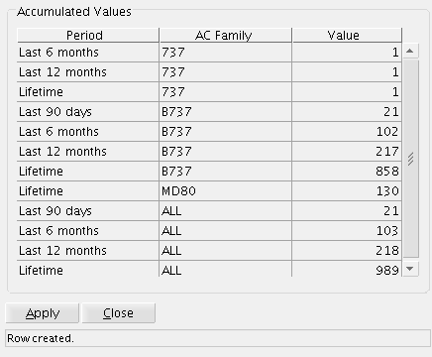

1. Accumulated Values

### Apply and Close (Save and Exit)

The “Apply” and “Close” buttons are located under the data section and above the status bar. When started from the Launcher, these buttons are named “Save” and “Exit”.

Apply will attempt to store the data as it looks when the button is pressed. More detailed information on the save process may be found in section 5.2.4 Saving Modifications.

Exit/Close will close the form without any warnings.

### Status Bar

The status bar provides feedback to the user. Error messages, indicating that something went wrong, will be shown with a red background.

Other informational messages will be shown with the normal background colour.

## Data Modification

In case the modification is linked to an activity that was performed with an A/C family that has never been used by SAS, select A/C family “Others”.

### Creating a New Row

The “Create” button creates a new row.

### Modifying a Row

Avoid modifying existing rows, instead add another row with a different time stamp, this to make changes traceable.

### Deleting a Row

Remove a row by marking any cell in the row and press the “Remove” button.

### Saving Modifications

Save your modifications by pressing the “Apply”/”Save” button.

If the application was started from the Launcher (“Save”) the modifications are saved to the database, and are available for others.

When started from within Studio (“Apply”), the modifications will be seen by other users first after a Save has been issued from the main Studio window. In this case a Save requires two operations, first pressing “Apply”, and then pressing Studio’s “Save” button.

A successful operation will be indicated in the status bar. There are two major reasons why “Save” could fail: either a row has insufficient data, or, a row with wrongly formatted data has been entered.

**Insufficient data (empty cells)**:

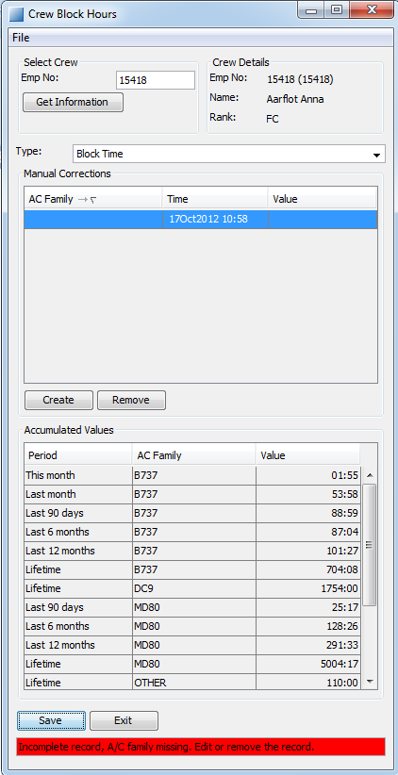

1. A row with empty cells.

To correct these problems either remove the row or enter some valid information into the empty cells.

**Format error**:

The following formats are allowed:

**A/C Family**: any A/C family used by SAS or “Others”.

**Tim**: date and time in the format DDMMMYYYY HH:MM, e.g. 05MAR2009 22:10

**Value**: for landings this is a number, for other quantities a time in the format HHH:MM.

* The hours may be any number of digits.
* The minutes are written with two digits and the value must not exceed 60.

A cell which contains data in wrong format is outlined in red.

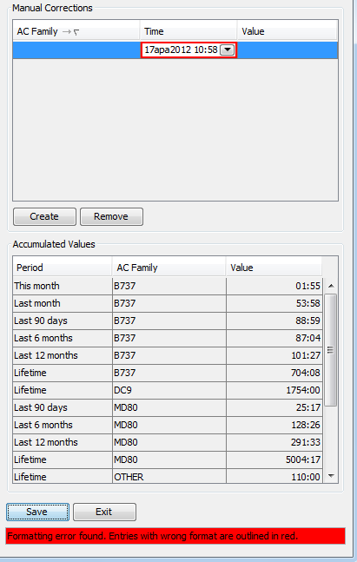

1. A format error.

To correct this error either change the value to the correct format (see above) or remove the row.

# Crew Training

The purpose with the Crew Training application is to have a single application throughout the entire planning process for administrating and maintaining training related data for crew. The idea of the form is to clearly present crew information together with logs of training activities and landings, and lists of training need and training related documents.

## User Interface

*For general guidelines, see also: 2 “*Wave forms*”*

The Crew Training form can be opened by selecting the “Training…” option from the “Crew Object > Crew Data” menu in Studio. The form will open showing data for the clicked crew. The figure below shows this scenario.

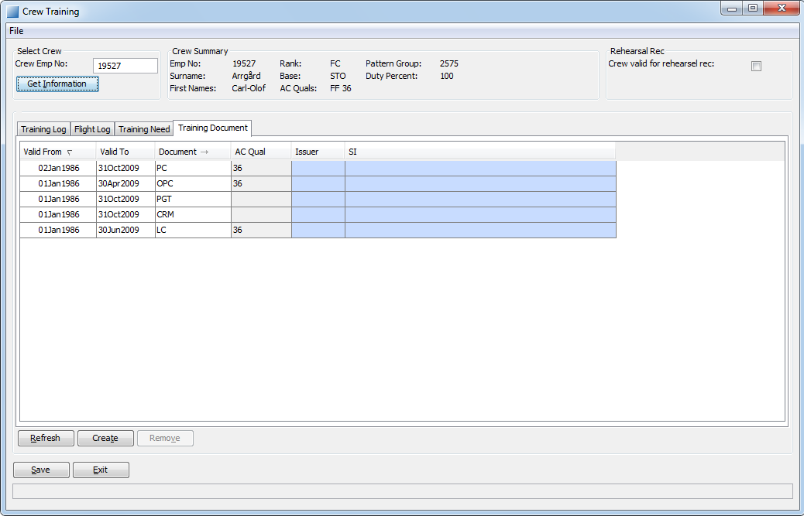

1. The crew training form for crew member Arrgård.

### Crew Selection

The crew selection interface is located in the top left corner of the form. This interface can be used to change crew member without closing the form. In order to do this, the employee number of the new crew member is written into the text field labelled “Emp No.” and either return or the button “Get Information” is pressed.

### Crew Summary

The crew summary contains some of the most important information regarding the crew. If some data is missing the corresponding field in the crew summary will remain blank.

Crew summary data is not affected by any filters and is updated when saving changes made for the crew or when getting information about another crew.

### Data View

The data is displayed in tables placed under different tabs. Each tab contains one table and may or may not contain additional functionalities (such as buttons for modifying or filtering the data). For more information regarding the specific available data and the functionalities see following sections.

**Sorting:**

The data presented in the table may be sorted by any of the columns. To change the data sorting press the column header on the desired column and the data will be sorted in an ascending manner. To sort the data descending press the column header again. An additional press on the column header will switch off the sorting.

### Apply and Close buttons

The apply and close buttons are located at the bottom of the form and shall be used for saving modifications and/or exiting the form. Both functionalities contain some validation which is described in greater detail in the Navigation chapter below.

### Status Bar

Below the save and exit buttons, there is a status bar. This provides feedback to the user when performing various actions. If an error occurs, the status bar will become red and an error description will be presented. In order to complete the action, the error must be corrected and the action repeated.

## Navigation

### Short Keys

There are a number of short keys available:

| Short key | Description |
| --- | --- |
| Alt+S  Alt+A | Saves all modifications in the form (when started from the launcher bar).  Applies all modifications in the form (when started from Studio). |
| Alt+E  Alt+C | Exits the application (when started from the launcher bar).  Closes the form (when started from Studio). |
| Tab Shift+Tab | Changes the focus to the next/previous element in the form. For tables: loops through the table-cells. Never switches the focus from the table. |
| Ctrl+Tab Shift+Ctrl+Tab | Changes the focus to the next/previous part of the form. May be used to switch from a table, or between data tabs. |

### Saving Changes

To save any changes made to the data, the Apply/Save button should be pressed. Complex validations are then made to the modified rows to ensure that they fulfil the requirements. Should the validation fail – one or more modifications being incorrect – the status bar will show the error message of the first error that occurred. If there were no errors the status bar will show “Save completed successfully”.

For more information on the validation made, see chapter on validation below.

### Closing the Form

To exit the form the Close/Exit button should be pressed. If the data has been modified but not saved, a pop-up will appear, informing that there are unsaved changes and requesting confirmation that the form should be closed anyway.

## Data

### Training Log

The training log view shows all logged training activities, for each showing type, code and time of the activity. Filter check-boxes are available to show a subset of the data. Simulators, ground activities, education, flights and other are available as filters.

No modification of the training log is possible from the application.

Data from the time before the interval opened in Studio will be gathered directly from the database and data from the interval opened in Studio will be collected from the roster. This means that changes on the roster will be visible automatically in the training log view, as soon as a refresh is performed.

### Flight Log

The flight log view shows all logged flights. Filter check-boxes are available to show a subset of the data. Landings, airports and flown are available as filters.

* A flight where landing is not performed by the crew will generate a “FLOWN” item.
* A flight where landing is performed by the crew will also generate a “LANDING” item.
* A flight to an airport requiring qualification, or an SKI airport, will also generate an “AIRPORT” item.

No modification of the landings is possible from the application.

Data is gathered and refreshed in the same way as for the training log view.

### Training Need

The training need view shows the current training program for the crew. The end date is inclusive, i.e. the last date training is legal to perform, with expiry at midnight the specified date.

Modifying the training need is possible.

### Training Document

The training document view shows all training related documents for the crew. The valid to date is inclusive, i.e. the last date the document is valid, with expiry at midnight the specified date.  
The document number field is limited to a set of values:

[blank]: Valid for any document

37/38: Valid only for PC/OPC document. Used for double qualified SKN crew that should perform PC and OPC duties on alternating AC type.

A3/A4: Valid only for LC document. Used for double qualified SKI crew that should perform LC duties on alternating AC type.

### Modifying Data

The data can be modified in three ways: new data can be added, old data can be removed and data can be modified.

The data modification buttons that are applicable are placed below the concerned table.

#### Create New Data

In order to create new data, the “Create” button should be pressed. A new, empty row is then created. This row can then be modified to contain the desired data.

#### Remove Data

When data is to be removed, the row which contains the data should be marked and the “Remove” button should be pressed.

#### Modify Existing Data

Existing data may be modified by double-clicking the table-cell containing the data, or single clicking it and pressing Ctrl+C. The cell will then become editable. If the value may only be from a limited set of values, a drop-down menu will appear, showing all the allowed values.

When entering the data a simple type of validation is performed. The entered value must be of the correct type (belong to the allowed set if this case is applicable). If this is not the case, the cell will be outlined in red.

#### Refresh Data

Data may be refreshed by clicking the button labelled “Refresh”. The currently viewed tab will then be reloaded, loosing any unsaved changes to the displayed data.

# Hotel Reservations

Jeppesen CMS is responsible for creating hotel reservations and forecasts. The process and the different reports are described shortly in the following sections.

## Basic process of booking a hotel

* Times considered: For all calculations, e.g., booking of hotels, values displayed in the reports, updates, forecast, performed reports.. etc, the system will always consider scheduled times STD/STA of flights. If flights are rescheduled, the system will consider new STD/STA of these rescheduled flights.
* Hotel Layover: A hotel layover is considered when a flight / ground transport is out of homebase, not a base break, and with a minimum time of five hours. The flight/transport must be connected with a return flight/transport
* Crew ill out of homebase: There is an exception to the connected flight. If a crew gets ill out of homebase, and there is no connection flight, the hotel will stay booked, and an update report will be sent with an interrogation mark “?” on the return date information. When the tracker sets a flight back for the crew, another update will be sent with the new flight back in the check out information column in the hotel report.
* Crew leased: If crew is leased to other non-SAS companies, even if the rosters shows in CMS Studio, the system will not book hotels for them, they are supposed to be taken cared by the other companies.
* Base break: If crew has a base freak in the arrival flight out of homebase, or in the departure connected flight, the system will not book hotel.
* Check-in / Check-out time at the hotel: The information sent to the hotels just say which are the arrival flights and departure flights for the crew. The check-in / check-out time will then be considered as these.
* Nights: In the forecast sent to the hotel, the number of nights is considered taking into account early-check in and late-check out of the hotel, and transport time from/to airport.
* Non-flight activities: For any other activity not flight or not ground transport, out of homebase, the system will also book a hotel if there is a minimum connection time of five hours or more. The check-in / check-out time at the hotel will still be the arrival and departure flights between these out of homebase activities.
* Airport hotel usage: For considering airport hotel instead of city hotel, there should occur one of these two:
  + The connection time between flights is below 14 hours, or below 16 hours at TRD or BGO station for SKD cabin crew.
  + Crew has a simulator activity or school activity out of homebase.

In one of these cases, if the database table “preferred\_hotel\_exc” has information about using airport hotel for the airport where this occurs, the system will book an airport hotel instead of a city hotel. In order to distinguish which is an airport hotel and which is a city hotel, the information must be correct in the tables, which are described later in this document.

## Reservation/Forecast generation

Forecasts are generated monthly after schedule release and cover the next month. Orders are generated every day and cover the following two days. A day period is considered from 02:00 to 01:59 of the next day. They are sent through email to hotels in the email found in ‘hotel’ table, and copied to SAS to the email found in ‘hotel\_customer’ table. The email sender will be the same email found in ‘hotel\_customer’.

For testing purposes, forecast can be generated manually through menus in Studio, this is described later in the document. This menu will be removed in production.

Forecasts and reservations are generated for every “preferred” hotel for each SAS region. Hotels with no demand receive a reservation with a message indicating that there is no demand for rooms.

## Forecast Reports

Forecasts are generated in PDF format. A hotel forecast contains information of the expected room demand for a hotel for a period. The forecast holds no personal information. The report shows information about the flight that crew is arriving and departing with how many rooms that there are demand for and how many nights crew will stay. If its more than one night, a “C” is showed in the report. In the last page of the report, a table with the total number of nights for every day is shown. The number of nights is calculated taking into account early-check in and late-check out of the hotel, and transport time from/to airport. So “C” could mean that the crew checks in at 09:00, but early check in is at 10:00, and then its two nights, or it could mean that the crew checks in at 13:00 and checks two days later at the same hour.

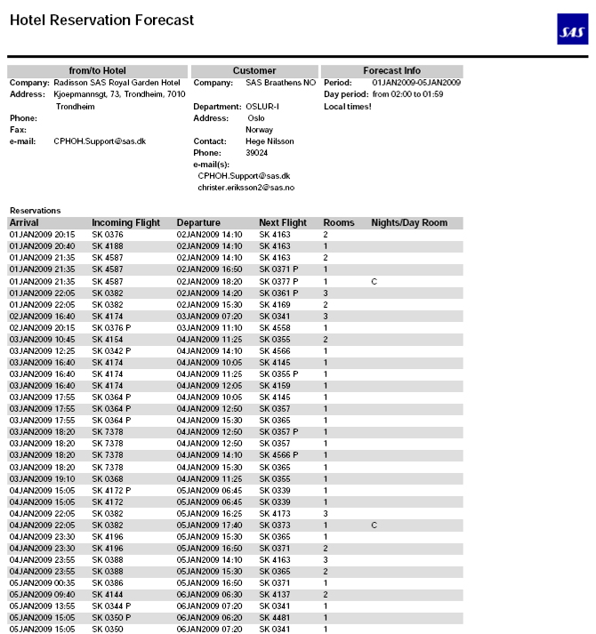

1. Forecast Report

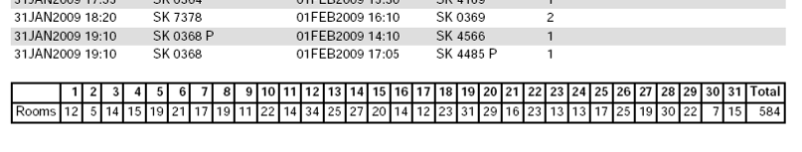

1. Forecast Report – total field

## Reservation Reports

Hotel reservations are generated in PDF format. The report contains information of the hotel, the SAS region and the crew which will need a room at the hotel.

Details about crew, such as employee number, rank and name is included in the report. The company responsible for the flight, arriving and departing flight details are also shown. If crew has a deadhead flight this is indicated with a ‘P’ after the flight number.

The number of rooms is always one for crew assigned on a flight, but if there is a flight with more than one unassigned position this will be presented as one row and the number of rooms will be more than one. The ‘Nights/Day Room’ column in the report indicates the number of nights crew will stay at the hotel. If it’s more than one night, it displays a ‘C’, if not, it’s empty. It also shows if the booking is a day room in the hotel, with the text ‘D’ in it. A day room is considered when the number of nights is 0. So if a crew arrives before early check in of the hotel, and leaves the room after this, even if the layover is five hours, it will not be considered a day room as one night is counted because of early check in / late check-out.

Below there are two examples of the hotel reservation report PDF, the first shows the first page of report and the next shows how cancelled flights are reported:

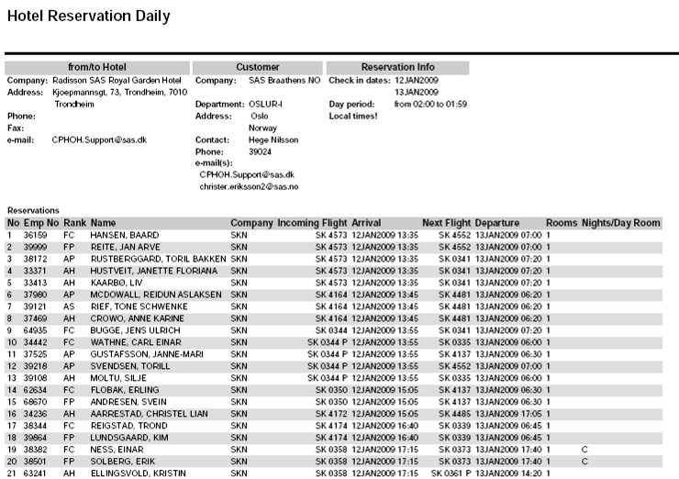

1. Hotel reservation report

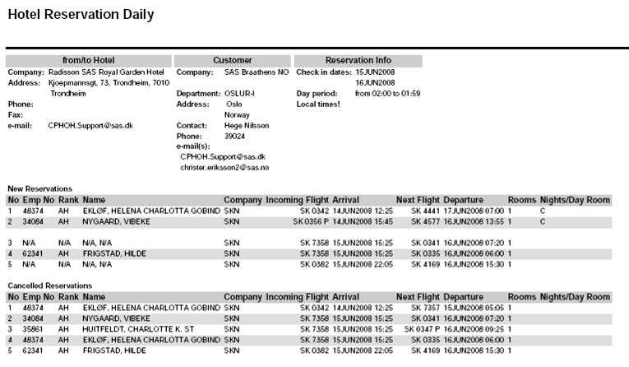

1. Hotel reservation report with cancelled reservations

## Performed Reports

Performed reports are generated in PDF format. A hotel performed contains information of the rooms booked for a hotel for a period. The performed report holds no personal information. The report shows information about the flight that crew has arrived and departed with, how many rooms that there were booked and for how many nights. An example of the performed PDF is shown below:

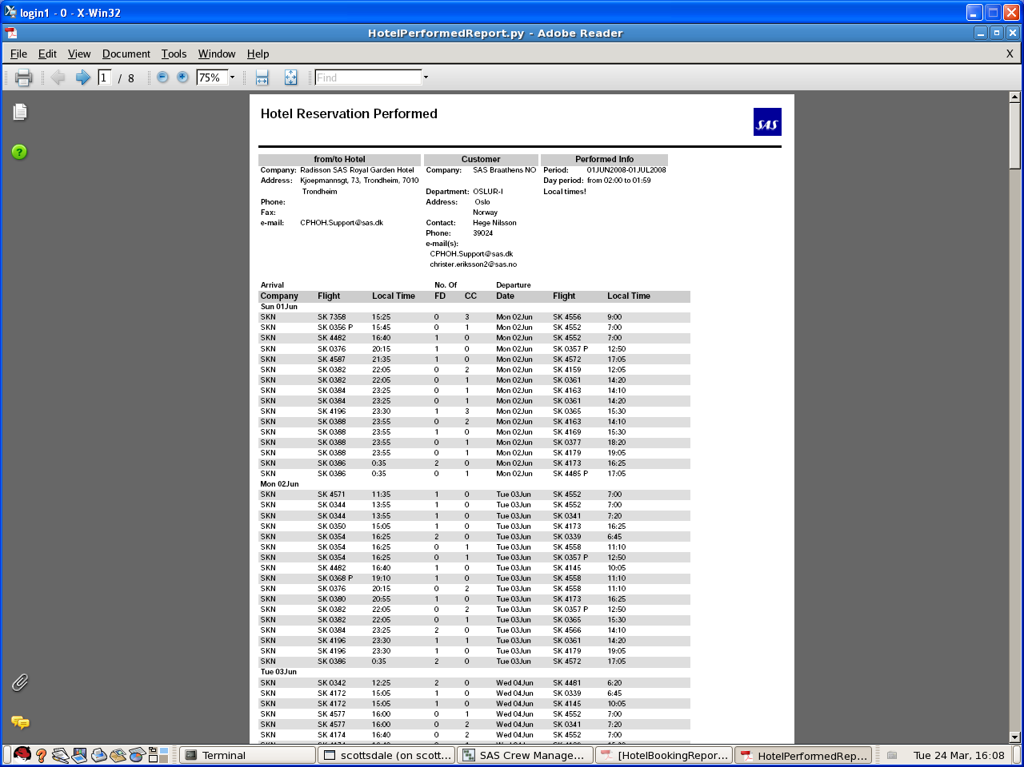

1. Hotel reservation Performed report

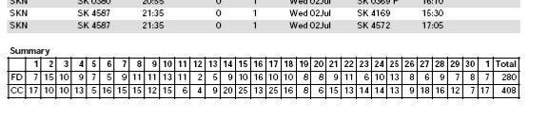

1. Hotel performed report – total field

## Process

The reservation process is generated automatically in a batch job scheduled daily. Reservations are sent nightly to the hotels but the reports can also be generated from the Studio Editor.

These reports are generated for every SAS region (SKS, SKD, SKN and SKI), and hotel stored in the database. The region is selected from the table ‘flight\_owner’ for every flight. If not found here, is selected from the field ‘cpe’ (cockpit\_employer) / ‘cae’ (cabin\_employer) in the table ‘flight\_leg’. If not found here, its defaulted to crew home base region.

A hotel reservation is created for each duty that ends away from home base. The details of when the reservation is considered are detailed in the first chapter of this section. Hotels used are defined in two tables which lists all the preferred hotels. It is also possible to mark if a hotel is to be used as a day hotel.

### Hotel Reservation

The hotel reservation process is divided in two phases. First, the demand for rooms is calculated for the entire plan for the coming two days. Second, a hotel reservation report is generated for each hotel and directly sent to the hotels for booking. This process is done automatically by the system each night.

The system takes into consideration all duties with need for hotel rooms in that period, both duties assigned to crew and currently not assigned. The reservation data is also stored in the database to enable updated reservations to be generated.

Every hour the system checks if there has been any saved change to the plan. This update process will look at all modified rosters and open trips to see if there are any differences to the currently stored hotel reservations and update the reservations so that they will correspond to the updated plan. These updates will be then automatically sent to the hotels if the changes require an update. The rosters don’t need to be published or released for detecting changes, as soon as they are saved, the changes will be noticed by the system in the next hourly batch job.

### Manually Create Hotel Reservation Reports

Hotel reservation reports can be run manually through the ‘Reports’ menu in Studio. A report can be generated for a SAS region and a hotel for a specific date, which must be in the planning period loaded in Studio.

Select Menu ‘Reports’, and ‘Hotel Reservation Report’. Select Region and Hotel. Enter the date, which must be in the planning period loaded in Studio, and click ’Ok’.

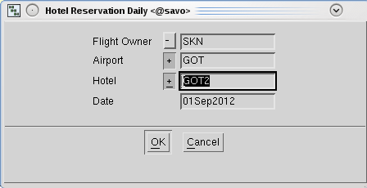

1. Form for creating hotel reservation reports

The report is also available in the “Assignment General Menu”, to allow for report generation for a selection of crew.

### Hotel Forecast

The hotel forecast report is automatically created every month after the release of the plan, and covers the next month. A forecast is calculated based on the current plan. This report is sent to the hotel email defined in ‘hotel’ table.

### Hotel Performed

The hotel performed report is automatically created the second of each month and covers the last month performed. A performed report is calculated based on the current plan. This report is sent to SAS in the email defined in ‘hotel\_customer’ table

## Database Administration

The data needed for hotel functionality to be working properly is described in this chapter. There are six tables involved in the database which need to be filled.

### Process

The hotel reservation process will automatically create bookings for all hotels associated to airports where crew is having a layover where a hotel is needed.

In order to do this, the system will look up at a few tables. The main table is ‘preferred\_hotel’. In this table we can see which hotel is preferred in every airport. It’s the normal table used for creating bookings.

If a special case is wanted, for instance, cabin crew in GOT airport, or flight crew resting in an airport hotel for a specific period of time in SVG airport, then the table ‘preferred\_hotel\_exc’ is used. It’s the first table where the system looks up. If there is no data in this table for a specific airport, then ‘preferred\_hotel’ is used.

For hotel functionality, those two are the main tables used. There is another table, ‘airport\_hotel’ where all associations between airport and hotels are stored. For instance, if GOT airport has three hotels associated, all of them are stored in this table. This table is also used for transport functionality, it tells the system which transport company is associated to an airport and a hotel, which is described later in this document.

Other tables used are ‘hotel’, ‘hotel\_contract’ and ‘hotel\_customer’, with information about hotels, contracts with hotels and SAS regions, respectively.

### Minimum Data Required

In order to work properly, the system needs a minimum amount of information. Except for preferred\_hotel\_exc table, the other five tables need to be filled, with the following minimum information:

* Hotel: *Id, name, street, city, country, email.*
* Hotel\_contract: *hotel, validfrom*
* Hotel\_customer: *region, email.*
* Preferred\_hotel: *airport, validfrom, hotel*
* Preferred\_hotel\_exc: If it´s not empty, the table needs *airport, region, category, airport\_hotel, validfrom, hotel.*
* Airport\_hotel: *airport, hotel*

### Email Sending Process

The system sends automatically information about hotel bookings to both the hotels and SAS departments. This information is sent via email to the addresses stored in the field *email* in the table ‘hotel’ for hotel orders, updates and forecast reports, and the field *email* in the table ‘hotel\_customer’ for hotel performed reports. All emails sent to the hotels, are copied to SAS in the email found in ‘hotel\_customer’, and this email will be also considered as the sender of the report to the hotel.

If it’s needed more than one destination, all different email addresses must be inserted in the field *email* separated by comma ‘,’.

## Storage of reports

The system will automatically store all reports generated in the File System.

To read this reports, one can use two methods:

1. Use the File Reader application in the Jeppesen application launcher. To use it, click on the File Reader icon, and a web browser is launched locally on your pc. It shows a clickable file tree, where you navigate the tree structure by clicking the directory links. When you click a file, it is opened by the browser, using the appropriate plugged in viewer like AcrobatReader, Excel or an xml viewer. From here you have to go to /HOTEL directory, and then just open the reports.
2. in Studio, go to Admin Tools (top menu) **->** Output File Manager … -> Hotel

Here you find all the hotel reports.

The naming method used for the files is: “date.name\_of\_the\_report.region.hotel\_id.update\_number.**pdf**”

The date is the first part of the file so that reports can be ordered by date easily.

For instance:

20080703.HotelBookingReport.SKN.TRD1.pdf

20080703.HotelUpdate.SKN.TRD1.U3.pdf

20080601.HotelPerformed.SKN.SVG1.pdf

20080801.HotelForecast.SKD.GOT2.pdf

If the file exists, the system will add a slash and a number, for instance:

20080703.HotelBookingReport.SKN.TRD1-2.pdf

This means that the same report has been generated twice.

# Transport Reservation

Jeppesen CMS is responsible for creating transport reservations and forecasts. The process and the different reports are described shortly in the following sections.

## Reports

### Reservation/Forecast Generation

Orders and forecasts are generated automatically every day and cover the following three days. The coming day is an order while the rest is a forecast for the following two days. . A day period is considered from 02:00 to 01:59 of the next day. They are sent through email to hotels in the email found in ‘hotel’ table, and copied to SAS to the email found in ‘hotel\_customer’ table. The email sender will be the same email found in ‘hotel\_customer’.

How orders and forecasts are generated is described later in this document. Reservations and forecasts are generated for every airport associated to every transport company for each SAS region. Transport companies with no demand receive a reservation with a message indicating that there is no demand for transport.

### Three Days Order Reports

The three-day transport booking order and forecast reports are generated in PDF format. It’s titled “3 Day Pick-Up List”. The report contains the number of crew to be picked up for each airport and hotel (airport to hotel and hotel to airport) on each day in the coming three days in the planning period. It holds no personal information, only the number of crew to be picked up. The report is divided in three days, the first one is a transport order, and the next two are forecast. The report has a header with transport company information, airport, hotel and pick-up dates. Each day is then divided into two parts:

* *Reservations from hotel to airport*: shows information about outgoing flights, departure time, number of crew and airport where to go.
* *Reservations from airport to hotel*: shows information about incoming flights, arrival time, number of crew to pick up and airport associated.

Open trips are also considered, as there is no need of knowing personal data of the crew to be picked up, only the number of crew associated to the flights. If open trips are assigned, and this affects to the number of crew to be picked-up, an update occurs when the plan is saved, and the batch job has run, so an updated report will be sent to the transport company, if needed. This only happens if updates occur after the order report has already been sent.

The pick-up time from the hotel to the airport is calculated with the next formula:

* Flight scheduled time of departure – flight check in time – transport time from hotel to airport + 5 minutes.

An example of the “3 Day Pick-Up List” is shown below:

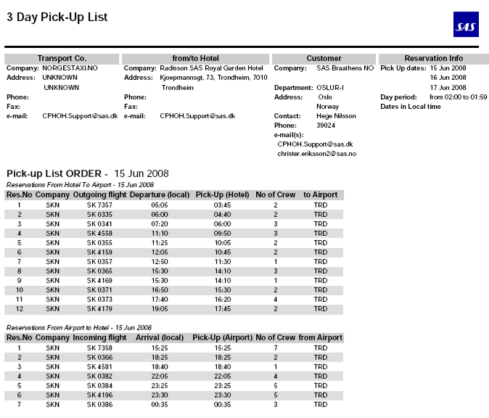

1. 3 Day Pick-Up List, Order part

*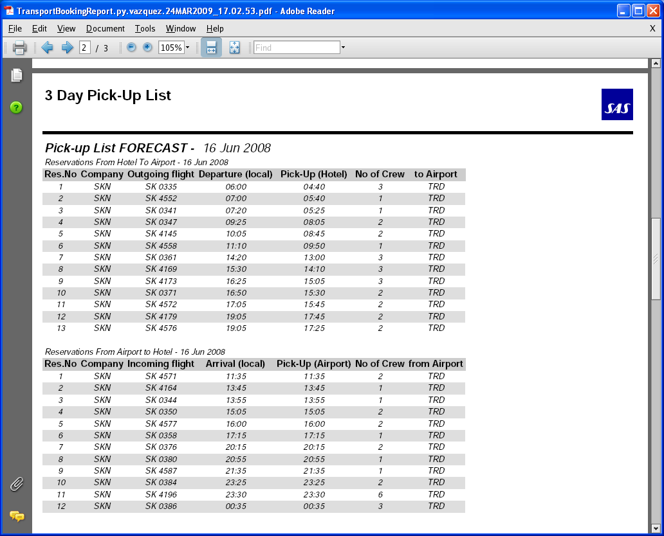*

1. 3 Day Pick-Up List, Forecast part

### Updated Order Reports

Updated transport order reservations are generated in PDF format. The report contains the same information as the normal order “3 Day Pick-Up List” but it is titled “Pick-Up List Update”.

It also contains information about cancelledflights or flights which number of crew to be picked up has changed. If the number of crew does not change, no update is sent. If it does, an updated report is sent to the transport company.

An example of the “3 Day Pick-Up List” PDF is shown below:

*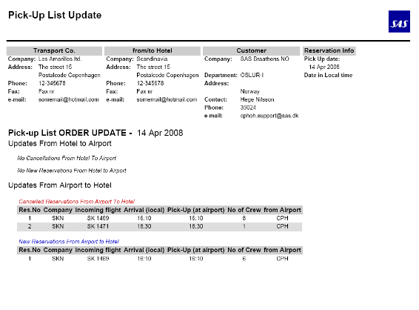*

1. Pick-Up List Update

### Performed Reports

Transport reservation performed reports are generated in PDF format. A transport reservation performed report contains information of the number of crew to be picked up for every airport associated to every transport company for each SAS region.

The information showed is the same as in normal order reports. However, the layout is slightly different.

An example of the “Transport Reservation Performed” PDF is shown below:

*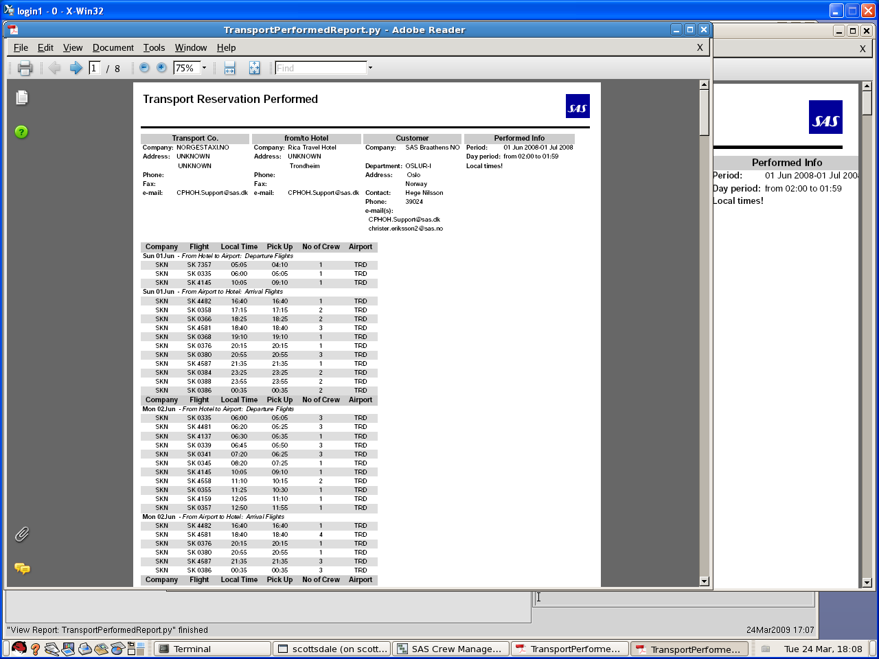*

1. Transport Reservation Performed, page 1

## Process

The coming sections describe the process behind creating transport reservations, forecasts and updates. An instruction on how to perform transport reservation runs manually is also included.

A transport reservation is created for each duty that ends away from home base, and has a transport associated between the airport and the hotel associated. Transports used are defined in two tables which list all the transport companies.

If the hotel assigned is a hotel which needs no transport, there is no need of a transport reservation, and no booking will be made. In order to know this, there is a table, “airport\_hotel”, which has information about hotels and transports associated to every airport. If there is a hotel associated, but there is no transport associated, this means that the airport in that row has no transport associated. For such a hotel no transport reports will be generated.

### Transport Reservation

The transport reservation process is divided in two phases.

First, the demand for transports is calculated for the entire plan for the coming three days. This includes all duties with need for transport in that period, both duties assigned to crew and currently not assigned. The calculated demand is then stored so that the data can be used to generate reports for the transports. Second, a transport reservation report is generated for each airport associated to each transport company and the reports are sent to each transport company.

If an airport has more than one hotel, a different report will be generated for every hotel needing transport.

The reservations are generated nightly and are automatically sent to the transport companies.

### Transport Updates

Once every hour, updates will automatically be sent to the transport companies if the changes require an update. This update process will look at all modified rosters and open trips to see if there are any differences to the currently stored hotel reservations and update the reservations so that they will correspond to the updated plan.

A report with information about cancelled, modified and new reservations will be sent.

### Manually Create Transport Reservation Reports

Transport reservation reports are generated automatically every night, but there is also an option to generate a report from the Studio Editor. When the report is run from the menu, the report is generated for all the crew in the plan.

The report can be created from the menu option ‘Transport Bookings Report…’ in the menu ‘Reports’. When generating the report, one needs to select for what region, airport and transport company the report should be generated for.

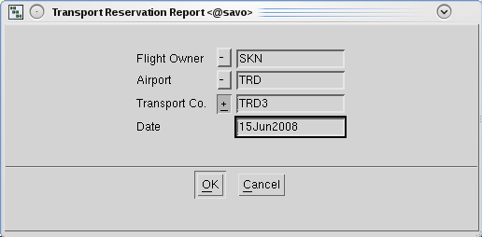

1. Form for creating transport update reservation reports

The report is also available in the “Assignment General Menu”, to allow for report generation for a selection of crew.

### Transport Performed Reports

The transport performed report is automatically created at the beginning of each month and covers the last month performed. A performed report is calculated based on the current plan.

## Database Administration

The data needed for transport functionality to be working properly is described in this chapter. There are five tables involved in the database which need to be filled.

### Process

The transport reservation process will automatically create bookings for all transports needed in airports where crew is having a layover where a hotel is needed, from both arrival flights and departure flights.

In order to do this, the system will look up at a few tables. The main table is ‘airport\_hotel’. In this table we can see if an airport and a hotel has a transport associated. If the *transport* field is empty in this table, we assume that for that specific airport and hotel, no transport is needed (maybe an airport hotel).

The table ‘hotel\_transport’ tells the system how long is the duration time between a hotel and an airport, and the cost associated (approximate value, for the optimizer).

The *duration* field is needed for the transport company to know when to pick up the crew at the hotel to take them to the airport.

Other tables used are ‘transport, ‘transport\_contract’ and ‘hotel\_customer’, with information about transport companies, transport contracts and SAS regions, respectively.

### Minimum Data Required

In order to work properly, the system needs a minimum amount of information. All five tables need to be filled, with the following minimum information:

* Transport: *Id, name, street, city, country, email, email\_upd.*
* Transport\_contract: *hotel, validfrom*
* Hotel\_customer: *region, email.*
* Hotel\_transport: *airport, hotel, validfrom, duration (empty if duration is 0:00)*
* Airport\_hotel: *airport, hotel, transport (empty if no transport is needed)*

### Email Sending Process

The system sends automatically information about transport bookings to both the transport companies and SAS departments. This information is sent via email to the addresses stored in the field *email* in the table ‘hotel’ for hotel orders and forecast reports; the field *email\_upd* in the table ‘hotel’ for update reports, and the field *email* in the table ‘sas\_customer’ for hotel performed reports. All emails sent to the transport companies, are copied to SAS in the email found in ‘hotel\_customer’, and this email will be also considered as the sender of the report to the transport company.

If it’s needed more than one destination, all different email addresses must be inserted in the field *email or email\_upd* separated by comma ‘,’.

## Storage of Reports

The system will automatically store all reports generated in the File System.

To read this reports, one can use two methods:

1. Use the File Reader application in the Jeppesen application launcher. To use it, click on the File Reader icon, and a web browser is launched locally on your pc. It shows a clickable file tree, where you navigate the tree structure by clicking the directory links. When you click a file, it is opened by the browser, using the appropriate plugged in viewer like AcrobatReader, Excel or an xml viewer. From here you have to go to /TRANSPORT directory, and then just open the reports.
2. in Studio, go to Admin Tools (top menu) **->** Output File Manager … -> Transport. Here you find all the transport reports.

The naming method used for the files is: “date.name\_of\_the\_report.region.hotel\_id.update\_number.**pdf**”

The date is the first part of the file so that reports can be ordered by date easily.

The hotel id is used instead of the transport company id because it’s most common that one transport company works in several hotels, so the hotel id is unique.

For instance:

20080703.TransportBookingReport.SKN.TRD1.pdf

20080703.TransportUpdate.SKN.TRD1.U3.pdf

20080601.TransportPerformed.SKN.SVG1.pdf

If the file exists, the system will add a slash and a number, for instance:

20080703.TransportBookingReport.SKN.TRD1-2.pdf

This means that the same report has been generated twice.

# Crew Annotations

Annotations are used to add free text information or predefined codes to a crew member. Annotation information is readable by all CTs and crew can be selected on annotation codes with a certain validity period.

Annotations can be set on one crew at a time, or on multiple crew at the same time.

The Crew Object menu contains the submenu Annotations which has two entries:

* Manage Annotations
* Set Annotation on Marked Crew

## Manage Annotations

The manage annotations form enables you to manage already created annotations or create new annotations for one specific crew member.

If the crewmember has annotations, they are displayed in the Annotation List. Click on one annotation to get more information in Annotation details. In Annotation details you can edit the annotation information or delete the annotation.

To create a new annotation, click the New Entry button in the Annotation List field (you also have to click in one of the fields in the Annotation List to enable the Annotation Details). Add the annotation attributes in the Annotation Details area.

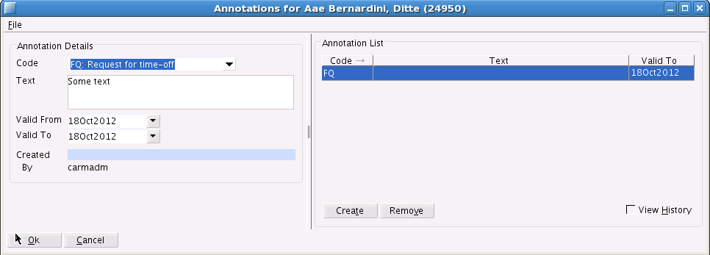

1. Manage Annotations form

## Set Annotation on Marked Crew

The Set Annotation on Marked Crew functionality enables you to set the same annotation on all marked crew. In the Set Annotation on Marked Crew form, you can add an annotation code, text and a validity period.

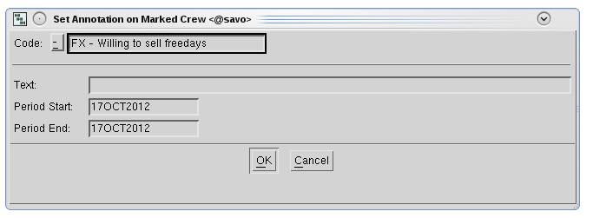

1. Set Annotation on Marked crew form

## Information Window

The bottom row in the information area shows information about the annotations for the active crew member. The currently, and future (within the next 30 days), valid annotation codes are shown. For each valid annotation code, the end date is displayed (if it is a daily annotation it is displayed as “d”) and the start date for future annotation t is also displayed. If the annotation is valid for the whole coming 30 days, no date is displayed.

# Crew Audit Trail

Crew audit trail is used to view changes to crew assignments. In tracking you activate crew audit trail by a mouse right click over a crew in the roster heading and in the Crew Object menu point to Reports and select "Audit Trail Crew…". In planning and prestudio you left click a crew and choose "Audit Trail Crew…" directly from the Crew Object menu.

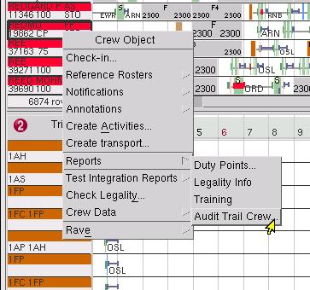

1. Activate Audit Trail Crew report in tracking studio

The Audit Trail Crew form appears where the period to view is selected:

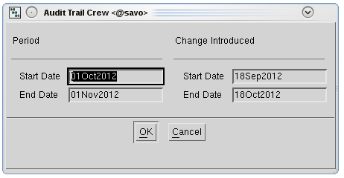

1. Audit Trail Crew form for planning and prestudio

Depending on the application the form is slightly different.

Two time intervals can be specified:

* “Period” defines the time period in the roster where to look for the changes. This is available in planning, pre and tracking studio.
* “Change Introduced” defines the actual time period when the changes were introduced. This is only available in planning and prestudio. In tracking studio changes done after the last publication of type “SCHEDULED” will be shown.

When you press OK in the audit trail form, the audit trail report is generated.

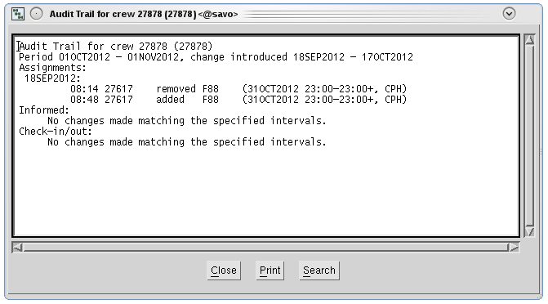

1. Audit Trail Report for Crew

The report consists of a header showing crew employment number and time intervals for this audit trail. The content is split into several sections:

* “Assignments” lists changes in database tables related to crew assignments.
* “Check-in/out” lists check-in and check-out events for this crew member

Each section is also split into one sub-section per day and ordered by the date the changed was introduced.

Each row in the audit trail starts and is ordered by the time of day the change was introduced. The second column shows which user made the change. Column number three states the action type. This can be:

* added
* changed
* removed

The fourth column shows an identifier for the database record. This can be a flight designator for a flight, an activity code for ground activities, status for check-in/out and a description or the valid-to date for qualification changes.

Additional information is shown within parentheses in the fifth column depending of the section. Changed records have an extra row with details for the change, showing what fields were changed, as well as previous and new values for this field.

# Leg Audit Trail

Leg audit trail report is used to view changes to one specific object, e.g. a flight, ground transport, ground duty etc. This report does not include any assignments/production changes.

You activate leg audit trail by positioning the mouse cursor over an object/leg, right-click and display the Assignment Object menu. Point to Reports and select "Audit Trail Leg…":

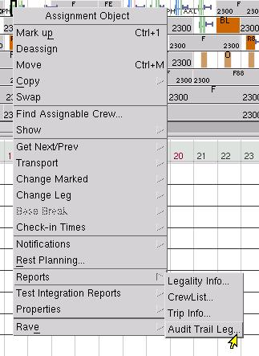

1. Activate Leg Audit Trail report

The report consists of three sections:

* Assigned to: describes to whom the activity is assigned, by whom and when.
* Created by: describes when the activity was first created.
* Changed by: describes the changes that have been done in the object, by who and when.

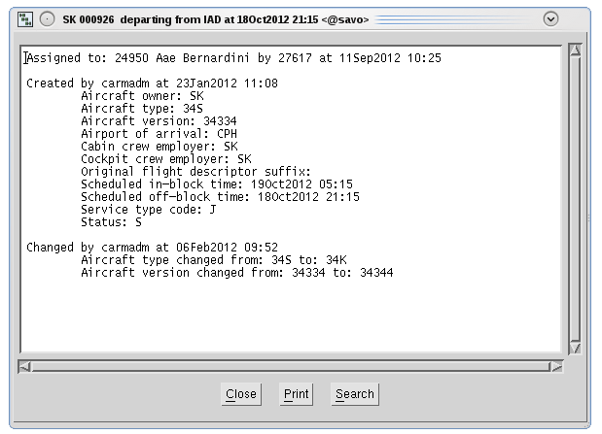

1. Leg Audit Trail report

# Planning Area

The planning area concept applies to crew, trips, and legs. It is used for limiting the amount of data loaded from the database, and to control that the planner rosters the correct crew with the correct production. The rostering and tracking specific parts are described in Functional Reference Rostering and Tracking respectively.

## Manual Trip Area Attribute

It is possible to set an **area attribute to trips in the trip window**. This attribute will mark the trip as belonging to a certain region/area, for example SKL or SKI. If set, the attribute will be used for filtering and selection of trips and override the regular home base-based calculation.

## User Interface

### Common

If a trip has a manual defined area attribute, this will show in the info window to the left:

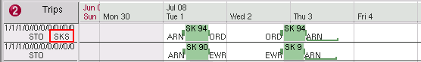

1. Trip with area set to SKS, which is visible in the info window

### Setting Area Attribute

The area attribute is set via following dialog:

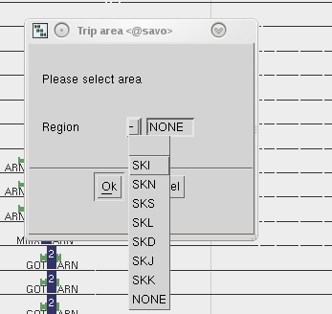

1. Dialog for setting area attribute

Setting area to ‘NONE’ will clear previous selected attribute.

#### Planning

The area attribute can be set for one trip, all trips in window, or all marked trips using the following menu options:

* Single trip; Trip Object 🡪 Properties…🡪Set Trip Area
* Marked Trips; Trip General 🡪 Set Trip Area 🡪 Marked
* All trip in window; Trip General 🡪 Set Trip Area 🡪 All in window

#### Tracking

In tracking attribute can be set to marked trips via menu options:

* Marked Trips (enough with one marked leg in trip);   
  Trip Object🡪 Set Trip Area for Marked.

# Table Editor

Table Editor is standard CARMSYS components that have two CARMUSR extensions. Here the CARMUSR extensions are explained, while the main Table Editor documentation is a part of the online help. These additions are enabled only in Stand Alone mode, the Table Editor that you start from the launcher. The Table Editor started from within studio does not have these features enabled.

## Filtering

The default behavior for Table Editor is to load the entire table, and the entire tables that the main table references in the data model. Some tables are simply too large to load in this way, causing severe performance problems and crashes. For this a filtering mechanism is introduced on larger tables. When opening any of these tables you will automatically be presented with a dialog box allowing you to enter the values you wish to filter/open the table for.

There are three different types of filters; period, crew and flight filter. Only valid filter options for the given table are shown. Different filter types cannot be combined.

Tables that display the filter dialog can only be opened in one single instance. Trying to open the same table again before it is closed, will cause an error message to be presented to the user.

### Period

The tab in the dialog for setting the start and end date for the period filter looks as following:

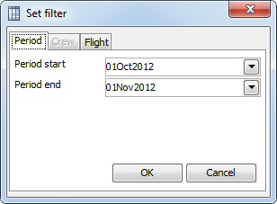

1. Period filter dialog

Note that for this table only period or crew filtering is available; the flight tab is grayed out and not accessible for this table. As a default value the current month will be preselected when you start Table Editor. The dates will be remembered during your session so that any other table with a period filter will present the last used values already pre filled in.

### Crew

Crew is always filtered by their crew id and not the employment number. The OK button is not available until a valid crew id has been given. A valid crew id is a five digit number not starting with 0. The crew value will be remembered during the current Table Editor session.

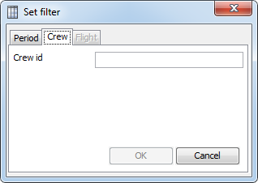

1. Crew filter dialog

### Flight

A flight filter requires the input of:

* Original scheduled date of departure, also sometimes referred to as “udor”.
* Flight descriptor
* Departure airport

The OK button will not be available until all parameters have been correctly given. Airports have to be three characters long to be accepted and flight descriptors need to contain a 2 or 3 character carrier code followed by a flight number. This filtering will be done against Jeppesen’s internal format for storing a flight leg, meaning that you can also provide a suffix after the flight number if wanted. If one is provided only that specific leg is returned otherwise if no suffix (or space ‘ ‘ is used as a suffix) all suffix variants of that leg are returned.

It is ok to use spaces before and after airport of departure and flight descriptor. It is also ok to use spaces between the carrier and flight number within the flight descriptor. Note that this dialog can use up to six digits for the flight number. The Table Editor will remember what flight you searched for the last time during the same session, and it will display that search pre filled in with all six numbers in the flight number specified.

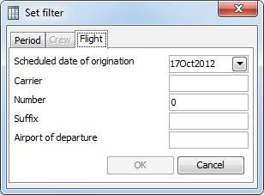

1. Flight filter dialog

## Audit Trail

Audit trail on a single row is executed by double clicking on any of the primary key columns for a data row. This will open a new dialog containing the audit trail as seen here:

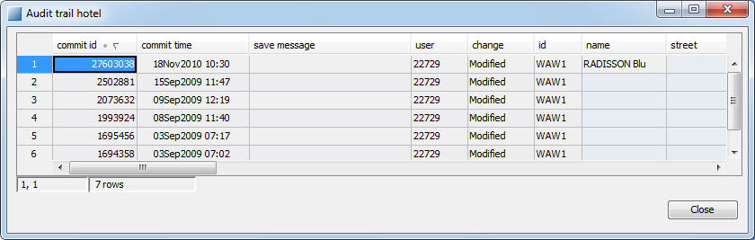

1. Table Editor Audit Trail

Commitid is a DAVE internal identifier for which commit that the data row was inserted, modified or deleted. Commit time identifies the point in time when the change was done, username contains the UNIX user who did the change and changetype indicates what happened to the data row. Each row in the Audit Trail corresponds to how this row looked at that point in time, in the example above one can see that the user “22729” changed the name to “RADISSON Bue” at the 18th of November 2010.