

**Functional Reference**

*Calculation of*  *Overtime* *and* *Other allowances*

*Document Type: Functional Reference*

*Document Status:* ***3.9***

*Last Changed: 24Feb 2014*

Table of Contents

*Calculation of Overtime and Other allowances* 1

1 Introduction 6

1.1 Summary 6

1.2 Document references 7

1.3 Abbreviations 7

2 Crew Overtime compensation 8

2.1 Introduction 8

2.1.1 Basic definitions 8

2.1.2 Rounding and balancing etc. - in general 10

2.2 Cabin Crew (CC) 11

2.2.1 Overtime Calculation – Cabin Crew – all 11

2.2.2 Part time Cabin Crew – all 12

2.3 Flight crew 13

2.3.1 Overtime calculation – Danish short haul flight crew 13

2.3.2 Overtime calculation – Norwegian Short haul flight crew 13

2.3.3 Overtime calculation – Swedish short haul flight crew 14

2.3.4 Overtime calculation – Long haul flight crew (all regions) 14

2.3.5 Passive + pilots 15

3 Other Allowances 16

3.1 Cabin Crew 16

3.1.1 SCC (Senior Cabin Crew) 16

3.1.2 Temporary cabin crew – Resource Pool 16

3.1.3 CC Instructors allowances 17

3.1.4 Bought Days (FX), Cabin Crew 17

3.2 Flight Crew 18

3.2.1 FC Instructors allowances 18

3.2.2 Bought days (FX) Flight Crew 19

4 Work Process 20

5 Output Reports 21

5.1.1 Overtime, “Salary “Overtime” run: 21

5.1.2 Temporary crew, Salary “TEMP_CREW” run: 21

5.1.3 Instructor Allowance, Salary “SUPERVIS” run: 22

5.1.4 Bought Days, Salary “COMPDAYS” run: 23

5.2 Reports 24

5.2.1 Supervision Details report 24

Change History

|  |  |  |  |
| --- | --- | --- | --- |
| Version | Date | Author | Description |
| 0.1 |  | Joakim Oskarsson | Draft version of the document. |
| 1.0 |  | Joakim Oskarsson | First delivered version of the document. Comments from Annette Christensen have been added to the document. |
| 1.1 |  | Leo Wentzel | Some issues solved. Changed specification when overtime periods overlap. Changes after meeting in CPH 2006-05-05 |
| 1.2 |  | Leo Wentzel | Time period definition added. Units of salary items added. |
| 1.3 |  | Leo Wentzel | Adjustments according to SAS comments inserted. |
| 1.4 |  | Leo Wentzel | Final version. A few small changes after SAS comments. |
| 1.5 |  | Joakim Oskarsson | Updated to include CR35 (flight crew overtime) and CR40 (new overtime rules for SCCA). |
| 1.6 |  | Joakim Oskarsson | Minor change to the SCC allowance payment principles (woodpecker item Non Core 23).  Made a note that the new/changed SCCA K06 overtime rules from CR40 is not implemented yet due to a postponed change request. |
| 1.7 |  | Hugo Vazquez | Updated the specification based on WPers change requests and emails from SAS. |
| 1.7sas |  | Carl-Henrik Coakley | Reviewed by SAS 28aug |
| 1.8 |  | Hugo Vazquez | Accepted the changes this is the Final version |
| 1.9 |  | Tomas Persson | Third bullet in 2.2.3.1 changed according to Rolf Nordmyr. Sent to Overtime users for approval. |
| 2.0 |  | Annette Christensen | Changes inserted from Rita Madssen and Hugo. |
| 2.1 |  | Annette Christensen | Final (Changes inserted from Leo Hjort, Bo Dithmar, Rita Madssen and Annette Christensen) Blue and green corrections. |
| 2.2 |  | Bill Hemsworth | Final (?) review. Corrected limits for SKD CC short haul overtime. Added SKS pilots overtime calendar month. Added general restrictions on loss of rest. Changed SKD and SKS loss of rest specifications |
| 2.3 |  | Bill Hemsworth | Added general rules for duty to be ignored when calculating overtime. Corrected error in limits for SKD CC loss of rest in 24hrs. Added overtime rules for FX-days and change LH<->SH pilots. Corrected loss of rest rules for FX-days. |
| 2.4 |  | Bill Hemsworth | Revised overtime SKN CC – F50 rules to be confirmed. Clarified 2.3 Other compensations, re temp CC. SKS MDC/SCC no roundup. SKN loss of rest SH – rest before/after night duty. Retro runs – need for historic rule code. Added salary code for SKN temp CC days. |
| 2.5 |  | Karin Markstad | - Added a change in epigraph 2.2.2.2, Overtime SKD CC long haul: “overtime entitled when duty time in a *duty period* exceeding 13 hours”.  - Added a change in epigraph 2.2.3.1, Overtime SKS CC short haul: “if its long haul or charter legs or legs with more than 4 *scheduled* hours or other service…”  - Section 2.3.2.2 for Norwegian cabin crew, 1. Rest short haul, was updated to best effort. There was duplicate information which has been removed. |
| 2.6 |  | Lars Roldsgaard | 2.2.4 Removed “Awaiting confirmation….”  2.3 Change from duty to block hour  2.3.2 changed to from block-on to next block-off |
| 2.7 |  | Rickard Petzäll | Cleaned up the document and made some definitions clearer. Separated the part about balancing of OT. Removal of private passive transfer from the specification. |
| 2.8 |  | Rickard Petzäll Hugo Vazquez | Added corrections requested by SAS. Corrections requiring code change will be added in a future CR. |
| 2.9 |  | Rickard Petzäll | Changed SKS/SKD FD overtime in accordance with CR 263 and CR 242. Changed SKN CC loss of rest in accordance with CR 259. |
| 3.0 |  | Bill Hemsworth Rickard Petzäll | Changed section 2.3.2 as of CR 397 (loss of rest should not be given in case of standby call-outs) Added section 2.3.1.3 about SKN CC exception from MDC/SCC when flying F50. |
| 3.1 |  | Rickard Petzäll | Clarification of loss of rest, SKD LH |
| 3.2 |  | Rickard Petzäll | CR470 (No MDC SKD) |
| 3.3 |  | Rickard Petzäll | SASCMS-2242 (SKS/SKD FD updates) |
| 3.4 | 26Jan 2011 | Carl-Henrik Coakley | Update of various changes and clarifications |
| 3.5 | 02Jun 2012 | Carl-Henrik Coakley | Cleaned up the document. Update of various changes and clarifications after K11 (before K12) |
| 3.6 | 16Oct 2012 | Carl-Henrik Coakley | K12 revisions |
| 3.7 | 12Nov2013 | Carl-Henrik Coakley | General clean up and 4EXNG revisions |
| 3.8 | 28Jan2014 | Carl-Henrik Coakley | Added §3.1.3 CC Instructors allowance and some minor editorial changes. |
| 3.9 | 24Feb2014 | Carl-Henrik Coakley | SASCMS-2836 Supervision Details, retrieve report from Tracking Studio (new §5.2.1) |

# Introduction

## Summary

Jeppesen CMS is responsible for calculating the overtime hours and other allowances for SAS crew. The information is used for many different purposes, displaying the overtime hours in the Crew Portal, feeding the salary system with the overtime hours each month and for producing statistical reports for the finance department. The two pictures below are taken from the contract, annex 1, and illustrate how the overtime and salary reports should be produced.



Figure : Overview of the overtime report produced for the back office user.



Figure : Overview of the salary files produced from Jeppesen CMS.

## Document references

The references are to show what the specification is based. It’s only the information in the specification that is valid.

Contract, Annex 1

27 Overtime (skallkrav), version 1.0, 2005-05-12

Interface 32.13.1 Duty Overtime months, version 1.1, 2006-02-20

Interface 44.3.1 Overtime and Allowances DK, version 1.0, 2006-01-17

Interface 44.3.2 Overtime and Allowances NO, version 1.0, 2006-01-18

Interface 44.3.3 Overtime and Allowances SE, version 1.0, 2006-01-18

Danish Cabin Crew Union Agreement: K07§ 6 (CPH) Bestemmelser vedrørande flyvetid, tjenstegøring og fritid for Cabin Crew i Danmark.

Swedish Cabin Crew Union Agreement: Bilaga B; Bestämmelser rörande flygtid, tjänstgöringstid och fritid för CC.

Temporary Danish Cabin Crew Agreement: *Bilag 3 fleksibel arbstyrke*, 23 March 2004 and “Administative Retningslinjer” Feb 2012.

32.13 Duty overtime (skallkrav), version 1.1, 2005-05-10

Kollektivavtal för flygkaptener och flygstyrmän (FC) , K04/05

## Abbreviations

CC Cabin crew  
FC Flight crew  
CMS Crew Management System  
LH Long haul  
SH Short haul  
FDP Flight Duty Period

# Crew Overtime compensation

## Introduction

The overtime calculations are always made on performed schedules using the rules applicable for each crew group (long haul/short haul, Sweden/Denmark/Norway, full time crew/part time crew etc). The overtime limits, for each area, are almost always identical to the rule limits defined by the union agreements. Overtime calculations are different for cabin crew and flight crew.

The crew compensation is not only covering overtime payments. There are a few additional reasons for compensation that are included in the crew compensation package, one example being compensation for not achieving minimum rest after a duty pass.

Chinese and Japanese crew is not included.

Overtime compensation and the other types of compensation are sent to the salary system three months after the month they were accumulated. This does not include compensation for temporary crew that is sent to the salary system the following month. Compensations are not to be sent to the salary system for crew that converts overtime to free days (4 hours equal to one F0 day to take out later on request). Overtime is stored in the system for use with retro runs and calculation of compensation days.

Generally speaking the CMS system report numbers only of unit pr salary code and pr. Crew member to be compensated and transferred information to HR function. Rates are set and calculated in the HR function.

### Basic definitions

##### Duty time

Duty time is always calculated from check-in to check-out. Swedish cabin crew does not have night upgrade, the rest do.

##### Duty / Duty period

A duty period ends when there is 5:00 or more from the end of one activity until the start of the next.

##### Duty pass

A duty pass is one or more duty periods where minimum rest is satisfied before and after the duty pass. If two duties have no minimum rest satisfied, both are counted in the same duty pass without the rest time.

##### Flight Duty Period (FPD)

Duty time from check-in to last block on.

##### Duty time 7 calendar days

Duty time in rolling 7 calendar day period calculated forward and backwards from 0:00 – 0:00 UTC.

##### Check-in

The Check-in time is calculated based on scheduled departure or override (delayed -D) check-in time.

##### Check-out

The check-out time is calculated based on actual arrival time.

##### Base and overtime payment

A crew member that shifts base receives overtime payment according to the base (country of employment) they belonged to the last day of the month.

##### Extended duty

Planned duty time according to OM-A 7.1 (cabin crew normally if duty exceeding 12 hours, passive duty after active not included).

##### Planned duty

Planned duty is counted as planned until midnight 23:59 the day before C/I to the first flight leg in that duty pass.

##### Month switches

Overtime and other allowance where calculation includes switches of month the compensations is calculated and reported in the following month.

##### Long and short haul flights areas in SKD region

Flights within -1 to +3 time zones and north of 34 Latitude are considered short haul, all other flights are long haul.

##### Time periods

All duties that end in a planning period are used to calculate the value of each compensation type within the scope of this document, for that planning period.

7 calendar days periods ending in a planning period are included in the calculations for that planning period. 7 calendar days (00:00 – 23:50) are calculated forward and backwards.  
If the 7 calendar day period is across month, the overtime belongs to the month where the period ends

Calculation of duty time

Duty time is calculated from check-in to check-out as described in [7], [8], with the following exceptions:

A duty period that includes a meeting (MTnn codes) and no active flight

Simulated passive transfers (Pnn codes) - calculate duty from/to the activity following/preceding the Pnn code.

### Rounding and balancing etc. - in general

For CC overtime is given per started hour.

For FC overtime is given per started half hour.

“Mertid” hours for part time CC are not rounded up.

“Mertid” hours for part time FC is given per started hour.

TEMP Crew (Resource Pool) hours are not rounded up.

Overtime is not paid twice for the same production. If two overtime limits is passed and overlap, only the period which yields the most overtime is counted.

For example, if you in a month have e.g. 2 hours overtime in a 7 calendar days period and 1 hour in a 2 months calculation, only the highest of the 2 overtime calculations, 2 hours, is included in overtime payment.

When calculating overtime, the duty on time-off day (sold FX-day or privately traded F-day) is never to be included.

There are no special considerations for charter flights.

## Cabin Crew (CC)

### Overtime Calculation – Cabin Crew – all [1]

Cabin crew is entitled overtime if:

**Duty in a rolling 7 calendar day period exceeds 47:30 hours.**

**Overtime if check-out on a planned free dag**:

If check out on a planned free day due to delay CC is compensated as follows:

###### If CO on free day between 00:01 and 02:00 (base time) CC is compensated with overtime per started hour, max 2 hours. CC in Resource Pool (TEMP Crew) is also entitled to overtime if CO on free day,

###### If CO after 02:00 CC is compensated with an F3 day (manually updated in crew accounts) and *no overtime according to a).* TEMP Crew is compensated with 5,6% of a monthly full time salary (manually reported to Salary office).

### Part time Cabin Crew – all

A part time CC will also receive overtime (“mertid”) payment if they exceed their monthly target (dependant on their service grade) up to the full time monthly target of 166 hours for VG or 498 hours in a fixed 3 months period for FG. If exceeding full time duty limit, part time CC receives overtime for the duty above the full time duty limit.

VG:

Service grades and maximum duty per month:

|  |  |
| --- | --- |
| **Service grade** | **Max duty per 1 month** |
| 80 % | 132:48 |
| 75 % | 124:30 |
| 60 % | 99:36 |
| 50 % | 83:00 |

The difference between actual performed duty and duty for service grade is compensated with “mertid” up to target for full time monthly limit 166 hours, - no rounding up. Duty above 166 hours is compensated with overtime per started hour.

If a crew member changes from FG to VG at the start of or in the middle of any month, then the maximum duty time that month should be only that for VG. *The "3 month limit" is not to be checked*.

FG:

Service grades and maximum duty per month:

|  |  |
| --- | --- |
| **Service grade** | **Max duty per 3 months** |
| 80 % | 398 |
| 75 % | 374 |
| 60 % | 299 |
| 50 % | 249 |

The 3-month periods are: SEP-NOV; DEC-FEB; MAR-MAY; JUN-AUG. The rule for FG should only be checked at the end of the 3 month period.

The difference between actual performed duty in the 3 months period and duty for service grade is compensated with “Mertid” up to target for full time in 3 months limit 498 hours, - no rounding up. Duty above 498 hours is compensated with overtime per started hour.

If a crew member changes within the FG or enters FG, there should be *no check* of maximum duty in 3 months or per calendar month.

Part time CC are entitled to normal monthly overtime for rolling 7 calendar days, however only the highest overtime of part time monthly / 3 months and normal overtime in 1 month or accumulated overtime for 3 months should be considered.

## Flight crew

### Overtime calculation – Danish short haul flight crew

Overtime compensation for FG and VG is given for duty time exceeding the target for either one calendar month, or two months, depending on which gives the most compensation.

##### Overtime for one month:

The duty time in a calendar month that exceeds.9,5 hours times the number of production days in the calendar month, rounded up to the nearest 30 minutes. BL-days also counts as production days with factor 9,5 hours.

For part time crew, overtime up to.9,5 hours times the number of production days (incl. BL-days) + LA8 days in the calendar month is paid as “mertid” rounded up to the nearest 60 minutes.

##### Overtime for two months:

If the duty time in a calendar month plus the month before that exceeds 9.5 hours times the number of production days (incl. BL-days) in the two months, rounded up to the nearest 30 minutes.

For part time crew, “mertid” is paid up to 9.5 hours times the number of production days (incl. BL-days) + LA8* days in the two months, rounded up to the nearest 60 minutes.

##### Overtime in a rolling 7 calendar day period:

Overtime compensation is given if duty time in a 7 calendar day’s period exceeds 47:30 hours.

### Overtime calculation – Norwegian Short haul flight crew

Overtime compensation for FG and VG is given for duty time exceeding the target for either one calendar month, or two months, depending on which gives the most compensation.

##### Overtime for one month:

The duty time in a calendar month that exceeds 9.5 hours times the number of production days in the calendar month, rounded up to the nearest 30 minutes. BL-days also counts as production days with factor 9,5 hours.

For part time crew, overtime up to 9.50 hours times the number of production days (incl. BL-days) + LA8 days in the calendar month is paid as “mertid”, rounded up to the nearest 60 minutes.

##### Overtime for two months:

If the duty time in a calendar month plus the month before that exceeds 9.5 hours times the number of production days (incl. BL-days) in the two months, rounded up to the nearest 30 minutes. BL-days also counts as production days with factor 9,5 hours.

For part time crew, “mertid“ is paid up to 9.5 hours times the number of production days (incl. BL-days) + LA8* days in the two months, rounded up to the nearest 60 minutes.

##### Overtime in a rolling 7 calendar day’s period:

Overtime compensation is given if duty time in a 7 calendar day’s period exceeds 47:30 hours .

### Overtime calculation – Swedish short haul flight crew

Overtime compensation VG:

Overtime compensation) is given for duty time in a calendar month exceeding the monthly target. For full time crew the target is 160 hours. Overtime is rounded up to the nearest 30 minutes.

For part time crew, the monthly target is the target factor for full time crew (160 hours) multiplied by the part time factor (e.g. 0.8 for 80% crew, 0.75 for 75% crew, 0.5 for 50% crew).

Overtime for part time crew up to the full time target (160 hours) is to be rounded up to the nearest hour and reported as “Overtime for part time crew” while overtime for duty time exceeding 160 hours is to be reported as for full time crew overtime.

##### Overtime Compensation FG:

##### Overtime for one month:

The duty time in a calendar month that exceeds 9.5 hours times the number of production days in the calendar month, rounded up to the nearest 30 minutes. BL-days also counts as production days with factor 9,5 hours.

For part time crew, overtime up to 9.50 hours times the number of production days (incl. BL-days) + LA8 days in the calendar month is paid as “mertid”, rounded up to the nearest 60 minutes.

##### Overtime for two months:

If the duty time in a calendar month plus the month before that exceeds 9.5 hours times the number of production days (incl. BL-days) in the two months, rounded up to the nearest 30 minutes. BL-days also counts as production days with factor 9,5 hours.

For part time crew, “mertid” is paid up to 9.5 hours times the number of production days (incl. BL-days) + LA8* days in the two months, rounded up to the nearest 60 minutes

##### Overtime in a rolling 7 calendar day’s period (FG and VG):

Overtime compensation is given if duty time in a 7 calendar day’s period exceeds 47:30 hours .

### Overtime calculation – Long haul flight crew (all regions)

FD long haul are entitled to overtime for block time exceeding the limit, which is 90 hours (even during the period June to August where crew can be *scheduled up to 100 block hours*).

Duty on time-off day (sold FX-day or privately traded F-day) is not to be included in overtime calculations.

#### Change from LH to SH or v.v.

LH Overtime for calendar month is to be calculated including only duty within the LH period, and with the normal limit.

SKS SH Overtime for calendar month is to be calculated including only duty within the SH period, and with the normal limit.

### Passive + pilots

Duty time for Passive+ (P+) pilots is calculated from CI at “other base” after passive from home base to CO at “other base” before passive to home base.

However, if “other base” is another base or station than the base belonging to the region the pilot is assigned to, then duty time (and overtime) should be calculated from/to homebase.

Example:

If home base is CPH and P+ is assigned to SKS, then “other base” is STO, then duty time starts at CI in STO after passive transfer from CPH and ends at CO in STO before passive transfer to CPH.

But if active duty starts in OSL after passive transfer from CPH, then duty calculation (overtime) starts at CI in CPH. If active ends in e.g. GOT before passive transfer to CPH, then duty calculation (overtime) ends at CO in CPH.

# Other Allowances

## Cabin Crew

### SCC (Senior Cabin Crew)

Calculation of SCC allowance is part of Salary “Overtime” run DK, NO and SE.

SCC can be given to CC on long haul or short haul flights.   
SCC is given independently if the flight demands AP or not. It is given to the AS/AH flying in higher position or to the CC with the highest seniority. In any case CC needs to have fulfilled the SCC course. SCC is *never given to AP*.

SCC is calculated for block time as SCC and there is no rounding up of block time. For each duty as SCC (trip/day) 1(one) hour is added for preparation and briefing.

### Temporary cabin crew – Resource Pool

Calculation of Temporary cabin crew hours is made in Salary “TEMP_CREW” run DK, NO, and SE.

#### Danish Temporary cabin crew

The temporary CC receives their pay based on the number of hours performed, without night upgrade. Jeppesen CMS must therefore feed the salary system with information on how many hours each temporary CC have worked during the month.

A temporary CC that is taken off production less then twelve (12) hours before the planned check-in time receives a payment compensation equivalent to two (2) hours of work. A temporary CC that is taken off production after check-in receives at least compensation equivalent ~~of four (4) hours of work~~ to planned duty hours.

Illness:

A temporary CC taken off production due to illness (IL, IL7, LA91 and UF) will be compensated with the planned duty hours before taken off duty.

CC will e.g. be scheduled ID06 indicating that compensation for 6 hours is to be reported to the salary system.  
The total monthly ILL compensation hours are *not* rounded up.

#### Norwegian Temporary cabin crew

Temporary CC receives their pay based on the number of duty days performed according to released roster. Jeppesen CMS must therefore feed the salary system with information on how many duty days each temporary CC has worked during the month. All days in a sling must be counted as Temp duty days, even days on outstation without any duty.

If Temp Crew is called on duty on free day’s duty *after roster release*, this duty is compensated with actual duty time, Temp hours, minimum 6 hours per day. If this duty is changed again later, then the new duty should also be compensated with actual duty hours (min. 6 hours) *or at least* the duty time as first agreed.

Changed duty in planned slings (released roster) is still compensated with Temp days.

**Note:** When temporary crew flies full time during summer, the same rules apply as for other CC.

Temporary crew should also have overtime, in the period they are not working full-time. The same rules apply as for other crew.

#### Swedish Temporary cabin crew

The temporary CC receives their pay based on the number of hours performed, without night upgrade

Minimum compensation on a calendar day (homebase time) is four (4) hours.

A temporary CC that is taken off production *less then fourteen (14) hours* before the planned check-in time receives a payment compensation equivalent to four (4) hours of work.   
A temporary CC that is taken off production after check-in receives at least compensation equivalent to the updated stand-by time (minimum 4 hours), alternatively the temporary CC receives payment compensation equivalent to the planned duty hours (minimum 4 hours).

Ill duty hours are reported in a special report based on scheduled Roster at time when reported ill. The Report can be viewed in the Salary GUI and report sent in mail (to HR amongst others) when Temp crew run is released.

### CC Instructors allowances

This paragraph concerns calculation of allowances related to CC Instructors. Calculation of CC Instructor allowance is done in Salary “SUPERVIS” run DK, NO and SE.

CC Instructors are compensated with actual time of duty codes OL1* (STO) OL2* (CPH) OL3* (OSL) on intartid ”INST_CC”.

Supervision Details report can be retrieved from Tracking Studio in the Report menu, see § 5.2.1.

### Bought Days (FX), Cabin Crew

Bought days compensation is included in Salary “COMPDAYS” run.

In case of CC shortages in the Traffic planning and execution phase, SAS can buy free days from CC, activities starting with F, LA and VA.

Bought day for a day’s production with scheduled duty > 6 hours, CC is compensated with a ‘BOUGHT’ day (14% of a100% month’s salary) in crew accounts.

Bought day for a day’s production with scheduled duty =< 6 hours, CC is compensated with a ‘BOUGHT_8’ day (8% of a 100% month’s salary) in crew accounts.

Bought days are sent to Out Payment in the following month by running a reset job in crew account the 1st. in the month.

For more details see Functional Reference Tracking § 9 Buy Day.

## Flight Crew

### FC Instructors allowances

This paragraph concerns calculation of allowances related to FC Instructors. Calculation of Instructor allowance is done in Salary “SUPERVIS” run DK, NO and SE.

Supervision Details report can be retrieved from Tracking Studio in the Report menu, see § 5.2.1.

#### Simulator training

Allowance for simulator training includes PC/OPC and Type rating:

Instructors on simulator pass marked I+S or IZ+S or marked I+C/K is compensated with Intartid ”INST_SIM” for actual hours, no rounding up. (PC/OPC is normally 2+2 hrs or 4 hrs. Type rating is normally 3 hours).

#### Simulator briefings

Briefing and debriefing in connections with OP/OPC is compensated with Intartid “INST_SIM_BR

#### LIFUS

Instructors on LIFUS (Line Flying Under Supervision) duty, I/X/T + flights duty are compensated with Intartid ”INST_LIFUS_ACT”. LIFUS allowance is calculated per block hour, no rounding up.

#### LCI

Instructors on LCI (Line Check) duty, UZ/LLZ/LH/BU/B/BLL/Z + flights duty, are compensated with Intartid ”INST_LCI on short haul Line Check and “INST_LCI_LH (double up) on long haul Line Check. LCI” allowance is calculated per number of calendar day (UTC).

#### CRM

Instructors on CRM (Crew Resource Management) are compensated with actual time of duty codes OL4-5-6. This duty includes supervision of instructors. OL4-5-6 duty codes are including 2 hours preparation time (normal duration of OL4-5-6 is 10 hours, 8 hours + 2 hours for preparation). Intartid ”INST_CRM”.

#### Classroom duty

Instructors on Classroom duty are compensated with actual time of duty code OXI on Intartid “INST_CLASS”. Minutes are rounded up to nearest 15 minutes.

#### Skill test

Instructors performing Skill Test is compensated with 2 hours per Skill Test pass on intartid “INST_ SKILL_TEST”

*Remark:* Latest agreement between STOOL and instructors requires compensation of 4 hours per Skill test. This is solved be doubling the payment in HR systems, instead of increasing CMS compensation from 2 to 4 hours.

### Bought days (FX) Flight Crew

Bought days compensation is included in Salary “COMPDAYS” run.

In case of FC shortages in the Traffic planning and execution phase, SAS can buy free days from FC, activities starting with F, LA, VA or BL.

Bought day for a day’s production with scheduled duty > 6 hours, FC is compensated with:

* A ‘BOUGHT’ day (14% of 100% month’s salary) in crew accounts, or
* A BOUGHT_COMP day, which is 7% of a 100% month’s salary and an F3 day in crew accounts, or
* A ‘BOUGHT_COMP_F3S’, which is an F3S day updated in crew accounts, no Out Payment.

Bought day for a day’s production with scheduled duty =< 6 hours, FC is compensated with a BOUGHT_8 day (8% of 100% a month’s salary) in crew accounts.

Bought BL day already converted to F day is compensated with a ‘BOUGHT_BL’ day (5,6% of a 100% month’s salary) updated in crew accounts.

Bought days are sent to Out Payment in the following month by running a reset job in crew account the 1st. in the month.

For more details see Functional Reference Tracking § 9 Buy Day

# Work Process

The document reference [2] describes the work process for overtime calculations. The work process is described in details in Functional Reference Salary Export.

.

# Output Reports

If not otherwise specified, the unit “hours” is represented as a number of hours with two decimals, e.g. 90 minutes is reported as “1.50”.

### Overtime, “Salary “Overtime” run:

|  |  |  |  |
| --- | --- | --- | --- |
| **CPH:** | | | |
| Salary Code  (Extartid) | CMS Intartid | Description | Unit |
|  |  |  |  |
| 317 | SCC | SCC, Senior cabin crew allowance (CA1) | Hours |
| 328 | SCCNOP | SCC, No purser scheduled | Hours |
| 409 | OTFC | Overtime flight crew (FC) | Hours |
| 410 | OT | Overtime cabin crew (CC) | Hours |
| 425 | OTPTCC | “Mertid” CC | Hours |
| 439 | OTPT | “Mertid” (Part time FC) | Hours |
| **OSL:** | | | |
| Salary Code | CMS Intartid | Description |  |
| 3145 | OT | Overtime (CC) | Hours |
| 3150 | SCC | Senior cabin crew allowance | Hours |
| 3160 | OTPTC | “Mertid” for CC | Hours |
| 3412 | SCCNOP | Senior cabin crew allowance (no purser planned) | Hours |
| 3770 | OTFC | Overtime flight crew | Hours |
| 3771 | OTPT | “Mertid” (Part time FC) | Hours |
| **STO:** | | | |
| Salary Code | CMS Intartid | Description |  |
| 200 | OTPT | “Mertid” for part time crew CC and FC | Hours |
| 201 | CALM_OTFC | Overtime for calendar month CC and FC | Hours |
| 202 | CALW | Overtime calendar week CC and FC | Hours |
| 350 | SCC | Senior cabin crew allowance | Hours |

### Temporary crew, Salary “TEMP_CREW” run:

|  |  |  |  |
| --- | --- | --- | --- |
| **CPH:** | | | |
| Salary Code  (Extartid) | CMS Intartid | Description | Unit |
| 229 | TEMPCREW | Temporary crew hours | Hours |
| 1229 | ILLTEMPCREW | Temporary crew ill compensation | Hours |
| **OSL:** | | | |
| Salary Code | CMS Intartid | Description |  |
| 6049 | TEMPDAY | Temporary crew days | Days |
| 6048 | TEMPCREW | Temporary crew hours | Hours |
| **STO:** | | | |
| Salary Code | CMS Intartid | Description |  |
| 013 | TEMPCREW | Temporary crew hours | Hours |

### Instructor Allowance, Salary “SUPERVIS” run:

|  |  |  |  |
| --- | --- | --- | --- |
| **CPH:** | | | |
| Salary Code  (Extartid) | CMS Intartid | Description | Unit |
| 0515 | INST_LCI | LCI SH | Cal. days |
| 0512 | INST_LCI_LH | LCI LH | Cal. days |
| 0719 | INST_LIFUS_ACT | LIFUS | Bl. Hours |
| 0717 | INST_SIM | Simulator duty (PC/OPC/Type Rating) | Hours |
| 0718 | INST_SIM_BR | Simulator Briefing/Debriefing (PC/OPC/Type Rating) | Hours |
| 0680 | INST_CLASS | Instructor classroom duties | Hours |
| 0683 | INST_CRM | Instructor CRM duties | Hours |
| 0702 | INST_SKILL_TEST | Instructor Skill_Test | 2 Hours |
| 0729 | INST_CC | Instruction CC (OL) | Hours |
| **OSL:** | | | |
| Salary Code | CMS Intartid | Description | Unit |
| 3480 | INST_LCI | LCI SH | Cal. days |
| 3482 | INST_LCI_LH | LCI LH | Cal. days |
| 3225 | INST_LIFUS_ACT | LIFUS | Bl. Hours |
| 329 | INST_PC_OPC | Simulator duty (PC/OPC/Type Rating) | Hours |
| 324 | INST_PC_OPC_DB | Simulator Briefing/Debriefing (PC/OPC/Type Rating) | Hours |
| 3228 | INST_CLASS | Instructor classroom duties | Hours |
| 03233 | INST_CRM | Instructor CRM duties | Hours |
| 3231 | INST_SKILL_TEST | Instructor Skill_Test | 2 Hours |
| 3232 | INST_CC | Instruction CC (OL) | Hours |
| **STO:** | | | |
| Salary Code | CMS Intartid | Description | Unit |
| 360 | INST_LCI | LCI SH | Cal. days |
| 372 | INST_LCI_LH | LCI LH | Cal. days |
| 374 | INST_LIFUS_ACT | LIFUS | Bl. Hours |
| 361 | INST_PC_OPC | Simulator duty (PC/OPC/Type Rating) | Hours |
| 362 | INST_PC_OPC_DB | Simulator Briefing/Debriefing (PC/OPC/Type Rating) | Hours |
| 378 | INST_CLASS | Instructor classroom duties | Hours |
| 377 | INST_CRM | Instructor CRM duties | Hours |
| 364 | INST_SKILL_TEST | Instructor Skill_Test | 2 Hours |
| 363 | INST_CC | Instruction CC (OL) | Hours |

### Bought Days, Salary “COMPDAYS” run:

|  |  |  |  |
| --- | --- | --- | --- |
| **CPH:** | | | |
| Salary Code  (Extartid) | CMS Intartid | Description | Unit |
| 9420 | BOUGHT_CC | Bought days CC (14%) | Days |
| 9419 | BOUGHT_8_CC | Bought days CC (8%) | Days |
| 9494 | BOUGHT_FC | Bought days FC (14%) | Days |
| 9495 | BOUGHT_8_FC | Bought days FC (8%) | Days |
| 9475 | BOUGHT_COMP | Bought days (FXC) FC (7%+F3) | Days |
| 0389 | BOUGHT_BL | Bought BL days FC | Days |
| **OSL:** |  |  |  |
| Salary Code | CMS Intartid | Description | Unit |
| 4582 | BOUGHT_CC | Bought days CC (14%) | Days |
| 4528 | BOUGHT_8_CC | Bought days CC (8%) | Days |
| 4522 | BOUGHT_FC | Bought days FC (14%) | Days |
| 4525 | BOUGHT_8_FC | Bought days FC (8%) | Days |
| 4521 | BOUGHT_COMP | Bought days (FXC) FC (7%+F3) | Days |
| 4566 | BOUGHT_BL | Bought BL days FC | Days |
| **STO:** |  |  |  |
| Salary Code | CMS Intartid | Description | Unit |
| 203 | BOUGHT | Bought days CC and FC (14%) | Days |
| 205 | BOUGHT_8 | Bought days CC and FC (8%) | Days |
| 213 | BOUGHT_COMP | Bought days (FXC) FC (7%+F3) | Days |
| 207 | BOUGHT_BL | Bought BL days FC | Days |

## Reports

These reports include overtime calculations:

* List 12
* Overtime Statement
* Tracking Studio “Compensation”

These documents are specified separately.

### Supervision Details report

Supervision allowance details can be viewed and checked in the Supervision Details report.

The report is retrieved from Tracking Studio menu “Reports”.

Open Tracking Studio including the month for the report, e.g. if you want to retrieve Supervision details for Feb 2014, be sure that Feb 2014 is included in the opened Tracking period and be sure that you open Area: **ALL**.

Go to *Reports -> Salary -> Supervision Details…*

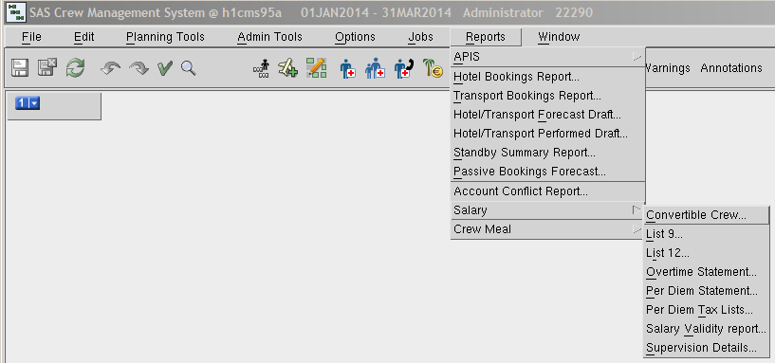

And press the “Supervision Details… option

This window opens:

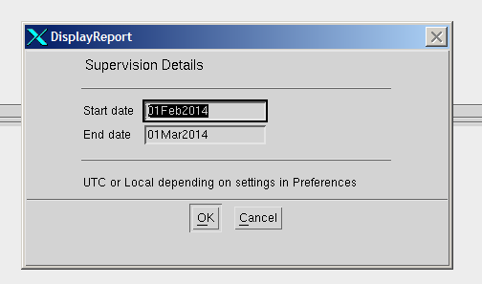

If you want to retrieve a report for Feb 2014, the above entry is correct, but   
- if e.g. Mar 2014 insert Start date: ***01mar2014*** and End date: ***01Apr2014***.

Press the OK button and this windows opens

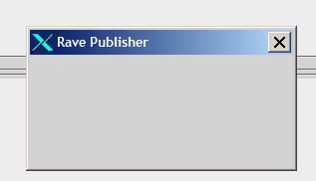

And then later this one

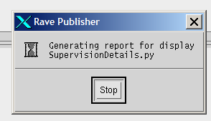

And finally the report opens in as a pdf file format.

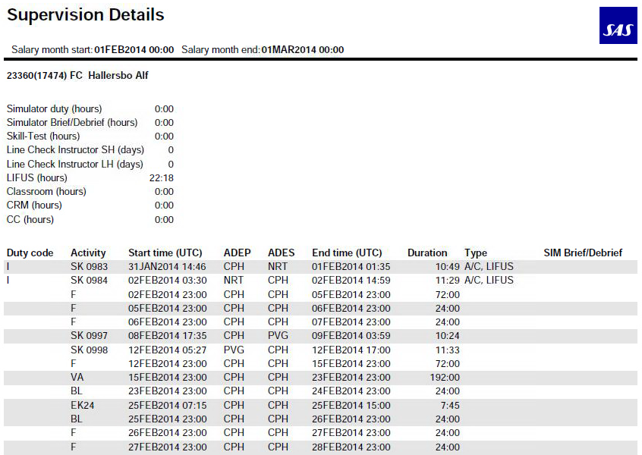

If you want to save a copy of the file, you can either ***Save a Copy*** of the file on the CMS server in your personal directory or send the file to yourself (*and others*) in an Email.

#### Save a copy of the report.

Go to “File” in the Adobe Reader action menu, and press the option “Save a Copy…”

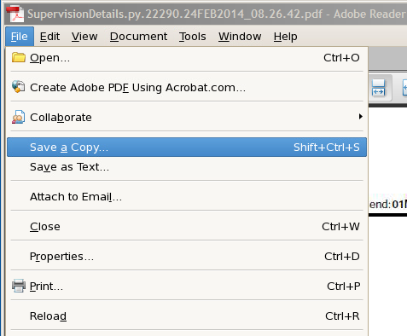:

This window opens:

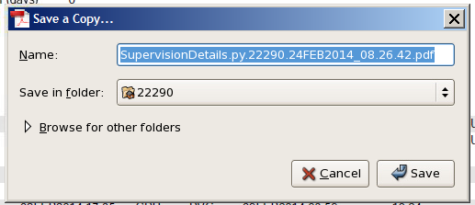

You can change the file name to something different if you want to.

Press the ***Save*** button.

Open a ***FileZilla*** client and open the CMS Server (*host/vært*).

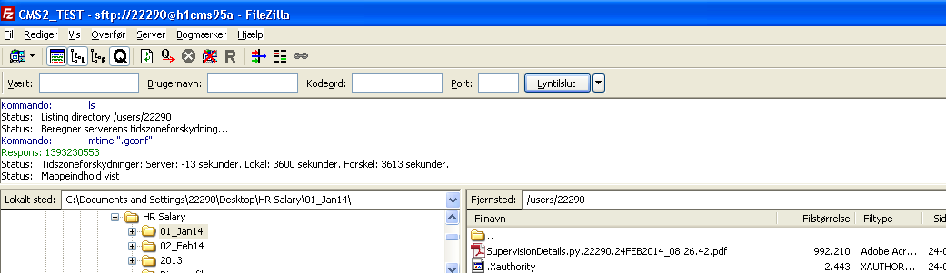

Copy the file from FileZilla to a directory on your Laptop or workstation.

#### Send pdf file in Email

The other option is to sent the report to yourself and/or others in an Email

Go to “File” in the Adobe Reader action menu, and press the option “Attach to Email…”

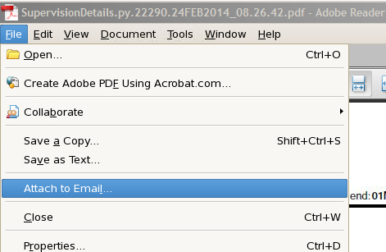

The “Compose Email” window opens.

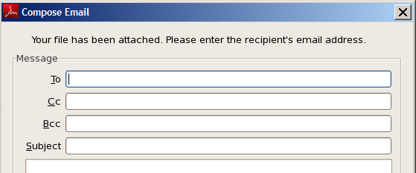

Insert Email addressee(s) (use comma as separator between adressees) , use e.g. your empl. nbr + @sas.dk (or no or se), see example below:

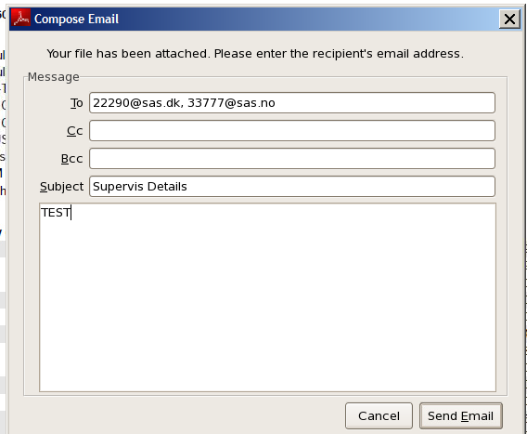

Press the Send Email button.

Copy the file from the Email to a directory on your Laptop or workstation.

**>End<**

1. Except CN and JP CC.