

**Functional Reference Manual**

*Perdiem*

*Document Type: Functional Reference*

*Document Status: Version 3.2*

*Last Changed: 27Jan 2014*

Table of Contents

1 Introduction 3

1.1 This Document 3

1.2 Change History 3

2 PerDiem 4

2.1 Introduction 4

2.2 Process 4

2.3 PerDiem Statement 4

2.3.1 PerDiem on Public Holidays, cabin crew only 7

2.3.2 PerDiem for extended duty, cabin crew only 1 8

2.3.3 PerDiem Passive + (P+) pilots 8

2.4 Tax rules 9

2.4.1 Tax rules Denmark 9

2.4.2 Tax rules Norway 10

2.4.3 Tax Report Norway 11

2.4.4 Tax rules Sweden 13

3 Instructions 14

3.1 Understanding how PerDiem was calculated 14

4 Tables 16

4.1 PerDiem salary codes 16

4.2 Exchange Rate table 17

4.3 PerDiem Compensation table 17

4.4 PerDiem Tax table 18

4.5 Special Weekends table 19

# Introduction

## This Document

Carmen CMS will calculate the PerDiem amounts for all crew and pass the information on to the salary system. This document outlines how the calculations are done and the available reports. It also instructs the end user in how to manually create the reports.

## Change History

|  |  |  |  |
| --- | --- | --- | --- |
| Version | Author | Date | Description |
| 1.0 | Leo Wentzel | 2006-04-06 | Initial version based on the Tracking time box 2 delivery (and sub-sequent bug corrections). |
| 1.1 | Hugo Vazquez | 2007-11-27 | Added more detailed information about how PerDiem is calculated. |
| 1.2 | Hugo Vázquez | 2008-10-03 | Updated menus |
| 2.0 | Andreas Wohrm | 2008-10-09 | Final Fat |
| 2.1 | Hugo Vázquez | 2008-12-12 | Minor updates |
| 2.2 | Hugo Vázquez | 2009-03-25 | More detailed information |
| 2.3 | Carl-Henrik Coakley | 26Jun 2012 | Major clean up of document, merge with PerDiem Specification document and update of changes since version 2.2 |
| 2.4 | Carl-Henrik Coakley | 15Oct 2012 | Reorganizing document. Update of Norwegian Tax rules and rates. |
| 2.5 | S. Olson | 28Feb2013 | Updated Instructions section |
| 2.6 | E. Linge | 20Sep2013 | Updated airport standby rules |
| 3.0 | Carl-Henrik Coakley | 20Nov2013 | Updated 4EXNG PerDiem changes and general clean up. |
| 3.1 | Carl-Henrik Coakley | 25Nov2013 | Added information about Norwegian Tax reports and files and some further details about Danish tax. |
| 3.2 | Carl-Henrik Coakley | 27Jan2014 | New Norwegian Tax deduction rates 2014, P+ pilots and some editorial changes. |

# PerDiem

This document describes the PerDiem process and report.

## Introduction

The PerDiem statement report is created for a roster month. All slings that end within the same month are included in the roster month, as seen in the picture to the right. Included in the report are all trips entitled to either course or flight PerDiem. The report includes basic trip and flight data together with the PerDiem amounts for each stop. The amount for tax deduct for each sling is also included.

Month start

Month end

It is possible to create the report for a selection of trips instead of a selection of rosters.

## Process

An automatic process is scheduled the 6th in the month, and it calculates PerDiem for the previous month. This job is generated as a batch job for each salary system (country), and can be checked from the Salary module (GUI). After approving the salary files, the job can be released from the Salary GUI, and then it will be copied to a release folder and marked with the release date. If the result file is not correct, another PerDiem job can be run manually from the Salary GUI, after correcting the issues in CMS Studio and saved, and then after checking it again, it should be released. For more details see Functional Reference Salary.

Please be aware that around one minute is needed between the save and the run of the new job, it cannot be done instantaneously.

## PerDiem Statement

The PerDiem Statement report is executed on the current crew selection. It uses three tables containing PerDiem amount, exchange rate and tax deduct amount to calculate the correct PerDiem values. The tables are described in more detail later.

PerDiem calculation is based on different rules for Norwegian crew, Swedish crew, Danish crew or international crew. At the moment all PerDiem rules are the same, except for one rule on SKN crew (early arrival) and one rule on SKD, SKN and SKS cabin crew (Airport standby after flight).

Cabin crew PerDiem is paid in connection with duty travels. Flight crew is entitled to flight PerDiem for time spent away from home base in connection with flight duty or simulator training. All crew are entitled to course PerDiem for duties including passive flight before and after course codes (not simulator). In this case, “Course” will be displayed in the report.

*Intervals:*

Full PerDiem is paid for each 24-hour period. All crew on flight duty can receive PerDiem for part of a 24 hour period. PerDiem is, in such cases, paid as follows:

All crew categories / countries, ***except Norwegian CC***

0:00 - 2:59 hours: *No* PerDiem

3:00 - 5:59 hours: 1/4 (0.25) PerDiem

6:00 - 11:59 hours: 1/2 (0.50) PerDiem

12:00 - 24:00 hours: 1/1 (1.00) PerDiem

***Norwegian CC:***

0:00 - 2:59 hours: No PerDiem

3:00 - 5:59 hours: 1/4 (0.25) PerDiem

6:00 - 8:59 hours: 1/2 (0.50) PerDiem

09:00 - 11:59 hours: 3/4 (0.75) PerDiem

12:00 - 24:00 hours: 1/1 (1.00) PerDiem

*PerDiem entitled period in general:*

The period for which PerDiem is paid is calculated from 60 minutes before scheduled departure (STD) at home base, or, if crew delayed at home, 60 minutes from new ETD updated in Tracking Studio, to 30 minutes after actual landing (ATA) at home base. However, if ATA is up to 30 minutes earlier than STA, then the PerDiem period ends 30 minutes after STA. If ATA is *more than 30 minutes* earlier that STA, then the PerDiem period ends 30 minutes after ATA.  
The PerDiem amount is established according to rates in each country. This information is found in *PerDiem Compensation* table.   
If the last activity in the sling is an airport standby, the period ends at the previous flight/activity, with the same rules as explained above. Airport standby at the end of the slings does not entitle to PerDiem nor showed in the PerDiem Statement for *flight crew*. Airport standby at the beginning of trip is entitles to PerDiem for *all crew*. No time is added before the airport standby.

*PerDiem entitled period Norway:*

There is a slightly different rule for the PerDiem trip period in Norway.

If the actual arrival time is earlier than the scheduled arrival time, then the PerDiem period ends at scheduled time of arrival STA plus 30 minutes. Otherwise, it ends at actual arrival time plus 30 minutes.

*PerDiem entitled period cabin crew Denmark, Norway and Sweden:*

For cabin crew in Denmark, Norway and Sweden airport standby at the end of the trip entitles to PerDiem and showed in the PerDiem Statement. When airport standby is in the end of a sling, no time is added after the airport standby..

*Allocation of PerDiem:*

The total number of PerDiem units for a certain sling is allocated to stopovers and meal stops in accordance with the following basic rules in order to decide correct currencies and amounts.

For stopovers at places other than home base with duration of 5 hours or more, PerDiem will be allocated based on the length of the stop. PerDiem will be calculated in stop over station “stop_country” currency.

Meal stops which allocates PerDiem is the normal meal stop (“X”) and hot and cold meals on board, meal codes “V” (during ground stop) and “VO” (during flight), no other meal codes are considered in the PerDiem calculation.

The PerDiem country rate is dependent on the stop over country or the arrival station country on the leg to which the mealcode is allocated.

For Swedish CC stop_country is calculated slightly different, i.e. “turnaround station” is used for determining stop_country in combination with meal codes X, V and VO. For all other crew “arrival station” stop_country currency for leg with X, V or VO is used.

* For short trips *) without any meal codes allocated or other trips without meal codes, home_country PerDiem currency is allocated, except for Swedish CC (SCCA), where stop_country (turnaround station) currency is used for PerDiem calculation.
* In order to qualify for meal stop PerDiem, the meal stop must begin between UTC 05:31 and 21:00.
  + To meal stops that begin UTC 5:31-14:00 – 1/4 (0,25) PerDiem is allocated
  + To meal stops that begin UTC 14:01-21:00 – 1/2 (0,50 ) PerDiem is allocated
* If the sum of the number of PerDiem allocated to the points described above does not correspond to the total entitled PerDiem for the flight/activity, then:
  + If total entitled PerDiem is more than allocated, the surplus PerDiem is assigned to the stop qualifying for most PerDiem. If equal, surplus PerDiem is allocated the longest stop (STA to STD).
  + If total entitled PerDiem is less than originally allocated, 1/4 PerDiem is reduced from the stop where most PerDiem is allocated.
  + If equal, the shortest stop is reduced. If still equal, the first stop is reduced. This process is repeated until allocated PerDiem corresponds to total entitled. This is why you see 0,75 PerDiem in some calculations and PerDiem slings.

In order to calculate PerDiem, more rules like these are applied. This information can be found in SAS Personnel manual (PER), chapters 3.1, 3.2, 3.3 and 3.4.

Below is an example of the PerDiem Statement report.

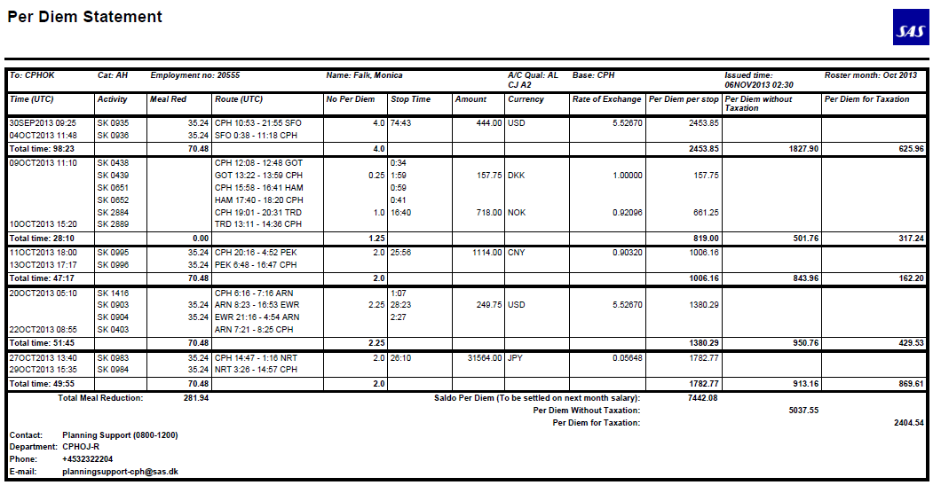

### PerDiem on Public Holidays, cabin crew only [1]

Danish, Norwegian and Swedish cabin crew receives extra PerDiem when on flight duty on a public holiday.   
According to CC agreements (4EXNG) CC are entitled to PerDiem with factor 2 on local public holidays (DK, NO, SE) as updated in CMS table “special_weekends”.

In practice, the factor 2 is calculated as an extra PerDiem indicated as PH in the PerDiem Statement. The calculation is based on the actual duty on the public holiday in homebase time (remember that normal PerDiem is calculated in 24 hour periods based on UTC).

The PH PerDiem is calculated in the same way as described in § 2.3, i.e. from 1 hour prior to STD (in base time) on the public holiday to 30 minutes after ATA on the public holiday (in base time).

The extra PerDiem on public holidays for Danish and Swedish CC is based on *local base time as* and assigned as follows*:*

0:00 - 2:59 hours: *No* extra PerDiem

3:00 - 5:59 hours: 1/4 (0.25) extra PerDiem to be assigned

6:00 - 11:59 hours: 1/2 (0.50) extra PerDiem to be assigned

12:00 - 24:00 hours: 1/1 (1.00) extra PerDiem to be assigned

The extra PerDiem on public holidays for Norwegian CC is based on *local base time as* and assigned as follows:

00:00 - 2:59hours: No extra PerDiem

3:00 - 5:59 hours: 1/4 (0.25) extra PerDiem to be assigned

6:00 - 8:59 hours: 1/2 (0.50) extra PerDiem to be assigned

09:00 - 11:59 hours: 3/4 (0.75) extra PerDiem to be assigned

12:00 - 24:00 hours: 1/1 (1.00) extra PerDiem to be assigned

The following criteria for currency apply for allocation of the extra PH PerDiem:

*Short Haul:*

###### If night stop is prior to the public holiday, the actual "stop_country" rate to be used for the extra PerDiem.

###### If no night stop, then the first "stop_country" rate according to meal allocation (X, V, VO) to be used for the extra PerDiem.

###### If current day is a public holiday and no night stop and trip is a "short trip" or no mealstop assigned to the trip, then "home_country" rate to be used for the extra PerDiem. If however there is a night stop after this trip, then "stop_country" PerDiem rate should be used for the extra PerDiem.

*Long haul:*

On longhaul stops, the extra PerDiem calculation will be based on Stop_country currency, e.g. . if stop in EWR, then rate for “stop_country” US to be used for the extra PerDiem.  
If PH is on arriving day on home base, PH PerDiem will be calculated based on home_country currency.

Examples:

If a CC is on duty from 11:00 to 00.00 base time, 13 hours, then the CC will receive 1/1 PerDiem extra.

The same applies if on duty all day, from 00:00 – 00:00 base time on a public holiday.

If on duty from 00:00 – 06:00 base time, 6 hours, on a public holiday the CC will receive ½ PerDiem extra.

Example of a PerDiem Statement including a PH PerDiem calculation for 22Jun 2013:

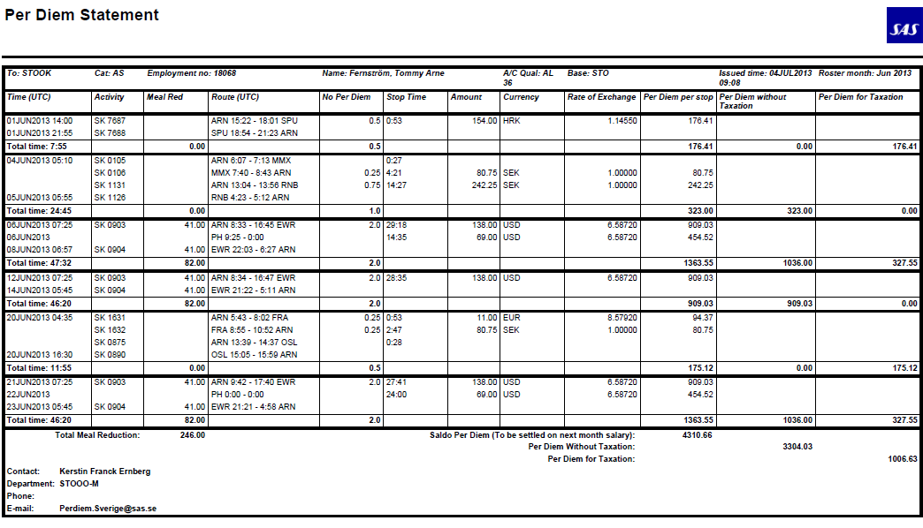

### PerDiem for extended duty, cabin crew only 1

Danish, Norwegian and Swedish cabin crew receives extra PerDiem factor 1,5 for extended duties if more than 2 extended duties in a calendar month (according to OM-A 7.1.) i.e. FDP with duty > 12 hours, passive duty after active duty is not included in extended duty calculation.

In practice an extra half EX PerDiem of the normal assigned PerDiem is allocated per extended duty in excess of 2, e.g. if 0,50 PerDiem is assigned to the duty, and extra 0,25 EX PerDiem is assigned.   
The EX PerDiem is calculated as follows:

* The stop_country rate for the first assigned mealstop (X, V, VO) on the Extended FDP should be used to determine the extra (½) PerDiem.

The extra EX PerDiem is shown separately in the PerDiem statement and in Compensation (CCT Studio) but does *not count in the total number* of PerDiem.

### PerDiem Passive + (P+) pilots

Pilots employed according to the P+ agreements will have PerDiem calculated from CI at “other base” after passive transfer from homebase to CO at “other base” before passive transfer to home base.

However, if “other base” is another base or station than the base belonging to the region the pilot is assigned to, then PerDiem is calculated from/to homebase.

Example:

If home base is CPH and P+ is assigned to SKS, the “other base” is STO and then PerDiem is calculated from CI in STO after passive transfer from CPH to CO in STO before passive transfer to CPH.

But, if the active duty starts in OSL after passive transfer from CPH, then PerDiem calculation starts at CPH or if active duty ends in e.g. GOT before passive transfer to CPH, then PerDiem calculation ends in CPH according to normal PerDiem calculation rules.

Tax deduction is however calculated from / to homebase according to local tax rules in Denmark, Norway and Sweden, - see paragraph 2.4 below.

## Tax rules

The tax reduction rules are different for each country/region.

### Tax rules Denmark

When calculating the tax deduction amount, a trip starts at ATD and ends at ATA, check-in/check-out times are not considered.

Trips shorter than 24 hours

The trip gives *no tax free* PerDiem.

Trips longer than or equal to 24 hours

The tax free per diem is calculated according to the following formula:

$$T_{t}=days×\sum_{ }^{legs}{p_{i}×T_{i}},$$

Where $T_{i}$ is the stipulated tax free per diem for the country of the leg destination, $p_{i}$ is the part of the total per diem assigned to that leg (see section ) and is the total trip length in fractional days (i.e. 2 days and 6 hours is represented as 2.25).

PerDiem is adjusted as described above, and then, for every flight/activity on the trip, the proportional part of PerDiem allocated is calculated in that flight, and then reduced with the tax deduction rate found in the per_diem_tax table.

For instance, let’s look at an example of a trip:

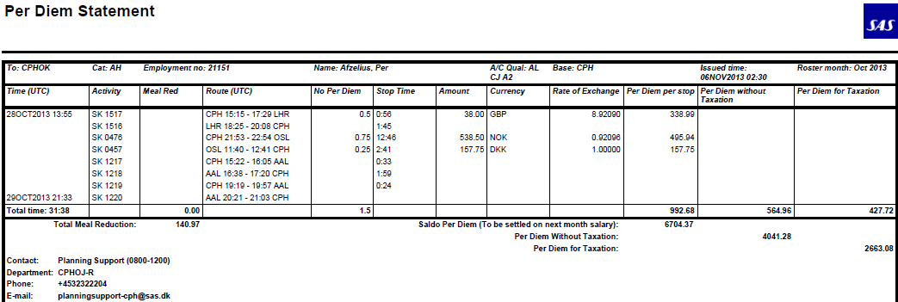

This trip has a total PerDiem of 1.5; it’s a two days trip. The PerDiem is allocated to the night stop at OSL.

The number of days is calculated as a part of the total time, so in this case, the trip time is   
ATA 21:03 – 15:15 = 29:48 hrs (= 1788 mins.) / 24:00 hrs (1440 mins.) = 1,24166 number of days.

So, the tax deduction formula in this case would be:

Part of total PerDiem * Number of days * tax reduction for that country =

1 * 1.24166 * 455 DKK = 564,96 DKK

According to Tracking Studio Compensation:

Trip 28OCT2013 13:55-29OCT2013 21:33:

Flight Compensation Tax-deduct

1517 CPH-LHR 0.50 x GBP 76.00 = 338.99 0.41 x 455.00 = 188.32

0476 CPH-OSL 0.75 x NOK 718.00 = 495.94 0.62 x 455.00 = 282.48

0457 OSL-CPH 0.25 x DKK 631.00 = 157.75 0.21 x 455.00 = 94.16

TOTAL 1.50 992.68 1.24 564.96

The partial tax deduction factor (days) in the calculation above is found by using the formula:

*factor = allocated PerDiem / actual PerDiem * number of days*

1517: 0,50 / 1,5 * 1,24 = 0,41

476: 0,75 / 1,5 * 1,24 = 0,62

457: 0,25 / 1,5 * 1,24 = 0,21

### Tax rules Norway

The trip starts at 1:00 before ETD, and ends 0:30 after the latest of STA and ATA. The length of the stop is defined as the time from ATA to ATD.

The Norwegian tax rules are easiest divided into trips longer than or shorter than 24 hours.

#### Trips longer than or equal to 24 hours

Each duty in the trip is treated separately. The PerDiem for the trip is the sum of PerDiem for each duty in the trip.

##### International duty

The total PerDiem amount is tax free.

###### Domestic duty

The amount of tax free PerDiem is the standard tax free PerDiem times the number of days, where the number of days is counted as the number of days of domestic duty where the duty extends at least 6:00.

#### Trips shorter than 24 hours

###### Trips covering >= 5 hours in the period 22:00 – 06:00 (e.g. ends after 03:00 on the next day) and has a stop of > 6 hours Trips covering all of the period 22:00 – 06:00

*Domestic trip:* One standard PerDiem tax deduct of type **A)** below if the trip is longer than 12 hours, otherwise no tax free PerDiem.

*International trip:* The whole PerDiem is tax free.

###### Trips with stop <= 5/6 hours (domestic/international trip)

*Domestic trip:* There is no stop, since a stop is never shorter than 5 hours. The trip gives no tax free PerDiem.

*International trip:* ½ of the total PerDiem is tax free.

###### Trips with stop > 5/6 hours (domestic/international trip) and < 12 hours

*Domestic trip:* If there is a stop of >= 9 hours, one standard PerDiem tax deduct of type **C)**, otherwise of type **D)**.

*International trip:* 2/3 of the total PerDiem is tax free.

###### Trips with stop > 12 hours

*Domestic trip:* One standard PerDiem tax deduct of type **B)**.

*International trip:* The total PerDiem is tax free.

#### Domestic tax deduct amounts

For domestic duties there are standard tax deduct amounts. These amounts are stored in the “PerDiem tax” table and can vary with time (see ). As a reference, the amounts are:

|  |  |  |  |  |
| --- | --- | --- | --- | --- |
| Type of Tax Deduction | Aug 2009 | 01Mar10 | 01Jan13 | 01Jan14 |
| A) Full overnight, stop code “NO” | 560 NOK | 640 NOK | 670 NOK | 690 NOK |
| B) Full day, stop code “/1” | 425 NOK | 445 NOK | 495 NOK | 510 NOK |
| C) Day, stop code “/2” | 260 NOK | 270 NOK | 300 NOK | 310 NOK |
| D) Half-day, stop code “/3” | 170 NOK | 175 NOK | 195 NOK | 200 NOK |

#### International tax deduct amounts

The ‘stop_country’ PerDiem rate for table ‘perdiem_compensation’ converted into NOK is used as international tax deduct amount.  
(Meaning, government tax free amounts for “kost*” is not used* in the CMS tax deduct calculation. The tax free amounts are found on the following link:

<http://www.regjeringen.no/nb/dep/fad/dok/lover-og-regler/retningslinjer/2009/utenlandsregulativet.html?id=438645> )

### Tax Report Norway

Immediately after the scheduled PerDiem run (batch job on the 6th in the month) a PerDiem Tax job runs (PERDIEMTAX) creating tax reports and tax files for bases OSL, SVG and TRD. You can also run this manually from the Salary GUI. The tax reports are in PDF and tax files in TXT format are stored in the SALARY_ REPORTS directory (/opt/Carmen/CARMDATA/carmdata_cms2/REPORTS/SALARY_REPORTS).

*Tax reports – IC218 – Norsk Beskatning:*

The report runs from December to October and sums up the monthly PerDiem including PerDiem for stops with overnight and number of days with overnight (salary code 610).

**Example**. Tax Report for October 2013 PerDiem Tax:

File name: PDTAX_YEARLY_IC218_NO_TRD_2013_10.pdf

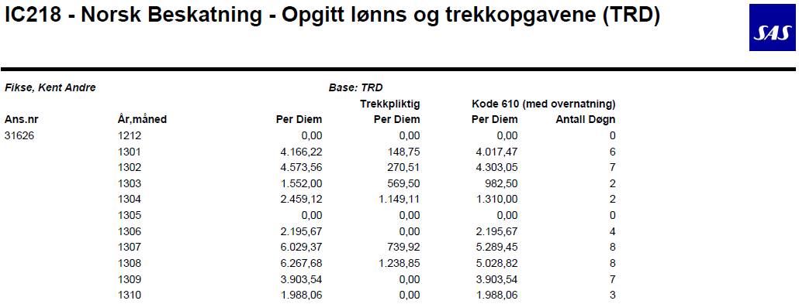

*Tax files:*

This file gives the total PerDiem amount on salary code 610 and the total number of days with overnight for the period from last December.

Same example as above – Oct13 file:

File name: PDTAX_LIST_NO_TRD_2013_10.txt:

0096151074000031626610 02901858 02901858 000047

0096151074000031786610 01916484 01916484 000033

0096151074000031791610 01633141 01633141 000027

2

4

6

5

3

1

Point 1: SAP system identifier

Point 2: Employee number

Point 3: Salary code (610)

Point 4 and 5: Total PerDiem on salary code 610 from Dec12 to Oct13 (29.018,58 NOK)

Point 6: Total number on days with overnight from Dec12 to Oct13 (47 days)

*Note.*

It is important to run PERDIEMTAX soonest possible after the PerDiem run in order to secure that you have the same data on PerDiem Statement/salary file and PerDiem tax file.

If running a manual PerDiem run for release or a retro run, it is very important to run a new PERDIEMTAX run immediately after.

E.g.

If Oct13 PerDiem has been run and you are running retro for July 2013 then you must run PERDIEMTAX for JUL – AUG – SEP and OCT 2013 (N run) as well and in that order to secure the correct PerDiem tax data in the files and on PerDiem statements/salary files.

### Tax rules Sweden

PerDiem tax for Sweden is calculated as follows:

1. *Trips with no tax deduction:*

If there is no night layover, there is no tax deduction. A night layover is defined as a stop where a minimum of 5 hours occur between 20:00 and 09:00

1. *Day in a sling with no tax deduction:*

If the sling ends between 00:00 and 04:29: The duration of a sling is calculated from ATD of the first leg to ATA on the last leg. Check-in and check-out times are not included in the tax calculation.

1. *Day in a sling with Swedish night tax deduction:*

If the sling ends between 04:30 and 06:00: The duration of a trip is calculated from ATD of the first leg to ATA on the last leg. Check-in and check-out times are not included in the tax calculation. Swedish night tax deduction is equal to half Swedish default deduction.

1. *Day in a trip with half day tax deduction:*

If the trip starts at 12:00 or later on day of departure, or return between 06:01 and 19:00 on day of arrival.

1. *Day in a trip with full day tax deduction:*

If starts before 12:00 on day of departure, ends after 19:00 on day of return, or 24 hours between day of departure and day of return

1. *Tax deduction:* Rate of the country where the longest stop takes place. The length of the stop is counted from ATA to ATD excluding time span 00:00 – 06:00. Local time at place of stop must be used. If there is no stop, homebase is used. If two stops are equal in length, either is valid. 24 hours of duty time in the middle of a trip generates a full day tax deduction.

*Allocation between salary codes on the salary file is as follows*:

391: one day sling is sling with maximum 1 night stop

396: If the sling contains only one international stopover, then the sling is international.

397: If the sling does not contain any international stopover, then the sling is domestic.

# Instructions

To be able to create the reports Carmen Studio has to be started.

A PerDiem Statement report can be generated for either trips or rosters. The report can also be created for a specific object or for all items (trips or rosters) in a window. This is just a draft report, the real one with approved salary information is the one generated in the monthly batch job, which can be showed from the Salary module, selecting a run id and clicking on button “Show Report”

1. Open a pairing, roster or tracking plan.
2. Show the trips or rosters.
3. The test menu can be open from:
   * + Assignment trip/object
     + *Crew object*
     + Top menu -> Test
4. In the test menu choose “PerDiem Statement…”
5. Select a valid start date and end date, and click on OK

## Understanding how PerDiem was calculated

In addition to the PerDiem Statement, there is another tool created to help understanding how PerDiem is calculated for a given crew member. In Tracking studio, choose Reports -> Compensation… from the Crew Object menu (right click the crew in the left margin).

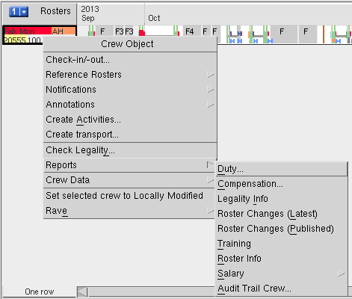

A dialog box allows you to specify which salary month that you want to review (it must be in the loaded data period).

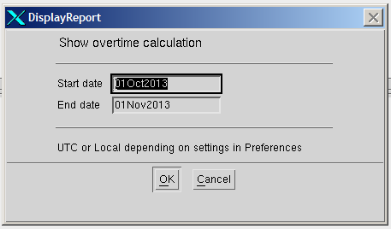

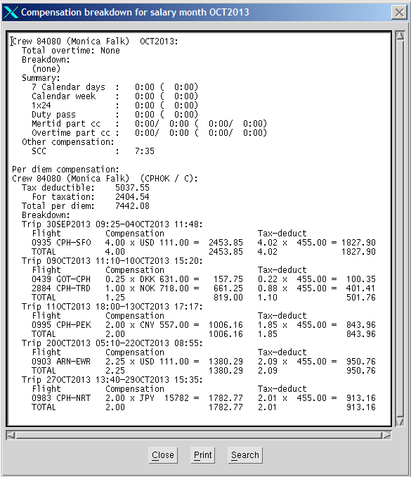The first part of the dialog box shows the calculation of overtime (see Functional Reference overtime 2.9). The lower part of the dialog box shows all trips that are entitled to PerDiem. The Compensation column shows the total entitled PerDiem. The Tax-deduct column shows the tax deductible PerDiem, with the number of days, (d) for domestic and (i) for international duty.

# Tables

The following tables are used by the PerDiem statement report and salary files to calculate the correct PerDiem amounts for the crew.

## PerDiem salary codes

The PerDiem salary codes are found in the table salary_article.

|  |  |  |
| --- | --- | --- |
| **Field** | **Data type** | **Description** |
| extsys | String | Salary system (country). |
| extartid | String | The reference currency to convert to. |
| validfrom | Date | The date from which the salary code is valid. |
| validto | Date | The date to which the salary code is valid. |
| Intartid | String | The exchange rate as an integer including the decimal part. |
| note | Text | General information of the use of the code |

PerDiem entries in the salary_article table:

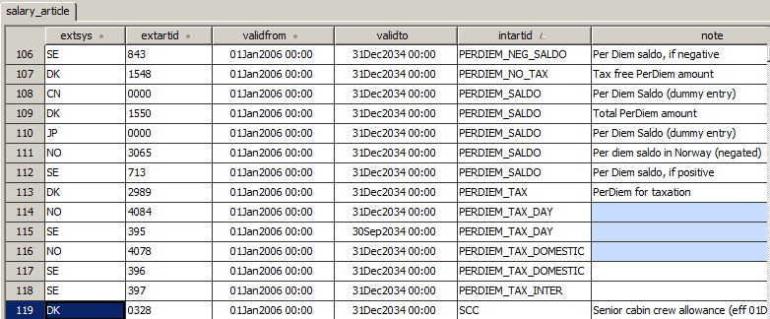

These are the Salary codes (extartid) used in PerDiem salary files:

**SKD:**

* PerDiem Total: 1550
* PerDiem without tax: 1548
* PerDiem for tax: 2989
* PerDiem Meal CC: 1540 (withdraw from salary)
* PerDiem Meal FC: 1530 (withdraw from salary)

**SKN**:

* PerDiem Total: 3065
* PerDiem tax day: 4084
* PerDiem tax domestic: 4078
* PerDiem Meal CC: 3705 (withdraw from salary)
* PerDiem Meal FC: 3700 (withdraw from salary)

**SKS:**

* PerDiem Total: 713
* PerDiem one day tax: 391
* PerDiem tax domestic: 396
* PerDiem tax international: 397
* PerDiem Meal: 841 (withdraw from salary)
* Withdraw of PerDiem: 843 (negative amount on total)

## Exchange Rate table

This table contains conversion rates between currencies. The columns include the currency to convert from and the currency to convert to, the exchange rate, the unit of the exchange rate and when the exchange rate is valid. The columns of the exchange rate table are described below.

|  |  |  |
| --- | --- | --- |
| **Field** | **Data type** | **Description** |
| cur | String | The current currency to convert from. |
| ref | String | The reference currency to convert to. |
| validfrom | Date | The date from which the exchange rate is valid. |
| validto | Date | The date to which the exchange rate is valid. |
| rate | Integer | The exchange rate as an integer including the decimal part. |
| unit | Integer | The unit of the exchange rate. The rate is divided with the unit to get the exchange rate used for the currency conversion. |

Below is an example of a row in the exchange rate table, which is used to convert from USD to SEK. To get the correct conversion, rate 64208 is divided with 10.000, which gives 6,4208 SEK.

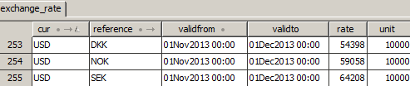

## PerDiem Compensation table

This table contains compensation amounts for flight and cabin crew from different home bases for different stops. The table also contains meal deduction amounts. It is also possible to have a default value if the stop country requested does not exist in the table. The amounts in the table include two decimals; for instance, 5410 means 54,10. Below are the columns described. Please note that capital letters has to be used in the tables, otherwise it won’t work!

|  |  |  |
| --- | --- | --- |
| **Field** | **Data type** | **Description** |
| stop_country | String | The country where the stop is. (Country code or “MEAL” for meal reduction or * for default country.) |
| home_country | String | The home country of the crew member. |
| category | String | Indicates if the crew member is flight or cabin crew (‘F’ or ‘C’). |
| currency | String | The currency of the compensation used at the stop. |
| compensation | Integer | The compensation amount for one PerDiem. |
| valid_from | Date | The start of the time period for which the PerDiem compensation is valid. |
| valid_to | Date | The end of the time period for which the PerDiem compensation is valid. |

The example below shows how much a Danish cabin crew member will get if he/she has a stop in Great Britain between the 20th of November 2012 and 31st of December 2013 (76 GBP).

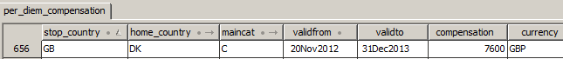

*Meal deduction*

On all longhaul flights and flights with a block time exceeding 5 hours, e.g. charter flights, an amount will be deducted each crew member’s salary for each leg. The amount is determined each year in January.

The meal deduction amount is located in a special way, where the stop country column is called “MEAL”.

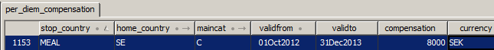

The meal deduction amount can be differentiated from country to country and crew category. If amount is stated in another currency than home country currency, the amount will be converted to home country currency in the PerDiem Statement usinge actual exchange rate.

E.g. if Meal deduction is 41 SEK for Norwegian flight crew, this amount will be converted to NOK using actual exchange rate for the PerDiem month.



## PerDiem Tax table

This table contains tax deduction amounts. Tax amounts are given for Danish, Norwegian and Swedish crew as an amount for a country or with a wildcard (*) as default amount. Start and end of the period for which the amount is valid are also included. The amounts in the table include two decimals; for instance, 5456 means 54.56. The columns are described below.

|  |  |  |
| --- | --- | --- |
| **Field** | **Data type** | **Description** |
| stop_country | String | The country where the tax deduct rate is valid. (Country code or ‘*’ as the default.) |
| home_country | String | The home country of the crew member. |
| Rate | Integer | The tax deduct amount PerDiem. |
| valid_from | Date | The start of the time period for which the PerDiem tax deduction rate is valid. |
| valid_to | Date | The end of the time period for which the PerDiem tax deduction rate is valid. |

The example below shows the tax deduction rate for Danish crew for any stop country, which is not explicitly defined on another row, between the 1st of January 2009 and 31st December 2013 (455 DKK).

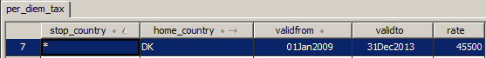

## Special Weekends table

Scandinavian public holidays as inserted in the special weekends table are used of calculation of PH (public holiday) PerDiem Calculation.

Below is an example of Norwegian public holidays in 2013.

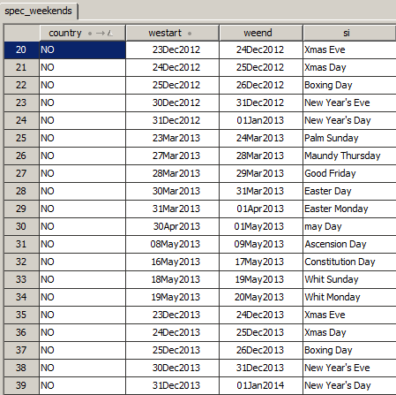

**Note** that the day before the public holiday has to be inserted as “westart” and the public holiday date as “weend”, thus New Years Day 2014 is *31Dec2013* as “westart” date and *01Jan2014* as “weend” date.

End

1. Except Chinese and Japanese cabin crew