**The SAS CMS project**

**Functional reference manual**

**Manpower PreStudio**

*Document type: Description*

*Document status: Final Fat*

*Version: 1.7*

*Last changed: Dec 01 2010*

*Owner: Ann Lindberg, Jeppesen*

Table of Contents

1 Introduction 3

1.1 This Document 3

1.2 Change History 3

2 Main Functionality 4

2.1 The Main Menu 5

2.1.1 File............. 5

2.1.2 Edit ................................................................................................................5

2.1.3 Options 5

2.1.4 Window 6

2.1.5 Jobs 6

3 The Roster Window 7

3.1 The Window Menu 7

3.2 The Crew Object Menu 7

3.3 The Assignment General Menu 8

3.4 The Assignment Object Menu 8

4 Crew Activities 9

4.1 Creating Crew Activities 9

4.1.1 Crew Object Menu 9

4.1.2 Assignment General Menu 11

4.2 Removing Crew Activities 13

4.2.1 Assignment Object Menu 13

4.2.2 Assignment General Menu 13

4.2.3 Tool Bar 13

4.3 Finding overlapping activities 14

5 Publish in PreStudio 15

5.1 Publish activities for one crew 15

5.2 Publish of marked activities 16

# Introduction

## This Document

This document contains a brief description of the PreStudio application. Some common functionality is described in Help.

## Change History

Change history

|  |  |  |
| --- | --- | --- |
| Version | Author | Description |
| 0.1 | Lena Björling | Initial version |
| 1.0 | Andreas Wohrm | Updated title and reference to studio functionality |
| 1.1 | Lena Björling | Minor changes |
| 1.2 | Ann Lindberg | Added chapter Publish in Prestudio |
| 1.3 | Grönberg Per | Open plan in prestudio |
| 1.4 | Ann Lindberg | Added Finding Overlapping Activities |
| 1.5 | Ann Lindberg | Clarified Create Activity when overlapping |
| 1.6 | Ann Lindberg | Updated screenshots, added Mark for Publish |
| 1.7 | Ann Lindberg | Added technical summary |

# Main Functionality

When PreStudio is started a dialog is displayed, in which it is possible to select which period that should be opened. It is also possible to select planning area.

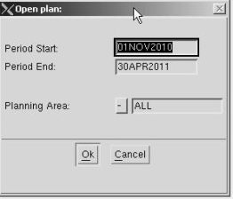

The form will not allow more than three months of historic data to be opened or a maximun of 12 months future data. If opening both historic and future (i.e. around current now-time), then the full previous month and 12 months into the future is allowed.

If period is too long, the form will display a warning and user cannot press OK-button.

When PreStudio is started one Roster window with crew is displayed.

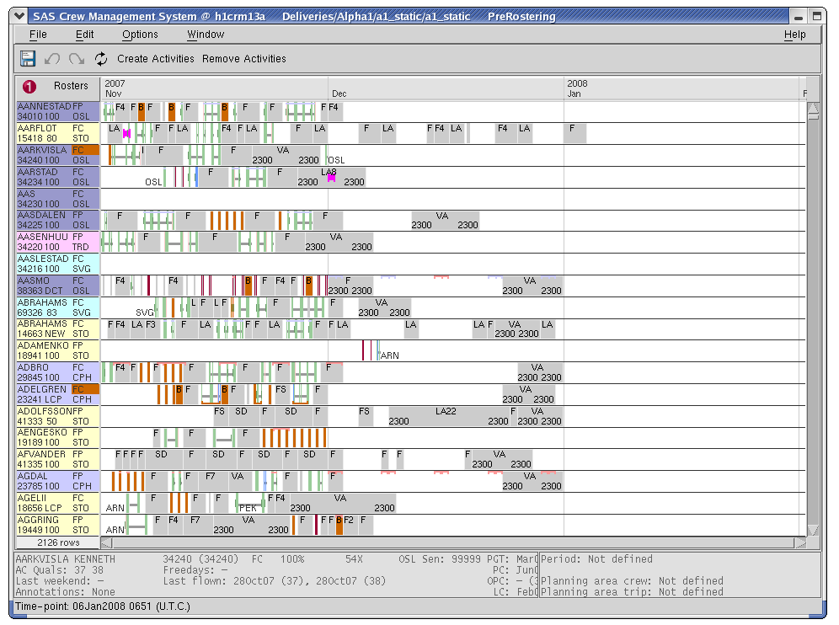

## The Main Menu

The following commands are available in the main menu:

### File

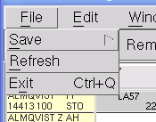

Save – Saves the changes to the database. 

Refresh – Refreshes data from the database.

Exit – Exits PreStudio.

### Edit

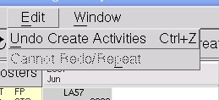

Undo – Undo of latest command.

Redo/Repeat – Redo/Repeat of latest command.

### Options



Preferences – Configuration of different preferences settings.

### Window

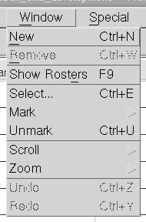

New – Creates a new roster window.

Remove – Removes a roster window.

Show … – Shows the selected items in the window.

Select – Performs a select on the items.

Mark – Marks selected items.

Unmark – Unmarks marked items.

Scroll – Scrolls the window.

Zoom – Zooms the window.

Undo – Undo of latest command.

Redo/Repeat – Redo/Repeat of latest command.

### Jobs

This menu is the same as in planning, but has no relevance for PreStudio.

# The Roster Window

In the roster window the crew rosters are displayed as a Gantt view.

## The Window Menu

In the roster window the following menu is displayed when left clicking on the window number.

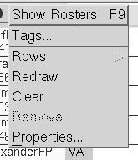

Show Rosters – Displays the crew rosters.

Tags – Handles user tags.

Rows – Configures row settings.

Redraw – Redraws the window.

Clear – Removes the crew rosters.

Remove – Removes the window.

Properties – Possibility to define properties of roster window such as number of rows displayed.

## The Crew Object Menu

In the roster window the following menu is displayed when left clicking on a crew row.

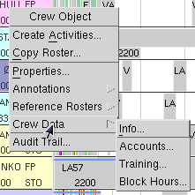

Create Activities – Creates activities for the crew.

Copy Roster – Copies the crew roster.

Properties – Displays crew properties.

Annotations – Handles annotations.

Reference Rosters – see description in chapter Publish in Prestudio.

Crew Data – Opens Crew Info, Crew Accounts, Crew Training or Crew Block Hours.

Audit Trail – Shows historical information.

## The Assignment General Menu

In the roster window the following menu is displayed when right or middle clicking in the Gantt view.

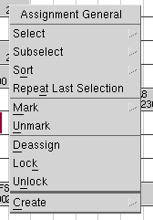

Using commands in this menu it is possible to select, subselect and sort crew, mark, unmark and create activities and to deassign, lock and unlock marked activities.

## The Assignment Object Menu

In the roster window the following menu is displayed when left clicking on an activity in the Gantt view.

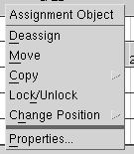

Deassign – Deassigns the activity.

Move – Moves the activity.

Copy – Copies the activity.

Lock/Unlock – Locks/unlocks the activity.

Change Position – Changes the assigned position.

Properties – Displays activity properties.

# Crew Activities

## Creating Crew Activities

Creating a crew/personal activity can be done in two different ways. The command “Create Activity” can be called from both “Crew Object” and “Assignment General” menus. The two different ways are slightly different and both are described below.

### Crew Object Menu

This way is very useful when assigning a pre-activity that spans over more than one day, e.g. long term illness.

If you create a new activity where there already is one, the old will be split and the new will be squeezed in.

Select “Create activities” in the “Crew Object” menu for a crew. The following dialog is displayed:

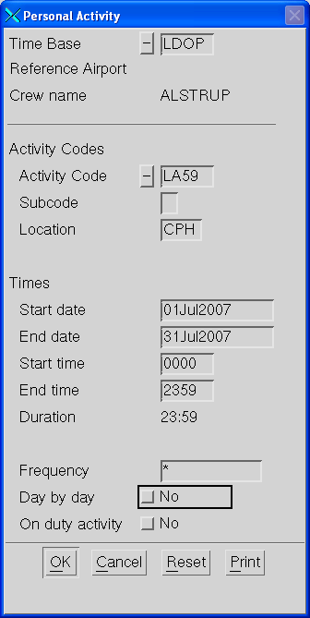

|  |  |
| --- | --- |
| Time Base | UDOP(UTC) or LDOP(Station local time) |
| Activity  Code | This will be filled in using a drop down menu. The drop down menu in pairing and rostering will contain all activity codes available in the system, but the list in the pre role in Studio could be limited to the activities that could be pre-assigned. It is also possible to manually type the activity code. |
| Subcode | N/A. |
| Location | Station of the activity. |
| Start date | The date when the activity should start. |
| End date | The date when the activity should end. |
| Start time | The time when the activity should start (on the first day “Day by day” is set to “no”, see below in this table). |
| End time | The time when the activity should end (on the last day “Day by day” is set to “no”, see below in this table). |
| Duration | Displays the total duration of the activity (hh:mm). |
| Frequency | Certain patterns can be created. E.g. DX67 (daily except Saturday and Sunday). |
| Day by day | If this tick box is set to “yes”, the activity is not kept together as one object, while “no” would make one long object. |
| On duty activity | N/A. |

Enter the values and select “OK”. The activity is created and displayed in the Gantt view.

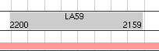

When moving the mouse over the activity, information is displayed in the info window at the bottom.

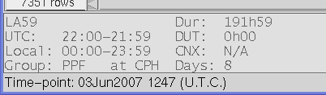

### Assignment General Menu

When assigning the same type of activity on a number of days and/or crew, this is very useful. Simply fill in the dialogue and use the mouse to click on all the days on all the crew where the activity should be assigned.

If you create a new activity from the General Menu where there already is one you will get a warning on overlapping activities. If you still want to create the new activity, the old one will be removed.

If you create a new activity from “Create Activities” in the toolbar where there already is one, the old will be split and the new will be squeezed in.

Select “Create - Activities” in the “Assignment General” menu or select “Create Activities” in the tool bar. The following dialog is displayed:

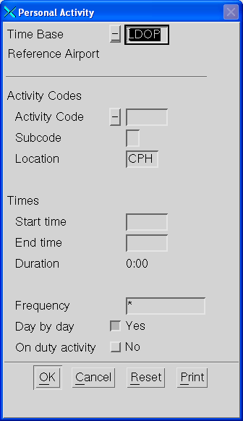

|  |  |
| --- | --- |
| Time Base | UDOP(UTC) or LDOP(Station local time) |
| Activity Code | This will be filled in using a drop down menu. The drop down menu in pairing and rostering will contain all activity codes available in the system, but the list in the pre role in Studio could be limited to the activities that could be pre-assigned. It is also possible to manually type the activity code. |
| Subcode | N/A. |
| Location | Station of the activity. |
| Start time | The time when the activity should start. |
| End time | The time when the activity should end. |
| Duration | Displays the total duration of the activity (hh:mm). |
| Frequency | N/A. |
| Day by day | N/A. |
| On duty activity | N/A. |

Enter the values and select “OK”. Left click in the Gantt view to create activities. Right click in the Gantt view to stop creating activities.

## Removing Crew Activities

Removing a crew/personal activity can be done in three different ways.

### Assignment Object Menu

Remove a specific activity by selecting “Deassign” from the “Assignment Object” menu.

### Assignment General Menu

Remove several activities by first selecting “Mark” from the “Assignment General” menu and after marking the activities, selecting “Deassign” from the “Assignment General” menu. This will remove all marked assignments.

### Tool Bar

Activities can also be removed by selecting “Remove Activities” in the tool bar. Left click at two positions on one crew row and all activities between the points will be removed. Right click to stop removing activities.

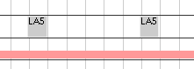

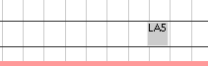

If the two clicks are on a long activity, the activity is split into two activities, i.e. the section of the activity between the two clicks is removed.

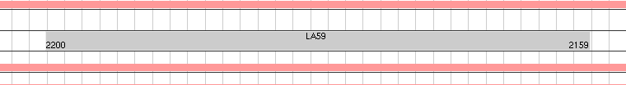



## Finding overlapping activities

In Manpower it is possible ta have overlapping assignments, but before handing over data to Rostering or to Crew Portal the overlaps have to be resolved. In Pre there is a command to find all overlaps :

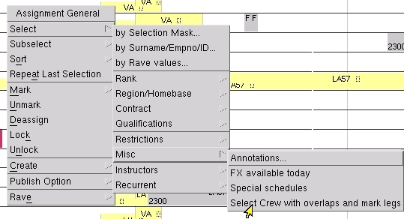

# Publish in PreStudio

## Publish activities for one crew

Two new buttons were added to the tool bar:

Clipboard03

* Use the button with the blue arrow pointing upwards to mark periods for publication.
* The button with the red arrow pointing downwards removes markings for publication.

The time periods that are marked for publishing will be published at next save.

The menu *Show Published* in the *Crew Object* can be used to compare current roster data with the published roster data.

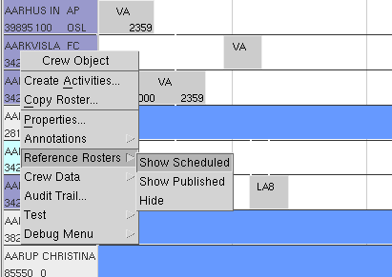

This screenshot shows parts of a roster that was never published (*Published Roster* is empty).

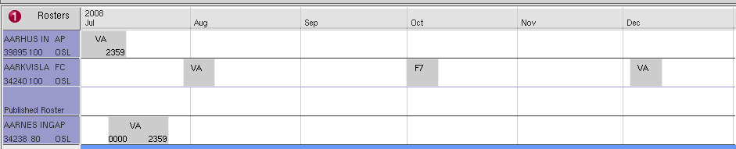

To publish the period between 15th of July and 24th of August, press the *Publish* button and mark the time period.

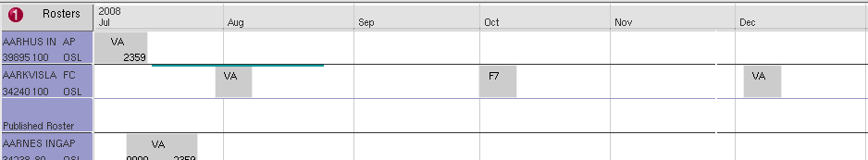

Periods marked for publication are shown with a thick green line.

Now press the *Save* button to commit the changes.

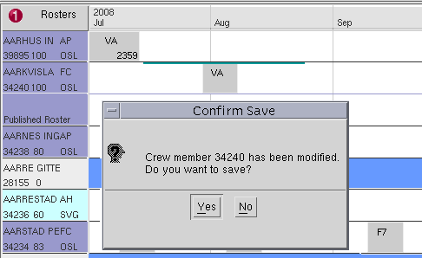

A dialog will appear, press *Yes* to accept.

The period marked for publication will now appear with a blue line and the *Published Roster* view will show activities that have been published.

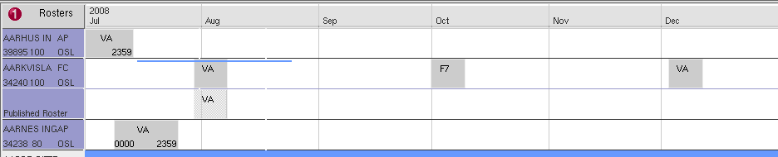

Note that the activities in October and December were not published, since they were never marked!

There is no way to “unpublish” an already published period, but the period can of course be published again.

## Publish of marked activities

The mark functionality available in the Assignment General menu can be used as a base for publishing a wide range of activities. When marked you can use the Publish Option, also in the Assignment General Menu to mark for publish what is already marked. The actual publish will be activated at Save.

# Technical summary

Python code is found under CARMUSR/lib/python/carmusr/preplanning

## Rave

A subset of the Rostering ruleset is defined as CARMUSR/crc/source/PreRostering

## Database Tables

## Scripts

## Forms

## Configuration