Carmen CMS Add-in

Soft Locks

Version 13


© 1994-2007 Jeppesen Systems AB. All rights reserved.
Jeppesen Systems AB retains all ownership rights to the information in this document. It is not allowed to disclose any information in this manual to a third party without the written permission of Jeppesen Systems AB.
Carmen Rave®, optimization matters® and resources in balance® are registered trademarks of Jeppesen Systems AB. Jeppesen Systems are trademarks of Jeppesen Systems AB.
All other product or company names mentioned may be registered trademarks or trademarks of their respective owner.
Göteborg February 2007

Table of contents
About this Manual 1
Overview 1
Introduction 1
Installation Guide 3
Functionality 5
Overview 5
Rules and Parameters 6
Visualisation 7
Reports 7
Soft Lock Types 8
Commands 14
Soft Lock GUI 15
Impact on planning process 19
Files 19

About this Manual

Overview
This document contains the following sections:
- Overview
- Introduction
- Installation Guide
- Functionality

Introduction

Package Name
Full name: Soft Locks
Short name: SL
Common file name: soft_locks

Product
This is an AiP for Carmen Crew Pairing.

Benefits
The Soft Locks functionality is used to manually predefine some characteristics of created trips within a solution. Some examples include two legs which should always follow one another, a layover must follow immediately after a certain leg, a leg must be flown by a specific base etc.
It helps in the creation of manual trips throughout the planning period. Instead of manually build the trips together and locking them with hard-locks within studio, the planner instead enters the wanted characteristics within the Soft Locks GUI and within the created solution these characteristics will be fulfilled.
Use case examples:
- Some specific trip characteristics that always should be followed from planning period to planning period.
- Adding min connection time buffers after special flights that are usually delayed in real life.
- Some specific flights that must be flown by a specific base because of qualifications that only exist at that base

Package Type
The package files are ready to be installed and used.

Installation Guide

How do I get it?
New projects have the possibility to use the Wizard to include the AiP code. For old implementations the Wizard can supply all files. They need to be manually integrated into the existing code.
The package is easy to install and easy to extend. To have full use you need basic admin, basic Rave and basic CRG knowledge.

Files / Interfaces
crc / source / SOFT_LOCKS_source
Rave code to be copied into the current source file
menu_scripts / Pac / SOFT_LOCKS_menu
Menu entries to be copied into the current StandardExtension
crc / modules / soft_locks
Rave definitions, table lookups, rule and penalty definitions
crc / modules / studio_soft_locks
Rave definitions for Soft Lock report and rudob definitions
crc / etable / ccp / SL.etab
Soft Lock table
menu_scripts / Pac/ SoftLocks.menu
Definitions for the Studio menus
lib / python / carmusr / SoftLocksBasic.py
Basic python definitions for Soft Lock functionality
lib / python / carmusr / SoftLocksGUI.py
Basic python definitions for Soft Lock GUI
lib / python / carmusr / SoftLocksStartGUI.py
Script for starting up Soft Lock GUI
lib / python / carmusr / SoftLocksValidateEtab.py
Basic python definitions for validate Soft Lock table script
crg / hidden / SoftLocksValidation.output
Report definitions for Soft Lock validation
crg / include / SoftLockDetails.inc
Report definitions for SoftLocksDetails report
crg / crr_window_object / SoftLockDetails
Report include for SoftLockDetails report
crg / crr_window_object / SoftLockDetails.output
Report include for SoftLockDetails report in text format

Installation
This information is intended for developers.
The followings steps are needed in order to fully install the base constraints package.
- Within the interface section in the soft_locks rave module, a number of needed rave expressions from other sections of the rave code are stated, these might need to be changed so they map towards the correct expression
- Add the soft_locks.%trip_penalty% rave variable to your cost function.
- Add the Soft Lock parameters, rules, penalties etc. to the groupdefs file in order to make them appear within the Rule Parameter form in a good way.
- Add the studio_soft_locks.%leg_color_bottom_middle% rave variable to the map variable that is used for showing the bottom middle leg colour within the leg and trip windows.
%map_leg_color_bottom_middle_crr% = “studio_soft_locks.%leg_color_bottom_middle”;
%map_leg_color_bottom_middle_leg% =
“studio_soft_locks.%leg_color_bottom_middle”;
- Add the soft_locks.%cxn_buffer_before% and soft_locks.%cxn_buffer_after% rave variables to the minimum connection time rule(s) that exist in the following way:
leg.%connection_time% >=
%EXP_min_leg_connection_time%
+ soft_locks.%cxn_buffer_after%
+ next(leg(duty),
Soft_locks.%cxn_buffer_before%);

Conflicts / Dependencies
The carmstd python package is required in order to run the python scripts

Functionality

Overview
If some requirements exist on how legs should be connected within a trip, these can be expressed with the Soft Locks functionality. Via the SoftLock GUI some different types of leg requirements can be entered and when the solution is created a rule (or penalty) will make sure that these requirements are fulfilled.
A Soft Lock is always based on one leg (except for the rest time soft lock, which is based on a duty). It expresses constraints for that leg and/or for the connection after/before the leg. A leg is defined by carrier code together with flight number and/or departure-arrival station. Additionally it’s possible to specify if the leg is active or deadhead, as well as the day/date of operation by means of traffic day and validity period.
When adding a soft lock, the possibility will exist to either add it as a rule or as a penalty and then either as one of 10 predefined penalty levels or as changeable value.
The requirements that can be expressed are the following:
- enforce/avoid a base covering a leg
- additional connection buffers before or after a leg
- specific connection time must be within an interval before or after the leg
- rest time must be within an interval before or after the duty
- enforce/avoid a connection to a particular leg, i.e. ”lock” or “prohibit” a leg-pair
- enforce/avoid a leg starting or ending a duty or a trip.
In addition, the following qualifiers can be used:
- the requirement applies only where an aircraft change takes place
- the requirement applies only if the leg is flown with a particular aircraft type
- the requirement applies only on specific traffic days
- the requirement applies only during the specified validity period
- the requirement applies only when the trip is flown from a specific base

Rules and Parameters
For Soft Locks there is a set of penalties and parameters defined.

General Parameters
Para ETAB: External table with soft locks
Name (and path) of the soft locks external table. If the soft lock table should be placed within a sub-directory, this can be specified within the parameter as well, for example “ccp/SL.etab”.
Para Use Soft Lock rules (turn off if not used)
Will turn off the rule part of the soft locks functionality, i.e. if adding a soft lock as a rule that soft lock will then not be applied
Para Use Soft Lock connection buffer (turn off if not used)
Will turn off the minimum connection time buffer option within the soft lock functionality
Rule Soft Lock master rule (use report for details)
The general soft lock rule that is used. Use the SoftLockDetails report in order to see detailed information on the reason for the illegality.

Cost Elements
There is a soft cost element that penalizes cases where a soft lock has been added as a penalty and the added soft lock is broken within the solution.
Para (C&P) Use Soft Lock penalties within cost function
Boolean for enable the cost function
Para (C&P) Standard Soft Lock cost 1…10
When adding a soft lock with 1 through 10 as the predefined value, this is where the mapping between value 1 and the actual penalty amount for that value

Visualisation Parameters
There are a number of parameters that define how granted/violated soft locks will be visualised. -1 as colour indicates that no colour should be used.
Para- (Soft Locks) Studio: Show markers for achieved and failed Soft Locks
Parameter that states if marked should be used to indicate achieved and failed soft locks
Para- (Soft Locks) Studio: leg colour for penalized legs
Colour of the bottom middle leg marker that will appear on a leg that is penalized
Para- (Soft Locks) Studio: leg colour for broken Soft Lock rule
Colour of the bottom middle leg marker that will appear on a leg that is failed via the soft lock rule
Para- (Soft Locks) Studio: leg colour for achieved Soft Lock
Colour of the bottom middle leg marker that will appear on a leg that has granted the soft lock

Visualisation
A leg that is entered within the soft lock functionality will be coloured differently at the bottom middle section of the leg, dependent on if it have achieved or failed the added soft lock.
The different meanings of the colours are given by the different leg marker parameters under Visualisation Parameters above.

Reports
The Soft Lock Details report shows detailed information per leg that soft locks are applied on. The information includes type of soft lock, if it’s been applied as rule or penalty and if it’s been achieved or broken.
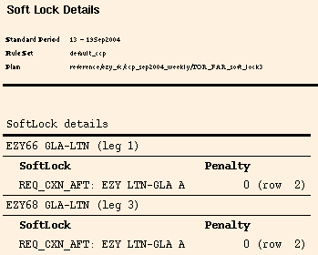

Soft Lock Types
The following soft lock types exist and can be used within the Soft Lock GUI when adding a new soft lock.
Types | Description
REQ_BASE | Impose a leg being flown by the crew from a certain base
NOT_BASE | Prohibit a leg being flown by the crew from a certain base
REQ_TRIPSTART | Impose a leg starting a trip.
REQ_TRIPEND | Impose a leg ending a trip.
NOT_TRIPSTART | Prohibit a leg starting a trip.
NOT_TRIPEND | Prohibit a leg ending a trip.
REQ_DUTYSTART | Impose a leg starting a duty.
REQ_DUTYEND | Impose a leg ending a duty.
NOT_DUTYSTART | Prohibit a leg starting a duty.
NOT_DUTYEND | Prohibit a leg ending a duty.
REQ_CXN_AFT | Impose (lock) a connection after a leg or between two legs, with or without a layover (or undefined or of XX:XX-YY:YY length) in between
NOT_CXN_AFT | Prohibit a connection after a leg or between two legs, with or without a layover (of undefined or of XX:XX-YY:YY length) in between.
REQ_CXN_BEF | Impose (lock) a connection before a leg or between two legs, with or without a layover (of undefined or of XX:XX-YY:YY length) in between.
NOT_CXN_BEF | Prohibit a connection before a leg or between two legs, with or without a layover (of undefined or of XX:XX-YY:YY length) in between.
REQ_REST_AFT | Impose at least XX:XX-YY:YY rest period after a duty.
REQ_REST_BEF | Impose at least XX:XX-YY:YY rest period before a duty.
CXN_BUFFER | XX:XX additional connection time before a leg and  YY:YY after. It is possible to specify that the buffer only should be used when connecting to a certain leg. Use the Rave variables %sl_cxn_buffer_after% and %sl_cxn_buffer_before% to access this Reltime buffer.

External Table Format
Name | Type | Example
Type | Enumeration | “REQ_BASE”
Carrier1 | String | ”DL”
FlightNr1 | Integer | 124
DepArr1 | String | “ATL-BRU”
ActiveOrDH1 | String | “A”
TrafficDay | String | “”
DateFrom | Abstime | 01jan1986
DateTo | Abstime | 28Dec2029
Carrier2 | String | “”
FlightNr2 | Integer | 0
DepArr2 | String | “”
ActiveOrDH2 | String | “”
LimitMin | Reltime | 0:00
LimitMax | Reltime | 0:00
Base | String | “ATL”
ACType | String | “”
ACChange | Boolean | False
Penalty | Integer | 0
Active | Boolean | True
Comment | String | “”

Type
[String] Case sensitive
Type string in a predefined set; see the existing Soft Lock Types above.
Carrier1
[String] Case sensitive
Carrier code for leg 1. Mandatory for all Soft Lock types.
FlightNr1
[Int] Unset value: 0
The flight number for leg 1. May be empty if the column DepArr1 is used instead
DepArr1
[String] Unset value: “” Case sensitive
The departure and arrival airport of leg 1 on the format DEP-ARR (in uppercase).
May be used instead of (or together with) column FlightNr1.
ActiveOrDH1
[String] Unset value: “”
Limits the Soft Lock to be used only for Active or DH as leg 1. Valid strings are "A" (active), "D" (deadhead) or "*" (any). "A" is the default value, which means that the Soft Lock only applies to an active leg.
TrafficDay
[String] Unset value: “”
D = Daily
X = Excluding
1-7 = Traffic day on which leg 1 departs (in local time).
Example strings:
“D” (daily)
“67” (weekend legs)
“DX67” (Mon-Fri)
“x1” (Tue-Sun)
DateFrom
[Abstime]
Start date for the soft lock interval. Date on which leg 1 departs (in local time).
DateTo
[Abstime]
End date for the soft lock interval. Date on which leg 1 departs (in local time).
ACType
[String] Unset value: “”
Aircraft type for which the soft lock apply. When set to “” the Soft Lock applies to all AC types.
Carrier2
[String] Unset value: “” Case sensitive
Carrier code for leg 2. Mandatory if the column FlightNr2 or DepArr2 is used.
FlightNr2
[Int] Unset value: 0
This flight number for leg 2, is used for soft lock types REQ_CXN_... and NOT_CXN_... (for the ..._BEF types, leg 2 is before leg 1, otherwise after)
DepArr2
[String] Unset value: “” Case sensitive
The departure and arrival airport of leg 2 on the format DEP-ARR. May be used instead of (or together with) column FlightNr2. (for the ..._BEF types, leg 2 is before leg 1, otherwise after)
ActiveOrDH2
[String]
Limits the Soft Lock to be used only for Active or DH legs 2. Valid strings are "A" (active), "D" (deadhead) or "*" (any). "A" is the default value, which means that the Soft Lock only applies to an active leg.
LimitMin
[Reltime] Unset value: 0:00
Reltime minimum time limit used for the appropriate soft lock types. Denoted as ‘XX:XX’. 0:00 means that the column LimitMin will not be used.
LimitMax
[Reltime] Unset value: 0:00
Reltime maximum time limit used for the appropriate soft lock types. Denoted as ‘YY:YY’. 0:00 means that the column LimitMax will not be used.
Base
[String] Unset value: “” Case sensitive
Base is the restriction for Soft Lock types REQ_BASE and NOT_BASE. Is also used as constraint for the other types, i.e. the soft lock is only active when the trip is flown from a specific base.
ACChange
[Bool] Unset value: false
If true, the Soft Lock is only applied if there is an AC change.
Penalty
[Int]
>10 = Penalty to use
1-10 = Standard penalty from parameter set is used (1=lowest, 10=highest)
0 = the soft lock is to be regarded as a rule.
Active
[Bool]
true = Use this soft lock
false = Do not use this soft lock
Comment
[String]
All comments go here (ignored by the Soft Lock package).

Mandatory and optional columns
All Soft Lock types require different columns to be used, both as mandatory columns but also as optional columns. Mandatory means that the stated data must have been entered; while optional means that it’s up to the planner and the current case to decide if the stated data needs to be entered.
M | Mandatory
O | Optional
OX | At least one of the columns with the same X must have a value.
Empty cell | The column isn’t used for this soft lock type

Soft Lock Type | REQ_BASE | NOT_BASE | REQ_  TRIP  START | REQ_TRIP  END | NOT_  TRIP  START | NOT_TRIP  END | REQ_  DUTY  START
Carrier 1 | M | M | M | M | M | M | M
Flight num 1 | O1 | O1 | O1 | O1 | O1 | O1 | O1
Dep Arr 1 | O1 | O1 | O1 | O1 | O1 | O1 | O1
Active or DH 1 | O | O | O | O | O | O | O
Traffic Day | O | O | O | O | O | O | O
Date From | M | M | M | M | M | M | M
Date To | M | M | M | M | M | M | M
AC Type | O | O | O | O | O | O | O
Carrier 2
Flight Num 2
Dep Arr 2
Active or DH 2
Limit Min
Limit Max
Base | M | M | O | O | O | O | O
AC Change
Penalty | M | M | M | M | M | M | M
Active | M | M | M | M | M | M | M
Comment | O | O | O | O | O | O | O

Soft Lock Type | NOT_DUTYEND | REQ_CXN_AFT | NOT_CXN_AFT | REQ_CXN_BEF | NOT_CXN_BEF | REQ_REST_AFT | REQ_REST_AFT | CXN_  BUFFER
Carrier 1 | M | M | M | M | M | M | M | M
Flight num 1 | O1 | O1 | O1 | O1 | O1 | O1 | O1 | O1
Dep Arr 1 | O1 | O1 | O1 | O1 | O1 | O1 | O1 | O1
Active or DH 1 | O | O | O | O | O | O | O | O
Traffic Day | O | O | O | O | O | O | O | O
Date From | M | M | M | M | M | M | M | M
Date To | M | M | M | M | M | M | M | M
AC Type | O | O | O | O | O | O | O | O
Carrier 2 |  | M | M | M | M
Flight Num 2 |  | O2 | O2 | O2 | O2
Dep Arr 2 |  | O2 | O2 | O2 | O2
Active or DH 2 |  | O | O | O | O
Limit Min |  | O | O | O | O | O | O | O
Limit Max |  | O | O | O | O | O | O | O
Base | O | O | O | O | O | O | O | O
AC Change |  | O | O | O | O
Penalty | M | M | M | M | M | M | M | M
Active | M | M | M | M | M | M | M | M
Comment | O | O | O | O | O | O | O | O

Commands
The following commands exist for the Soft Lock functionality

Validate Soft Lock table
Within the Trip window, Trip General menu, the Validate Soft Lock table command, will create a simple report that states any problems that might exist within the actual soft lock table. These problems that are stated can be one of the following, dependent on which soft lock type that is used:
Soft Lock Type | Validation
- | The Soft Lock type must be one of the valid Soft Lock types above
All Soft Lock types  REQ_CXN_AFT  NOT_CXN_AFT  REQ_CXN_BEF  NOT_CXN_BEF | - The column Carrier1 must hold a 2- to 3-letter string.  - At least one of the columns FlightNr1 and DepArr1 must be given.  - The column ActiveOrDH1 must be set to one of “A”, “D” or “*”.  - If the column ActiveOrDH1 is “A” or even “*” the leg key for leg 1 should occur in the plan. The full leg key in this case is:  - Carrier1  - FlightNr1 and / or DepArr1  - ACType  - TrafficDay  - Local departure within DateFrom – DateTo  If the leg key doesn’t occur this might be an exception for the specific planning period, but a warning is issued anyway.  - The date interval of the plan must overlap the interval DateFrom – DateTo.  - If the column ACType is set it must occur in the plan.  - All the columns Type, Carrier1, DepArr1, Carrier2, DepArr2 and Base must be in upper-case when given. This is done automatically when using the SoftLock GUI.  - If the column Base is set and the Soft Lock type isn’t “NOT_BASE”, that base must occur in the plan.  - The column ActiveOrDH2 must be set to one of “A”, “D” or “*”.  - If at least one of FlightNr2 and DepArr2 is given the following must be fulfilled:  - The column Carrier2 must hold a 2- to 3-letter string.  - If ActiveOrDH2 is “A” or even “*” the leg key for leg 2 should normally occur in the plan. The full leg key in this case is:  - Carrier2  - FlightNr2 and / or DepArr2  If the leg key doesn’t occur this might be an exception for the specific planning period, but a warning is issued anyway.  - At least one of the columns FlightNr2 and DepArr2 should be set.

Select -> Soft Lock legs (and mark)
Within the Trip window, Trip General menu, sub-menu Select, the Soft Lock legs (and mark) command, will select all legs that have been added to the soft lock table as well as mark them.

Soft Lock GUI
Within the Trip window, Trip General menu, the Soft Lock GUI command will start up the Soft Lock GUI which can be used to enter soft locks to the soft lock table.

Overview — Main Window
The main window is started from the general menu in a trip window. The currently used soft locks etable is loaded by default. The window is divided into three areas:
- SL etab
- Soft Locks
- Soft Lock groups
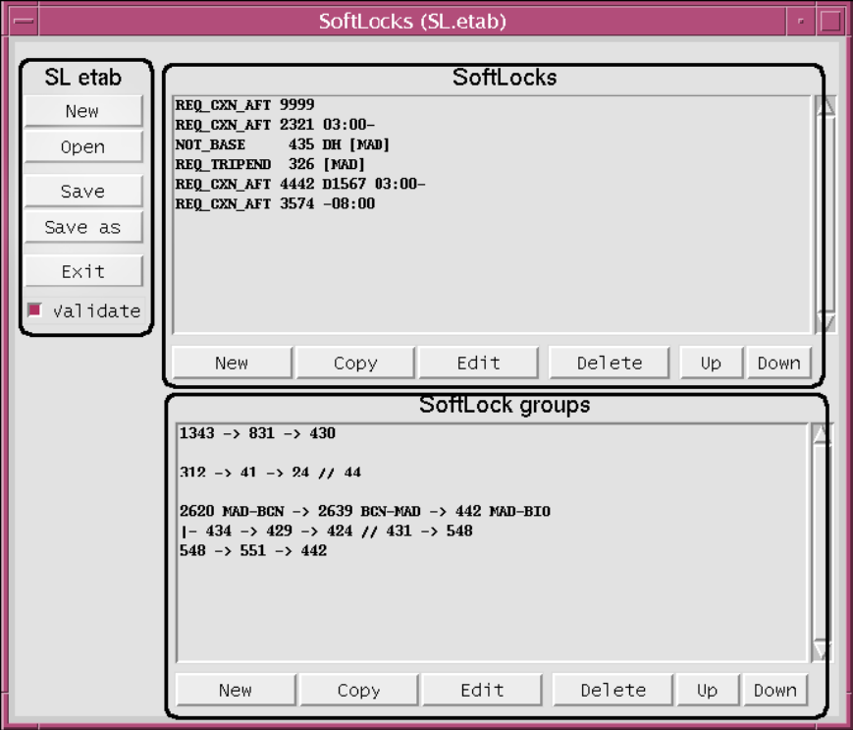
1.

3.

2.

SL etab area
This area contains the following buttons:
New | Clears all data from the GUI and creates a new empty etable
Open | Opens an existing soft locks etable
Save | Saves the currently loaded etable
Save As | Saves the current etable using another name
Exist | Exits the GUI

The Validate check box indicates whether the table is validated when saving.
To see soft locks changes reflected in Studio, you must first click the Save button in the SoftLocks GUI and then select Refresh & Redraw in Studio.

Soft Locks area
This area contains a list of all “single” soft locks in the current table.
Use the list to select soft locks that you want to copy, edit, or delete. The area contains the following buttons:
New | Opens an empty Edit Soft Lock window (with some default values)
Copy | Opens the Edit Soft Lock window with data for the selected soft  lock
Edit | Opens the Edit Soft Lock window with data for the selected soft  lock
Delete | Deletes the selected soft lock.
Up | Moves the selected soft lock up in the list
Down | Down Moves the selected soft lock down in the list

Soft Lock groups area
This area contains a list of all soft lock groups in the current etable. By using soft lock groups, you can assign the same constraints to several legs at a time.
Use the list to select soft lock groups that you want to copy, edit, or delete. The area contains the following buttons:
New | Opens an empty Edit Soft Lock Group window (with some default values)
Copy | Opens the Edit Soft Lock Group window with data for the selected soft  Lock
Edit | Opens the Edit Soft Lock Group window with data for the selected soft  Lock
Delete | Deletes the selected soft lock group.
Up | Moves the selected soft lock group up in the list
Down | Down Moves the selected soft lock group down in the list

Edit Soft Lock Window
The Edit Soft Lock window is displayed when you click New, Copy, or Edit in the SoftLocks area in the main window.
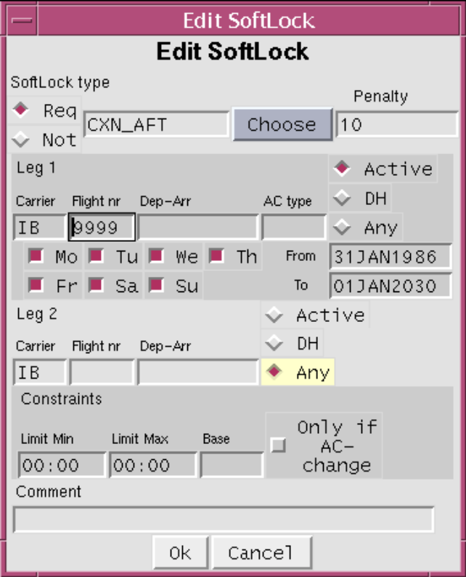

Parameters
The parameters correspond to the columns within the soft lock table.
Soft Lock Type | The type of soft lock (click the Choose button to  display a list of available types)
Penalty | The penalty given if the soft lock is not enforced
Leg 1
Carrier | Carrier of leg 1
Flight nr. | Flight number for leg 1
Dep-Arr | Departure and arrival stations for leg 1
AC type | Aircraft type for which the soft lock applies
Active/DH/Any | Indicates whether the soft lock is limited to active, deadhead or any type of leg
Mo - Su | Weekday (default: all???)
From - To | Start and end date
Leg 2
Carrier | Carrier of leg 2
Flight nr. | Flight number for leg 2
Dep-Arr | Departure and arrival stations for leg 2
Active/DH/Any | Indicates whether the soft lock is limited to active, deadhead or any type of leg
Constraint
Limit Min | Minimum time limit
Limit Max | Maximum time limit
Base | The constraint for Soft Lock types REQ_BASE and NOT_BASE. Is also used as constraint for the other types.
Only if AC change | If checked, the constraint only applies if it involves an aircraft change
Comment | An optional comment field

The layout of this window varies depending on the type of soft lock. Some columns in the soft locks table are not used for all soft locks, and this means that the corresponding fields in the GUI are not displayed. See Mandatory and Optional Columns on page 22 for details.

Edit Soft Lock Group Window
The Edit Soft Lock Group window is displayed when you click New, Copy, or Edit in the SoftLock groups area in the main window.
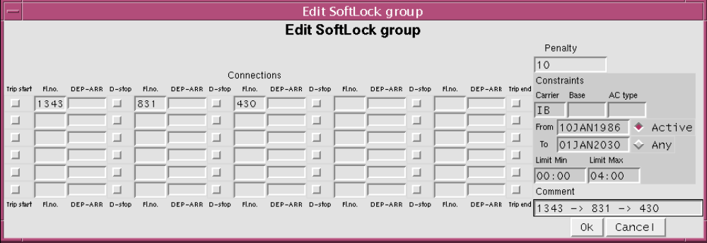

With Soft Lock groups you can, for example, specify once that the legs A-B-C-D should be connected instead of having to enter three different SoftLocks (A-B, B-C and C-D). (In the table, the result is stored as three separate SoftLocks.) If a trip has more than five legs that should be connected, you must repeat the last leg of each row on the following row, like this:
A-B-C-D-E
E-F-G-H-I
I-J
It is possible to define trips with several duties. Checking "D-stop" between two legs means that a duty stop (layover) is required between the legs. To prevent an intended connection of two legs within a duty to be split into two duties (this may happen if a leg is missing on a certain day) it is advisable to set "Limit max" to 20:00 or similar.

Parameters
Connections
Trip start | Indicates whether the leg must start a trip
Fl. No. | Leg number
DEP-ARR | Departure and arrival stations
D-stop | Indicates whether the leg must end a duty
Penalty | The penalty given if the soft lock is not enforced
Constraint
Carrier | Carrier name
Base | Base
AC type | Aircraft type
From-To | Date range for the soft lock
Active / Any | Indicates whether the soft lock applies to any leg or only to active legs
Limit Min | Minimum time limit
Limit Max | Maximum time limit
Comment | An optional comment

Impact on planning process
By using the Soft Lock functionality, the planning process will contain less manual interference, since most likely the soft locks that were added for one planning period, will be the same for the next and no additional work is then required the following planning periods.

Files

Rave
Name | Location | Description
Soft_locks | crc/modules | Basic soft lock definitions, including rule and penalty definitions and external table lookup
studio_soft_locks | crc/modules | Studio mappings regarding soft lock rudobs and report definitions

Scripts
Name | Location | Description
SoftLocks.menu | menu_scripts/PAC | Definition of menu entries
SL_validate.csl | menu_scripts/Pac | Start script for validate soft lock table
SoftLocksBasics.py | lib/python/carmusr | Basic soft lock python definitions
SoftLocksGUI.py | lib/python/carmusr | Basic soft lock GUI python definitions
SoftLocksStartGUI.py | lib/python/carmusr | Script for starting soft lock GUI
SoftLocksValidateEtab.py | lib/python/carmusr | Script for validate soft lock table

Reports
Name | Location | Description
SoftLocksValidation  .output | Crg/hidden | Report definition for validating the soft lock table
SoftLockDetails.inc | Crg/include | Report definition for SoftLockDetails report
SoftLockDetails | Crg/crr_window_object | Report include file
SoftLockDetails  .output | Crg/crr_window_object | Report include file

External Tables
Name | Location | Description
SL.etab | Crc/etable/ccp | Table that is manually updated by the planner via the soft lock GUI

Extra features

Service
Who can help me install? CSC
Who can help me with bugs? CSC
Where can I send enhancement requests? CSC

Future Improvements
Add possibility to have SoftLock table local to the current sub-plan

