

The SAS CMS Project

Functional Reference Manual
Carmen Postplanner File Reader

Document Type: Functional Reference
Document Status: Released
Version: 2.0
Last Changed: 11 Sep 08
Owner: Hasse Eliasson, Jeppesen

Table of Contents
1 Introduction 3
1.1 This Document 3
1.2 Change History 3
2 How to use file reader 4
3 How file reader works 5
4 Dependencies and setup 6

Introduction

This Document
This document describes how to use the Carmen Postplanner filereader application, used to access files on the server, in a local browser, and launch them with suitable plug-in.

Change History
Version | Author | Date | Description
1.0 | Hasse Eliasson | 15May08 | Initial version
2.0 | Andreas Wohrm | 11Sep08 | Updated format
2.1 | Michael Lundell | 12Oct2012 | Updated for CMS2. Very small changes.

How to use file reader

- Log in to Jeppesen application launcher.
- Click on the Carmen Postplanner File Reader icon.
- A web browser is launched locally on your pc. It shows a clickable file tree, where you navigate the tree structure by clicking the directory links.
- When you click a file, it is opened by the browser, using the appropriate plugged in viewer like AcrobatReader, Excel or an xml viewer.
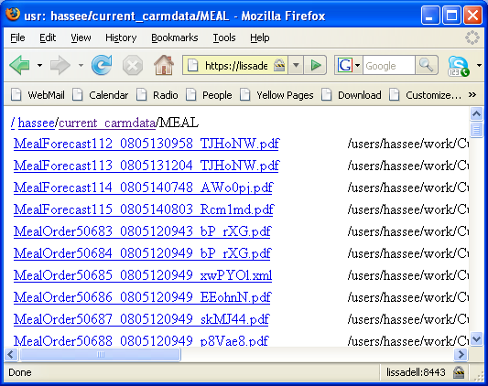

How file reader works
On the client side a browser is started with an url that points to an server that shows content of a server directory.
The actual viewing of the files is done by the browser, using plug-in when necessary.

Dependencies and setup
The Sessionserver must be configured to show the appropriate directory.
In systems.xml add a <show> tag under the <carmfileservlet> tag.
This will make the carmfileservlet publish the path as a url.
See example below where the MEAL directory has been added.
<carmfileservlet>
<show>data/config/views/launcher_transforms/tableeditor</show>
<show>data/config/alertmonitor</show>
<show>current_carmdata/MEAL</show>
</carmfileservlet>

In the Jeppesen Application server, the Carmen Postplanner filereader application is configured to launch Windows default browser with an url to the directory configured above.

