

The SAS CMS Project

Functional Reference Manual
List 9

Document Type: Functional Reference
Document Status: Final Fat
Version: 2.2
Last Changed: 2013-03-055

Table of Contents
1 Introduction 3
1.1 This Document 3
1.2 Change History 3
2 List9 Report – WHO FLEW WHAT 4
2.1 Introduction 4
2.2 Report generation 4
2.3 Information displayed 4
2.4 Presentation and crew ordering 8

Introduction

This Document
The purpose with List 9 Report is to generate a report with information about all the flights performed in the last month, and who flew those flights.

Change History
Version | Author | Date | Description
1.0 | Hugo Vazquez | 15May08 | Initial version
2.0 | Andreas Wohrm | 11Sep08 | Updated format
2.1 | Sven Olsson | 08Oct2012 | Reviewed for CMS2
2.2 | S. Olsson | 05Mar2013 | Removed owner

List9 Report – WHO FLEW WHAT

Introduction
List 9 Report – “Who Flew What” generates report with information about transferred crewmembers on each flight leg within a specified report month. For each flight leg there is a list of crewmembers that have had an active or passive transferred on the leg. All time information is shown in UTC time.

Report generation

List9 report is generated one time every month after schedule release and covers last month. It generates a PDF file with the specified information.

Information displayed

The information showed is divided in different sections, and ordered firstly by flight leg number.

For each flight leg, the crew members are listed in three columns according to their category. The left column shows crew members with category {FC, FP, FR}, the middle column shows crew members with category {AP, AS} and the right column shows crew members with category {AH}.

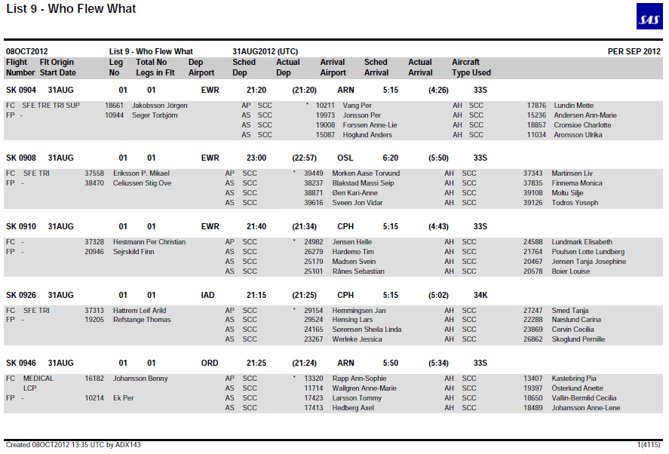
Figure [1]: List 9 Report for Sep 2012.

The information showed is divided in four main parts:

1.3.1.- General information

Information regarding the selection made:
- title of the report
- run date
- period in UTC
- month selected.

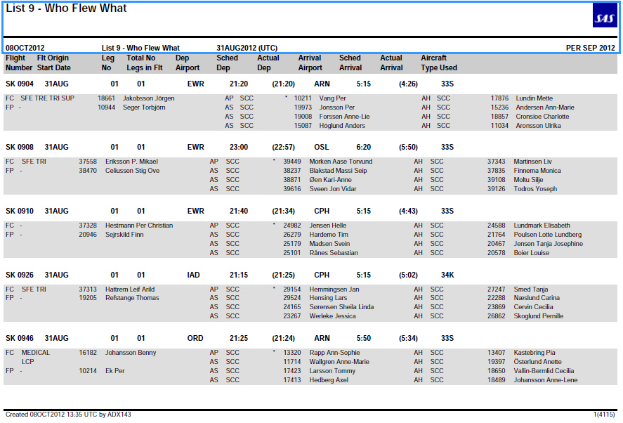
Fig. [2]: List9 – part1, General Information

1.3.2.- Flight information

Information related to every flight displayed in the report.

 | Field | Value | Comments
1 | FLIGHT NUMBER | Flight Number
2 | FLT ORIGIN START DATE | Start date | UTC time
3 | LEG NO | Leg number
4 | TOTAL NO LEGS IN FLT | Total number of legs in the flight | Sum of sequences for the flight.
5 | DEP AIRPORT | Departure airport
6 | SCHED DEP | Scheduled departure time | UTC time
7 | ACTUAL DEP | Actual departure time | UTC time
8 | ARRIVAL AIRPORT | Arrival airport
9 | SCHED ARRIVAL | Scheduled arrival time | UTC time
10 | ACTUAL ARRIVAL | Actual arrival time | UTC time
11 | AIRCRAFT TYPE USED | AC type used

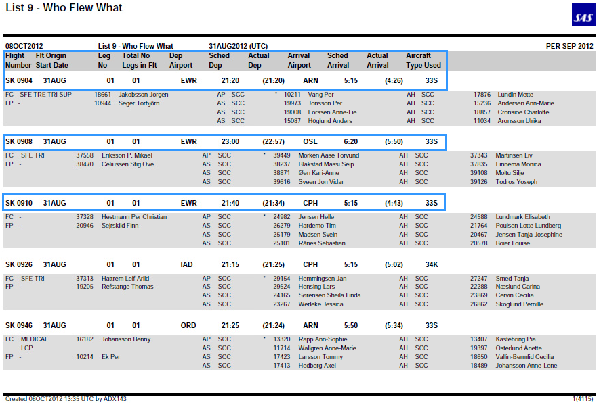
Figure[7]: List12 Report – part 2, Individual Information

1.3.3.- Crew information

Information related to the crew inside a specific flight.

 | Field | Selection | Value | Kommentarer
1 | crew employment |  | AH, AP, AS, FC, FP, FR
2 | crew restriction | For type =  TRAINING, MEDICAL, NEW | CAPT, MEDICAL, NEW, DCT, TRAIN, 6M, ACTYP | All the restrictions are showed. If there are no qualifications or restrictions, a '-' is displayed.
3 | crew qualification | For type =  LCP, INSTRUCTOR, POSITION | TRI, TRE, SFI, SFE, LINST, LIFUS, FLEET, CRM, TEST,  BCP, CP, INSTR, OPT, LCP | All qualifications are showed. If there are no qualifications or restrictions, a '-' is displayed.
4 | duty code |  |  | All duty codes are shown. For example, passive, training and H/L.
5 | */+ |  | *, + | '+' is displayed if crew has worked as chief of cabin at a flight without purser demand.  '*' is displayed if crew has worked as chief of cabin at a flight with purser demand.
6 | crew employment |  |  | Employee number
7 | crew |  |  | Last name, first name
8 | crew seniority | grp =SAS |  | It is used for crew ordering, but not displayed in the report.

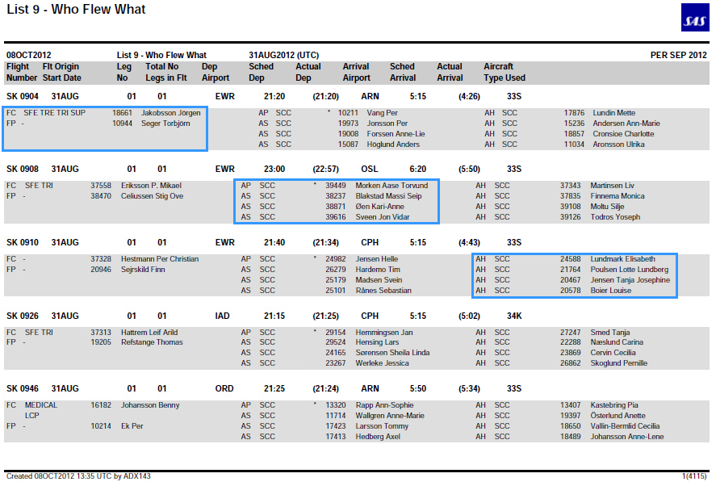
Figure [4]: List 9 Report – part 3, Crew Information

Presentation and crew ordering

Crew is displayed following a specific order criteria:

For each flight leg crew members having an active transfer are shown before crew members with passive transfer.

Crew members in the same column (and passive/active group) are sorted according to their rank (category), duty code and seniority number. FC’s not operating at lower rank are shown before all other flight deck crewmembers and within this ordering crewmembers are sorted in ascending order according to their seniority number. Note that if a crewmember has seniority number zero, then he is shown last on the list. AP’s not operating at lower rank and AS’s operating at higher ranks are shown before all other cabin crew and within this ordering, crewmembers once again are sorted according to their seniority number. AH’s operating at higher rank are shown before all other AH’s and once again the crewmembers are finally sorted according to their seniority number.

