Fatigue Risk Management
The Fatigue Risk Management (FRM) functionality allows you to manage the prediction of crew alertness/fatigue and related risks in all phases of crew planning and operation. With it, you can create and evaluate predicted alertness in the system according to different scientific models.

This package is built to evaluate alertness levels according to the BAM model. However, it does not include the BAM model itself which is sold as a separate product. Instead, it contains a dummy jigsaw model that allows a customer to try out the functionality without acquiring the BAM model.

The package includes a function layer on top of the BAM model which allows a user to control alertness when optimizing solutions. It also contains functionality for evaluating and analyzing solutions with respect to alertness using reports and the user interface.

Version
Unreleased, previous released version was 1.0.1

Rules and Parameters
The Fatigue Risk Management package uses the following parameters and penalties.

Fatigue parameters
Para- (Fatigue) Minimum alertness on flight
Turns on or off the rule for minimum alertness allowed on active flights.
Para- (Fatigue) Minimum allowed alertness for rule (CAS points)
Sets the minimum alertness value allowed in the fatigue rule. The legs with alertness level below this value will break the fatigue rule.
Para- (Fatigue) Low alertness penalty limit (CAS points)
Defines the minimum alertness level allowed on a leg before being penalized.
Para- (Fatigue) Use penalty on low alertness
Whether to use penalty cost for legs with alertness below the value specified by the parameter “(Fatigue) Low alertness penalty limit (CAS points)”.
Para- (Fatigue) Penalty value per CAS point below limit (quad)
Multiplier for the penalty value to apply to each leg.
Para- (Fatigue) Invert (+/-) penalty for alertness
Inverts the penalty to become a reward. This is useful in order to make the optimizer find situations in which rosters are legal from a regulation perspective, but still have low alertness levels.
Para- (Fatigue) Use Rudobs to draw alertness markers after duties
Whether to use Rudobs to draw coloured alertness markers after duties in the trip view.
Para- (Fatigue) Level for Alertness marker 1
Sets the alertness level below which duties are followed by a dark red marker.
Para- (Fatigue) Level for Alertness marker 2
Sets the alertness level below which duties are followed by a bright red marker.
Para- (Fatigue) Level for Alertness marker 3
Sets the alertness level below which duties are followed by an orange marker.
Para- (Fatigue) Level for Alertness marker 4
Sets the alertness level below which duties are followed by a dark yellow marker. Duties with higher alertness will be followed by a yellow marker.

CAPI parameters
.
Para- (CAPI) Use BAM predicted initial state (Recommended)
The BAM alertness model can predict the rested initial state before it starts predicting a chain of activities. Use this unless specific conditions are needed for specific chains. Such conditions are controlled by code.
Para- (CAPI) Use BAM predicted initial acrophase (Recommended)
The BAM alertness model will by default start predicting with crew acclimatized to the local time zone of the first leg departure station. Alternatively the acclimatization can be set explicitly.
Para- (CAPI) Initial acro-phase in homebase time (manual)
The time of day (in homebase time) for the initial acro-phase if not BAM predicted mode is used.
Para- (CAPI) Diurnal type
Individual factor with regard to morning/eveningness. Default is “3” for intermediate and should be used when no individual information is available.
Para- (CAPI) Habitual sleep length
Individual factor with regard to habitual sleep length. (Can typically be set to 8:00 when/if no individual values are present.)
Para- (CAPI) Typical transport time at homebase
Commuting time for additional transport time at homebase.
Para- (CAPI) Typical transport time at outstation
Commuting time for additional transport time at arrival airport.
Para- (CAPI) Time at rest-location before sleep
Time spent at the rest location before actually going to sleep.
Para- (CAPI) Time at rest-location after sleep
Time spent at the rest location from awakening until start of transportation to the departure airport.
Para- (CAPI) Min connection length for split duty rest
Minimum connection time for a split-duty rest.
Para- (CAPI) Number of days predicted before planning period start (roster)
For performance reasons the model shall not predict unnecessary long rosters. This parameter controls when the prediction starts relative to the planning period. It shall be long enough to give enough context for an accurate prediction at the start of the planning period.
Para- (CAPI) Number of days predicted after planning period end (roster)
If the roster chains also contain some future activities this parameter controls when to stop prediction relative to planning period end.
Para- (CAPI) Use deadhead naps on long flights
Whether to use deadhead naps on long flights.
Para- (CAPI) Use augmentation naps on long flights
Whether to use augmentation naps on long flights.
Para- (CAPI) Use special overnight strategies
Whether to use special overnight strategies (not implemented).
Para- (CAPI) Use sleep diary if available, false forces predicted sleep
Whether to use crew sleep diary. If set to false sleep prediction is used according to the fatigue model implemented in the system. (Using diary data is normally only useful close to day of ops when/if crew would report prior sleep at check-in.)

Filtering and Selecting
The entries described below are available in the Filter/Select sub-menus of the General menu (obtained by right-clicking the background of a window).

Trips/Rosters window
Menu entry | Description
Trips with low alertness | Filters / Selects all trips/rosters containing legs with alertness value below a certain level (the 4 available values are set through the parameters (Fatigue) “Level for Alertness marker 1...4”

The entry described below is available in the Sort sub-menu of the General menu (obtained by right-clicking the background of a window).

Trips/Rosters window
Menu entry | Description
Alertness | Sorts from top to bottom the trips/rosters according to their worst alertness from top to bottom.

Visualization
In Studio, low alertness markers are displayed by rudobs after the last leg in the duty using the following colours:
Colour | Description | Example
Dark Red | Duties with lower alertness then level 1 | 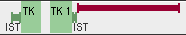
Bright Red | Duties with lower alertness then level 2 | 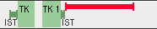
Orange | Duties with lower alertness then level 3 | 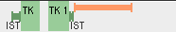
Dark Yellow | Duties with lower alertness then level 4 | 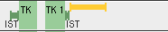
Yellow | Duties with higher alertness then level 4 | 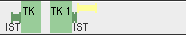

The low alertness visualization is controlled by the following parameters:
Para- (Fatigue) Level for Alertness marker 1
Para- (Fatigue) Level for Alertness marker 2
Para- (Fatigue) Level for Alertness marker 3
Para- (Fatigue) Level for Alertness marker 4

Reports
Two reports are available in the fatigue package, Alertness plot and Alertness distribution.

Alertness plot
The Alertness plot report shows the alertness level for the crew members as it varies over time. Note that you can “zoom in” on particular legs or trips by selecting them and generating the report using the Object menu. The scale for alertness is between 0 and 10,000 anchored to the Karolinska Sleepiness Scale as follows:

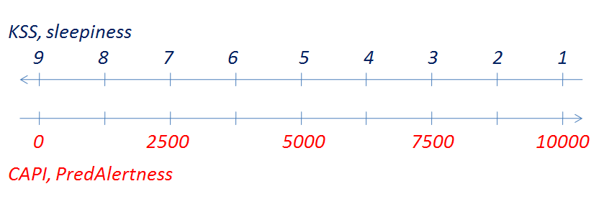
A value of 0 corresponds to KSS 9 that equals “Very sleepy, fighting sleep”. (More about the science behind can be reached through www.jeppesen.com/FRM.)
The header of the diagram contains the date and the legs for each duty in the trip, together with information on flight number, departure and arrival times and airports. The main body of the diagram plots the level of alertness for the trip and draws grey columns corresponding to predicted sleep within the sleep opportunities (white boxes between the flights in the Gantt part).
The HTML-version of the report includes tool-tip information for the legs, sleep opportunities, and predicted sleep intervals.

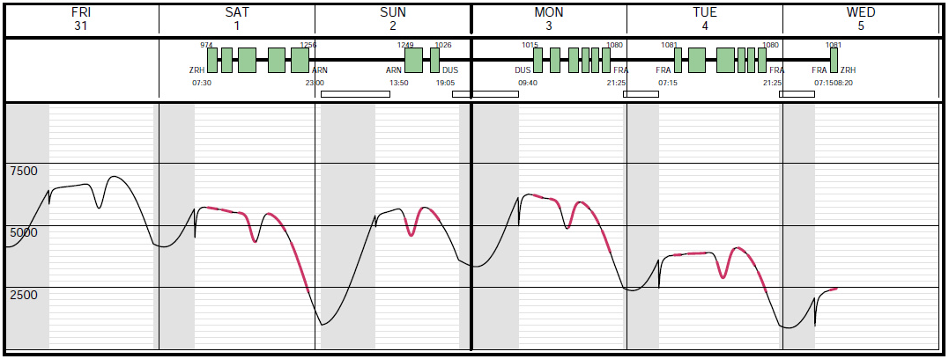

Alertness distribution
The alertness distribution report provides a bar diagram visualizing the alertness distribution across all the selected legs in the trips / rosters.
Each bar represents a number of legs falling in the certain alertness interval. The alertness minimum value is 1 while the maximum is 10000 and intervals are 250 units wide. The interval bars below 3000 are highlighted with a darker blue color. On the right side of the bar diagram the same information is provided in tabular form.
By clicking on a bar or on the corresponding number in the “Alertness Details” table the trips containing those legs are showed in another window in Studio.
Some statistical info about the alertness distribution are shown below the bar diagram. For more information see the table “Fields” below.

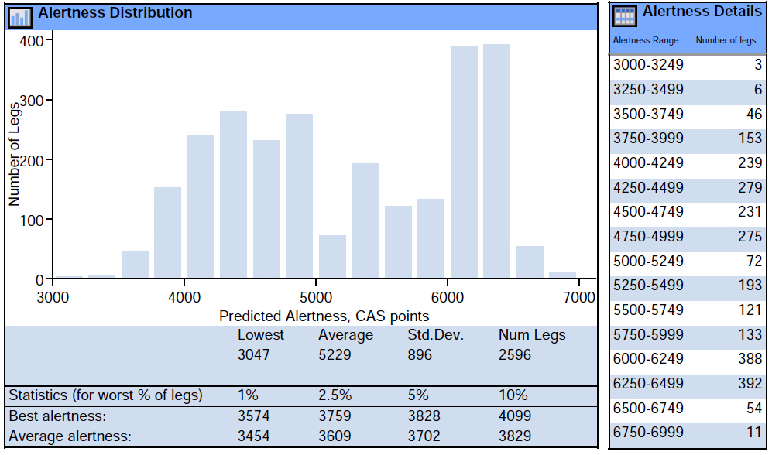

Fields
Field name | Description
Alertness statistics | Statistical data on alertness lowest, average and standard deviation. Num legs is the number of considered legs (on-duty flights in planning period)
Best alertness | for (worst % of legs); Best alertness value for the 1%, 2.5%, 5% and 10% legs with worst alertness in the plan.
Average alertness | for (worst % legs); Average alertness value for the 1%, 2.5%, 5% and 10% legs with worst alertness in the plan.

Files

Rave
Name | Location | Description
Capi | crc/modules | Definitions for the Common Alertness Prediction Interface
capi_bam | crc/modules | Implementation of the CAPI interface using the Boeing Alertness Model.
fatigue | crc/modules | Alrtness values, penalties, parameters and rudobs definitions.
report_fatigue | crc/modules | Definitions used in the alertness reports.
studio_fatigue | crc/modules | Fatigue definitions regarding external table creation and Studio rudobs.
studio_mappings_fatigue | crc/report | Studio mappings regarding fatigue rudobs.

Python
Name | Location | Description
gui.py | lib/python/carmusr/fatigue/ | GUI functions for fatigue implementation in Studio
kpi.py | lib/python/carmusr/fatigue/ | KPI definitions for inclusion in the Custom KPI report
report.py | lib/python/carmusr/fatigue/ | Report classes
alertness_plot.py | lib/python/ report_sources/* | Alertness plot report.
alertness_distribution.py | lib/python/ report_sources/* | Alertness distribution report.

Menu files
Name | Location | Description
Fatigue.menu | menu_scripts | Definition of fatigue menu entries in studio

Documentation
Name | Location | Description
frm_installation_guide.doc | Doc | Installation Guide
frm_function_reference.doc | Doc | This document

Supporting files
Name | Location | Description
report_utils.py | lib/python/carmusr/fatigue/ | Support classes and functions for the alertness reports

