Week 3 Task: Advanced Data Analysis and Visualization in Logistics
Logistics Route Optimization and Delivery Performance Analysis

1. Introduction and Objective
This report presents exploratory data analysis of a hypothetical logistics delivery dataset. The objective is to examine delivery performance, shipment volume, distance, vehicle type, traffic, cost and delay, then communicate useful findings through Python visualizations.

2. Dataset Definition
The dataset contains 80 simulated delivery orders. Each record includes order ID, service zone, vehicle type, distance, package count, vehicle capacity, traffic level, expected delivery time, actual delivery time, delivery cost and an on-time indicator. Delay_min is calculated as actual time minus expected time.

3. Key KPIs
The main KPIs are on-time delivery rate (35.0%), average delivery delay (9.2 minutes), average delivery cost (599.99), average distance (59.9 km), and average packages per order (17.5).

4. Exploratory Data Analysis
The analysis starts with descriptive statistics and grouped summaries. Across 80 orders, the overall on-time rate is 35.0%. Zone and vehicle comparisons are used to identify operational differences. Distance, packages, time, cost and delay are also examined through correlation analysis.

5. Visualization 1 — Delivery Delay by Zone
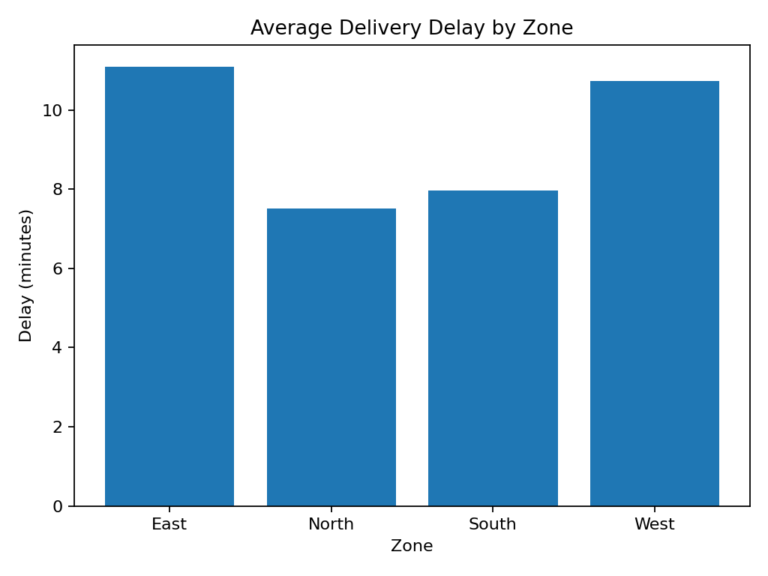
The zone comparison highlights where average delays are relatively high. Such zones should be reviewed for congestion, route design, dispatch timing or capacity issues.

6. Visualization 2 — Cost by Vehicle Type
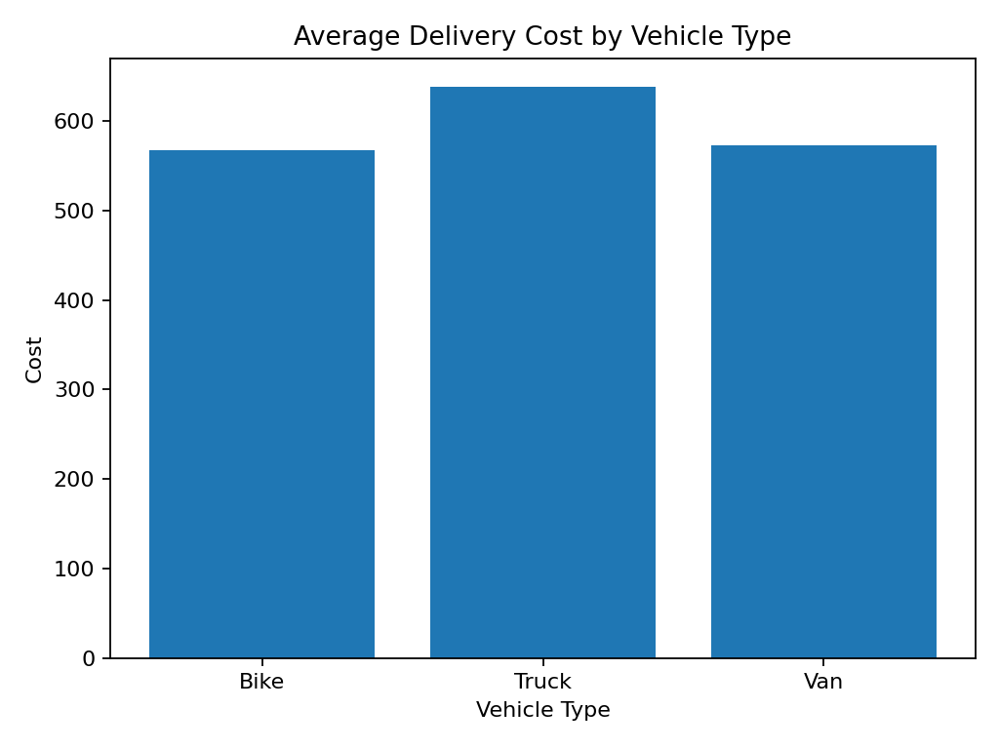
Vehicle types have different operating and capacity characteristics. Cost comparison can support better vehicle assignment based on route length and shipment volume.

7. Visualization 3 — Distance vs Actual Delivery Time
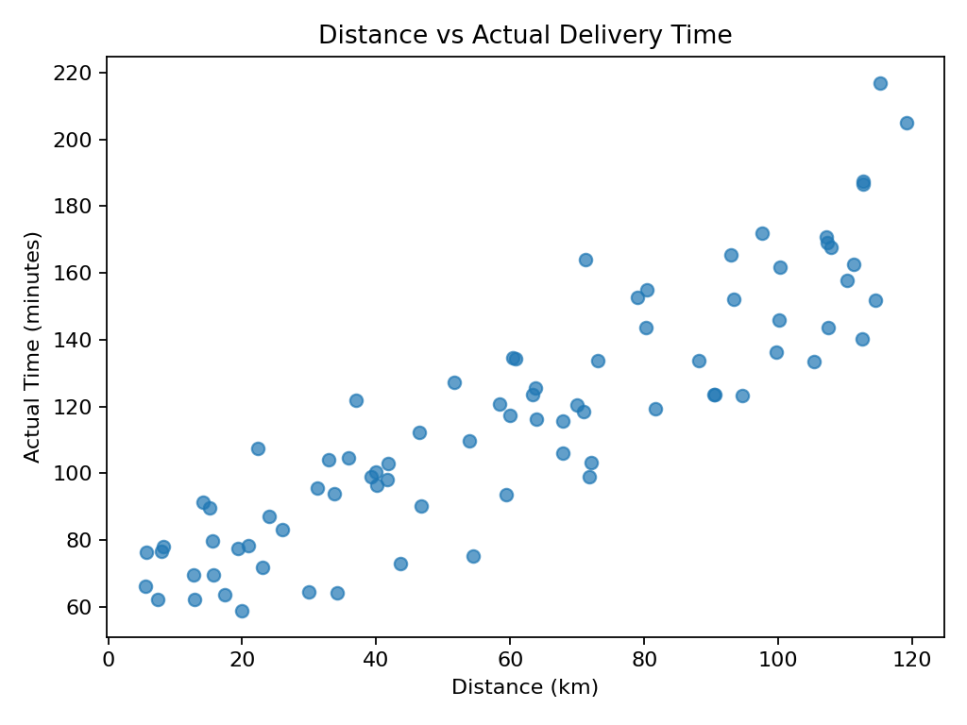
The scatter plot shows how actual delivery time changes with route distance. A positive relationship would support future regression-based delivery-time prediction.

8. Visualization 4 — Distribution of Delivery Delays
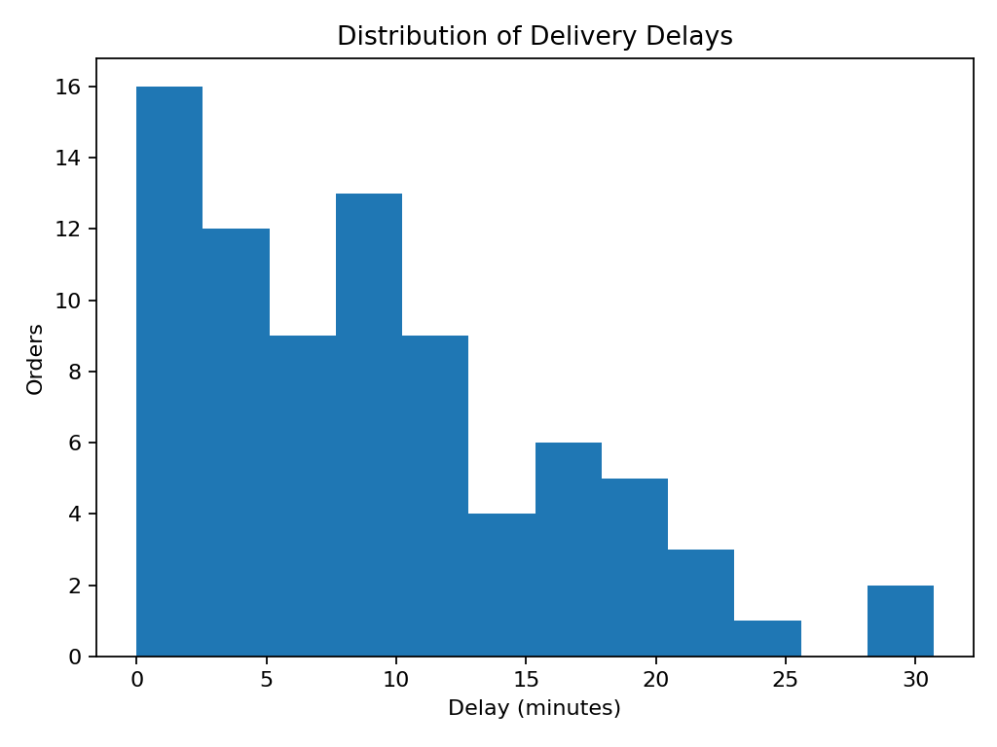
The histogram shows the spread of delays. Large values in the upper tail can indicate exceptional events or operational bottlenecks that deserve investigation.

9. Visualization 5 — Correlation Analysis
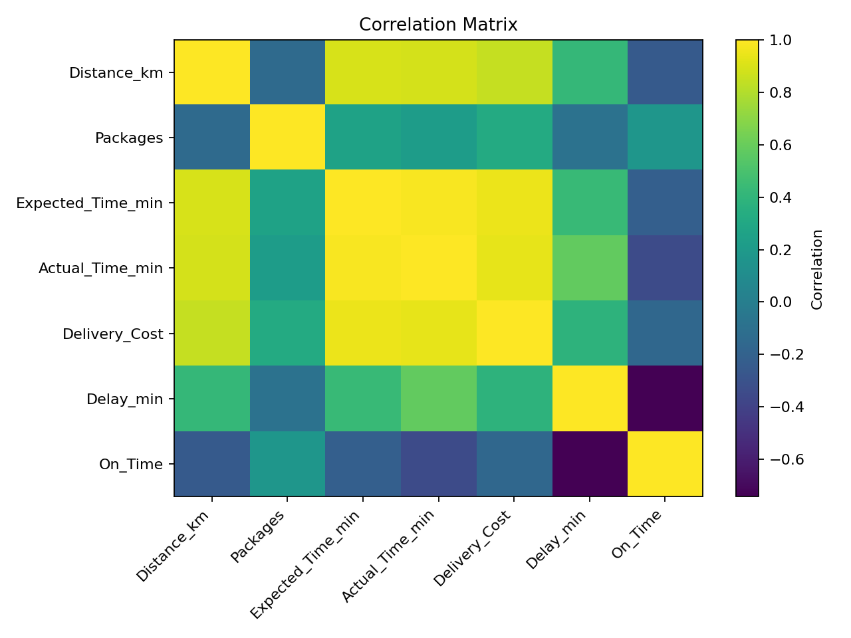
The correlation matrix gives an initial view of linear relationships among logistics variables. Correlation can guide later feature selection but does not prove causation.

10. Analytical Insights and Recommendations
The EDA provides several decision-support directions. Managers should compare zones instead of relying only on an overall KPI, investigate high-delay routes, match vehicle capacity with shipment volume, and use realistic time estimates for longer routes. Extreme delays should be reviewed individually to identify congestion, dispatch problems or route inefficiency. The dataset can later support regression, clustering and route-optimization models.

11. Python Methodology
The workflow is: load data → inspect variables → calculate Delay_min → calculate KPIs → group by zone and vehicle type → visualize distributions and relationships → interpret findings → recommend improvements. Pandas performs data manipulation and aggregation; Matplotlib produces the charts.

12. Python Code Illustration
df = pd.read_csv("data/logistics_week3_dataset.csv")
df["Delay_min"] = df["Actual_Time_min"] - df["Expected_Time_min"]
print("On-time rate:", df["On_Time"].mean() * 100)
print("Average cost:", df["Delivery_Cost"].mean())
zone_summary = df.groupby("Zone")["Delay_min"].mean()
zone_summary.plot(kind="bar")
plt.show()
plt.scatter(df["Distance_km"], df["Actual_Time_min"])
plt.xlabel("Distance (km)")
plt.ylabel("Actual Time (minutes)")
plt.show()

13. Conclusion
This analysis demonstrates how EDA and visualization convert logistics records into practical decision-support information. KPIs summarize service performance, while charts reveal differences between zones, vehicle types and route characteristics. The results can help improve vehicle allocation, delivery-time planning and bottleneck identification. Future work can use regression for prediction, clustering for segmentation and optimization for route planning.

14. References / Research Context
1. World Bank Logistics Performance Index (LPI) — logistics performance context.
2. Kaggle DataCo Global Supply Chain dataset — public supply-chain data reference.
3. Pandas documentation — data analysis and aggregation.
4. Matplotlib documentation — visualization methods.

