Week 4 Task: Predictive Modeling and Optimization in Logistics Systems
Delivery Time Prediction and Vehicle Allocation Strategy

1. Problem Definition
The logistics problem considered in this project is predicting actual delivery time and using the prediction context to improve vehicle allocation. Accurate delivery-time estimates can support dispatch planning, customer communication and resource utilization. A secondary optimization objective is to select a vehicle that has sufficient capacity while minimizing an estimated operating cost.

2. Dataset and Target Variable
The project uses a hypothetical dataset containing 80 delivery orders. Variables include distance, packages, vehicle type, vehicle capacity, traffic level, expected delivery time, actual delivery time, delivery cost and on-time status. The prediction target is Actual_Time_min. Traffic is converted to a numeric score: Low=0, Medium=1 and High=2.

3. Model Selection
Linear regression is selected as a transparent baseline because delivery time is expected to increase with distance, shipment volume and traffic. Its coefficients are easy to interpret and it provides a practical benchmark before moving to more complex models such as decision trees or ensemble methods.

4. Training and Validation
The data is divided into 80% training and 20% testing records. A least-squares linear regression model is fitted on the training data and evaluated on unseen test data. The test results are MAE = 5.10 minutes, RMSE = 5.96 minutes and R-squared = 0.973. MAE provides an intuitive average error, RMSE penalizes larger errors more strongly, and R-squared summarizes explained variation.

5. Model Performance Visualization
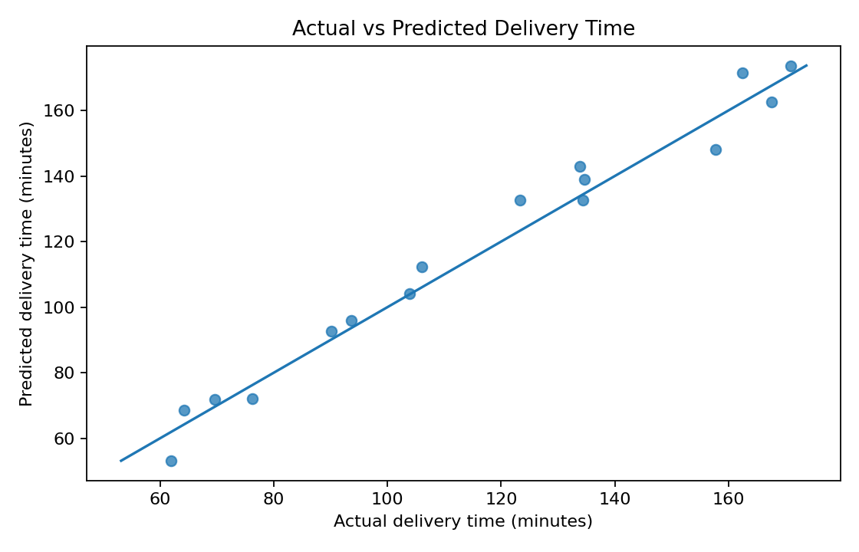
Points closer to the diagonal line indicate more accurate predictions. This chart helps identify whether the model systematically under- or over-predicts delivery time.
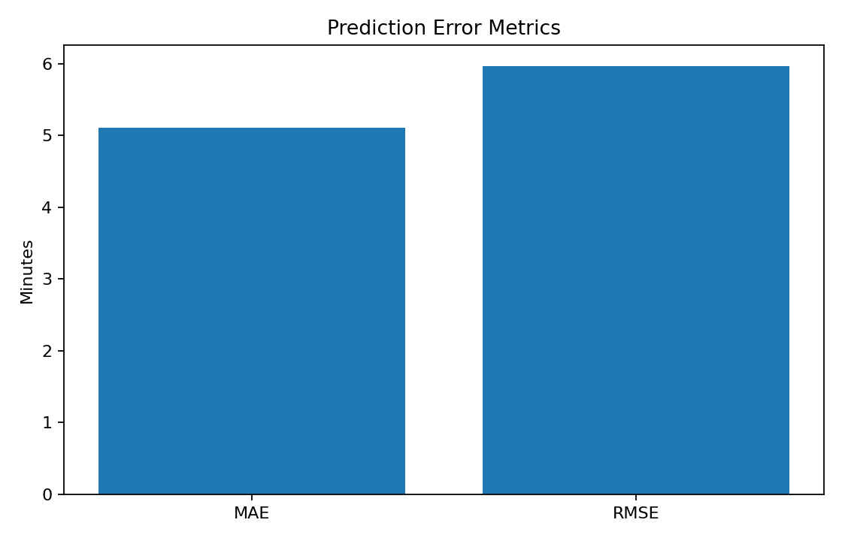
The error metrics summarize predictive accuracy on the held-out test set.

6. Optimization Strategy
A simple capacity-and-cost optimization is applied. For every order, vehicles that cannot carry the package count are removed. Among the remaining feasible vehicles, the one with the lowest estimated cost is selected. This represents a practical constrained resource-allocation problem. In a production system, the same idea could be extended to driver availability, delivery windows, vehicle locations, fuel consumption and multi-stop routing.
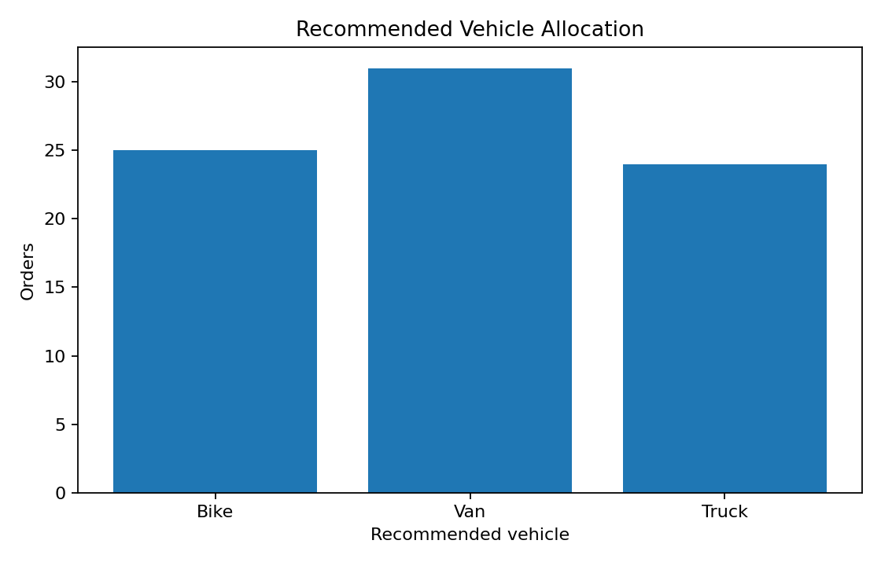
The chart summarizes the recommended vehicle allocation produced by the capacity-and-cost rule.
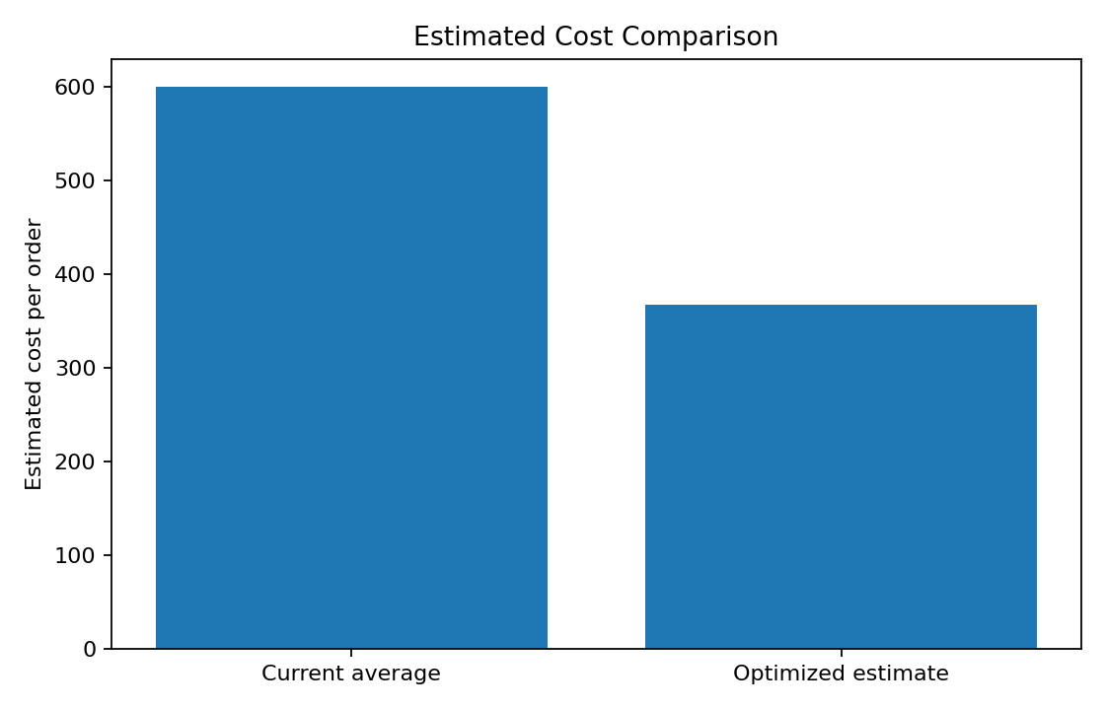
The illustrative cost comparison gives a current average recorded cost of 599.99 and an estimated optimized cost of 367.96. The simple cost model indicates an estimated improvement of 38.7%. This is an illustrative simulation, not a real-world savings guarantee.

7. Python Code Illustration
df = pd.read_csv("data/logistics_week4_dataset.csv")
df["Traffic_Score"] = df["Traffic_Level"].map(
{"Low": 0, "Medium": 1, "High": 2}
)
X = df[["Distance_km", "Packages", "Traffic_Score"]].to_numpy()
y = df["Actual_Time_min"].to_numpy()
# Fit regression on training data
beta = np.linalg.lstsq(X_train_with_intercept, y_train, rcond=None)[0]
pred = X_test_with_intercept @ beta
mae = np.mean(np.abs(pred - y_test))
rmse = np.sqrt(np.mean((pred - y_test) ** 2))
# Choose the cheapest feasible vehicle
recommended = min(
feasible_vehicles,
key=lambda v: fixed_cost[v] + cost_per_km[v] * distance
)

8. Business Recommendations
- Use predicted delivery time to improve dispatch estimates and customer communication.
- Prioritize investigation of orders with large prediction errors because they may represent unusual traffic or operational conditions.
- Use capacity constraints before cost minimization so that low-cost vehicles are not assigned to orders they cannot carry.
- Extend the optimization model with driver schedules, vehicle availability, time windows and route distance between consecutive stops.
- Compare the linear regression baseline with decision trees or ensemble models in future iterations and select the model using validation performance.

9. Conclusion
This Week 4 project demonstrates an end-to-end predictive and optimization workflow for logistics. A transparent linear regression model is used to estimate delivery time, while MAE, RMSE and R-squared provide objective performance measures. A capacity-and-cost rule then converts operational requirements into a simple vehicle-allocation optimization. Together, prediction and optimization can support faster, more consistent logistics decisions. The project is based on a simulated dataset, so the reported performance and cost improvement should be treated as educational examples rather than production claims.

10. References / Research Context
1. World Bank — Logistics Performance Index, for logistics performance and supply-chain context.
2. scikit-learn documentation — regression and model evaluation concepts.
3. NumPy documentation — numerical least-squares computation.
4. Matplotlib documentation — visualization techniques.

