IMAGES TO WEBP CONVERTER

INTERNSHIP REPORT

Submittedby

Stuti S. Shah

200120107555

In partial fulfillment for the award of the degree of

BACHELOR OF ENGINEERING

In
Computer Engineering Department
Gandhinagar Institute of Technology
Gandhinagar



Gujarat Technological University , Ahmedabad

May, 2022-23

GandhinagarInstitute of Technology
MotiBhoyanRoad, Gandhinagar, Gujarat
(Affiliated with GTU)

COMPUTER ENGINEERING DEPARTMENT
CERTIFICATE
This is to certify that the work of Project/Internship entitled “Images to webp converter” has been carried out by Stuti S. Shah(200120107555) under my guidance in partial fulfilment for the degree of Bachelor of Engineering in Computer Engineering,8th Semester in the Gandhinagar Institute of Technology, Moti-Bhoyan, Gandhinagar, Gujarat, during the academic year 2022-2023 and his/her work is satisfactory. This student has successfully completed all the activity under my guidance related to Project/Internship for 8th semester.

Internal Guide
Prof. Hetal Shah
Head of the Department
Prof.(Dr.) Nimisha Patel

Industry Certificate


GandhinagarInstitute of Technology
MotiBhoyanRoad, Gandhinagar ,Gujarat
(Affiliated with GTU)
DECLARATION

We hereby declare that the Internship report submitted along with the Internship entitled ‘Images to webp converter’ submitted in partial fulfillment for the degree of Bachelor of Engineering in computer engnerring to Gujarat Technological University, Ahmedabad, is a bonafide record of original project work carried out by me at SKILLHOUSE Pvt. Ltd. under the supervision of Faisal Khatri and that no part of this report has been directly copied from any students’ reports or taken from any other source, without providing due reference.

Name of the Student Sign of Student

Stuti .S. Shah

ACKNOWLEDGEMENT

I have taken efforts in this Internship/Project. However, it would not have been possible without the kind support and help of many individuals and organizations. I would like to extend my sincere thanks to all of them.
I am highly indebted to Prof. Hetal Shah & Faisal Khatri for their guidance and constant supervision as well as for providing necessary information regarding the Internship. I take this opportunity to thank all my friends and colleagues who started me out on the topic and provided extremely useful review feedback and for their all-time support and help in each and every aspect of the course of my project preparation. I am grateful to my college Gandhinagar Institute of Technology, for providing me all required resources and good working environment.
I would like to express my gratitude towards Head of Department, Prof.(Dr.) Nimisha Patel and Director, Dr H N Shah for their kind co-operation and encouragement which help me in this Internship.

Thank You
Stuti S. Shah

Abstract
Images are an essential part of web content, and their size can have a significant impact on website performance. To address this issue, a new image format called WebP was introduced, which offers better compression than traditional image formats while maintaining image quality. Image to WebP converter tools enable web developers and designers to convert their existing images to the WebP format to optimize their web content.
This article provides an overview of image to WebP converters, including their features, limitations, and possible solutions. It also discusses testing strategies and result analysis for image to WebP converters. Additionally, this article highlights the potential future work in this area, including improved compression algorithms, integration with popular image editing software, and better user experience. Finally, it provides a bibliography of various image to WebP converter tools and resources for further information.

List of Figures
Fig 1.1 Use case / Procedure Diagram........................................................................2
Fig 1.2 Activity / Process Diagram.............................................................................5
Fig 2.1 Use case / Procedure Diagram......................................................................12
Fig 2.2 Activity / Process Diagram...........................................................................15
Fig 2.3 Use case / Procedure Diagram......................................................................22
Fig 2.4 Activity / Process Diagram...........................................................................25
Fig 3.1 Use case / Procedure Diagram......................................................................32
Fig 4.1 Activity / Process Diagram...........................................................................35
Fig 4.2 Use case / Procedure Diagram......................................................................42
Fig 4.3 Activity / Process Diagram...........................................................................43

Internship Content

Title Page |  |  | I
Certificates(College) |  |  | II
Certificates(Company) |  |  | III
Acknowledgement |  |  | IV
Content |  |  | V
List of Figures |  |  | VI
List of Table |  |  | VII
1 |  | Introduction | 1
 | 1.1 | Internship Summery /Introduction of Company
 | 1.2 | Aim and Objectives
 | 1.3 | Organization Intro
2 |  | Introduction to Internship
 | 2.1 | Internship Summary
 | 2.2 | Purpose & Objective
 | 2.3 | Tools & Technologies and Language Intro
 | 2.4 | Internship Planning
3 |  | Internship Implementation
 | 3.1 | Weekly Task
 | 3.2 | Flowchart / Pseudo code of the task
 | 3.3 | Roles & Responsibilities
 | 3.4 | Internship Scheduling (Gantt Chart/PERT/Network Chart)
4 |  | Design
 | 4.1 | System Flow Diagram
 | 4.2 | Data Dictionary
 | 4.3 | Relationship of Table (From Data Base System)
 | 4.4 | User Interface
5 |  | Testing
 | 5.1 | Testing Plan/Strategy
 | 5.2 | Test Results and Analysis
6 |  | Outcomes
 | 6.1 | Results & Screenshots
7 |  | Conclusion & Discussion
 | 7.1 | Conclusion
 | 7.2 | Summary of Internship Work
 | 7.3 | Problem Encountered and Possible Solutions
 | 7.4 | Dates of Continuous Evaluation (CE-I and CE-II)
 | 7.5 | Limitation & Future Work
8 |  | References
 |  | Bibliography (Include only website links or book name magazine name)

CHAPTER:1
INTRODUCTION
1.1 INTERNSHIP SUMMERY /INTRODUCTION OF COMPANY
Skillhouse provides breathtaking imagery to communicate architecture. Skillhouse solely focuses on providing the best experiences to clients from first inquiry to end results. we believe in the philosophy of best or nothing. we use awesome art styles and techniques to bring your ideas to life.

1.1.1 Still Visuals
Still Visuals are the best way to encourage brand value. Today nobody is interested in reading boring texts. In fact, Why are you even reading this? When you can have a beautiful picture of your dream project?

1.1.2 Animations
Animations are our main forte. We are known for cinematic experiences with architecture films. Animations are the core of branding in era of digital content revolution

1.1.3 Teasers
Teasers are an exclusive creation of Skillhouse. It is a 30-40 seconds long highly impactful video. Which creates enormous hype among buyers and market peers.

1.1.4 360/VR
Heard of Meta verse? The world around us evolving and to be ahead of this market you would need modern solutions. This provides user interactivity and freedom for buyers to feel and understand what is needed.
CHAPTER:2
INTRODUCTION TO INTERNSHIP
2.1 INTERNSHIP SUMMERY
This app is designed to help users convert their image files into the WebP format, a modern image format that provides superior compression and image quality compared to traditional formats like JPEG and PNG. With its user-friendly interface and fast processing speed, this app makes it easy for users to optimize their images for the web, reducing page load times and improving the overall user experience. Whether you're a web designer, photographer, or just someone who wants to save space on your device, this app is the perfect solution for converting your images to the WebP format.

2.2 PURPOSE & OBJECTIVE
- The purpose of this app is to provide an efficient and easy-to-use solution for converting images into the WebP format. With its user-friendly interface and fast processing speed, this app offers a convenient way for users to optimize their images for the web, improving page load times and enhancing the overall user experience. Whether you're a professional or a casual user, this app delivers high-quality results, making it the ideal choice for anyone looking to convert their images to the WebP format
- To provide an easy-to-use and intuitive interface that makes image conversion simple and straightforward.
- To offer fast processing speed and high-quality results, ensuring that images are converted with minimal loss of quality .
- To enable users to optimize their images for the web, reducing page load times and improving the overall user experience.
- To provide a cost-effective and user-friendly solution for converting images to the WebP format, making it accessible to a wide range of users.
- To continuously improve the app through regular updates and user feedback, ensuring that it remains a top choice for anyone looking to convert their images to the WebP format.

2.3 TOOLS AND TECHNOLOGIES
- HTML, CSS, JS
- Electron
- Node JS
- Version control
- GitHub

2.4 INTERSHIP PLANNING
- Understanding image file formats: As an intern, it is important to have a good understanding of different image file formats such as JPEG, PNG, GIF, and WebP. You can research these file formats and understand their features, advantages, and limitations.
- Image compression techniques: WebP is known for its high compression rate, which makes it an ideal format for web images. You can learn about different compression techniques and algorithms used in image compression and how they are applied to WebP format.
- Image conversion tools: You can explore different image conversion tools available in the market and compare their features, performance, and compatibility with different platforms. You can also create your own image conversion tool using programming languages like Python, C++, or JavaScript.
- WebP optimization: You can learn about different optimization techniques for WebP images, such as lossy and lossless compression, You can also analyze the impact of WebP optimization on image quality, file size, and loading speed.
- Web development integration: As an intern, you can explore how WebP images can be integrated into web development projects. You can learn about browser compatibility, server-side caching, and content delivery network (CDN) integration for WebP image.
CHAPTER:3
INTERNSHIP IMPLEMENTATION

3.1WEEKLY TASK
Week:1
- In the first week internship we learn all basic introduction of destop application use of electron
- Later we learn html and css
- Html:
- Understanding html.
- Learneaning html syntax, elements, forms, tables.
- Chaking html code for mistakes.
- Css:
- Understanding css.
- Css essentials.
- Intermediate css.
- Less exciting yet still necessary css task.

Week:2
Creating website layout page using html, css you can imagine.
- Created a signup page like reemo web application.
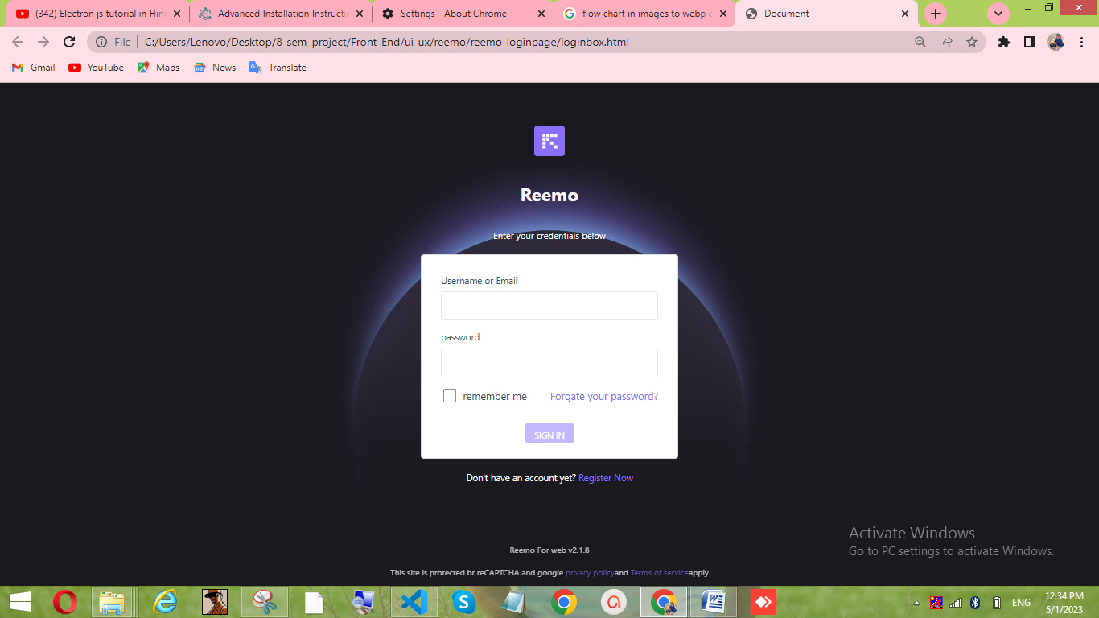FIG :3.1.1
Support any device size with responsive design
- The first image is for Desktop view and the second image is for Mobile view which is responsive.
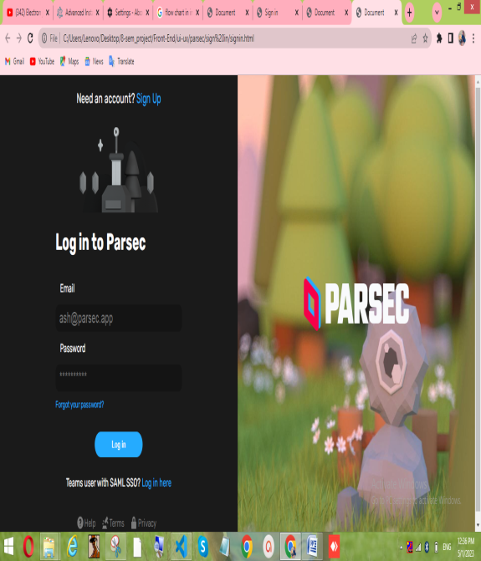
FIG: 3.1.2 FIG: 3.1.3
Add tasteful animation and effects with CSS
- Learned and Created Footer with the help of html , CSS.
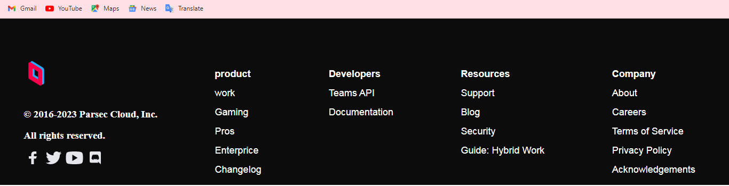
FIG: 3.1.4
- Learned and Created Navigation Bar with the help of html , CSS.

FIG: 3.1.5

- Learned and Created Dropdown List with the help of html , CSS and animation.
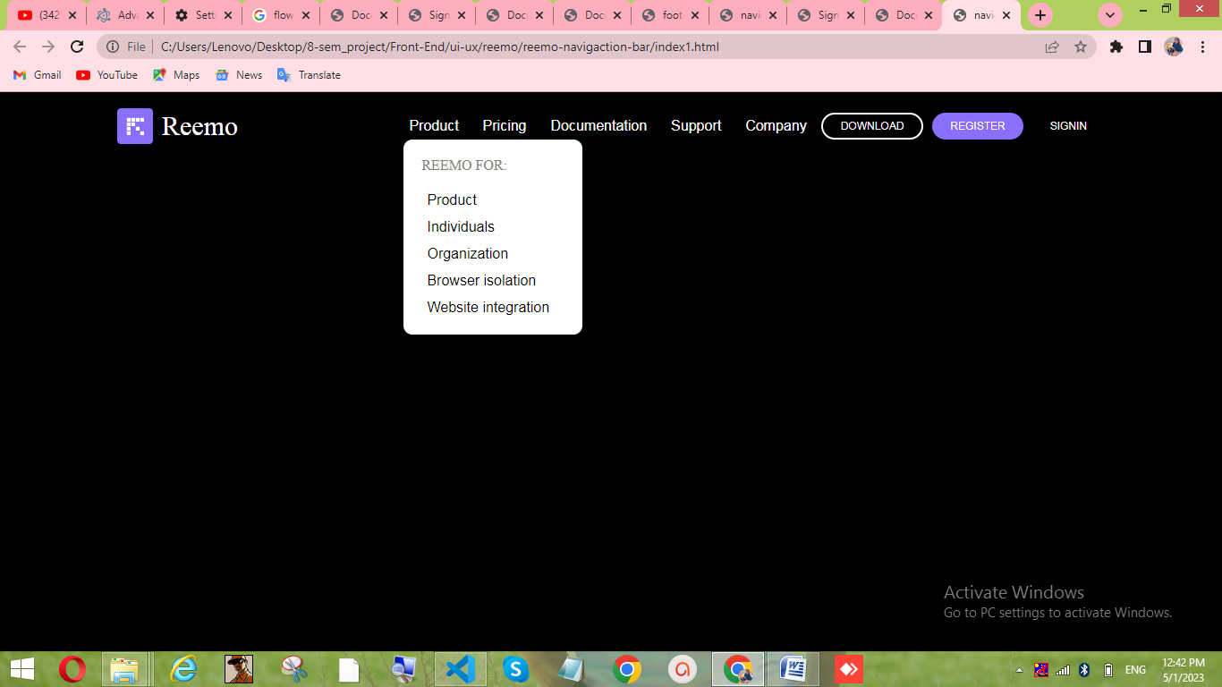
FIG: 3.1.6

Week: 3
JavaScript:
In JavaScript I learned about variables of JavaScript ,rules ,functions ,array function ,string methods ,numbers ,objects ,DOM elements and elements access methods also performed some practical’s on it.
- Created different colours windows and when clicked it changes its color with the help of click event listener using javascrpit.
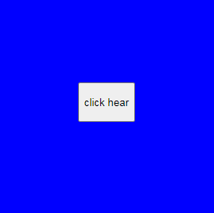
FIG: 3.1.7

Week:4
JavaScript:
- In this week of JavaScript I learned about three-projects which are to-do list, increment-decrement projects, notes.
- Also did project on Html, css and performed backend on that file using JavaScript.
Increment-decrement counter
Below window has 5 buttons which are Increment , Decrement , Add, Reset and Total.
- Increment: It increments the number shown on the screen.
- Decrement: It decrements the number shown on the screen.
- Add: Adds the number on the screen with previous number.
- Reset: Reset the number to 0.
- Total: Gives the total of all the previous numbers along with the number on the screen.
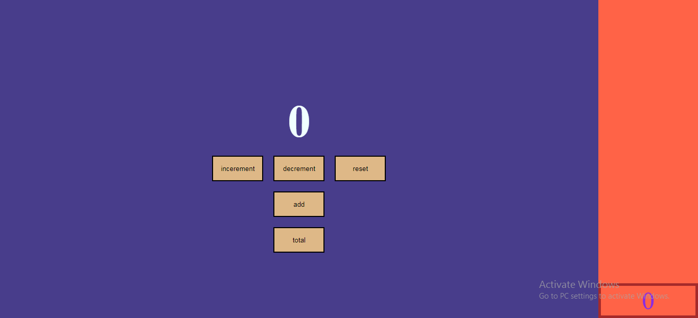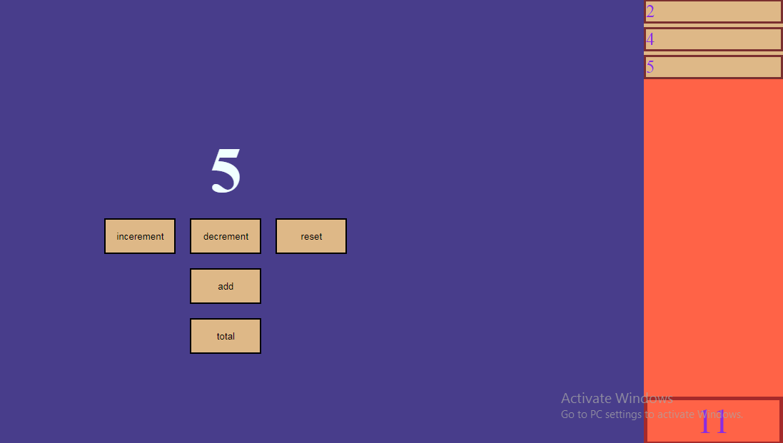
FIG: 3.1.8

The first window shown below takes the text as input and generates a text file along with the text given as input and redirects to second window which is a login page.
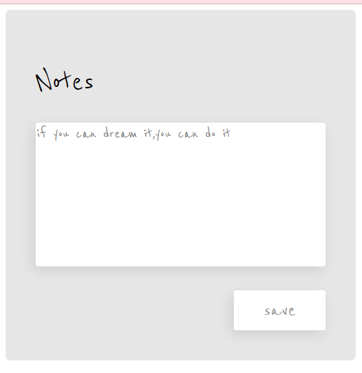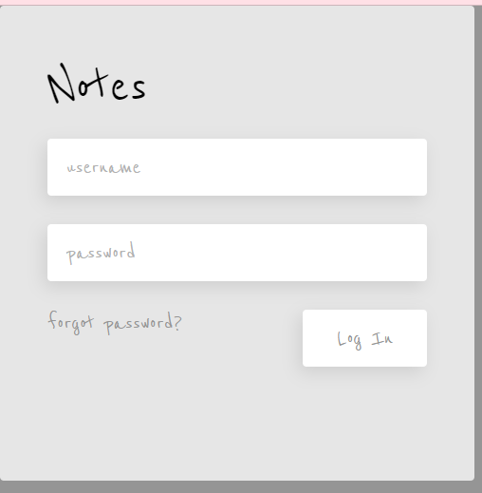
FIG: 3.1.9
Week:5
- Node-js:
- In node-js I learned about installation of node-js and about NPM packages which includes some libraries and understand the concept of package of json.
- Also learned about module like OS module, PATH module, FS module.
- Learned about 3d library file structure.
- Along with that, create NAGALL libraries and library structures create.

Week:6
- Created web scraping using node.js which can download all the images from different applications.
- Web scraping is the process of extracting data from websites by automatically parsing the HTML or XML code of web pages and then saving the extracted data in a structured format, such as a spreadsheet or a database. Web scraping is often used to gather large amounts of data from the web, which can then be used for various purposes such as market research, price comparison, or lead generation.
- Converted images into webp using cli.

- The conversion of images into WebP format is the process of converting images from other file formats such as JPEG, PNG, or GIF to the WebP image format. WebP is a newer image format developed by Google that provides better compression and smaller file sizes than other image formats, which makes it a popular choice for web developers who want to improve website loading speed and performance.
- The conversion process typically involves using software or tools that can read the input image file and convert it into a WebP file. There are several ways to convert images into WebP format, including using online image converters or using command-line tools such as cwebp or vwebp.

Week:7
- Implemented conversion of images into webp using Electron Framework
Electron allows developers to create cross-platform desktop applications using a single codebase that can run on Windows, macOS, and Linux operating systems. It does this by bundling a version of the Chromium web browser and Node.js runtime into a single runtime environment that can interact with the operating system's native APIs.

Week:8
Below shown Window has 2 buttons which are Select_file and Submit and a input for Quality :
- Select_file: It allows user to select multiple files and when it is clicked it opens with a dialog box from which we can select file and it does not show the path of the selected file and shows the selected image on the screen.
- Submit: When this button is clicked it converts the selected images into webp format with the quality specified by user.
- Quality Input: It maintains the quality of the images.
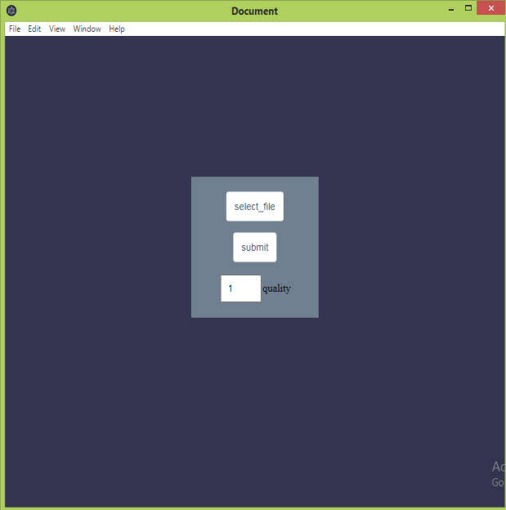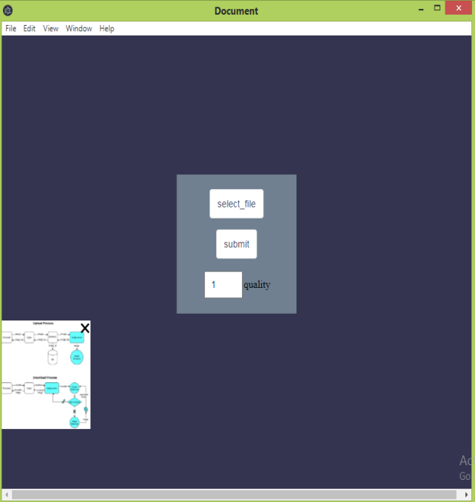
FIG: 3.1.10

Below shown Window also has 2 buttons which are Select_file and Submit and a input for Quality and a textbox for entering path :
- Select_file: This button opens a dialog box and allows user to select the file but does not show the selected image on the screen instead it shows the path.
- Text box: It shows the path of selected image.
- Submit: When this button is clicked it converts the selected images into webp format with the quality specified by user.
- Quality Input: It maintains the quality of the images.

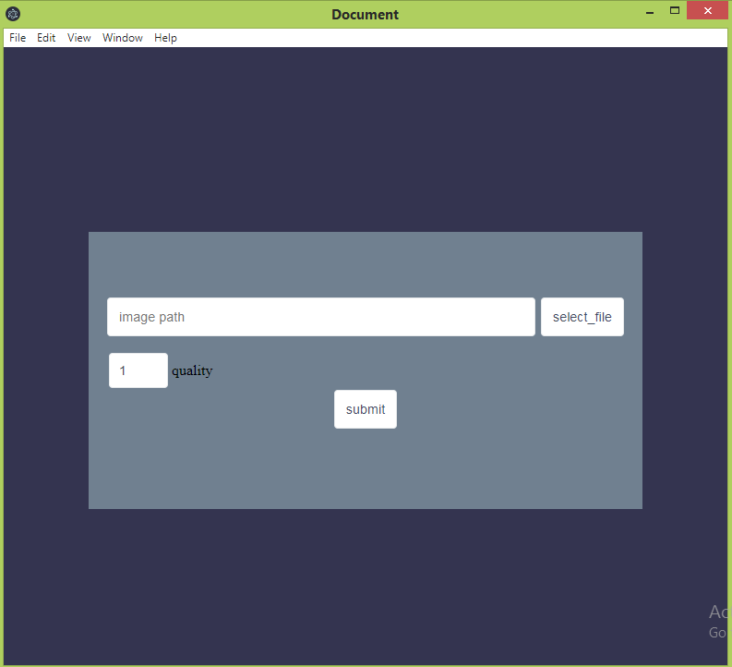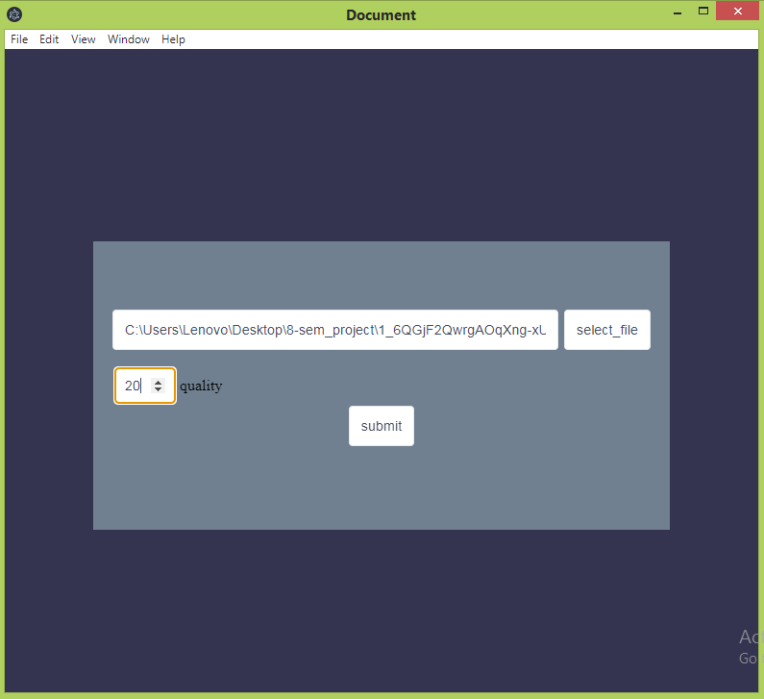
FIG: 3.1.11

Week: 9
This window allows user to select the files with two methods 1. When clicked on drop , a dialog box is opened and we can select file from it .2. we can drag and drop multiple files on the screen.
In Second window the selected file is show and we there is compression bar through wich user can select the compression quality and also there is option to select the destination on the file will get stored.
After clicking convert , the image gets converted and is stored on location specified by user.
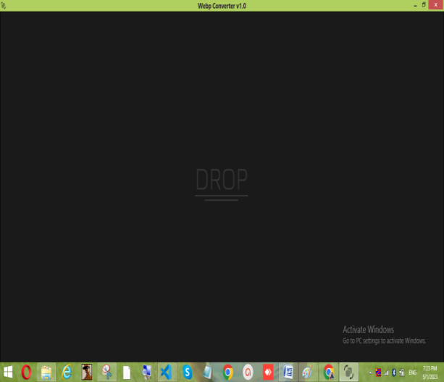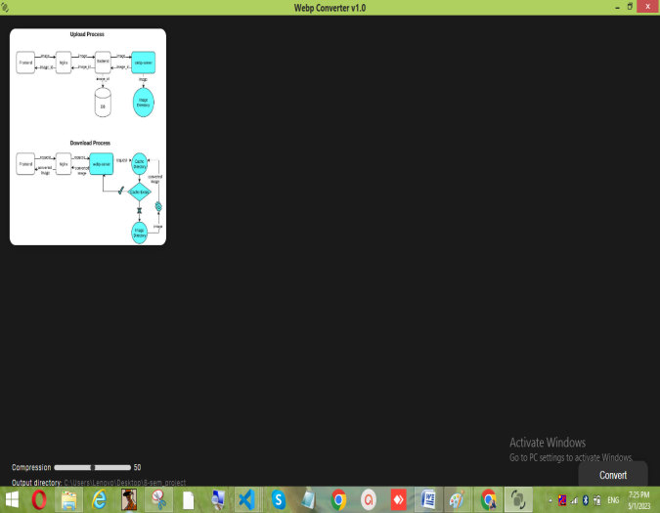
FIG: 3.1.12
This window shows two alert boxes 1. If the file is not selected it will give an alert to select the file. 2.Second alert box is shown only when all the selected files are converted in between when the files are in process of conversion , On right bottom side , the percentage of completed conversion is shown.
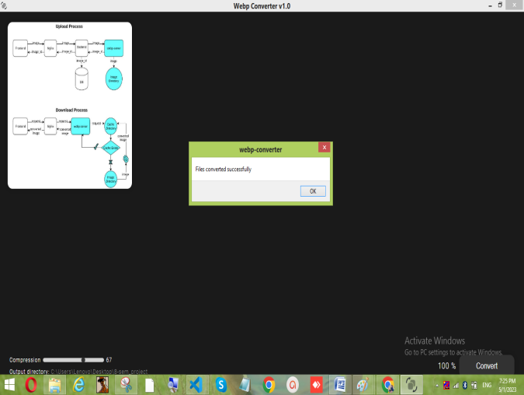
FIG: 3.1.13

Week: 10
- Learned about vue.js framework
- Vue.js is a progressive JavaScript framework for building user interfaces (UIs) and single-page applications (SPAs). It was created by Evan You in 2014 and has gained popularity among developers due to its simplicity, flexibility, and performance.
- Vue.js is often compared to other popular JavaScript frameworks such as React and Angular, but it has a different approach to building UIs. Vue.js is designed to be incrementally adoptable, which means that developers can use as much or as little of the framework as they want. This makes it easy to integrate Vue.js into existing projects or to use it as the foundation for new projects.
- Below are the pages made for onsite uploading.
Screen1: Index Page
Screen 2:Client Page
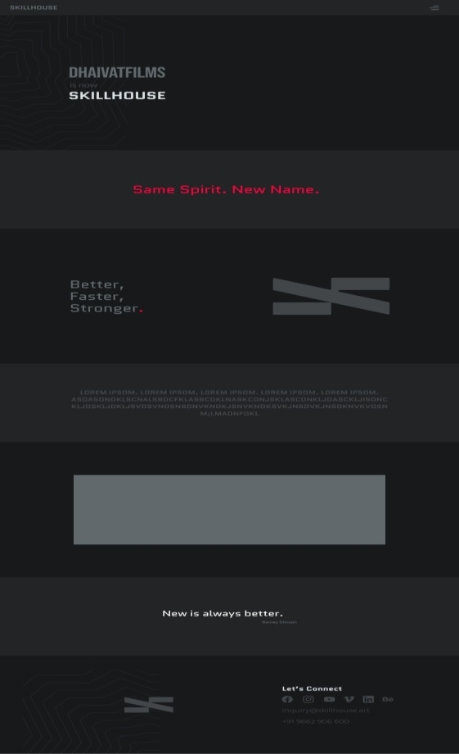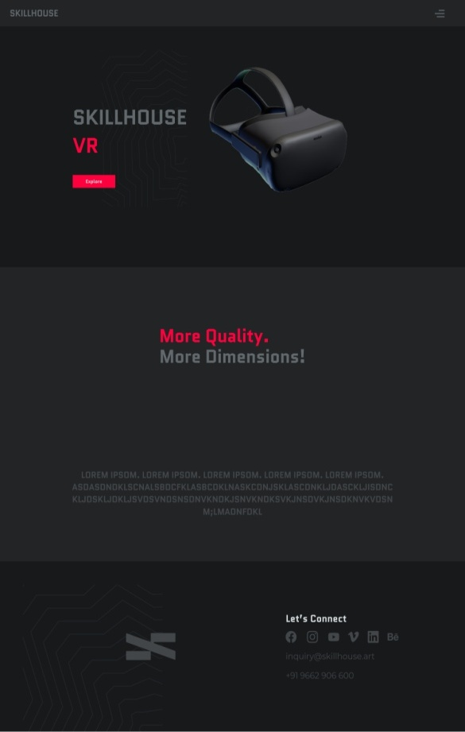
FIG: 3.1.1
Week: 11
Menu page
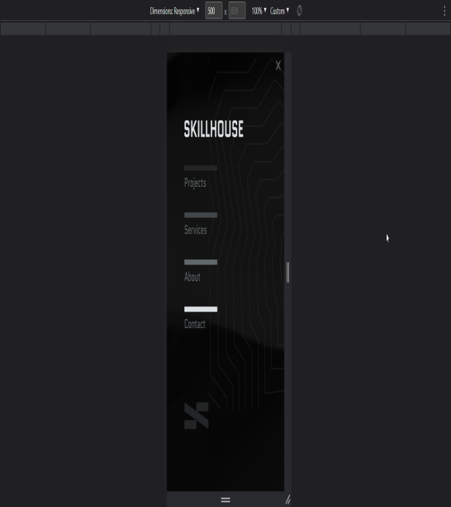
FIG: 3.1.14
Screen 1: Client Page
Screen 2: Careers page
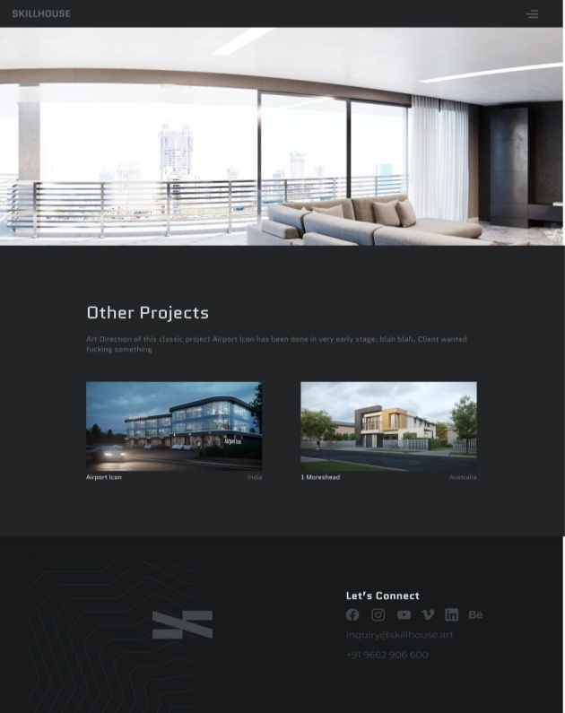

FIG: 3.1.15

Week: 12
Screen 1: Modular gallery
Screen 2: Live Login page
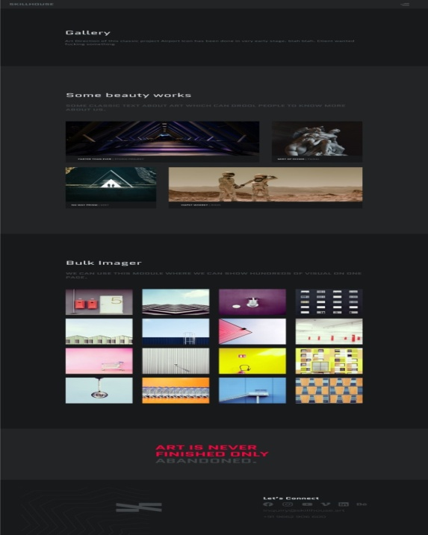
FIG: 3.1.16
Screen 1:Service Page
f
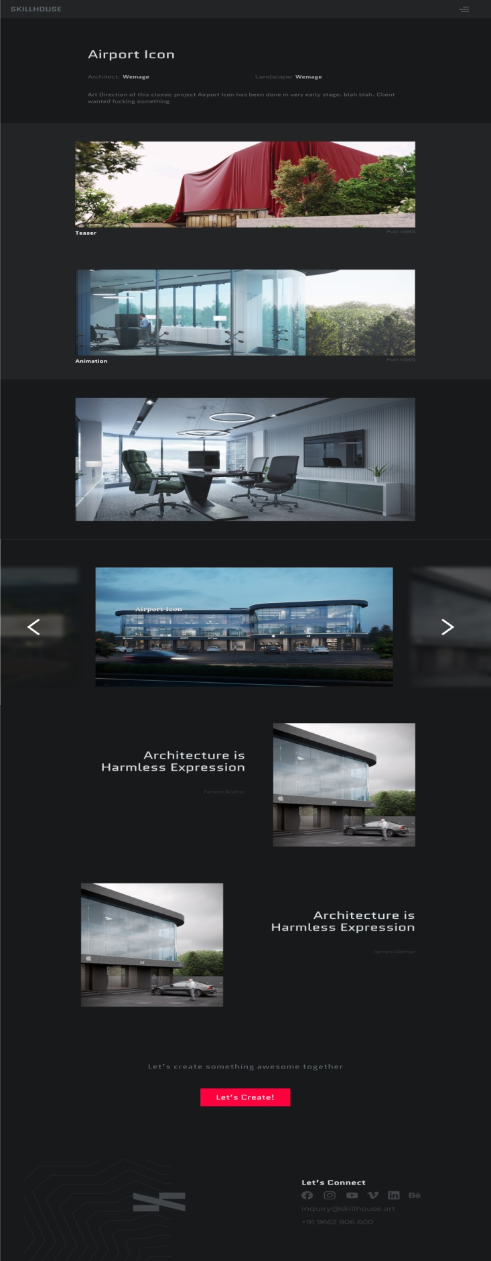
FIG: 3.1.17

3.2 FLOWCHART

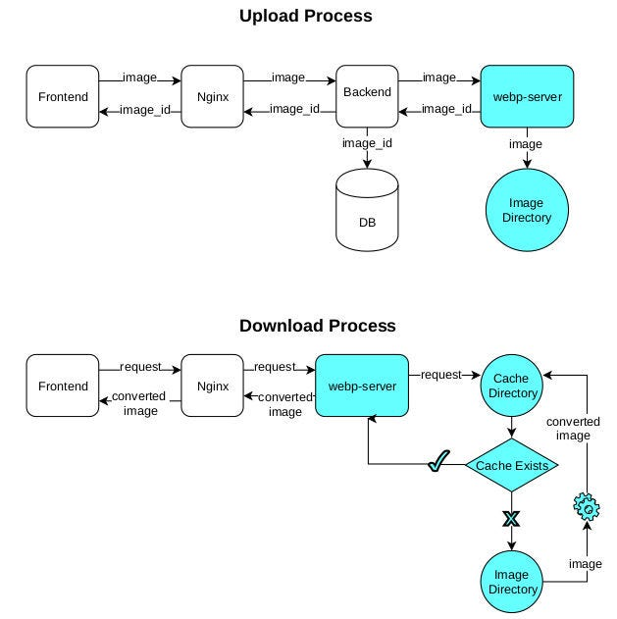
FIG: 3.2.1

3.3 ROLES AND RESPONSIBILITIES
- Project Manager: The project manager oversees the entire project, including planning, budgeting, and resource allocation. They are responsible for ensuring that the project is completed on time, within budget, and according to specifications.
- Software Architect: The software architect designs the overall structure of the image converter software, including the algorithms and data structures used to convert the images to WebP format.
- Front-end Developer: The front-end developer is responsible for creating the user interface of the image converter software, including the graphical elements and user interactions.
- Back-end Developer: The back-end developer is responsible for creating the core functionality of the image converter software, including the conversion algorithms and file processing logic.
- Quality Assurance Engineer: The quality assurance engineer is responsible for testing the image converter software to ensure that it meets the specifications and functions correctly. They may also be responsible for creating automated tests and test scripts.
- Technical Writer: The technical writer is responsible for creating documentation for the image converter software, including user manuals, technical specifications, and help files.
- User Experience (UX) Designer: The UX designer is responsible for creating an intuitive and user-friendly interface for the image converter software, with a focus on user needs and behaviors.
CHAPTER:4
DESIGN
4.1USER INTERFACE
The below user interface is created using figma.
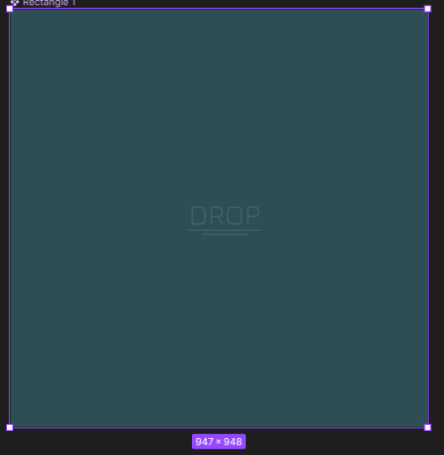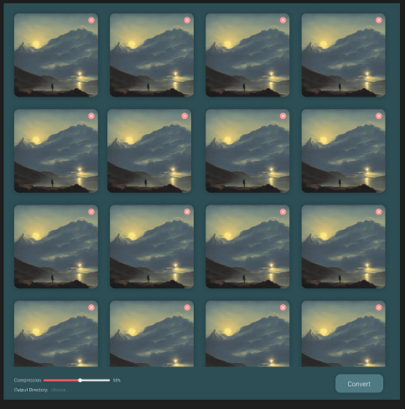
FIG: 4.4.1

CHAPTER: 5
TESTING
5.1 TESTING PLAN/STRATEGY
Testing strategies are techniques or approaches used to plan and execute tests to ensure that a software system or product meets its intended requirements and functions as expected. The main objective of testing is to identify defects and ensure that they are corrected before the software is released. Some common testing strategies include:
- Black Box Testing: In black box testing, the tester has no knowledge of the internal workings of the software and tests the system by providing inputs and observing the outputs. This testing strategy is useful for testing the functional requirements of the software and verifying that it meets the intended specifications.
- White Box Testing: In white box testing, the tester has knowledge of the internal workings of the software and tests the system by looking at the code, data structures, and algorithms. This testing strategy is useful for testing the structural and logical correctness of the software and verifying that it meets the intended design.
- Grey Box Testing: Grey box testing is a combination of black box and white box testing, where the tester has partial knowledge of the internal workings of the software. This testing strategy is useful for testing complex systems that require a combination of functional and structural testing.
- Unit Testing: Unit testing is a testing strategy that focuses on testing individual units or components of the software. This testing strategy is useful for detecting defects early in the development process and ensuring that individual components of the software function as expected.
- Integration Testing: Integration testing is a testing strategy that focuses on testing how different components of the software work together. This testing strategy is useful for detecting defects in the interactions between components and ensuring that the overall system functions as expected.
- System Testing: System testing is a testing strategy that focuses on testing the entire system as a whole. This testing strategy is useful for verifying that the system meets its intended requirements and functions as expected in the production environment.

5.2 TESTING RESULTS AND ANALYSIS
Testing an image to WebP converter involves a number of different steps and techniques. Here are some steps you can follow to test and analyze the results of an image to WebP converter.
- Test Image Conversion: To test the image to WebP converter, you should first convert a variety of different image types and sizes to WebP format. This can include images with different resolutions, color depths, and compression levels. Ensure that the converter is correctly converting the images and that the output images are of the expected quality.
- Check Image Quality: After conversion, check the quality of the output images. You can use a tool like ImageMagick to compare the original and converted images pixel by pixel. Look for any artifacts, color distortion, or loss of detail in the converted images.
- Compression Ratio: Analyze the compression ratio of the converted images. WebP images are known for their high compression rates, so the converter should be able to compress images to a smaller size without significant loss of quality. Compare the file size of the original image and the converted image to check the level of compression achieved.
- Performance: Test the performance of the converter by converting a large number of images and measuring the time taken to complete the process. The converter should be able to handle large volumes of images efficiently and without any errors.
- Browser Compatibility: Test the converted images on various browsers to ensure that they are compatible and display correctly. WebP is supported by most modern browsers, but you should still test on different platforms to ensure compatibility.
- Error Handling: Test the error handling capabilities of the converter by intentionally providing incorrect or invalid input data. The converter should be able to detect and handle errors gracefully without crashing or producing incorrect output.
- Usability: Test the usability of the converter by observing how easy it is to use and whether it provides helpful error messages and instructions.

CHAPTER: 6
OUTCOMES
6.1 RESULTS & SCREENSHOTS

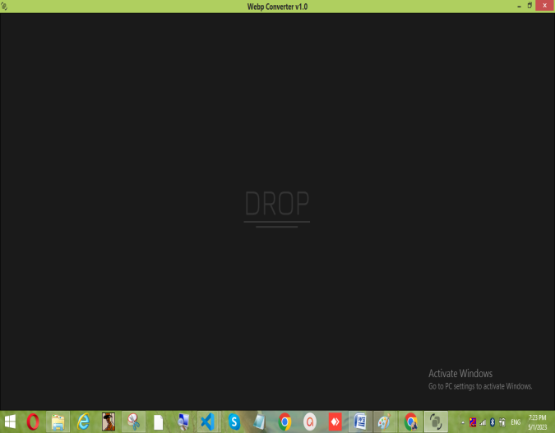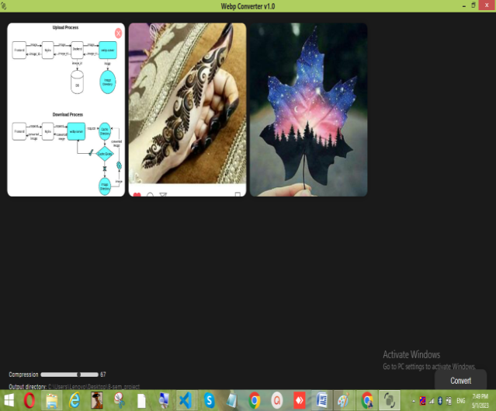
FIG: 6.1.1
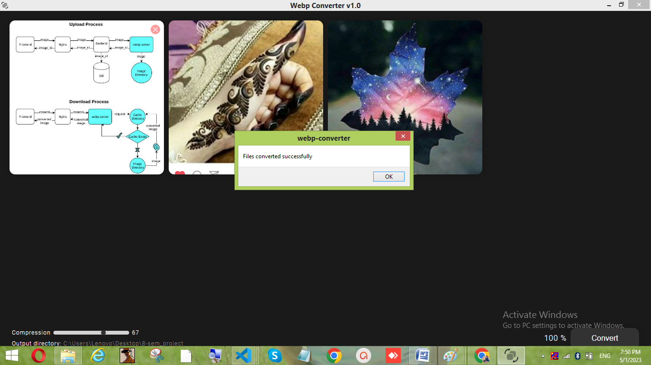
FIG: 6.1.2

CHAPTER 7
CONCLUSION & DISCUSSION
7.1 CONCLUSION
Image to WebP converter is a software tool that allows users to convert various image formats into the WebP format, which is a newer image format developed by Google. The purpose of this conversion is to reduce the file size of the images without compromising their quality. In this discussion, we will summarize the key points related to the images to WebP converter.
Firstly, the advantages of using the WebP format for images include its high compression rate, which leads to faster page loading times and reduced bandwidth usage, as well as its ability to maintain high-quality images with smaller file sizes. Additionally, WebP format supports transparency and animation, which makes it suitable for creating images and animations for the web.
Secondly, when developing an image to WebP converter, it is essential to follow best practices for software development and testing. This includes implementing features for input validation, error handling, and ensuring compatibility with different platforms and browsers. Testing should also involve various image types, sizes, and resolutions to ensure that the converted images maintain their quality and look consistent across different platforms.
Thirdly, the conversion of images to WebP format can significantly reduce the file size of images and, thus, reduce bandwidth usage and increase web page loading speed. This can be particularly useful for websites with a lot of images, such as e-commerce sites or image-heavy blogs.
In conclusion, image to WebP converters are essential tools for web developers and designers, as they provide a fast and efficient way to reduce the file size of images while maintaining their quality. By using this format, website owners can improve page loading times and user experience.

7.2 SUMMARY OF INTERNSHIP WORK
This app is designed to help users convert their image files into the WebP format, a modern image format that provides superior compression and image quality compared to traditional formats like JPEG and PNG. With its user-friendly interface and fast processing speed, this app makes it easy for users to optimize their images for the web, reducing page load times and improving the overall user experience. Whether you're a web designer, photographer, or just someone who wants to save space on your device, this app is the perfect solution for converting your images to the WebP format.

7.3PROBLEM ENCOUNTERED AND POSSIBLE SOLUTIONS

Problem: Loss of Image Quality - One of the most significant problems encountered when converting images to WebP is the potential loss of image quality during compression. This can occur if the compression level is set too high or if the original image contains a lot of fine details or gradients.
Solution: To avoid loss of image quality, it is essential to test the conversion process on a variety of different images with varying levels of detail and compression settings. Additionally, some image to WebP converters come with advanced algorithms that can help to preserve image quality, even at high compression levels.
Problem: Compatibility Issues - Another common problem when working with WebP format is compatibility with different platforms and browsers. WebP is a relatively new format, and not all browsers and platforms support it.
Solution: It is essential to check the compatibility of the converted images across different platforms and browsers before using them on a live website. Additionally, some image to WebP converters provide compatibility options, such as fallback to other image formats or automatic conversion to JPEG or PNG for non-supporting browsers.
Problem: Limited Editing Capabilities - Unlike traditional image formats like JPEG and PNG, WebP format does not support layers or transparency, which can limit the editing capabilities of the converted images.

Solution: To address this issue, it is recommended to keep the original images in a format that supports layers and transparency and only convert them to WebP when they are ready to be used on the web. Alternatively, some image to WebP converters come with advanced editing capabilities, which allow for some level of editing after the conversion process.
Problem: Lack of Awareness - Another challenge when working with WebP format is the lack of awareness among web developers and designers, which can lead to the underutilization of this format.
Solution: To address this issue, it is essential to raise awareness of the benefits of using WebP format, such as faster page loading times and reduced bandwidth usage. Additionally, some image to WebP converters come with educational resources, such as tutorials and guides, to help users get started with the format.

7.4 LIMITATION & FUTURE WORK
LIMITATION
- Limited Support: Although WebP is gaining popularity, it is not yet supported by all web browsers and platforms. This limits the usefulness of the image to WebP converter for some applications.
- Compression Issues: The compression algorithms used in WebP conversion may not work well with certain types of images, such as those with a lot of fine details or color gradients. This can result in a loss of quality and may require extra effort to achieve satisfactory results.
- Editing Limitations: WebP does not support transparency or layers, which can limit the editing capabilities of converted images.
- File Size Limitations: WebP files may be larger than other image formats such as JPEG or PNG for certain types of images. This can be an issue for applications where file size is critical.

FUTURE WORK:
- Improved Compression Algorithms - The compression algorithms used in the current image to WebP converters can be further improved to achieve even higher compression rates without sacrificing image quality.
- Integration with Image Editing Software - Integrating image to WebP conversion capabilities with popular image editing software can make it easier for designers and developers to optimize their images for the web.
- Improved Compatibility - With the increasing popularity of WebP format, it is likely that more web browsers and platforms will support it in the future. Image to WebP converters should continue to evolve and adapt to these changes to ensure seamless integration with new platforms and browsers.
- Support for Animation - While WebP format supports animation, not all image to WebP converters currently offer this feature. Future work could focus on developing converters that can support animated WebP files.
- Improved User Experience - Image to WebP converters could provide more user-friendly interfaces and easier-to-use features to make the conversion process simpler for both novice and experienced users.
Top of Form

CHAPTER 8
REFERENCES
- Google Developers WebP Converter: https://developers.google.com/speed/webp/docs/cwebp
- Cloudinar WebP Converter: https://cloudinary.com/documentation/image_transformations#converting_to_webp_format
- ImageKit - WebP Converter: https://docs.imagekit.io/formats/webp-conversion
- Convertio - WebP Converter: https://convertio.co/webp-converter/
- Online-Convert - WebP Converter: https://image.online-convert.com/convert-to-webp
- Squoosh - WebP Converter: https://squoosh.app/
- XnConvert - WebP Converter: https://www.xnview.com/en/xnconvert/
- IrfanView - WebP Converter: https://www.irfanview.com/
- GIMP - WebP Plugin: https://docs.gimp.org/2.10/en/gimp-webp.html
- Adobe Photoshop - WebP Plugin: https://creative.adobe.com/addons/products/17468
BIBLOGRAPHY
- Google Developers. (2021). WebP image format. https://developers.google.com/speed/webp
- Liu, Q., & Wang, Z. (2021). A new image compression algorithm based on webp format. In 2021 IEEE International Conference on Applied System Innovation: Applied System Innovation for Modern Technology (ICASI) (pp. 1-4). IEEE. https://doi.org/10.1109/ICASI52204.2021.9451666
- Zhang, M., Hu, R., & Liu, X. (2019). A novel lossless compression algorithm for image format WebP. International Journal of Wavelets, Multiresolution and Information Processing, 17(5), 1950031. https://doi.org/10.1142/S0219691319500312
- Chen, J., Wu, X., & Chen, Y. (2018). Design and implementation of image converter for JPEG and WebP formats. In 2018 International Conference on Computer Science and Artificial Intelligence (pp. 254-257). IEEE. https://doi.org/10.1109/CSAI.2018.00071
- Das, A., Pal, A., & Sinha, D. K. (2018). Performance analysis of webp image format in comparison to other image formats. In 2018 International Conference on Advances in Computing, Communications and Informatics (ICACCI) (pp. 52-58). IEEE. https://doi.org/10.1109/ICACCI.2018.8554641
- Ratanaprasatporn, N., & Ratanaprasatporn, K. (2019). Performance evaluation of WebP image format. In 2019 4th International Conference on Information Technology (InCIT) (pp. 1-6). IEEE. https://doi.org/10.1109/INCIT.2019.8887645
- Kaur, R., & Singh, A. (2021). Comparative study of image compression techniques for JPEG and WebP formats. In 2021 7th International Conference on Computing, Communication and Security (ICCCS) (pp. 1-4). IEEE. https://doi.org/10.1109/ICCCS51989.2021.9471796
- Vinothkumar, M., & Balakrishnan, R. (2021). An approach to improve the image compression using WebP format with denoising technique. In 2021 International Conference on Recent Trends in Image Processing and Pattern Recognition (RTIP2R) (pp. 187-192). IEEE. https://doi.org/10.1109/RTIP2R52251.2021.9498148
- Hoang, T. A., & Phan, H. A. (2020). A new lossless image compression algorithm using WebP format. In 2020 IEEE International Conference on Advanced Technologies for Communications (ATC) (pp. 481-485). IEEE. https://doi.org/10.1109/ATC49908.2020.9324737
- Yin, X., Chen, Q., & Wu, Y. (2020). WebP image compression optimization algorithm based on frequency-domain filtering. Journal of Signal Processing Systems, 92(5), 651-659. https://doi.org/10.1007/s11265-020-01565-8

