TATA TECHNOLOGIES LTD.
TECH PULSE FY-26 | AI/ML Capstone Project
TECHNICAL REPORT
Field | Details
Institute / University | Pimpri Chinchwad College of Engineering (PCCOE), Pune
Programme / Batch | TECH PULSE FY-26 | AI/ML Capstone Project
Student Name | Ayan Mujawar
PRN | 123B1B196
Case Study ID (CS1–CS5) | CS5 – Case Study 5
Project Title | UDS Diagnostics and Automated Test Generation Assistant

1. Problem Statement and Intended Users
Unified Diagnostic Services (UDS, ISO 14229) testing asks engineers to combine the generic standard with OEM-specific and ECU-specific implementations. For every requirement a test engineer has to work out the right service and sub-function, the data or routine identifier, the diagnostic session and security level needed, the exact request bytes, the expected positive response and the negative response codes (NRCs) that should appear when a precondition is violated. That knowledge is spread over long PDFs and spreadsheets, so the same requirement is often tested differently by different people, negative cases are skipped, and small byte-level mistakes (wrong length, wrong response SID, missing session switch) slip into automation scripts.
This project proposes a local, retrieval-augmented assistant that answers diagnostic questions with citations, builds and validates request/response structures through deterministic protocol rules, generates positive and negative test cases with preconditions and pass/fail criteria, and exports approved cases as Python or CAPL templates. The language model plans and explains; a rule engine owns every hex byte; an engineer approves every test before it can be exported or executed.
Intended users: diagnostic test engineers (primary), ECU software developers, validation engineers, test-automation developers, technical leads and quality managers who review coverage.

2. Input Data / Knowledge Base
Item | Description
Sources | Synthetic, self-authored knowledge base only (no copyrighted ISO text, no confidential OEM data): (1) UDS service guide written in our own words — 12 services (0x10, 0x11, 0x14, 0x19, 0x22, 0x27, 0x28, 0x2E, 0x31, 0x34/0x36/0x37 summary, 0x3E, 0x85) and 15 common NRCs; (2) fictional 'Demo OEM' diagnostic spec with session timing (P2/P2*), security rules and OEM NRC preferences; (3) ECU extract for a fictional Body Control Module 'BCM-X1' — ~25 DIDs, 6 RIDs, 3 sessions, 2 security levels; (4) ~40 diagnostic requirements; (5) ~20 existing reviewed test cases; (6) Python (udsoncan) and CAPL automation templates.
Size and format | Approx. 15 files, ~60–80 pages equivalent: Markdown/PDF for prose (service guide, OEM spec), JSON/CSV for tables (DIDs, RIDs, NRCs, sessions, requirements, tests), Jinja2 for templates. Expected index size: ~300–400 chunks across 4 collections (standard_uds, oem_spec, ecu_extract, project_reqs).
Preprocessing / EDA done | Planned: text extraction with pdfplumber/PyMuPDF; normalisation of hex notation (0x22, 22h, $22 → 0x22) and DID/RID formats; de-duplication; schema checks on JSON tables (every DID has length, access sessions, security level); EDA on service/NRC frequency, DID count per access level, requirement-to-service distribution and coverage gaps in the existing test set (e.g. how many requirements have no negative test).
Chunking strategy | Structure-aware: each table row group (one service, one DID, one RID, one NRC) becomes its own chunk so identifiers are never split; prose sections use ~400-token windows with 60-token overlap, split on headings. Every chunk carries metadata — collection, source file, section, ID (e.g. ECU-DID-F190), version — used for filtering and for citations.

3. Solution Architecture

Component | Choice (name, version, hosting)
Pre-trained model | Qwen3-4B (qwen3:4b, Q4_K_M quantised, Apache-2.0) served locally through Ollama on the developer laptop; temperature 0.1, JSON-format output. Alternatives evaluated if needed: Llama-3.2-3B, Mistral-7B. No cloud API.
Embedding model | BAAI/bge-small-en-v1.5 (384-dim, sentence-transformers, run locally on CPU); sentence-transformers/all-MiniLM-L6-v2 as a fallback. Combined with a BM25 keyword index because exact hex IDs (0x2E, F190) matter.
Vector store (FAISS / ChromaDB) | FAISS (faiss-cpu) IndexFlatIP on L2-normalised vectors (cosine), one index per collection persisted to disk with a JSON metadata side-file; allows filtering Standard / OEM / ECU / Project evidence separately.
RAG pipeline / AI-agent design | Custom Python pipeline: query/requirement → hybrid retrieval (dense + BM25, reciprocal-rank fusion, top-k = 6) → controlled prompt with numbered evidence → LLM returns JSON (service, identifiers, scenario list, cited chunk IDs) → guardrails → deterministic rule engine builds bytes and expected responses → structured test case stored as DRAFT → engineer review.
Service layer and UI | FastAPI (uvicorn) REST API: /ask, /validate-request, /generate-tests, /review, /export, /coverage. Streamlit UI with tabs for Q&A, request validator, test generator, review queue, export and coverage. SQLite for test cases, approvals and audit log.
Tools / deterministic rules | UDS rule engine (pure Python): service table with valid sub-functions and min/max lengths; positive response SID = request SID + 0x40; negative response 0x7F + SID + NRC; session/security precondition matrix; DID/RID whitelist from the ECU extract; NRC derivation (0x12, 0x13, 0x22, 0x24, 0x31, 0x33, 0x35, 0x7E, 0x7F). Exporter: Jinja2 templates for Python (python-can + udsoncan) and CAPL.

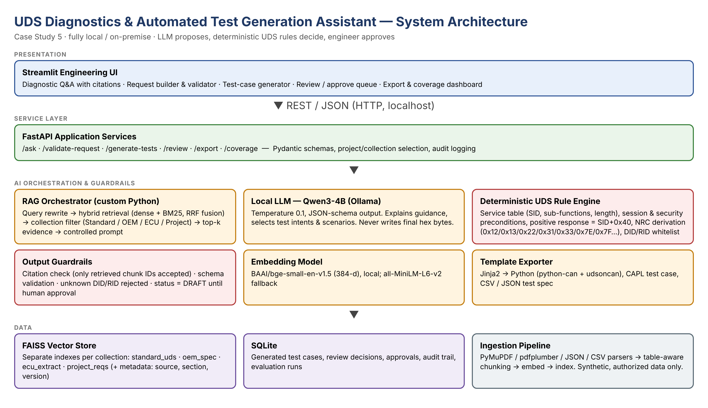
Figure A: System architecture of the UDS Diagnostics and Test Generation Assistant

4. Implementation and Configuration
Implemented in four increments, matching the case-study phases: (1) knowledge pilot — ingestion of the synthetic knowledge base into 151 structure-aware chunks, FAISS + BM25 indexes with reciprocal-rank fusion and cited Q&A with an identifier guard, an out-of-scope guard and a citation guardrail; (2) test generation — a deterministic UDS rule engine (virtual BCM-X1), a scenario-planning prompt, guardrails, a coverage checklist and a DRAFT → APPROVED review workflow in SQLite; (3) automation — Jinja2 export of approved cases to Python (python-can + udsoncan) and CAPL; (4) a coverage view, evaluation script, 22 unit tests and a FastAPI REST API. Docker packaging is left as future work.
Key configuration (Model_Prompts_Config/config.yaml): LLM qwen3:4b (Ollama 0.40.8, temperature 0.1, num_ctx 4096 — reduced from the planned 8192 so the model fits the 4 GB GPU — format=json, thinking disabled); embeddings bge-small-en-v1.5; FAISS IndexFlatIP; BM25Okapi; RRF k=60; top-k 6 with max 3 chunks per collection; out-of-scope threshold 0.55 cosine; SQLite database Code/uds_assist.db; FastAPI on 127.0.0.1:8000, Streamlit on localhost:8501. Prompts are version-controlled files and every generated case stores the model name, prompt version and cited chunk IDs.
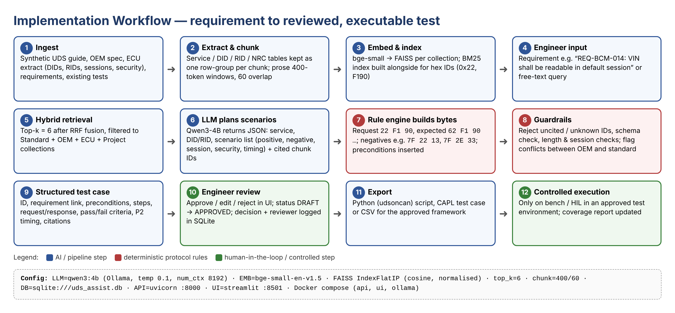
Figure B: Implementation workflow from requirement to reviewed, exportable test

5. Evaluation Steps and Results
Evaluation (Code/evaluate.py, run run_20261023_122136, model qwen3:4b): a hand-built ground-truth set of 30 diagnostic questions (27 in scope, each mapped to the chunk IDs that answer it, plus 1 unknown-identifier probe and 2 off-topic questions), 20 hand-labelled request/response pairs, and an expert scenario checklist for 10 requirements. Metrics: retrieval Hit@k and MRR (dense vs BM25 vs hybrid ablation), grounded-answer rate, citation validity and relevance, keyword recall against expected facts (faithfulness proxy), abstention accuracy, rule-engine accuracy, scenario recall/precision, JSON validity and latency. All numbers below are measured; failures are reported.
# | Test question / scenario | Expected answer / behaviour | Result (Pass/Fail, notes)
1 | Q&A: 'What is required to read the VIN on BCM-X1?' | Cites ECU-DID-F190 and the 0x22 service chunk; request 22 F1 90, positive 62 F1 90 + 17 bytes, default session, no security | Pass — cited ["REQ-BCM-008", "ECU-DID-F190", "ECU-SVC-22"]; keyword recall 1.0; 11.78 s
2 | Validate request '2E 4A 10' (missing data byte) in extended session, unlocked | Rule engine flags length error; expected NRC 0x13 → 7F 2E 13 | Pass — rule engine returns 7F 2E 13 (incorrectMessageLengthOrInvalidFormat)
3 | Generate tests for REQ-BCM-021 (write DID 0x4A10 only in extended session + security level 1) | Positive (6E 4A 10), session-negative (7F 2E 7F or OEM-defined NRC), security-negative (7F 2E 33), length (7F 2E 13), range (7F 2E 31); all cited, status DRAFT | Pass — LLM proposed ["out_of_range", "positive", "security_locked", "wrong_session"], checklist added ["wrong_length", "unsupported_identifier"]; final ["out_of_range", "positive", "security_locked", "unsupported_identifier", "wrong_length", "wrong_session"]; bytes 6E 4A 10 / 7F 2E 7F / 7F 2E 33 / 7F 2E 13 / 7F 2E 31; status DRAFT
4 | SecurityAccess sequence: send key 27 02 without requesting a seed first | Expected 7F 27 24 (requestSequenceError); wrong key → 7F 27 35; repeated wrong keys → 7F 27 36 | Pass — 27 02 without seed → 7F 27 24; invalid keys → 7F 27 35, 7F 27 35, 7F 27 36; next seed → 7F 27 37 (unit test + case V09)
5 | Out-of-scope / hallucination probe: 'Read DID 0xF1A5' (not in ECU extract) | Assistant states the DID is not in the approved extract, proposes only a negative test (7F 22 31) and does not invent a data length | Pass — identifier_guard: states 0xF1A5 is not in the extract, proposes only 22 F1 A5 → 7F 22 31

Metric | Score / observation
Answer relevance / faithfulness | Grounded (cited) answers 100% of 27 in-scope; mean keyword recall 0.969, fully correct 93%; rule-engine corrections 0; abstention on unknown-ID / off-topic 100%; false abstentions 0%
Retrieval hit rate / citation accuracy | Hybrid Hit@1 0.852, Hit@3 0.926, MRR 0.892 (dense MRR 0.878, BM25 MRR 0.822); citation validity 100%, citation relevance 96%
Latency | Q&A median 9.55 s (max 18.1 s); test generation median 11.61 s per requirement; retrieval + rules < 1 s when the LLM is idle (RTX 3050 4 GB, ~66 % of layers on GPU)
Rule engine (20 request/response pairs) | Validity accuracy 100%; exact expected-response match 100%
Test generation (10 requirements) | LLM scenario recall 0.382, precision 1.0; after checklist completion recall 1.0, precision 1.0; JSON valid 100%; schema compliance 100%; citations existing in KB 100%; 46 cases

6. Responsible AI Measures
Area | Measure adopted in this project
Grounding and citations | Answers and test cases are built only from retrieved chunks; every claim carries a chunk ID; outputs citing an ID that was not retrieved are rejected. Hex bytes come from the deterministic rule engine, never from free LLM text. Conflicts between standard and OEM evidence are flagged instead of silently resolved.
Privacy | Fully local: LLM, embeddings, vector store and database run on the developer machine; no prompts or documents leave it. Only synthetic data is used — no ISO text, OEM documents or real VINs.
Security | Separate collections per source (Standard / OEM / ECU / Project) to avoid cross-project leakage; API bound to localhost; input validation with Pydantic; no execution against vehicles — exported scripts are templates meant for an approved bench/HIL environment only.
Human oversight / review | Every generated test is stored as DRAFT; only an engineer can Approve, Edit or Reject it, and only APPROVED cases can be exported. Reviewer, timestamp, model and prompt version are logged in SQLite for audit.

7. Innovation Highlights
Beyond the baseline RAG chatbot, the design adds:
- LLM-plans / rules-decide split: the model selects scenarios and explains them, while a deterministic UDS rule engine generates and checks every request and expected response — removing byte-level hallucination. A rule-consistency guardrail corrects any LLM answer whose NRC or bytes contradict the rule engine (found in testing: Qwen3-4B said 0x31 instead of 0x33 for a locked write).
- Hybrid dense + BM25 retrieval with structure-aware chunking so identifiers like 0xF190 or NRC 0x7E are retrieved exactly, plus collection filters that keep standard, OEM and ECU knowledge apart.
- Coverage-driven generation: each requirement is checked against a scenario checklist (positive, wrong session, locked security, wrong length, out-of-range, sequence error) and the UI shows which categories are still missing.
- One-click export of approved cases to Python (udsoncan) and CAPL templates, with requirement ID and citations embedded as comments for traceability.

8. Screenshots, Logs and Evidence
Figures below are real screenshots of the running system (captured 23/10/2026). Per-item logs: Evaluation_Results/run_20261023_122136/ (qa_results.csv, retrieval_results.csv, rule_engine_results.csv, generation_results.csv, sample_outputs.md) and the SQLite audit log.
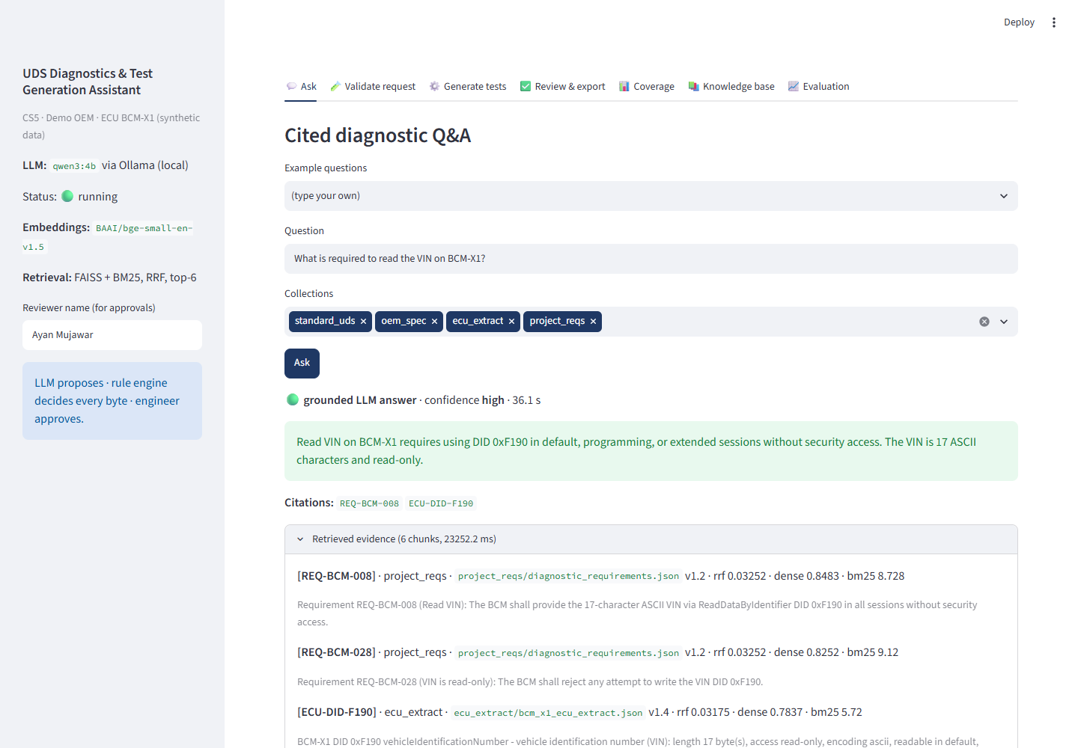
Figure 1: Ask tab — grounded answer for the VIN question with chunk-ID citations, rule-engine byte table and the retrieved evidence (dense, BM25 and RRF scores).

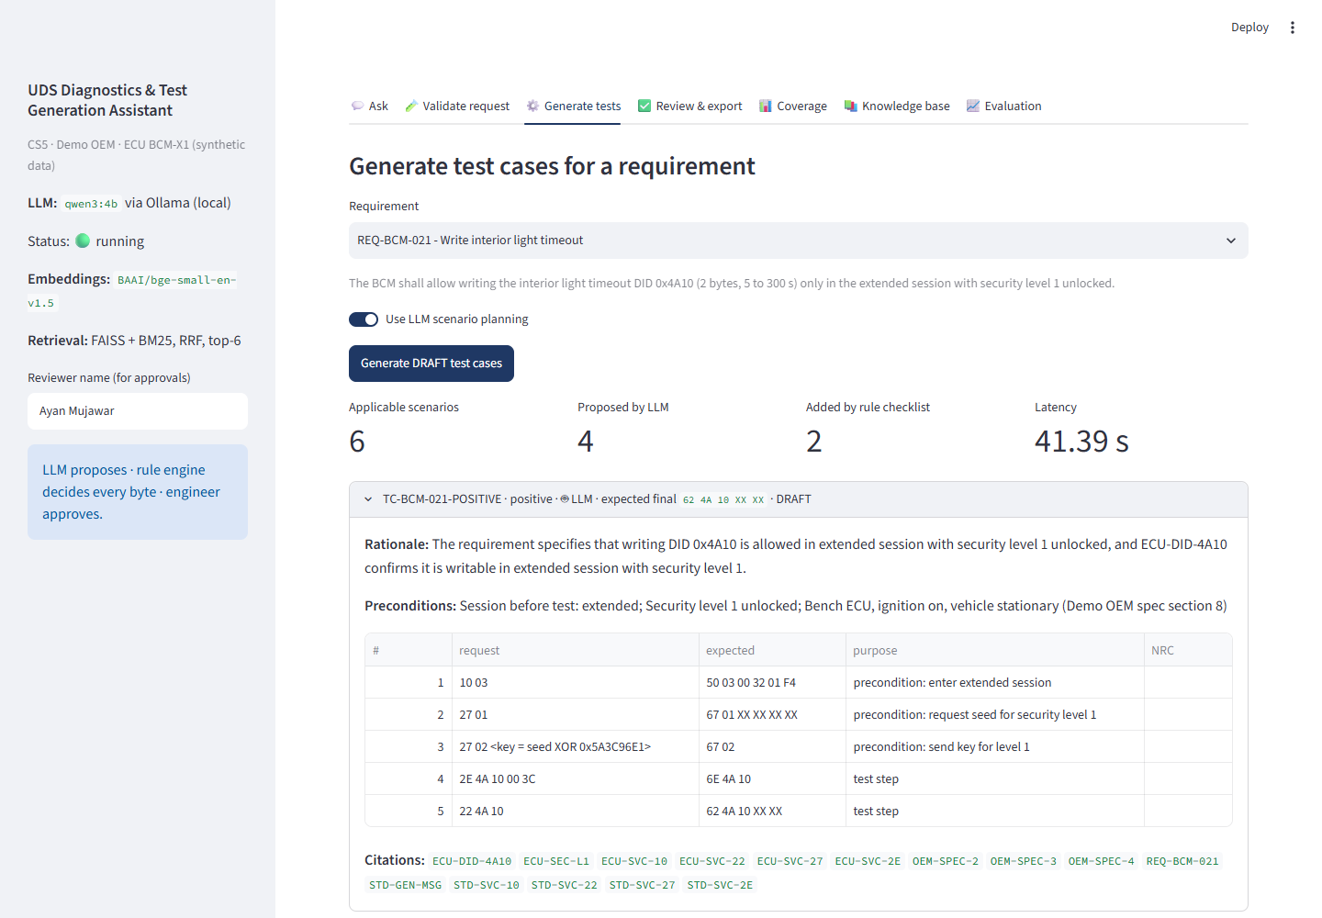
Figure 2: Generate tests — REQ-BCM-021: LLM-proposed and checklist-added scenarios, rule-engine request/expected bytes per step, citations, saved as DRAFT.
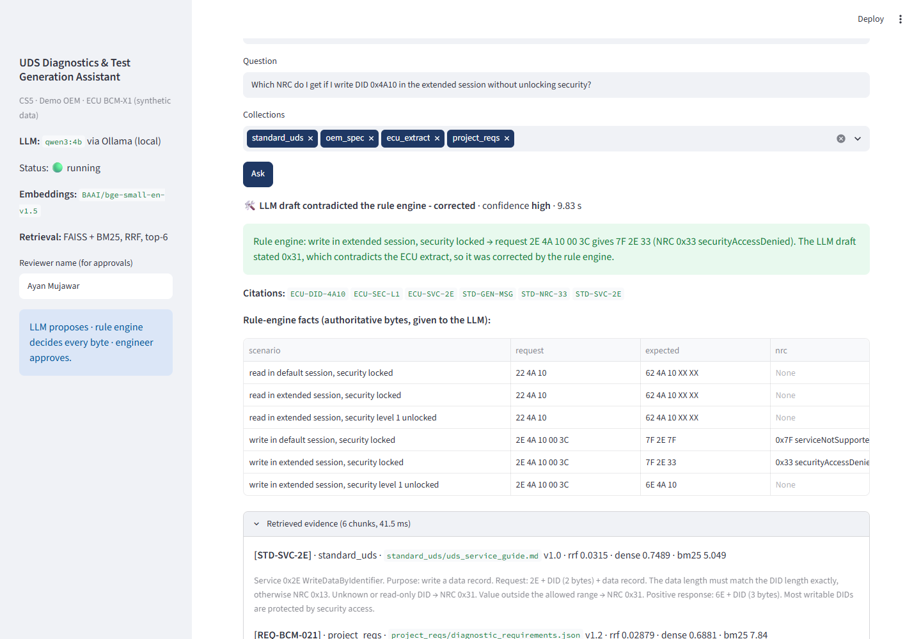
Figure 3: Rule-consistency guardrail correcting a wrong NRC in the LLM draft.
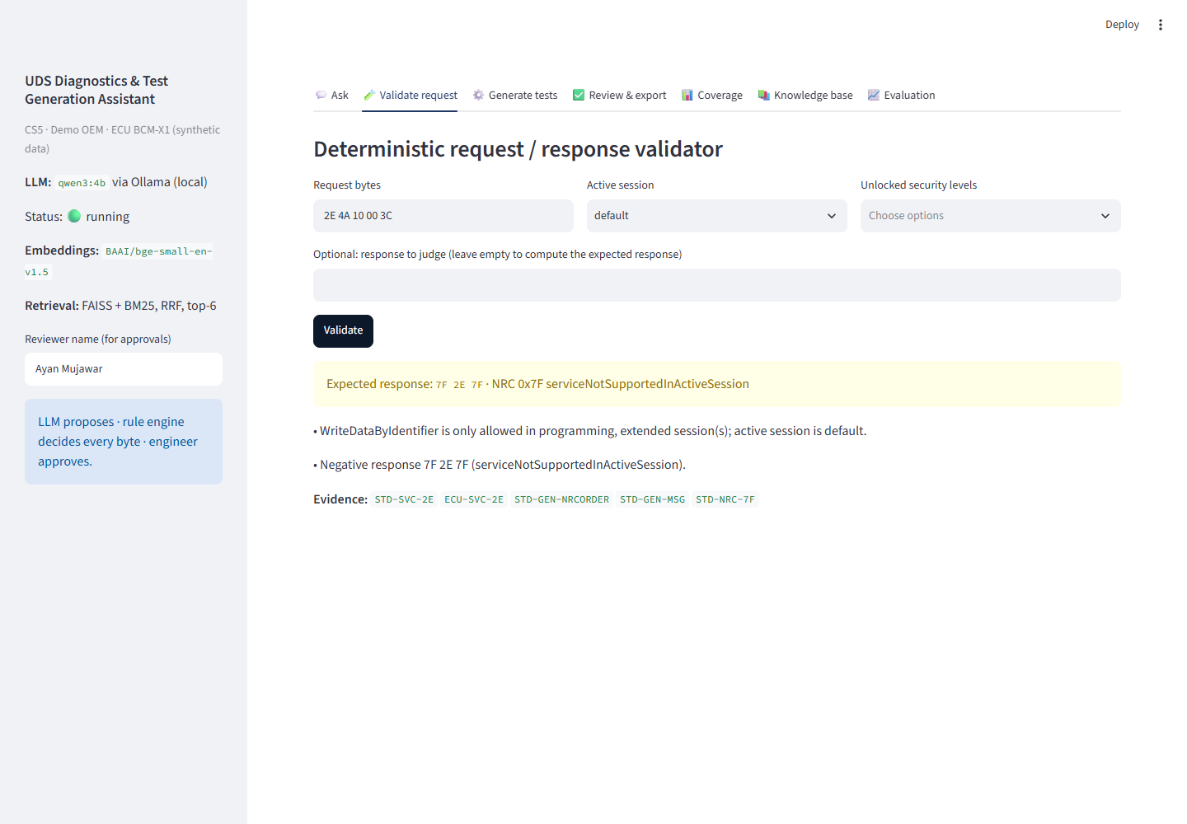
Figure 4: Deterministic request validator — 2E 4A 10 00 3C in the default session → 7F 2E 7F with explanation and evidence.
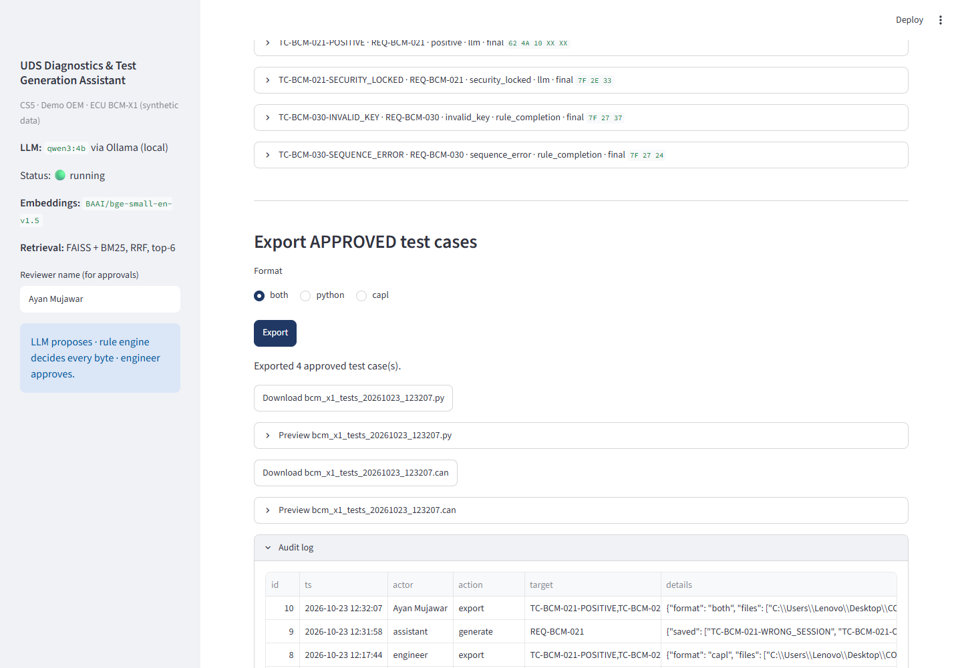
Figure 5: Review & export — APPROVED cases exported to Python/CAPL, with the audit log.
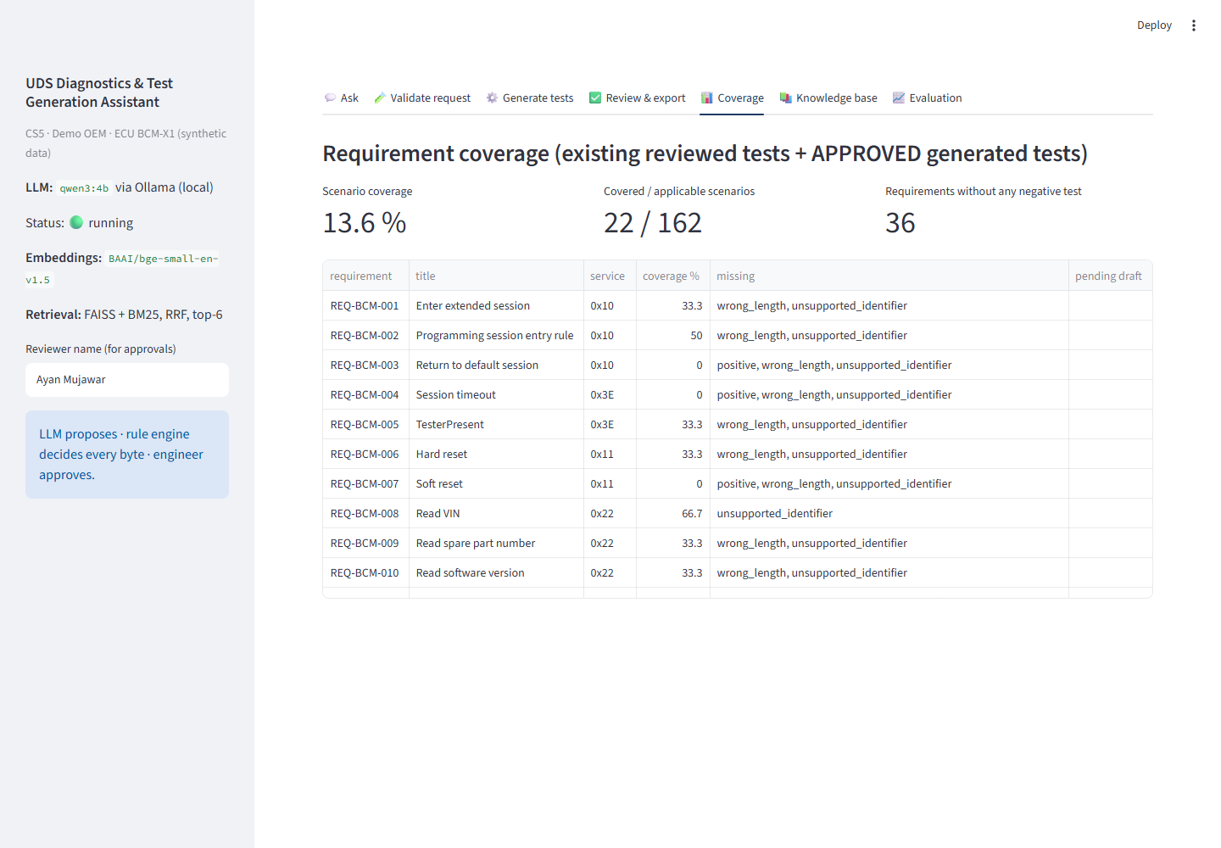
Figure 6: Coverage view — applicable scenarios per requirement vs reviewed tests.
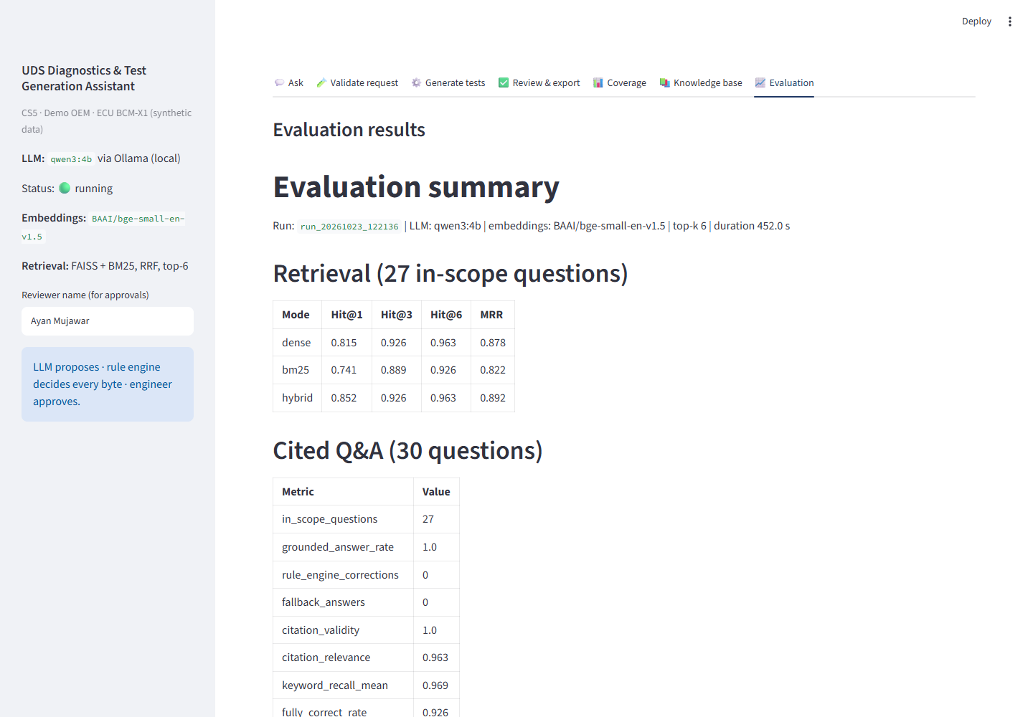
Figure 7: Evaluation tab — measured metrics of the submitted run.

9. Reflection and Conclusions
Key learnings, challenges faced, limitations, and future improvements.
Key learning: in a protocol domain, the safest use of an LLM is narrow — retrieving and reasoning over evidence, choosing what to test — while protocol facts (lengths, SIDs, NRCs, preconditions) belong to deterministic rules that can be unit-tested.
Challenges faced: (1) per-collection rank fusion pushed the 8-chunk OEM collection to the top of every query — fixed by fusing one global dense list with one global BM25 list and capping 3 chunks per collection; (2) the VIN chunk was missed because the extract only said 'vehicleIdentificationNumber' — fixed with readable names and aliases; (3) Qwen3-4B sometimes states a wrong NRC even when given the rule table — fixed by the rule-consistency guardrail; (4) the 4 GB GPU could not hold the model at num_ctx 8192 — reduced to 4096; (5) the local 4B model needs ~10-40 s per answer, so the UI shows evidence and rule results immediately.
Limitations: synthetic knowledge base for a single fictional ECU; no live CAN/DoIP connection; timing tests (P2/P2*) are generated but cannot be verified without a bench; a 4B model on CPU is slow for long requirement batches.
Future improvements: python-can/udsoncan execution against a virtual ECU simulator, a Neo4j traceability graph (requirement → test → result), coverage analytics across programs, PostgreSQL and role-based access for multi-user use, and CI-based regression of prompts and rules.

10. AI-Tool Usage Declaration
AI tool / model | Purpose | Artifact affected | Verified by Student (Y/N)
Claude (Anthropic) | Code scaffolding and review, synthetic knowledge-base drafting, documentation and diagrams | Source code, synthetic input data, synopsis, technical report | Y
Qwen3-4B via Ollama (local) | Runtime model inside the assistant for scenario planning and explanations | Generated Q&A and DRAFT test cases (always reviewed) | Y

11. Student Declaration
I confirm that this report represents my own understanding and contribution, that the work follows the approved case-study scope, and that I can explain every significant part of the implementation.

Signature: | 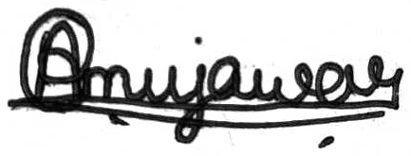 | Date: | 15/10/2026
Name: | Ayan Mujawar | PRN: | 123B1B196

