TATA TECHNOLOGIES LTD.
TECH PULSE FY-26 | AI/ML Capstone Project
PROJECT SYNOPSIS

Student Details
Institute/University: Pimpri Chinchwad College of Engineering (PCCOE), Pune
Programme / Batch: TECH PULSE FY-26 | AI/ML Capstone Project
Student Name: Ayan Mujawar
PRN: 123B1B196
1. Case Study ID and Project Title / Topic
Case Study ID (CS1 to CS5): CS5 – Case Study 5
Project Title / Topic: UDS Diagnostics and Automated Test Generation Assistant
2. Objectives
Define the specific objectives and focus areas of the allocated AIML case study.
Objectives
- Reduce the effort needed to interpret UDS, OEM and ECU diagnostic specifications through cited natural-language Q&A.
- Generate consistent positive and negative test scenarios (session, security, length, range, sequence) for each diagnostic requirement.
- Validate request and expected-response structures with deterministic protocol rules so no byte-level value comes from the LLM.
- Convert approved test cases into executable Python (udsoncan) or CAPL templates with full traceability to requirements and sources.
3. Scope
Clearly state what will be implemented in the project and what will not be covered. Respect mandatory controls such as citations, human review, and approved or synthetic data.
In Scope – To Be Implemented
- Ingestion and hybrid retrieval over a synthetic UDS, OEM and ECU knowledge base with citations.
- Service, sub-function, DID, RID, NRC, session and security guidance; request construction and validation.
- Structured test-case generation with preconditions, pass/fail criteria and positive/negative coverage.
- Engineer review workflow (DRAFT → APPROVED), audit log, and export to Python/CAPL templates.
Out of Scope – Will Not Be Implemented
- Execution against production vehicles or real ECUs without controlled bench safeguards.
- Use of copyrighted ISO 14229 text or confidential OEM documents (synthetic data only).
- Automatic acceptance of ECU behaviour or test results without engineer review.
4. Proposed Approach
Pre-trained model (name, version, local/private hosting)
Qwen3-4B (qwen3:4b, Q4_K_M) served locally via Ollama; temperature 0.1, JSON output.
Runs fully on the laptop (CPU); Llama-3.2-3B / Mistral-7B as alternatives if quality is insufficient.
Embedding model
BAAI/bge-small-en-v1.5 (384-dim) via sentence-transformers, local; all-MiniLM-L6-v2 fallback.
Paired with a BM25 index so exact hex identifiers (0x22, F190, NRC 0x33) are matched.
Vector store (FAISS / ChromaDB)
FAISS (faiss-cpu) IndexFlatIP with normalised vectors, persisted to disk.
Separate indexes per collection: standard_uds, oem_spec, ecu_extract, project_reqs, with metadata for filtering and citations.
RAG pipeline and/or AI-agent design – brief description
Requirement/query → hybrid retrieval (RRF, top-6) → controlled prompt → LLM returns JSON scenarios + cited chunk IDs.
Guardrails reject uncited/unknown IDs; rule engine builds bytes and expected responses; result stored as DRAFT for review.
Service layer and UI (e.g., FastAPI / Flask / Streamlit)
FastAPI backend (/ask, /validate-request, /generate-tests, /review, /export, /coverage).
Streamlit UI with Q&A, validator, generator, review, export and coverage tabs; SQLite for approvals and audit.
Tools / deterministic rules, if applicable
UDS rule engine: service table (SID, sub-functions, lengths), positive SID = SID + 0x40, negative 0x7F + SID + NRC.
Session/security precondition matrix, DID/RID whitelist from ECU extract, NRC derivation; Jinja2 exporter for Python/CAPL.
Proposed System / Architecture
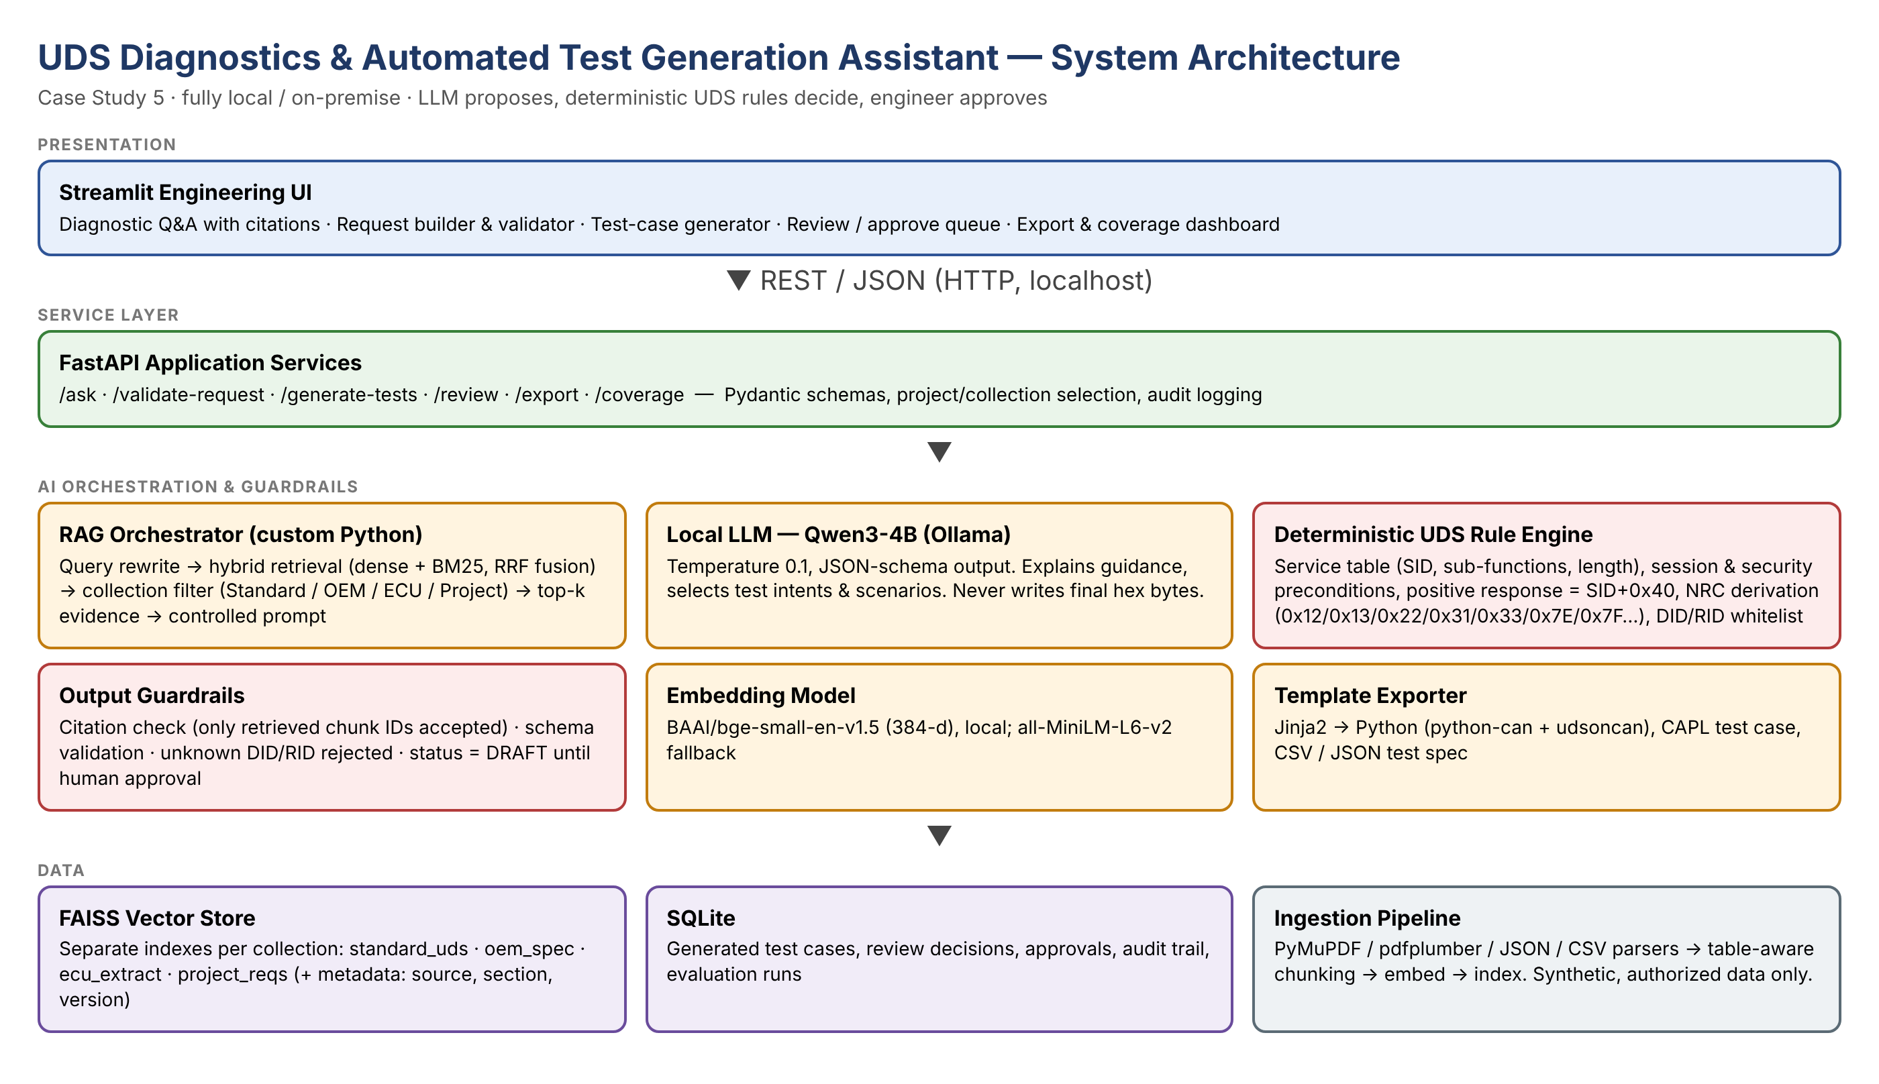
Figure 1: Proposed system architecture (LLM proposes, deterministic UDS rules decide, engineer approves)
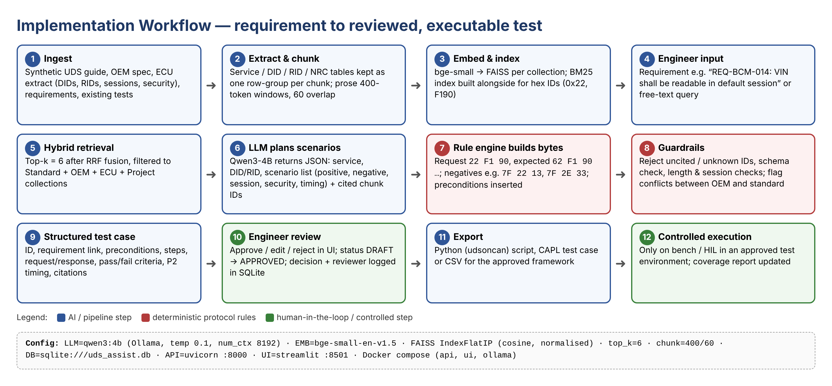
Figure 2: Planned workflow from requirement to reviewed, exportable test case
5. Input Data / Knowledge Base
Use approved or synthetic data only.
Data / Knowledge Sources
Self-written UDS service guide (12 services, 15 NRCs), fictional 'Demo OEM' spec, ECU extract for fictional BCM-X1.
~40 synthetic requirements, ~20 reviewed test cases, and Python/CAPL automation templates.
Approximate Size and Format
About 15 files (Markdown/PDF prose, JSON/CSV tables, Jinja2 templates), roughly 60–80 pages equivalent.
Expected ~300–400 chunks across 4 collections.
Preprocessing and EDA Planned
Text extraction, hex-format normalisation, schema checks on DID/RID/NRC tables, structure-aware chunking.
EDA: service/NRC distribution, DIDs per access level, requirements without negative tests (coverage gaps).
6. Expected Outcomes and Evaluation Plan
Expected Outputs – aligned to the case study
Cited diagnostic guidance, validated request templates, expected positive and negative responses.
Structured test cases, Python/CAPL automation templates and a coverage report per requirement.
Evaluation Method – test question set / ground truth / metrics / validation approach
30-question Q&A ground truth (Hit@3, MRR, citation validity, faithfulness); 20 request/response validity cases.
10 requirements vs expert scenario checklist (coverage %), JSON-schema compliance and latency per step.
Responsible AI Measures – grounding and citations / privacy / security / human oversight
Answers only from retrieved evidence with chunk-ID citations; rule engine owns all bytes; fully local, synthetic data.
Separate collections, localhost API, mandatory engineer approval before export; audit log of every decision.
MLOps / Deployment Elements Planned – versioning / Docker / tracking
Git versioning of code, prompts and knowledge base; model/prompt version stored with every output.
Docker Compose (api, ui, ollama); evaluation script with JSON results tracked per run.
7. Planned AI-Tool Usage
Mention the AI tools / models used for coding assistance and specify the purpose and project artifact affected. This information will be carried into the final AI-tool usage declaration.
AI Tool / Model
Claude (Anthropic) for documentation and code assistance; Qwen3-4B (local, Ollama) as the project runtime model.
Purpose
Drafting documents and diagrams, code scaffolding and review; runtime scenario planning and explanation inside the assistant.
Artifact Affected
Synopsis, report, demo video, source code (reviewed by student); generated DRAFT test cases (engineer-reviewed).
Student Declaration
☑ I will not change the approved case-study scope, major methodology, or implementation approach without prior faculty approval.
☑ I confirm that the work submitted under this synopsis represents my own understanding and contribution, and I will be responsible for explaining every significant part of the selected case study and its implementation.

Name and Signature: Ayan Mujawar 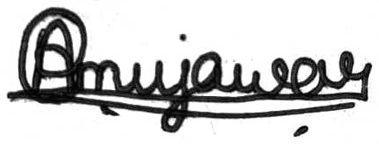 Date: 15/10/2026

