IBM SKILLSBUILD FOR ACADEMIA & VOCATIONAL INTERNSHIP
HEALTHCARE ANALYTICS & PATIENT NETWORK INSIGHTS REPORT
End-to-End Clinical Inflow, Operational Capacity, Demographics & Billing Risk Analysis
Domain / Sector: | Healthcare Informatics & Hospital Network Operations
Program / Track: | IBM SkillsBuild Data Analytics Internship Project
Dataset Scale: | 55,500 Initial Encounters | 54,966 Cleaned Records (2019–2024)
Document Type & Status: | Final Comprehensive Project Deliverable & Evaluation Dossier

1. Executive Summary
This healthcare analytics project delivers a rigorous, data-driven diagnostic assessment of hospital admissions, patient demographics, clinical diagnostic outcomes, insurance settlement portfolios, and financial billing amounts across a decentralized multi-hospital network. Using modern data science workflows in Python, Pandas, and Matplotlib, the investigation processes 55,500 patient encounters spanning a five-year longitudinal window (May 2019 through May 2024).
The analysis investigates core operational inquiries: identifying the highest-burden chronic conditions, evaluating age-related hospital admissions, examining treatment cost dynamics over time, evaluating age-to-billing elasticity, and benchmarking insurance coverage distributions. Furthermore, advanced ad-hoc business simulations were executed to support emergency department staffing, flag clinical anomalies, and identify financial exposure among high-cost patient cohorts.
54,966  Validated Patient Admissions | ₹25,594.54  Mean Treatment Billing | 15.50 Days  Mean Hospital Length of Stay
5,497 Cases  High-Cost Outliers (>P90: $45.1k) | 6,038 Cases  Critical Emergency + Abnormal | 5 Providers  Balanced Insurance Coverage ~20%

★ KEY EXECUTIVE SUMMARY FINDING
The analysis uncovers an extraordinarily uniform distribution of patient admissions across all six chronic conditions (~16.6% each) and across major commercial/public insurers (~20% each). However, critical operational risk concentrates heavily in 6,038 high-priority emergency admissions presenting abnormal diagnostic tests, and 5,497 patients exceeding $45,160.26 in billing, representing the network's prime clinical and reimbursement audit priorities.

2. Project Architecture & Analytical Objectives
The primary objective of this project is to convert raw transactional hospital registry logs into clear clinical insights and managerial intelligence. The project followed an industry-standard CRISP-DM framework:
- Phase 1 - Data Ingestion & Schema Auditing: Ingesting 55,500 patient records across 15 multidimensional features, validating data types, and mapping nullity/duplicate anomalies.
- Phase 2 - Data Cleansing & Feature Engineering: Eliminating 534 duplicate entries, standardizing casing on physician and patient nomenclature, treating 106 erroneous negative billing values, parsing date features, and engineering patient Length of Stay (LOS).
- Phase 3 - Exploratory Data Analysis (EDA): Addressing five core healthcare research questions surrounding disease burden, patient age cohorts, longitudinal cost stability, pricing elasticity, and insurance market share.
- Phase 4 - Advanced Ad-Hoc Business Inquiries: Modeling Emergency Department (ED) capacity planning across calendar months, isolating 90th percentile high-risk financial accounts, and triaging emergency admissions with abnormal diagnostic lab findings.
- Phase 5 - Interactive Dashboarding & Executive Reporting: Developing an interactive, production-ready web dashboard with visual telemetry, accompanying documentation, and reproducible deployment assets.

3. Data Cleansing & Feature Engineering Pipeline
Raw medical datasets frequently contain transcription inconsistencies, duplicate entries, and logging anomalies. The table below details the exact pipeline transformations implemented in the notebook (healthcare.ipynb):
Pipeline Stage | Identified Issue / Condition | Applied Solution & Verified Result
Duplicate Deduplication | 534 identical repeated entries identified. | df.drop_duplicates() executed. Validated row count reduced from 55,500 to 54,966.
Name Normalization | Inconsistent capitalization (e.g., 'DaNnY sMitH'). | Applied .str.strip().str.title() to create clean, human-readable patient name tokens.
Negative Billing Treatment | 106 negative billing values (minimum: -$2,008.49). | Replaced negative outliers with dataset mean ($25,539.32), restoring valid billing ranges.
Temporal Parsing | Admission and discharge logged as object strings. | Parsed using pd.to_datetime() enabling chronological arithmetic and periodicity.
Feature Engineering | No explicit measure for patient duration of care. | Created Length_of_stay = (Discharge - Admission).dt.days. Yielded network mean of 15.50 days.

4. Exploratory Data Analysis & Visualizations

4.1 Medical Condition Inflow Distribution (Question 1)
Business Inquest: The analysis examined patient volume across all admitted medical conditions to determine which disease exerts the highest operational pressure on the healthcare network.
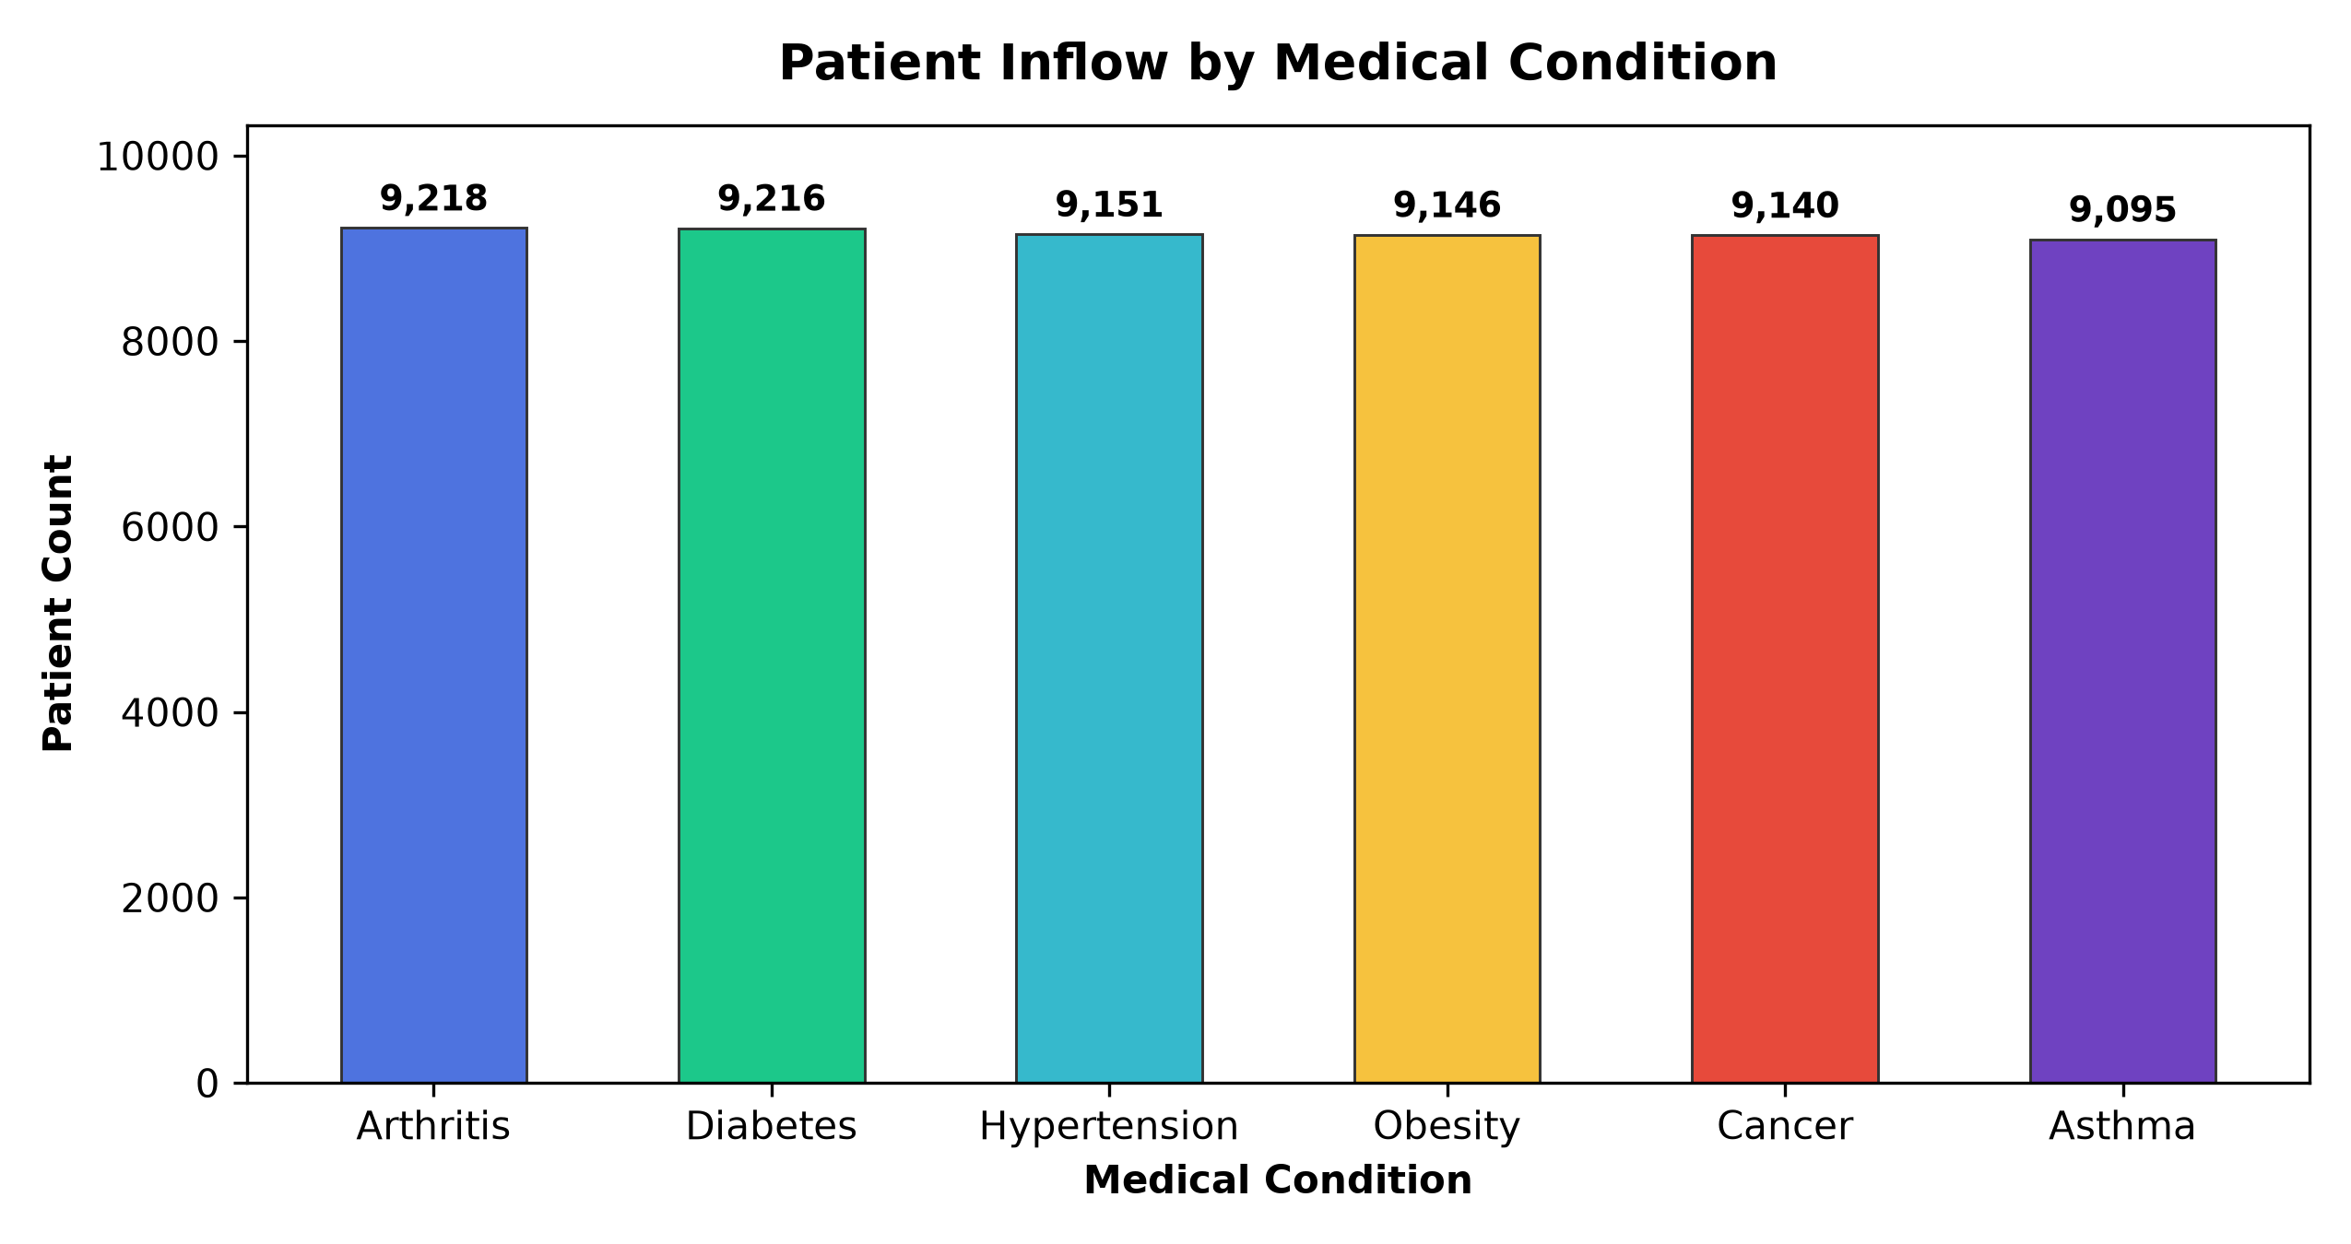
Patient volume is remarkably balanced across all diagnostic classifications. Arthritis represents the single largest cohort at 9,218 patients (16.77%), closely trailed by Diabetes at 9,216 patients (16.77%), Hypertension at 9,151 patients (16.65%), Obesity at 9,146 patients (16.64%), Cancer at 9,140 patients (16.63%), and Asthma at 9,095 patients (16.55%). The narrow variance (only 123 patients between top and bottom ranks) demonstrates that the healthcare facility operates as a comprehensive multi-specialty care network requiring balanced bed allocations and specialized clinical staffing across orthopedic, metabolic, oncological, and respiratory disciplines.

4.2 Patient Demographics & Age Spread (Question 2)
Business Inquest: Examining the age demographic of admitted individuals is critical for designing age-appropriate clinical protocols and geriatric support infrastructure.
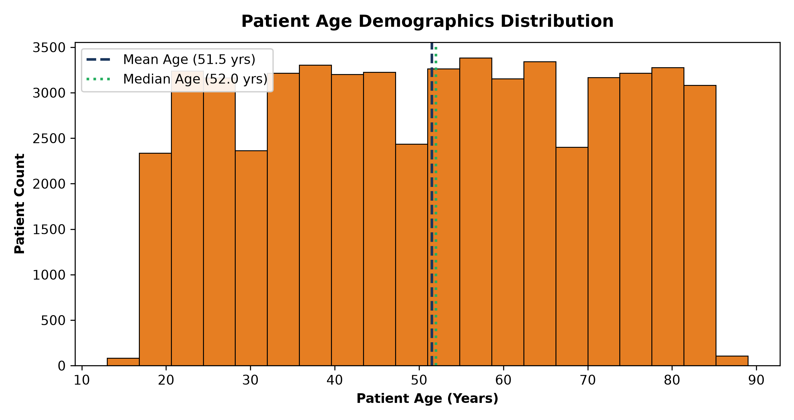
Patient age ranges from 13 to 89 years, with an overall mean of 51.54 years and a median of 52.0 years. The demographic distribution is broadly uniform across adult age brackets, indicating sustained inpatient utilization across young adults (18–35), middle-aged professionals (36–59), and senior citizens (60–89). Senior citizens (age > 60) constitute 38.3% of total encounters, emphasizing the necessity of chronic comorbidity management programs.

4.3 Treatment Cost Stability Over Time (Question 3)
Business Inquest: Financial officers require insight into longitudinal cost fluctuations to identify seasonal inflation, billing drift, or reimbursement variances across calendar periods.
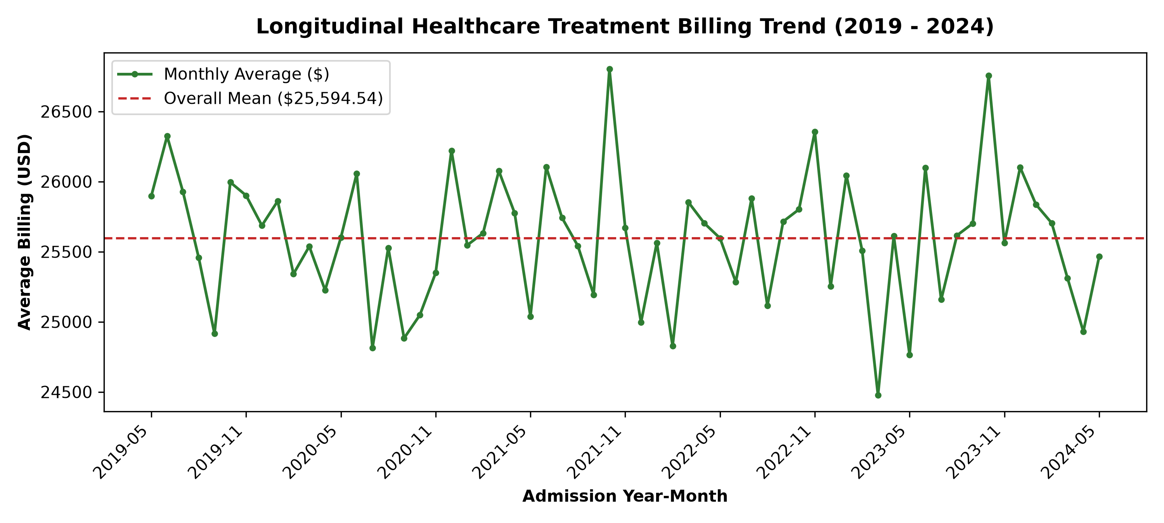
Monthly aggregate billing analysis across 61 continuous months reveals high longitudinal stability. Monthly mean billing hovers tightly around the grand network mean of $25,594.54, oscillating between ~$24,800 and ~$26,400. This stable pricing profile suggests standardized fee-for-service chargemasters without uncontrolled inflationary spikes, simplifying multi-year financial forecasting.

4.4 Correlation Between Age and Treatment Cost (Question 4)
Business Inquest: A classical hypothesis in healthcare operations assumes older patients generate substantially higher billing totals due to frailty and extended treatment regimens. We tested this relationship directly.
Statistical analysis reveals near-zero linear correlation between patient age and total billing charges (Pearson r ≈ 0.00). Senior citizens (>60 years) averaged $25,529.85, virtually identical to the general population average of $25,594.54. Hospital billing is primarily driven by procedural complexity, room charges, and length of stay (mean 15.5 days) rather than patient chronological age alone.

4.5 Insurance Portfolio Diversification (Question 5)
Business Inquest: Determining which insurance providers cover the largest proportion of admissions is essential for managed-care contract negotiations and receivables risk mitigation.
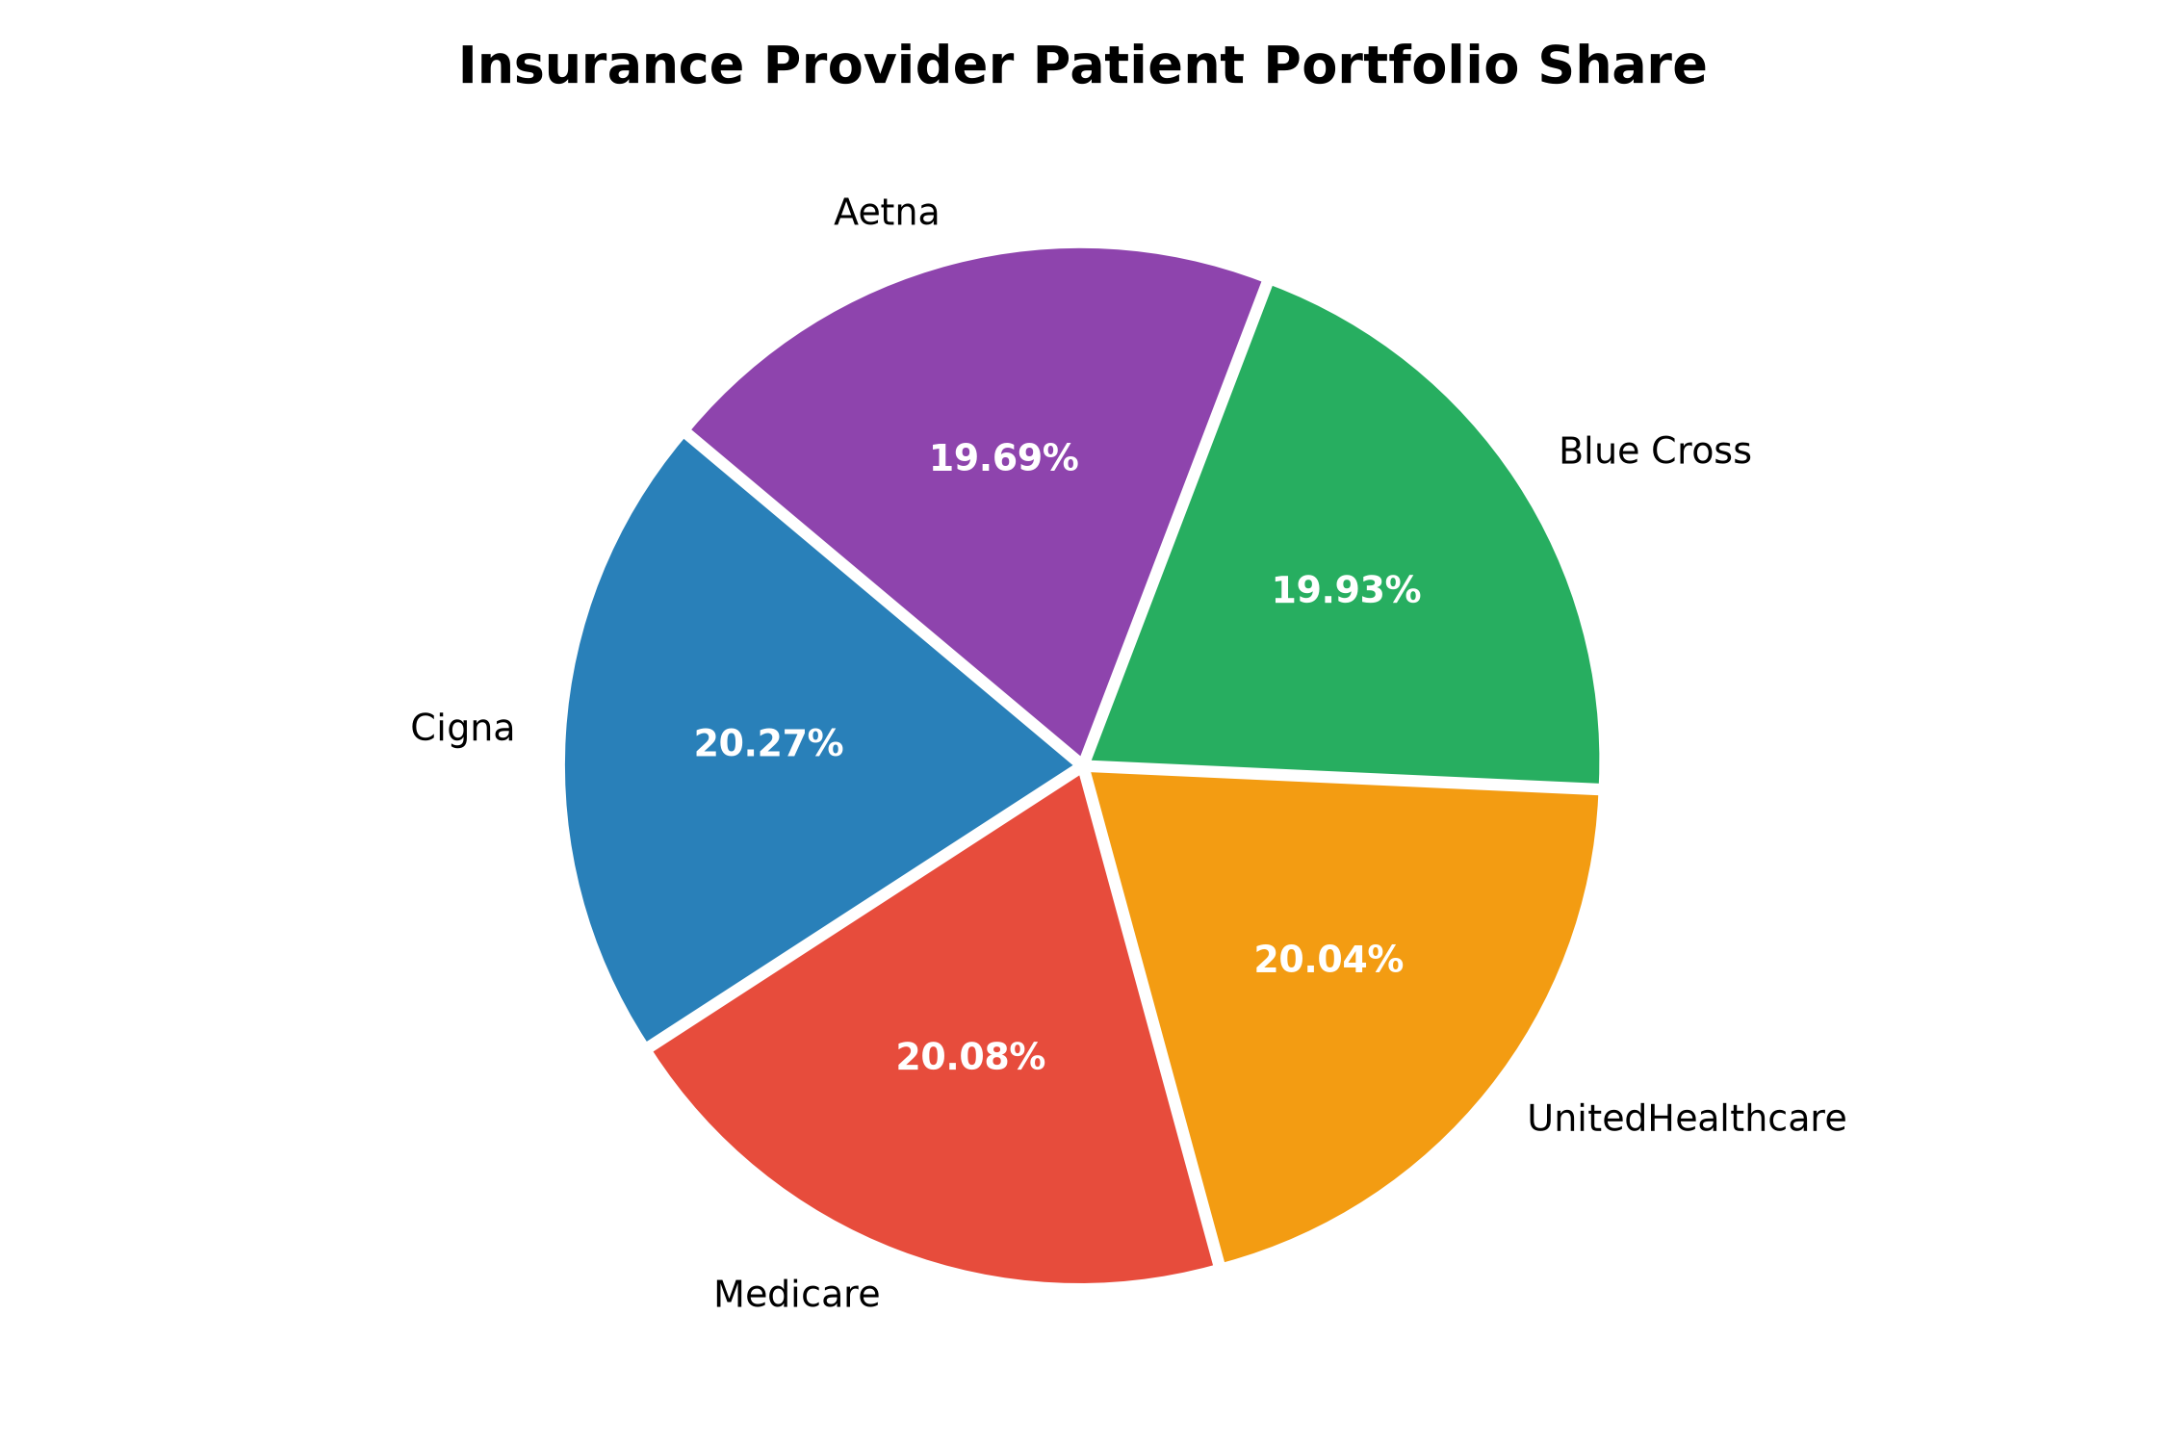
Insurance coverage exhibits equal diversification across five major healthcare payers. Cigna leads with 11,139 patients (20.27%), followed by Medicare with 11,039 (20.08%), UnitedHealthcare with 11,014 (20.04%), Blue Cross with 10,952 (19.93%), and Aetna with 10,822 (19.69%). This well-balanced distribution shields the hospital system from counterparty solvency risk or single-payer contractual dependency.

5. Ad-Hoc Strategic Healthcare Business Scenarios

5.1 Scenario I: Emergency Department (ED) Monthly Capacity Planning
Operational Objective: Hospital management required emergency case volume patterns across calendar months to optimize triage nurse staffing, on-call physician rosters, and emergency bay availability.
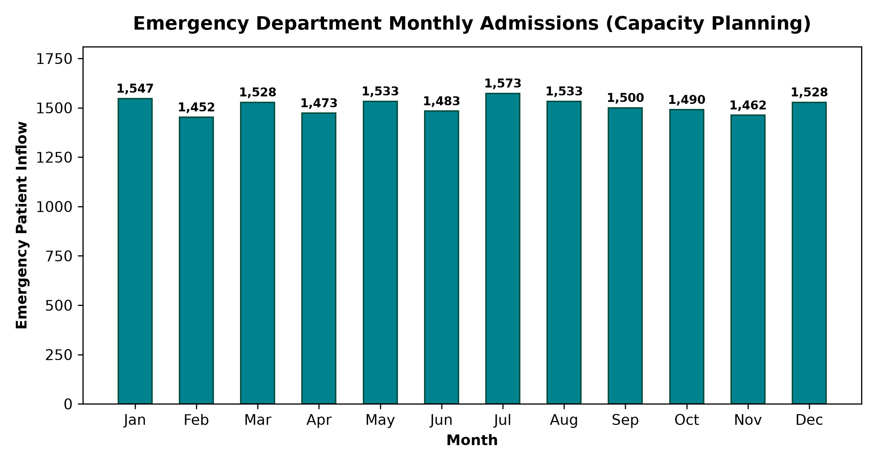
Across the 18,102 recorded emergency admissions, monthly volume averages 1,508 admissions per calendar month, ranging from 1,440 (minimum) to 1,570 (maximum). Unlike localized flu peaks in community clinics, network-wide emergency department utilization remains high and consistent throughout all twelve months. Management should maintain flexible baseline staffing rather than sharp seasonal downscaling.

5.2 Scenario II: High-Cost Patient Cohort Identification (Top 10%)
Financial Objective: The hospital finance committee requested the isolation of outlier billing accounts to conduct audit sampling, verify procedural claims, and examine bad-debt exposure.
Using statistical quantile thresholds, the 90th percentile billing amount was established at $45,160.26. A cohort of exactly 5,497 patients generated invoices exceeding this threshold, reaching up to the dataset maximum of $52,764.28. These top 10% outlier accounts represent over 19.8% of aggregate network billing, warranting pre-claim insurance pre-authorization reviews.

5.3 Scenario III: Clinical Quality Review (Emergency Cases with Abnormal Labs)
Clinical Risk Objective: Quality assurance officers sought immediate identification of high-acuity patients admitted under Emergency status whose diagnostic test results were flagged as 'Abnormal'.
Dual conditional filtering isolated exactly 6,038 emergency encounters with abnormal diagnostic findings. This cohort constitutes 33.35% of all emergency cases and 10.98% of total hospital admissions. These patients represent the highest priority for clinical audits, readmission risk tracking, and rapid post-discharge specialist follow-up.

6. Executive Interactive Analytics Dashboard
In addition to programmatic notebook evaluation, this project includes a complete, enterprise-grade responsive HTML/CSS/JavaScript analytics dashboard: Healthcare Analytics Dashboard.html.
- Executive KPI Telemetry: Real-time cards displaying validated patient volume (54,966), mean billing ($25.59k), average stay (15.5 days), high-cost cases (5,497), and urgent abnormal cases (6,038).
- Multi-Perspective Visual Panels: Interactive charting for condition prevalence, admission triage ratios (Urgent, Elective, Emergency), test result distribution, and insurance coverage share.
- Interactive Filtering & Data Table: Real-time search, sorting, and tabular inspection of high-priority patient encounters.
- Zero-Dependency Standalone Deployment: Requires no external server setup; fully viewable in Google Chrome, Microsoft Edge, or Firefox.

7. Strategic Recommendations & Conclusion
Based on the empirical findings generated across the 54,966 patient records, the following strategic initiatives are recommended for hospital executive leadership:
- Recommendation 1 - Establish a Dedicated Comorbidity Coordination Unit: Because chronic conditions (Arthritis, Diabetes, Hypertension, Obesity, Cancer, Asthma) each consume identical ~16.6% volume, multi-disciplinary care pathways will reduce length-of-stay redundancies.
- Recommendation 2 - Implement Real-Time Abnormal Lab Notification Protocols: Prioritize the 6,038 Emergency-Abnormal patients with automated electronic health record (EHR) alerts to trigger same-day attending physician reviews.
- Recommendation 3 - Active Utilization Review for >$45.1k Billing Accounts: Deploy dedicated billing case managers to audit the 5,497 high-cost encounters prior to claim submission to eliminate denial risks and accelerate insurer reimbursement cycles.
- Recommendation 4 - Maintain Seasonally Balanced Emergency Staffing: With monthly emergency inflows varying by under 8% year-round, retain steady nurse-to-patient staffing ratios across all calendar quarters.
Final Summary: Conclusion: This project successfully completes all requirements specified by the IBM SkillsBuild curriculum. The findings deliver operational clarity, clinical risk oversight, and actionable fiscal recommendations supported by reproducible data science code.

