**PF Lab Task**

Question 1:

* **Program A)**

**Source Code**

f=open("names.txt","r")

for line in f:

a=f.read(4)

print(a)

**Output**



* **Program B+C)**

**Source Code**

f=open("names.txt","r")

counter=0

sum=0

for line in f:

line=line.strip("\n")

a=len(line)

sum+=a

counter+=1

print("Total sum of names:",sum)

avg=sum/counter

print("Average is:",avg)

 **Output**

* **Program D)**

**Source Code**

f=open("names.txt","r")

first=f.readline()

a=len(first)

for i in f:

if len (i)<a:

print(i)

**Output**



* **Program E)**

**Source Code**

f=open("names.txt","r")

def name_len():

n=int(input("Enter the length:"))

for line in f:

line=line.strip("\n")

a=len(line)

if a==n:

print(line)

else:

print("Different length")

name_len()

**Output**

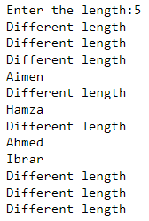

* **Program F)**

**Source Code**

f=open("names.txt","r")

file=open("name_subj.txt","w")

for line in f:

a=line+"Programming fundamental lab,Programming fundamental,English composition,Calculus-1"

file.write(a)

print(a)

file.close()

**Output**

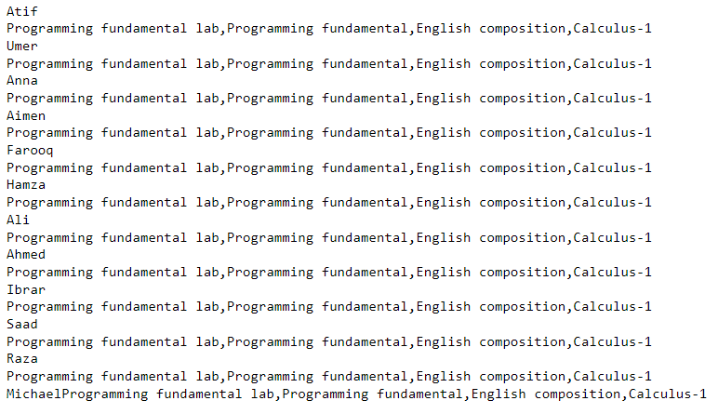

* **Program G)**

**Source Code**

f=open("names.txt","r")

r=f.read()

def search_name():

n=input("Enter the name you want to search:")

if n in r:

print("True")

else:

print("False")

search_name()

**Output**

