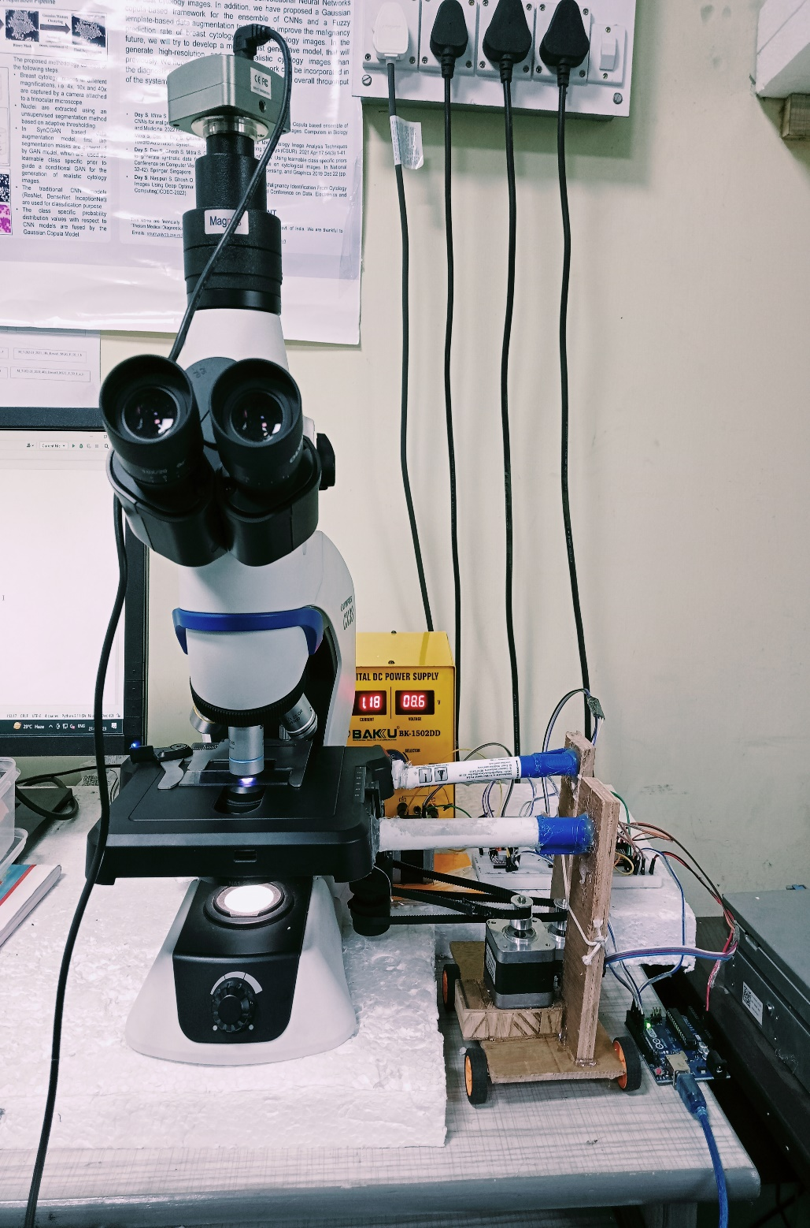

Condenser

Stage

Camera

Fine Focus Knob

Bread Board Connections

Arduino UNO

Power Supply

Stepper Motor

Wooden Cart

Microscope Frame

Revolving nosepiece

Objective

Eyepieces