**HTML & CSS**

Html and CSS work hand in hand, CSS holds the styling of the web page.

There are two parts of CSS:

* The selector – specifies the pattern in the HTML and if the pattern matches
* The Declaration block- The style within the declaration block are applied to the corresponding HTML elements.

In CSS each style declaration consists of two parts:

1. A property
2. A value

**First element selector**

CSS Syntax

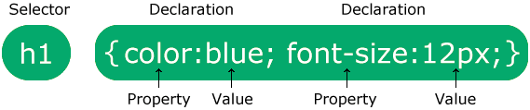

The selector points to the HTML element you want to style.

* **Element selector**
* **Id selector #**
* **Class selector .**
* **Universal selector \***
* **Group selector.**

**Colour**

Background-color:green;

Background.image:url(‘image.png’) repeat:none;

* In CSS, you can use the **background-image** property to set an image as the background of an HTML element.
* Additionally, you can use the **url()** function to specify the path to the image file.