NAME: AYANIKA PAUL  
SEC: D   
ROLL NO. 22  
BATCH:D1

LAB1

Q1) To count the number of lines and characters in a file.

Code:

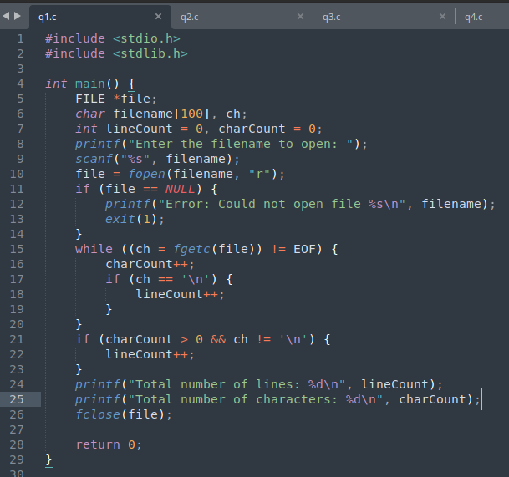

Input: file.txt

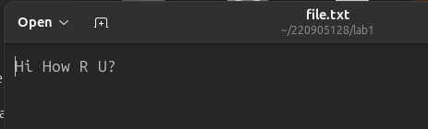

Output:

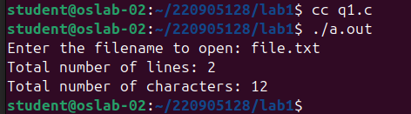

Q2) To reverse the file contents and store in another file. Also display the size of file using file handling function.

Code:

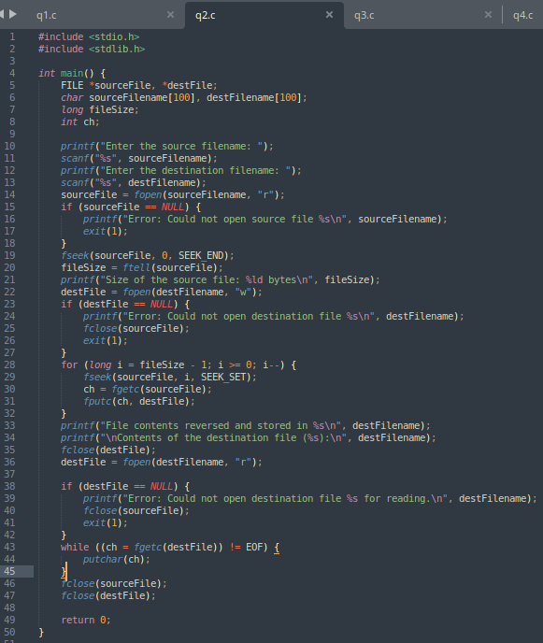Input:

srcfile.txt



dstfile.txt → empty

Output:

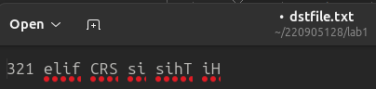

Q3)That merges lines alternatively from 2 files and stores it in a resultant file.

Code: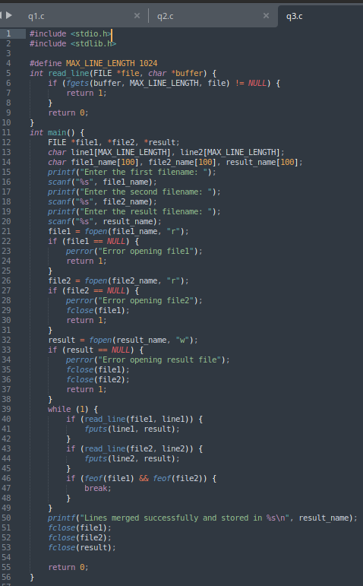

Input: file1.txt

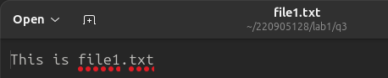

file2.txt 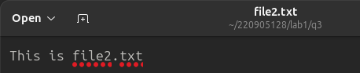

Output: res.txt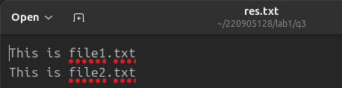

Q4)That accepts an input statement, identifies the verbs present in them and performs the following

functions

a. INSERT: Used to insert a verb into the hash table.

Syntax: insert (char \*str)

b. SEARCH: Used to search for a key(verb) in the hash table. This function is called by INSERT

function. If the symbol table already contains an entry for the verb to be inserted, then it returns

the hash value of the respective verb. If a verb is not found, the function returns -1.

Syntax: int search (key)

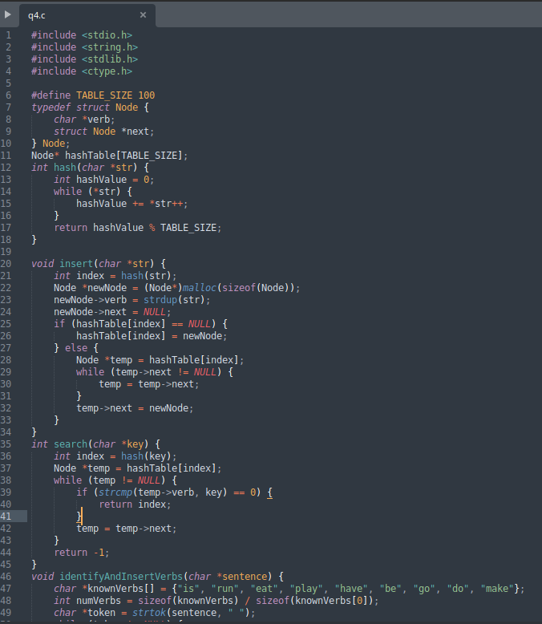

Code:

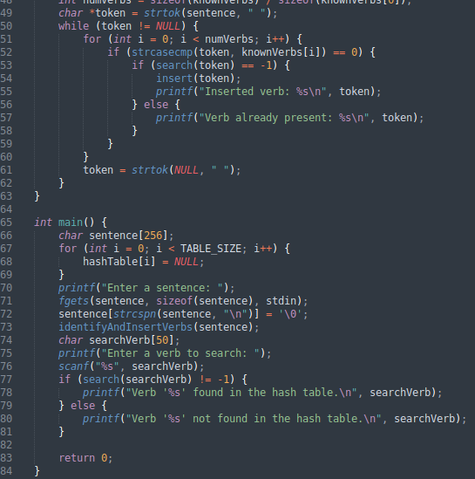

Input/Output:

