NAME:AYANIKA PAUL
Roll No. 22
D1
LAB 2
Q1)Write a ‘C’ program
1. That takes a file as input and replaces blank spaces and tabs by single space and writes
the output to a file.

CODE:

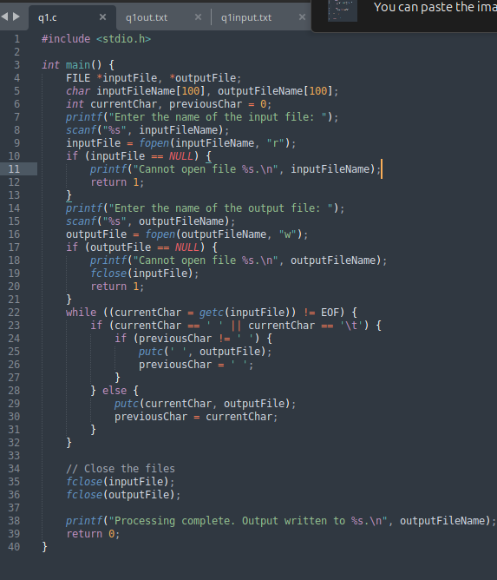

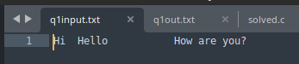
Input file : q1in.txt

Terminal
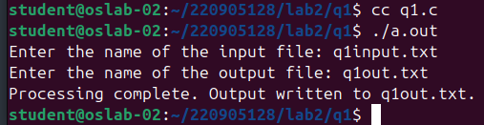

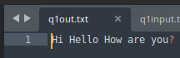
Output file: q1out.txt

Q2) To discard preprocessor directives from the given input ‘C’ file.

CODE:
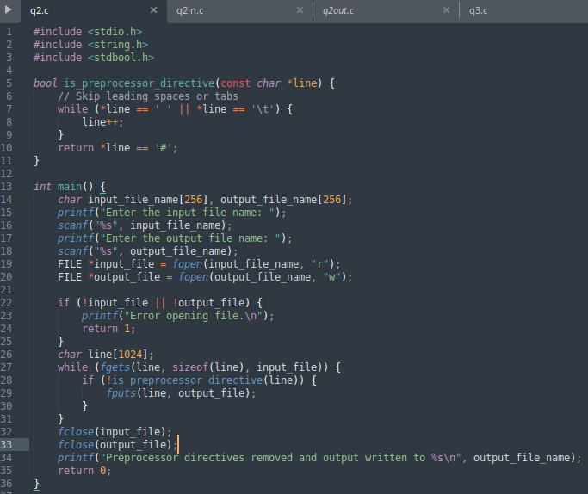

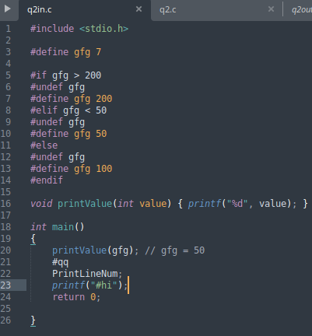

Input file: q2in.c

Terminal:

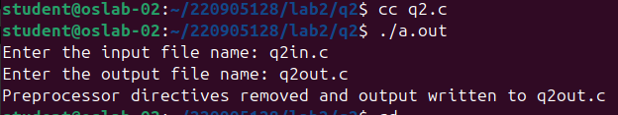

Output file: q2out.c

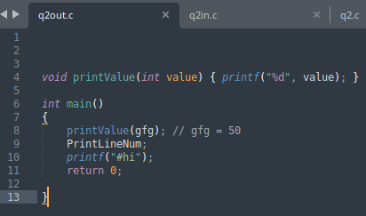

Q3)That takes C program as input, recognizes all the keywords and prints them in upper
case.

CODE:

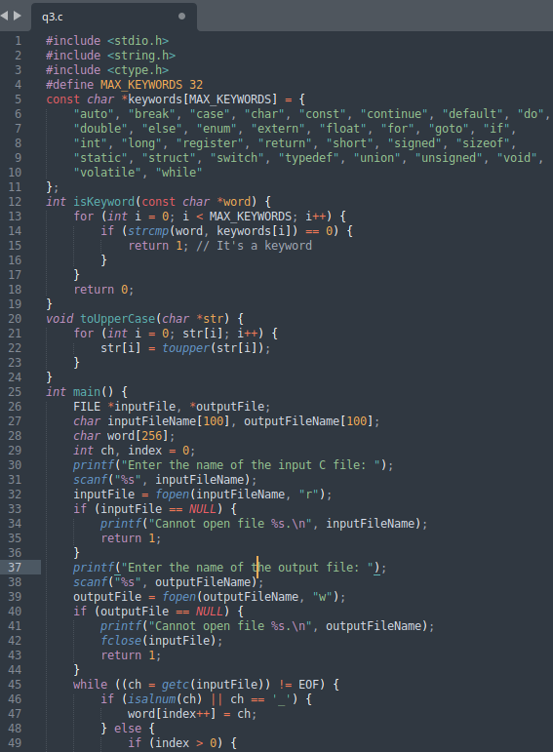

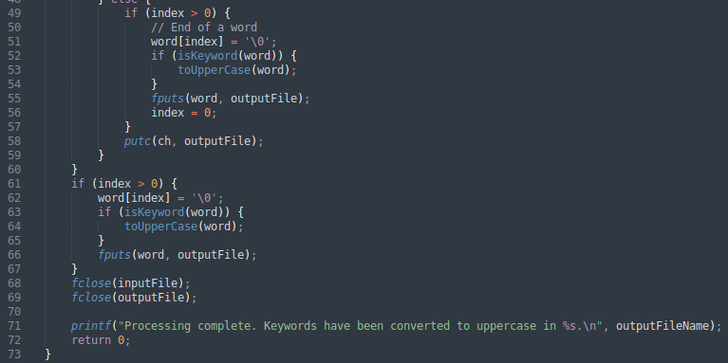

Input file: q3in.c
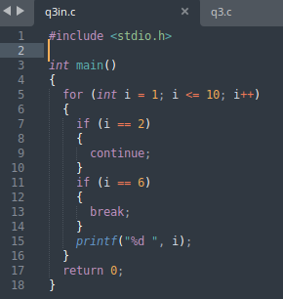

Terminal:

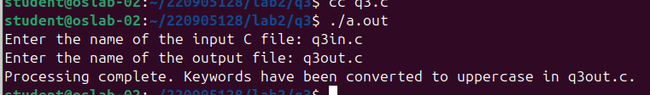

Output file: q3out.c

