LAB9

NAME: AYANIKA PAUL

REG NO. 220905128

ROLL NO. 22

D1

Q1. Develop an SLR(1) parser for the given expression grammar and demonstrate parsing actions.
E->E+T|T
T-> T*F|F
F-> ( E )|id

Code:
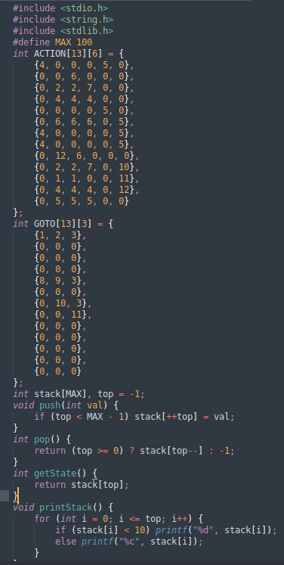

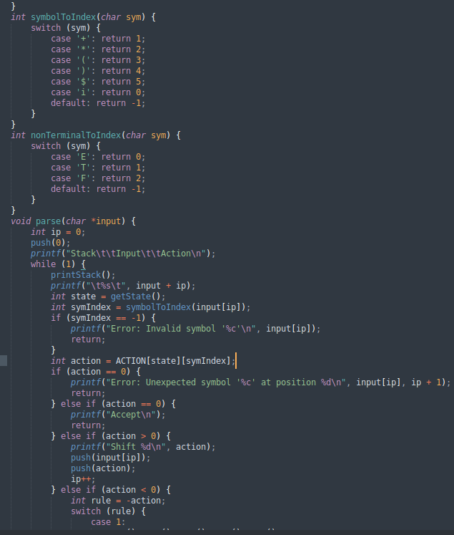

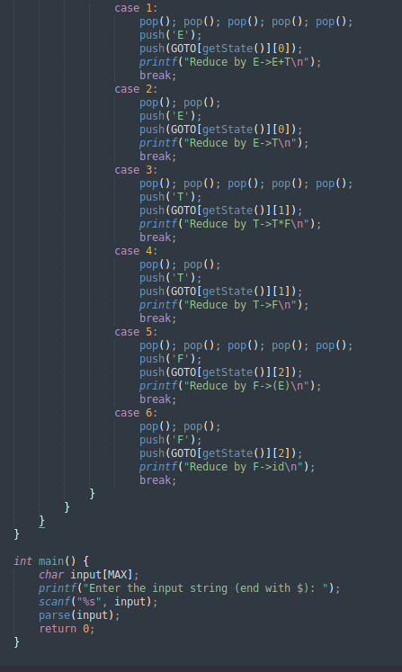

OUTPUT:
