LAB 7 – 8

NAME: AYANIKA PAUL
ROLL NO. 22
REG NO. 220905128
D1

lab7) For given subset of grammar 7.1, design RD parser with appropriate error messages with expected
character and row and column number.
Lab8) Design the recursive descent parser to parse C program with variable declaration and decision statements
with error reporting of grammar 7.1.

CODE:
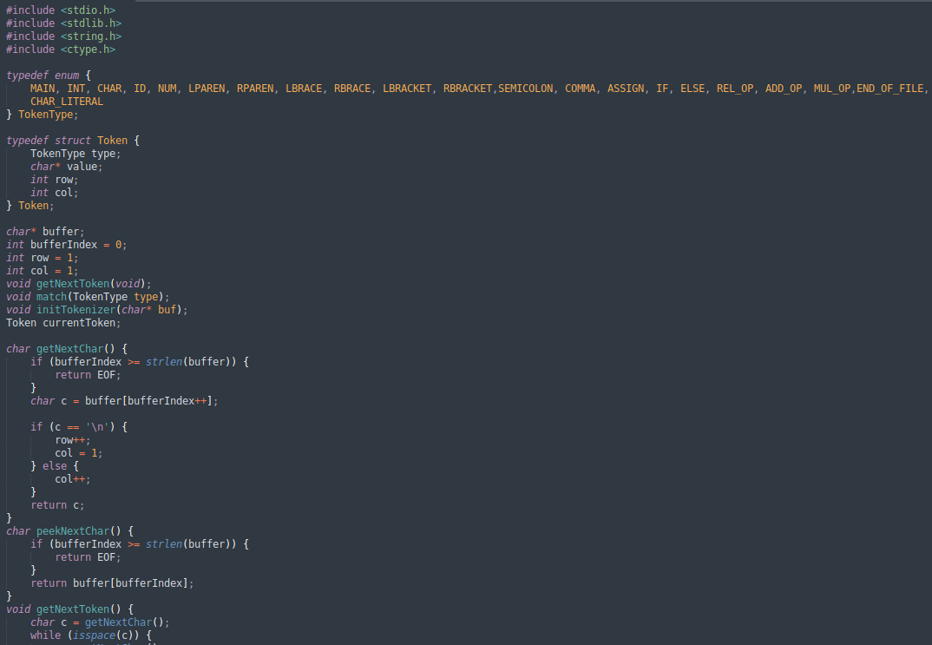

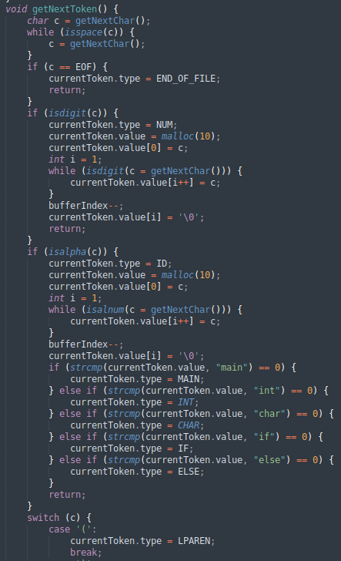

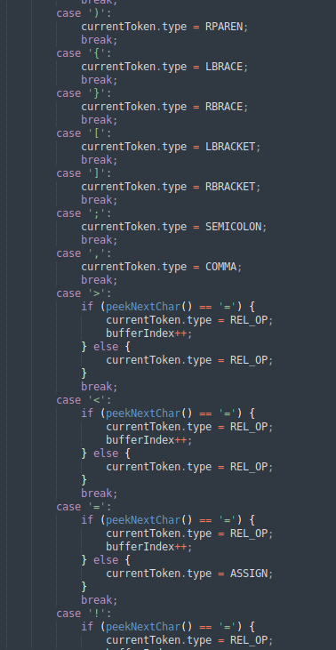

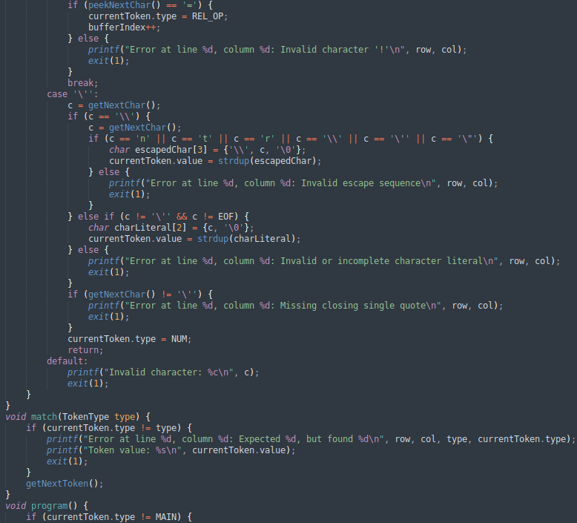

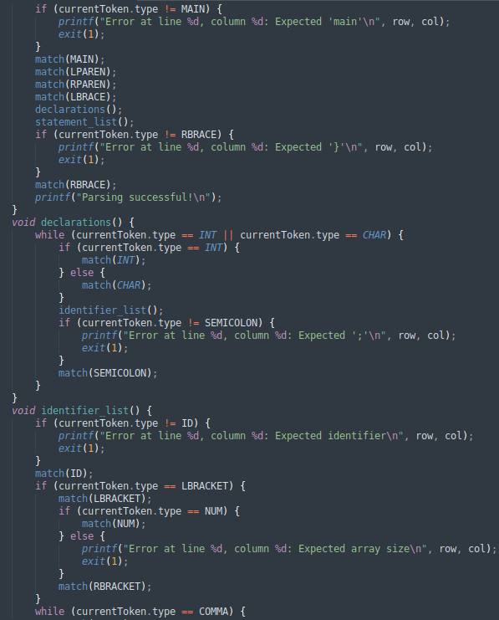

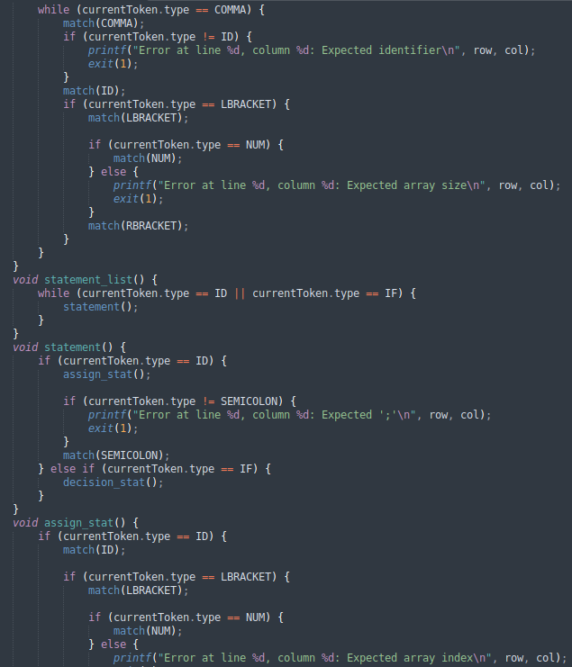

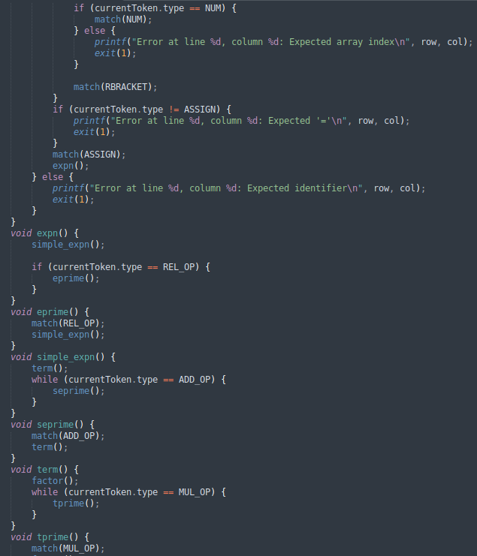

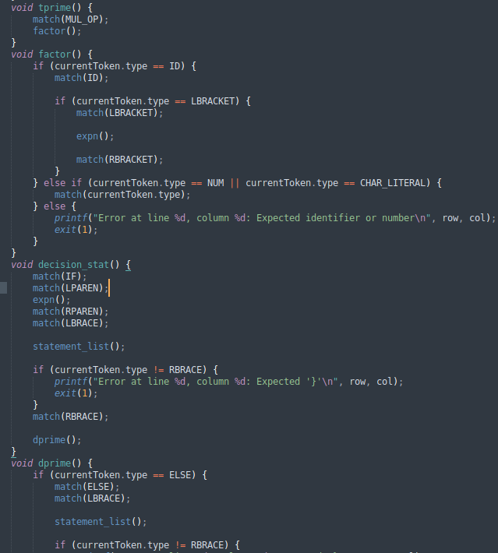

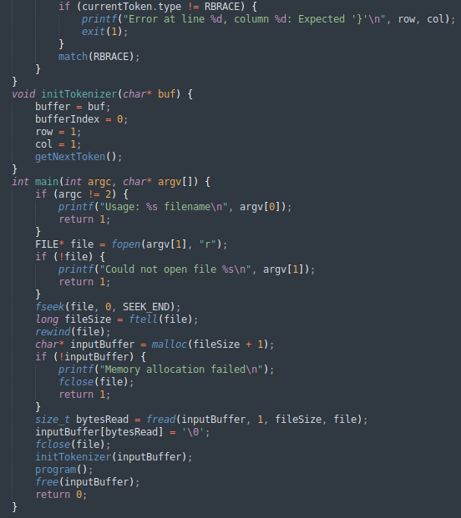

INPUT:

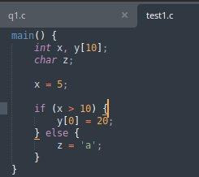
test1.c

OUTPUT:

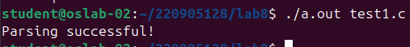

WRONG INPUT:

err1.c

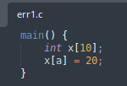

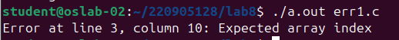

LAB7 Inputs:
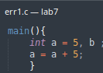
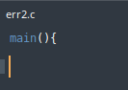

OUTPUT:
