Lab 10

Name: AYANIKA PAUL
Reg no. 220905128
Roll No. 22

Q1)Write a bison program,
1. To check a valid declaration statement.

CODE:

q1.y
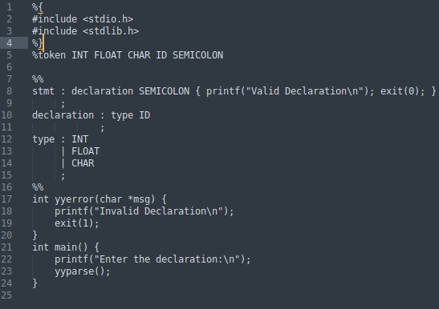

q1.l
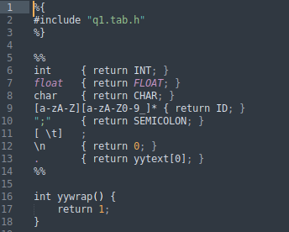

OUTPUT:

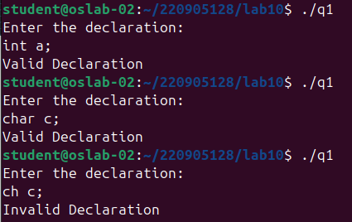

2. To check a valid decision making statements.

CODE:

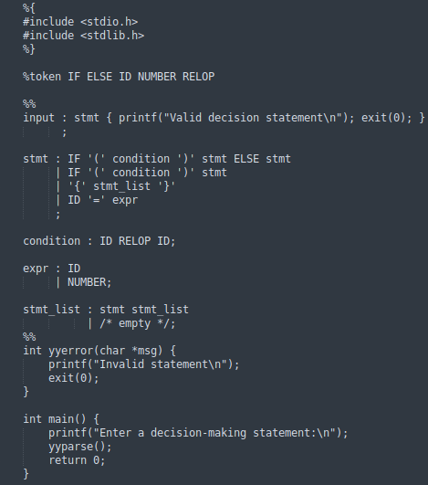
q2.y

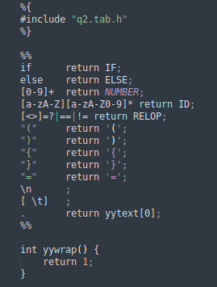
q2.l

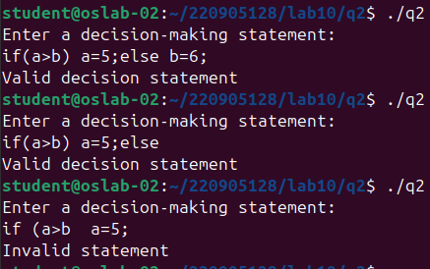
OUTPUT:

3. To evaluate an arithmetic expression involving operations +,-,* and /.

q3.l
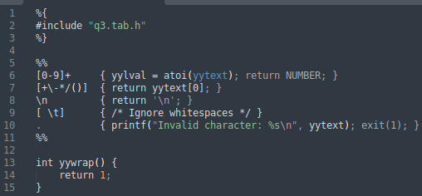

q3.y

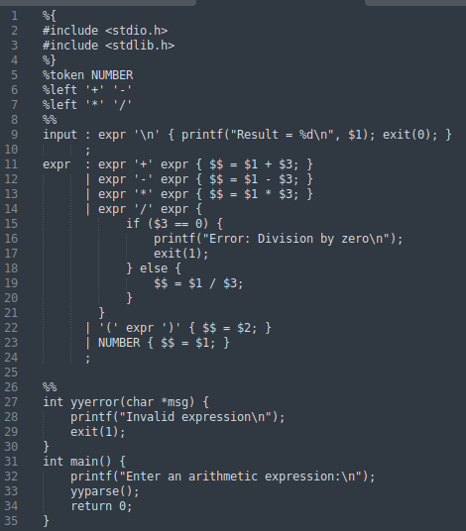

OUTPUT:

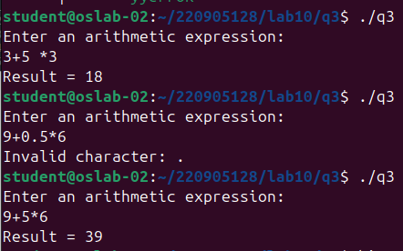

4. To validate a simple calculator using postfix notation. The grammar rules are as follows –
input → input line | ε
line → ‘\n’ | exp ‘\n’
exp → num | exp exp ‘+’
| exp exp ‘-‘
| exp exp ‘*’
| exp exp ‘/’
| exp exp ‘^’
| exp ‘n’

CODE:

q4.y

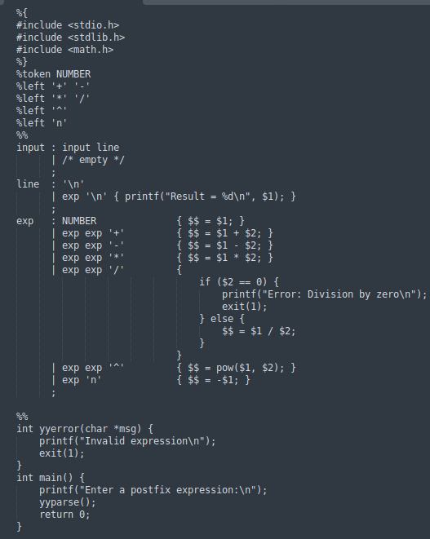

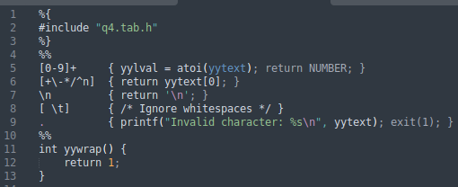
q4.l

OUTPUT:

