NAME:AYANIKA PAUL
Roll No. 22
D1
LAB 5

Q1)Count the number of vowels and consonants in the given input.

CODE:

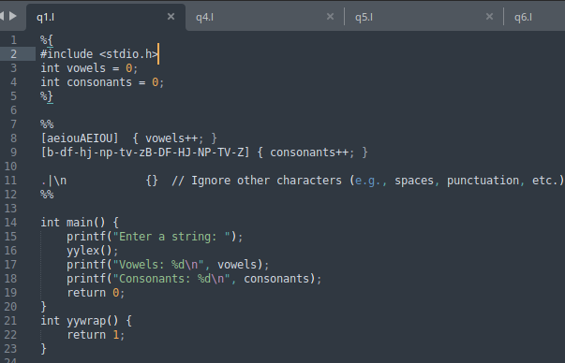

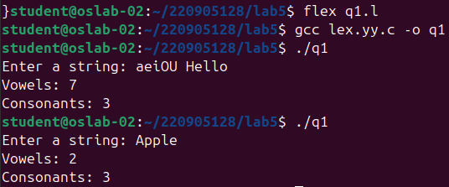
OUTPUT:

Q2)Count the number of words, characters, blanks and lines in a given text.

CODE:

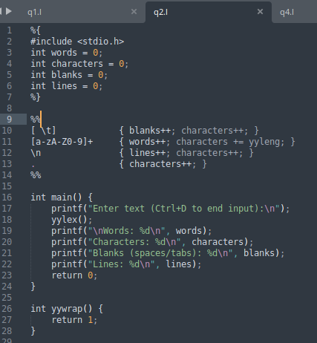

OUTPUT:
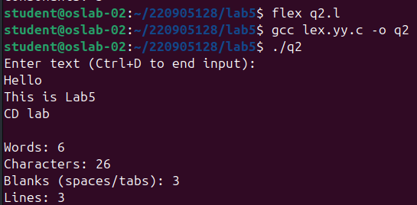

Q3)Find the number of positive integer, negative integer, positive floating positive number and negative floating point number

CODE:
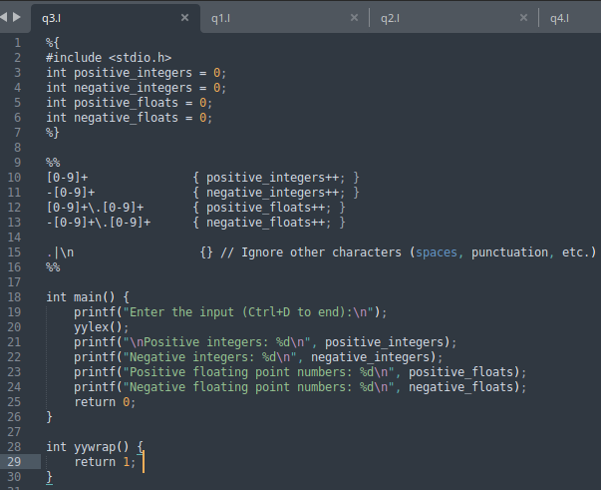

OUTPUT:

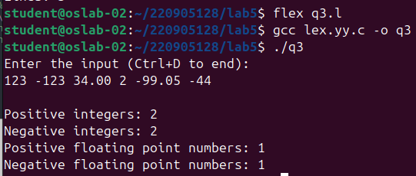

Q4)Given a input C file, replace all scanf with READ and printf with WRITE statements also find the number of scanf and printf in the file.

CODE:
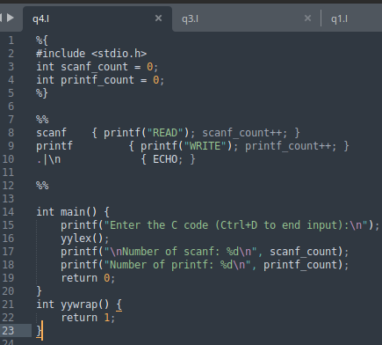

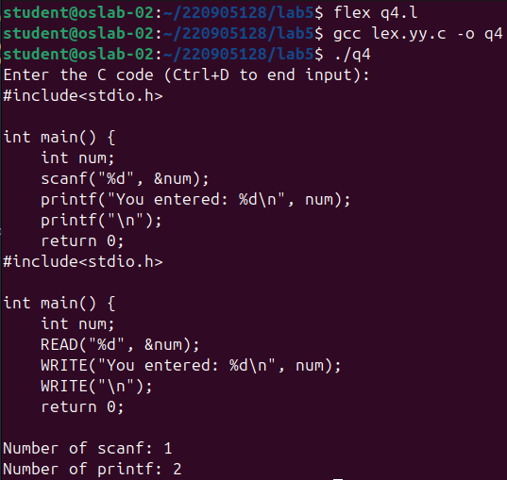
OUTPUT:

Q5)That changes a number from decimal to hexadecimal notation.

CODE:
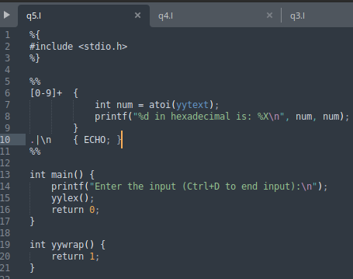

OUTPUT:
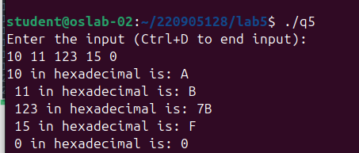

Q6)Convert uppercase characters to lowercase characters of C file excluding the characters present in the comment.

CODE:
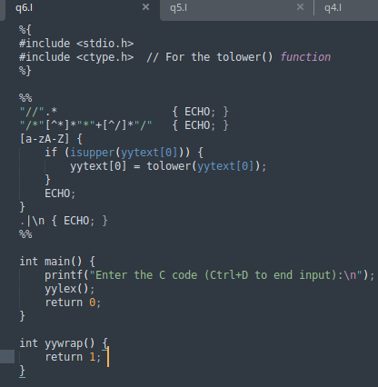

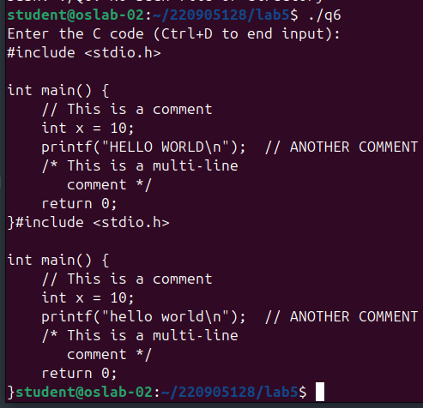
OUTPUT:

