NAME:AYANIKA PAUL
Roll No. 22
D1
LAB 6

Write a recursive descent parser for the following simple grammars.

1. S→a | > | ( T )
T→T, S|S

After removing Left Recursion ,
S -> a | > | ( T )
T -> S T'
T' -> , S T'| Epsilon

CODE:

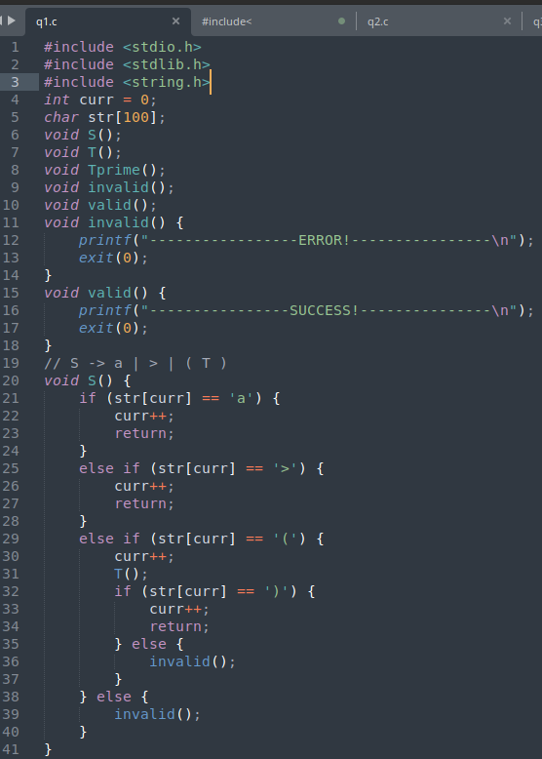

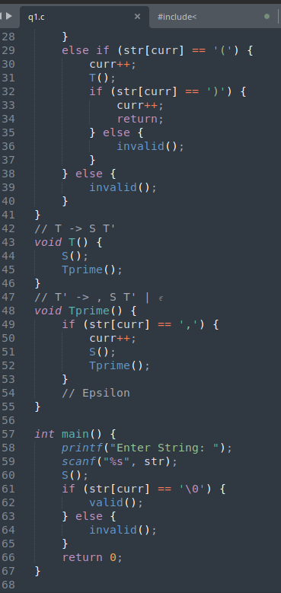

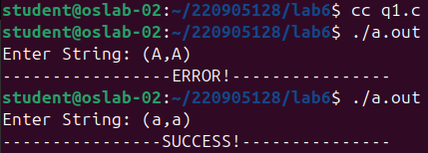
OUTPUT:

Q2)
S→UVW
U →(S) | aSb | d
V → aV | 𝜖
W → cW | 𝜖

CODE:

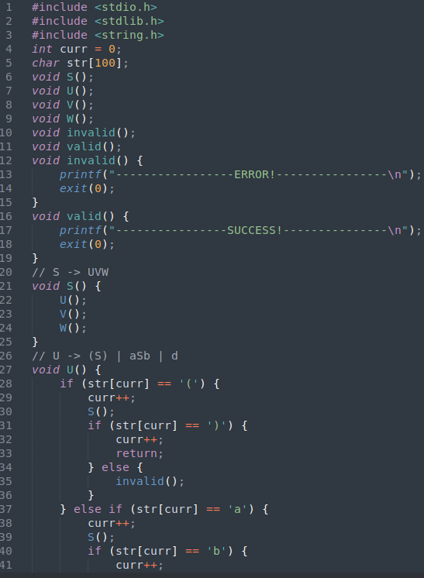

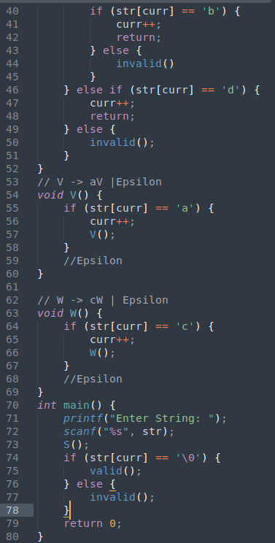

OUTPUT:

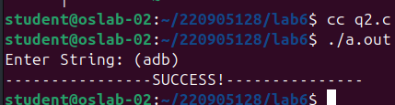

Q3)
S→aAcBe
A→Ab|b
B→d

After removing Left Recursion ,
S -> aAcBe
A -> b A'
A' -> b A' |Epsilon
B -> d

CODE:

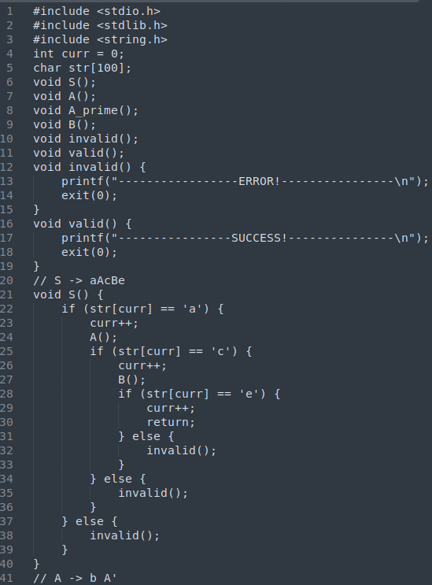

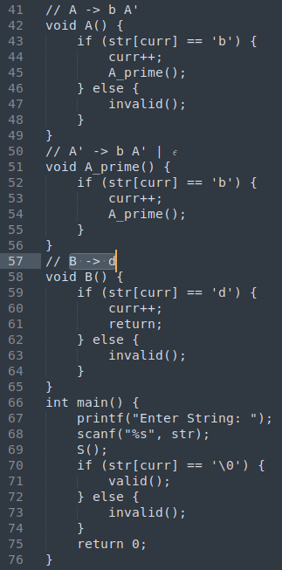

OUTPUT:

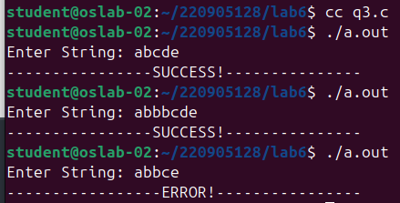

Q4)
S →(L) | a
L → L,S | S

After removing Left Recursion ,
S -> (L) | a
L -> S L'
L' -> , S L' | Epsilon

CODE:

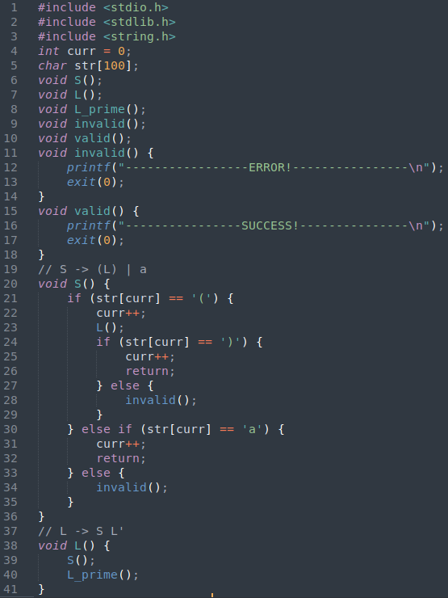

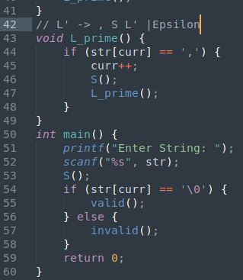

OUTPUT:

