LAB2

Q1) Write a web page which contains table with 3 X 3 dimensions (fill some data) and one
image. Style the rows with alternate color. Move the table and image together from
right to left when button is clicked.

CODE:

<!DOCTYPE html>
<html lang="en">
<head>
<meta charset="UTF-8">
<meta name="viewport" content="width=device-width, initial-scale=1.0">
<title>Table and Image Animation</title>
<script src="/home/lab4/Desktop/220905128/lab2/jquery-3.7.1.js"></script>
<style>
body {
font-family: Arial, sans-serif;
margin: 20px;
}
.container {
display: flex;
align-items: center;
position: relative;
left: 0;
}
table {
border-collapse: collapse;
margin-right: 20px;
}
table, th, td {
border: 1px solid black;
text-align: center;
padding: 10px;
}
tr:nth-child(odd) {
background-color: #faf170;
}
tr:nth-child(even) {
background-color: #d49cee;
}
img {
width: 150px;
height: 150px;
}
button {
margin-top: 20px;
padding: 10px 15px;
background-color: #ff00f2;
color: rgb(0, 0, 0);
border: none;
border-radius: 5px;
cursor: pointer;
}
button:hover {
background-color: #a1b300;
box-shadow: 2;
}
</style>
</head>
<body>

<h1>Table and Image Animation</h1>

<div class="container" id="move-container">
<table>
<tr>
<th>Column 1</th>
<th>Column 2</th>
<th>Column 3</th>
</tr>
<tr>
<td>Row 1</td>
<td>Data 1</td>
<td>Data 2</td>
</tr>
<tr>
<td>Row 2</td>
<td>Data 3</td>
<td>Data 4</td>
</tr>
<tr>
<td>Row 3</td>
<td>Data 5</td>
<td>Data 6</td>
</tr>
</table>
<img src="/home/lab4/Desktop/220905128/lab2/q1/Pasted image.png" alt="Sample Image">
</div>

<button id="move-button">Move Table and Image</button>

<script>
$(document).ready(function() {
$('#move-button').click(function() {
$('#move-container').animate({ left: "-=300px" }, 1000);
});
});
</script>

</body>
</html>

output:
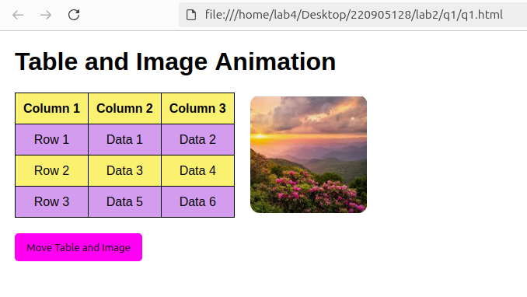

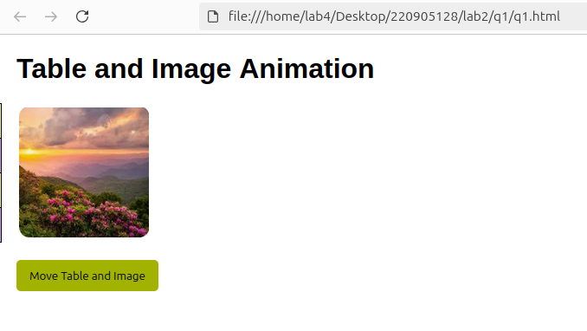

Q2)Design a calculator to perform basic arithmetic operations. Use textboxes and buttons
to design web page.

CODE:

<!DOCTYPE html>
<html lang="en">
<head>
<meta charset="UTF-8">
<meta name="viewport" content="width=device-width, initial-scale=1.0">
<title>Basic Calculator</title>
<script src="/home/lab4/Desktop/220905128/lab2/jquery-3.7.1.js"></script>
<style>
body {
font-family: 'Segoe UI', Tahoma, Geneva, Verdana, sans-serif;
display: flex;
justify-content: center;
align-items: center;
height: 100vh;
background-color: #cbf1f7;
margin: 0;
}

.calculator {
background-color: #fff ;
padding: 20px;
border-radius: 10px;
box-shadow: 10px 12px 14px rgba(0, 0, 0, 0.1);
width: 320px;
}
.calculator input[type="text"] {
width: 100%;
height: 60px;
font-size: 36px;
text-align: right;
padding: 10px;
margin-bottom: 20px;
border: 1px solid #ccc;
border-radius: 8px;
box-sizing: border-box;
background-color: #f9f9f9;
}
.calculator div {
display: flex;
flex-wrap: wrap;
gap: 10px;
margin-bottom: 10px;
}
.calculator button {
width: 70px;
height: 70px;
font-size: 28px;
border: none;
background-color: #f0f0f0;
border-radius: 10px;
cursor: pointer;
transition: background-color 0.3s, transform 0.2s;
}

.calculator button:hover {
background-color: #dcdcdc;
transform: scale(1.05);
}

.calculator button:active {
background-color: #c5c5c5;
transform: scale(1);
}
.calculator button.operator {
background-color: #f39c12;
color: white;
}

.calculator button.operator:hover {
background-color: #e67e22;
}
.calculator button.clear {
background-color: #e74c3c;
color: white;
}

.calculator button.clear:hover {
background-color: #c0392b;
}
.calculator button.equals {
background-color: #27ae60;
color: white;
}

.calculator button.equals:hover {
background-color: #2ecc71;
}
</style>
</head>
<body>

<div class="calculator">

<input type="text" id="display" disabled>
<div>
<button class="clear" id="clear">C</button>
<button class="operator" id="divide">/</button>
<button class="operator" id="multiply">*</button>
<button class="operator" id="subtract">-</button>
</div>
<div>
<button id="7">7</button>
<button id="8">8</button>
<button id="9">9</button>
<button class="operator" id="add">+</button>
</div>
<div>
<button id="4">4</button>
<button id="5">5</button>
<button id="6">6</button>
<button class="equals" id="equals">=</button>
</div>
<div>
<button id="1">1</button>
<button id="2">2</button>
<button id="3">3</button>
<button id="0">0</button>
</div>
<div>
<button id="decimal">.</button>
</div>
</div>

<script>
$(document).ready(function() {
let currentInput = '';
let previousInput = '';
let operator = '';
function updateDisplay(value) {
$('#display').val(value);
}
$('button').click(function() {
const buttonValue = $(this).text();
if (buttonValue === 'C') {
currentInput = '';
previousInput = '';
operator = '';
updateDisplay(currentInput);
return;
}
if (buttonValue === '=') {
if (previousInput && operator) {
currentInput = calculate(previousInput, currentInput, operator);
previousInput = '';
operator = '';
updateDisplay(currentInput);
}
return;
}
if (['+', '-', '*', '/'].includes(buttonValue)) {
if (previousInput === '') {
previousInput = currentInput;
currentInput = '';
operator = buttonValue;
return;
}

if (operator) {
currentInput = calculate(previousInput, currentInput, operator);
previousInput = currentInput;
operator = buttonValue;
currentInput = '';
}
}
if (buttonValue === '.' && currentInput.includes('.')) {
return;
}

currentInput += buttonValue;
updateDisplay(currentInput);
});
function calculate(prev, curr, operator) {
prev = parseFloat(prev);
curr = parseFloat(curr);

if (operator === '+') return prev + curr;
if (operator === '-') return prev - curr;
if (operator === '*') return prev * curr;
if (operator === '/') return prev / curr;
}
});
</script>

</body>
</html>

Output:

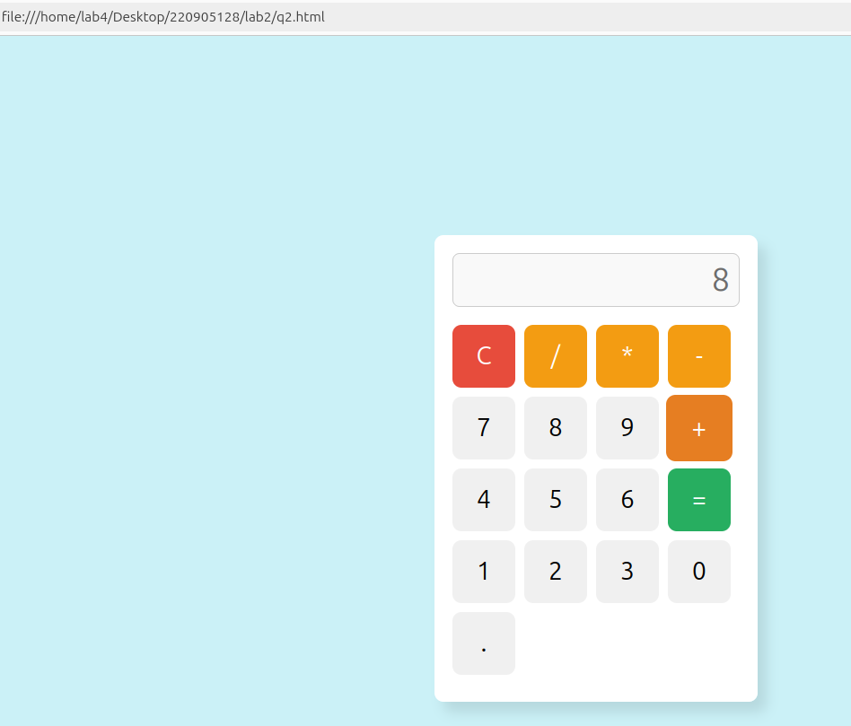

Q3)Create a web page to design a birthday card shown below.
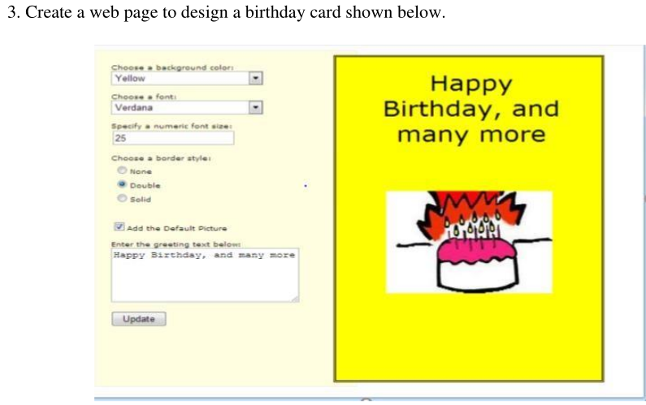

CODE:

<!DOCTYPE html>
<html lang="en">
<head>
<meta charset="UTF-8">
<meta name="viewport" content="width=device-width, initial-scale=1.0">
<title>Birthday Card Designer</title>
<script src="/home/lab4/Desktop/220905128/lab2/jquery-3.7.1.js"></script>
<style>
body {
font-family: Arial, sans-serif;
margin: 0;
padding: 20px;
background-color: #f0f0f0;
}
.container {
display: flex;
}
.controls {
background-color: #ffffe0;
padding: 20px;
border-radius: 8px;
margin-right: 20px;
width: 300px;
box-shadow: 0px 2px 5px rgba(0, 0, 0, 0.2);
}
.card {
width: 300px;
height: 438px;
border: 2px solid black;
padding: 20px;
text-align: center;
position: relative;
background-color: yellow;
}
.default-picture {
display: block;
margin: 20px auto;
width: 150px;
height: 100px;
}
label {
font-weight: bold;
}
button {
background-color: #4caf50;
color: white;
border: none;
padding: 10px 15px;
cursor: pointer;
border-radius: 5px;
}
button:hover {
background-color: #45a049;
}
</style>
</head>
<body>

<h1>Birthday Card Designer</h1>
<div class="container">
<div class="controls">
<label for="bg-color">Choose a background color:</label><br>
<select id="bg-color">
<option value="Yellow" selected>Yellow</option>
<option value="Pink">Pink</option>
<option value="LightBlue">Light Blue</option>
<option value="LightGreen">Light Green</option>
</select><br><br>

<label for="font-family">Choose a font:</label><br>
<select id="font-family">
<option value="Verdana" selected>Verdana</option>
<option value="Arial">Arial</option>
<option value="Georgia">Georgia</option>
<option value="Times New Roman">Times New Roman</option>
</select><br><br>

<label for="font-size">Specify a numeric font size:</label><br>
<input type="number" id="font-size" value="25"><br><br>

<label>Choose a border style:</label><br>
<input type="radio" id="border-none" name="border-style" value="none">
<label for="border-none">None</label><br>
<input type="radio" id="border-double" name="border-style" value="double">
<label for="border-double">Double</label><br>
<input type="radio" id="border-solid" name="border-style" value="solid" checked>
<label for="border-solid">Solid</label><br><br>

<input type="checkbox" id="add-picture" checked>
<label for="add-picture">Add the Default Picture</label><br><br>

<label for="greeting-text">Enter the greeting text below:</label><br>
<textarea id="greeting-text" rows="3">Happy Birthday, and many more</textarea><br><br>

<button id="update-card">Update</button>
</div>

<div class="card" id="birthday-card">
<div id="card-text" style="font-family: Verdana; font-size: 25px;">Happy Birthday, and many more</div>
<img src="/home/lab4/Desktop/220905128/lab2/cake.png" alt="Default" class="default-picture" id="default-image">
</div>
</div>

<script>
$(document).ready(function() {
$('#update-card').click(function() {
let bgColor = $('#bg-color').val();
$('#birthday-card').css('background-color', bgColor);
let fontFamily = $('#font-family').val();
let fontSize = $('#font-size').val() + 'px';
$('#card-text').css({
'font-family': fontFamily,
'font-size': fontSize
});
let borderStyle = $('input[name="border-style"]:checked').val();
$('#birthday-card').css('border-style', borderStyle);
if ($('#add-picture').is(':checked')) {
$('#default-image').show();
} else {
$('#default-image').hide();
}
let greetingText = $('#greeting-text').val();
$('#card-text').text(greetingText);
});
});
</script>

</body>
</html>

Output:

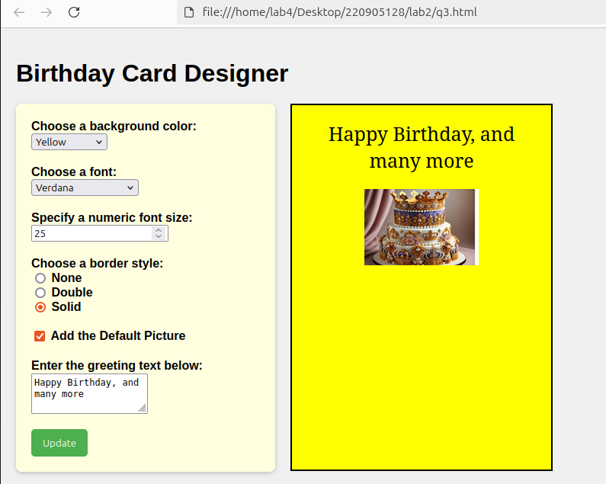

Q4)Design a webpage. The page contains:
• Dropdown list with HP, Nokia, Samsung, Motorola, Apple as items.
• Checkbox with Mobile and Laptop as items. Textbox where you enter quantity.
• There is a button with text as ‘Produce Bill’.
On Clicking Produce Bill button, alert should be displayed with total amount.

CODE:
<!DOCTYPE html>
<html lang="en">
<head>
<meta charset="UTF-8">
<meta name="viewport" content="width=device-width, initial-scale=1.0">
<title>Produce Bill</title>
<script src="/home/lab4/Desktop/220905128/lab2/jquery-3.7.1.js"></script>
<style>
body {
font-family: Arial, sans-serif;
background-color: #a4a4d4;
display: flex;
justify-content: center;
align-items: center;
height: 100vh;
margin: 0;
}

.container {
background-color: #fff;
padding: 20px;
border-radius: 10px;
box-shadow: 0px 4px 12px rgba(0, 0, 0, 0.1);
width: 400px;
}

.form-group {
margin-bottom: 20px;
margin-right: 15px;
}
label {
display: block;
margin-bottom: 5px;
font-weight: bold;
}

select, input[type="number"], input[type="checkbox"] {
width: 100%;
padding: 10px;
margin-bottom: 10px;
font-size: 16px;
}

input[type="checkbox"] {
width: auto;
margin-right: 10px;
}

button {
background-color: #28a745;
color: white;
font-size: 16px;
padding: 10px;
border: none;
border-radius: 5px;
width: 100%;
cursor: pointer;
transition: background-color 0.3s;
}

button:hover {
background-color: #218838;
}
</style>
</head>
<body>

<div class="container">
<h2>Bill Generator</h2>
<div class="form-group">
<label for="brand">Select Brand</label>
<select id="brand">
<option value="HP">HP</option>
<option value="Nokia">Nokia</option>
<option value="Samsung">Samsung</option>
<option value="Motorola">Motorola</option>
<option value="Apple">Apple</option>
</select>
</div>
<div class="form-group">
<label>Select Products</label>
<input type="checkbox" id="mobile" /> Mobile
<input type="checkbox" id="laptop" /> Laptop
</div>
<div class="form-group">
<label for="quantity">Enter Quantity</label>
<input type="number" id="quantity" min="1" placeholder="Enter quantity">
</div>
<button id="produceBill">Produce Bill</button>
</div>

<script>
$(document).ready(function() {
const prices = {
mobile: 300,
laptop: 600
};

$('#produceBill').click(function() {
const brand = $('#brand').val();
const quantity = $('#quantity').val();
if (!quantity || quantity <= 0) {
alert("Please enter a valid quantity.");
return;
}
let totalPrice = 0;
let selectedItems = [];
if ($('#mobile').is(':checked')) {
totalPrice += prices.mobile * quantity;
selectedItems.push("Mobile");
}
if ($('#laptop').is(':checked')) {
totalPrice += prices.laptop * quantity;
selectedItems.push("Laptop");
}
if (selectedItems.length === 0) {
alert("Please select at least one product (Mobile or Laptop).");
return;
}

alert(`Bill Summary:\nBrand: ${brand}\nProducts: ${selectedItems.join(", ")}\nTotal Quantity: ${quantity}\nTotal Amount: $${totalPrice}`);
});
});
</script>

</body>
</html>

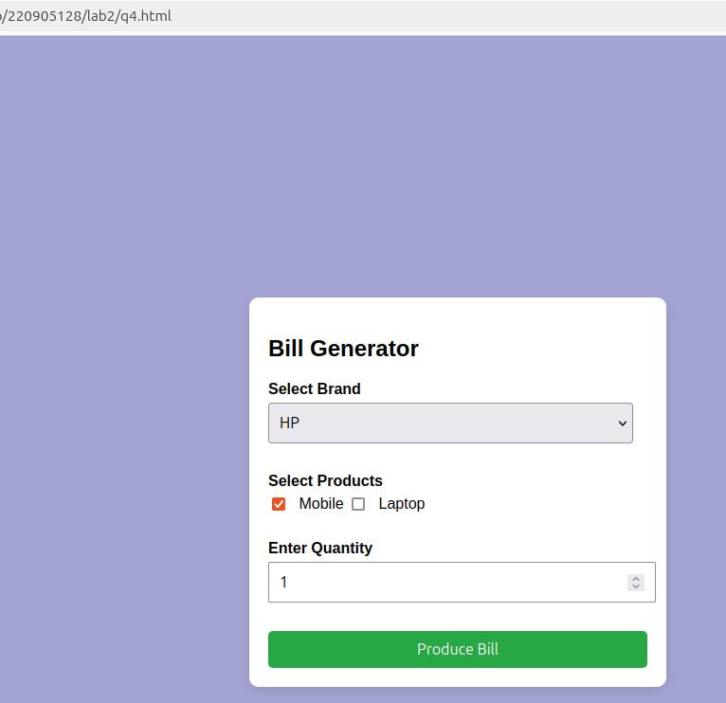

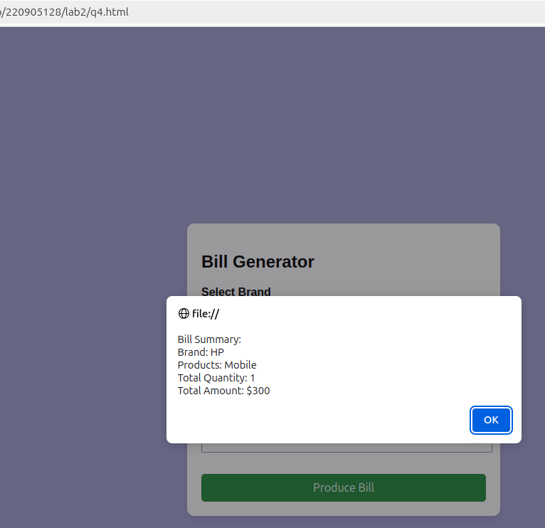

ADDITIONAL QUESTION:

Q1)Implement the bouncing ball using animate() function.

CODE:<!DOCTYPE html>
<html lang="en">
<head>
<meta charset="UTF-8">
<meta name="viewport" content="width=device-width, initial-scale=1.0">
<title>Bouncing Ball Animation</title>
<script src="/home/lab4/Desktop/220905128/lab2/jquery-3.7.1.js"></script>
<style>
body {
font-family: Arial, sans-serif;
display: flex;
justify-content: center;
align-items: center;
height: 100vh;
margin: 0;
background-color: #f4f4f4;
}
.container {
position: relative;
width: 500px;
height: 400px;
border: 2px solid #333;
overflow: hidden;
background-color: #ffffff;
}
.ball {
position: absolute;
width: 50px;
height: 50px;
border-radius: 50%;
background-color: red;
top: 0;
left: 50%;
transform: translateX(-50%);
}
</style>
</head>
<body>

<div class="container">
<div class="ball"></div>
</div>

<script>
$(document).ready(function() {
function bounceBall() {
$(".ball").animate(
{ top: "350px" }, // Move down
800, // Duration in milliseconds
"swing", // Easing effect
function() {
$(".ball").animate(
{ top: "0px" }, // Move up
800, // Duration in milliseconds
"swing", // Easing effect
bounceBall // Recursively call the function
);
}
);
}

bounceBall(); // Start the animation
});
</script>

</body>
</html>

Output:
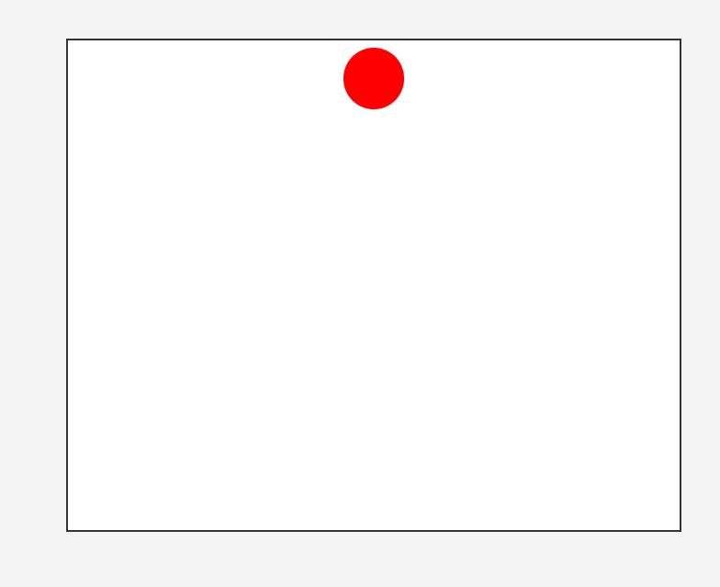

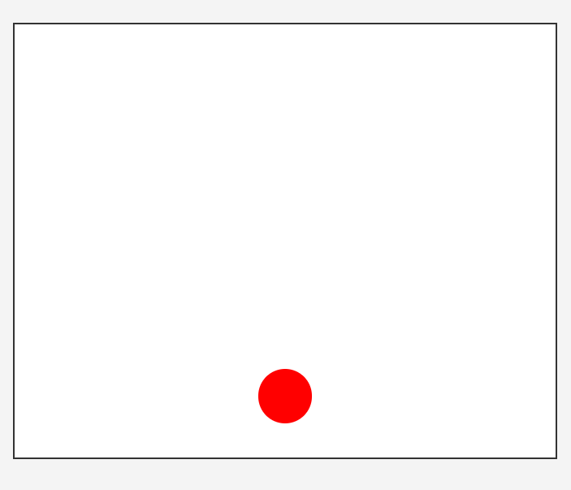

Q2)Write a web page which displays image and show the sliding text on the image.

CODE:

<!DOCTYPE html>
<html lang="en">
<head>
<meta charset="UTF-8">
<meta name="viewport" content="width=device-width, initial-scale=1.0">
<title>Sliding Text on Image</title>
<script src="/home/lab4/Desktop/220905128/lab2/jquery-3.7.1.js"></script>
<style>
body {
font-family: Arial, sans-serif;
margin: 0;
padding: 0;
display: flex;
justify-content: center;
align-items: center;
height: 100vh;
background-color: #f4f4f4;
}

.image-container {
position: relative;
width: 600px;
height: 400px;
overflow: hidden;
}

.image-container img {
width: 100%;
height: 100%;
display: block;
}

.sliding-text {
position: absolute;
bottom: -50px;
left: 0;
width: 100%;
text-align: center;
background: rgba(0, 0, 0, 0.6);
color: white;
font-size: 24px;
padding: 10px 0;
box-sizing: border-box;
transition: all 0.5s ease-in-out;
}
</style>
</head>
<body>

<div class="image-container">
<img src="/home/lab4/Desktop/220905128/lab2/paris.png" alt="Sample Image">
<div class="sliding-text">Welcome to the Paris!</div>
</div>

<script>
$(document).ready(function () {
$(".image-container").hover(
function () {
$(".sliding-text").animate({ bottom: "0px" }, 500);
},
function () {
$(".sliding-text").animate({ bottom: "-50px" }, 500);
}
);
});
</script>

</body>
</html>


Output:



