LAB ASSIGNMENTS

NAME:AYANIKA PAUL
BATCH:D1
ROLL NO. 22

Q1)Develop a simple web page to perform basic arithmetic operations. Take two
integer inputs from the user, select the operation to be performed using a
dropdown. Include a button “Calculate” to perform the selected operation, and
then display the result in the same web page.

CODE:

q1/settings.py

INSTALLED_APPS = [
'django.contrib.admin',
'django.contrib.auth',
'django.contrib.contenttypes',
'django.contrib.sessions',
'django.contrib.messages',
'django.contrib.staticfiles',
'calculator',
]

TEMPLATES = [
{
'BACKEND': 'django.template.backends.django.DjangoTemplates',
'DIRS': [
BASE_DIR / 'templates',
],
'APP_DIRS': True,
'OPTIONS': {
'context_processors': [
'django.template.context_processors.debug',
'django.template.context_processors.request',
'django.contrib.auth.context_processors.auth',
'django.contrib.messages.context_processors.messages',
],
},
},
]

q1/urls.py

from django.contrib import admin
from django.urls import path, include

urlpatterns = [
path('admin/', admin.site.urls),
path('', include('calculator.urls')),
]

calculator/urls.py

from django.urls import path
from . import views

urlpatterns = [
path('', views.calculate, name='calculate'),
]

calculator/urls.py

from django.urls import path
from . import views

urlpatterns = [
path('', views.calculate, name='calculate'),
]

calculator/views.py

from django.shortcuts import render

def calculate(request):
result = None
if request.method == "POST":
try:
num1 = int(request.POST['num1'])
num2 = int(request.POST['num2'])
operation = request.POST['operation']

if operation == 'add':
result = num1 + num2
elif operation == 'subtract':
result = num1 - num2
elif operation == 'multiply':
result = num1 * num2
elif operation == 'divide':
if num2 != 0:
result = num1 / num2
else:
result = 'Cannot divide by zero'
except ValueError:
result = 'Invalid input'

return render(request, 'calculator/calculate.html', {'result': result})

calculator/templates/calculate.html

<!DOCTYPE html>
<html lang="en">
<head>
<meta charset="UTF-8">
<meta name="viewport" content="width=device-width, initial-scale=1.0">
<title>Simple Calculator</title>
<style>
body {
font-family: Arial, sans-serif;
background-color: #f4f4f9;
margin: 0;
padding: 0;
display: flex;
justify-content: center;
align-items: center;
height: 100vh;
background-color: rgb(87, 124, 204);
}

.calculator-container {
background-color: #fff;
border-radius: 10px;
box-shadow: 0 4px 8px rgba(0, 0, 0, 0.1);
padding: 30px;
width: 479px;
text-align: center;
}

h1 {
font-size: 24px;
margin-bottom: 20px;
color: #333;
}

label {
font-size: 16px;
margin-top: 10px;
display: block;
text-align: left;
color: #555;
}

input[type="text"], select {
width: 100%;
padding: 10px;
margin-top: 5px;
border: 1px solid #ccc;
border-radius: 5px;
font-size: 16px;
}

button {
background-color: #4CAF50;
color: white;
border: none;
padding: 10px 20px;
border-radius: 5px;
cursor: pointer;
font-size: 16px;
margin-top: 20px;
}

button:hover {
background-color: #45a049;
}

h3 {
margin-top: 20px;
font-size: 18px;
color: #333;
}

.error {
color: red;
font-size: 16px;
}
</style>
</head>
<body>
<div class="calculator-container">
<h1>Simple Calculator</h1>

<form method="POST">
{% csrf_token %}
<label for="num1">Number 1:</label>
<input type="text" name="num1" id="num1" required>

<label for="num2">Number 2:</label>
<input type="text" name="num2" id="num2" required>

<label for="operation">Operation:</label>
<select name="operation" id="operation" required>
<option value="add">Add</option>
<option value="subtract">Subtract</option>
<option value="multiply">Multiply</option>
<option value="divide">Divide</option>
</select>

<button type="submit">Calculate</button>
</form>

{% if result is not none %}
<h3>Result: {{ result }}</h3>
{% endif %}

{% if result == 'Invalid input' %}
<p class="error">Please enter valid numbers!</p>
{% endif %}
</div>
</body>
</html>

OUTPUT:

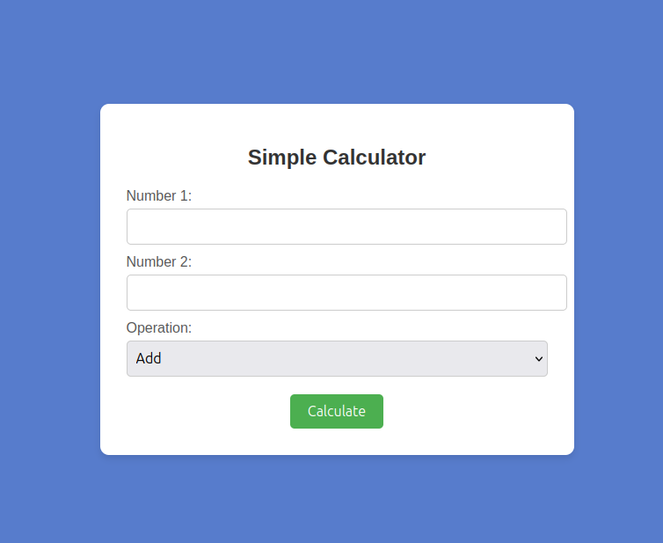

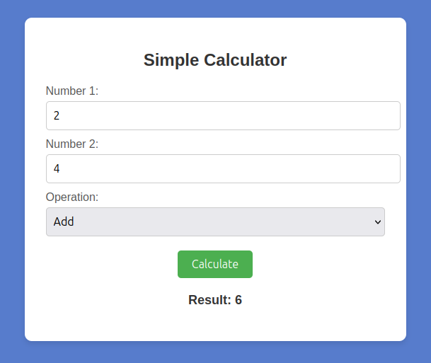
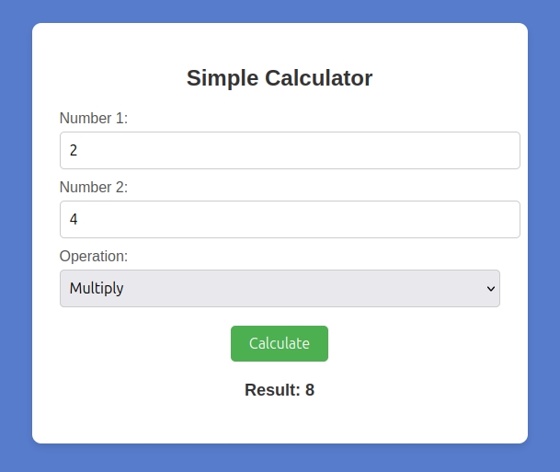

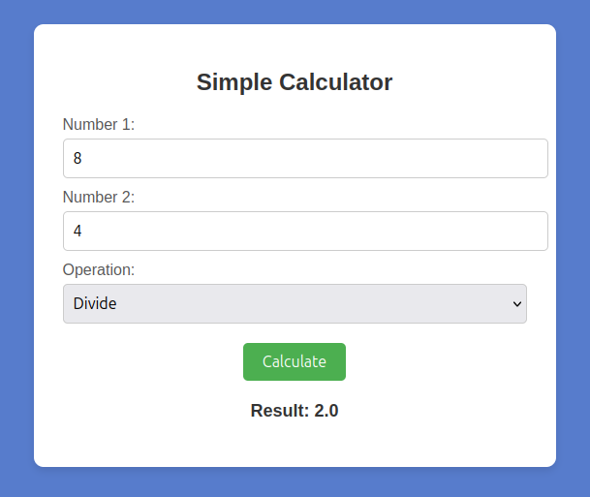
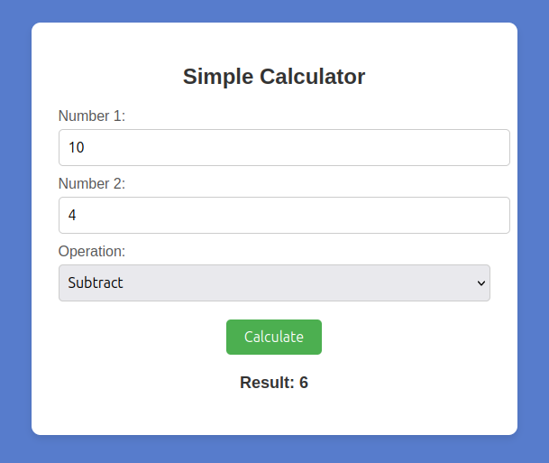

Q2)Develop a simple web form that generates the front cover for a magazine. The
form should provide the options for selecting the image, background color,
changing font size, color etc. Input messages must be taken from the user so
as to display it on the front cover with legible font family and font size. The
front cover developed should be proportionate to the web page size. Place the
css files inside static folder.

CODE:

q2/settings.py

INSTALLED_APPS = [
'django.contrib.admin',
'django.contrib.auth',
'django.contrib.contenttypes',
'django.contrib.sessions',
'django.contrib.messages',
'django.contrib.staticfiles',
'magazine_cover',
]

TEMPLATES = [
{
'BACKEND': 'django.template.backends.django.DjangoTemplates',
'DIRS': [BASE_DIR / 'templates'],
'APP_DIRS': True,
'OPTIONS': {
'context_processors': [
'django.template.context_processors.debug',
'django.template.context_processors.request',
'django.contrib.auth.context_processors.auth',
'django.contrib.messages.context_processors.messages',
],
},
},
]
STATIC_URL = '/static/'

STATICFILES_DIRS = [
BASE_DIR / "static",
]

MEDIA_URL = '/media/'
MEDIA_ROOT = BASE_DIR / 'media'

q2/urls.py

from django.contrib import admin
from django.urls import path, include
from django.shortcuts import redirect
from django.conf import settings
from django.conf.urls.static import static

urlpatterns = [
path('admin/', admin.site.urls),
path('cover/', include('magazine_cover.urls')),
path('', lambda request: redirect('cover/')),
]

if settings.DEBUG:
urlpatterns += static(settings.MEDIA_URL, document_root=settings.MEDIA_ROOT)

magazine_cover/urls.py

from django.urls import path
from . import views
urlpatterns = [
path('', views.generate_cover, name='form'),
]

magazine_cover/views.py

from django.shortcuts import render
from .forms import MagazineCoverForm

def generate_cover(request):
if request.method == 'POST':

form = MagazineCoverForm(request.POST, request.FILES)
if form.is_valid():

title = form.cleaned_data['title']
image = form.cleaned_data['image']
bg_color = form.cleaned_data['bg_color']
font_color = form.cleaned_data['font_color']

return render(request, 'magazine_cover/result.html', {
'title': title,
'image': image,
'bg_color': bg_color,
'font_color': font_color,
})

else:
form = MagazineCoverForm()

return render(request, 'magazine_cover/form.html', {'form': form})

magazine_cover/templates/form.html

<!DOCTYPE html>
<html lang="en">
<head>
<meta charset="UTF-8">
<meta name="viewport" content="width=device-width, initial-scale=1.0">
<title>Form Page</title>
{% load static %}
<link rel="stylesheet" href="{% static 'css/form.css' %}">
</head>
<body>
<div class="form-container">
<h2>Magazine Cover Form</h2>
<form action="" method="POST" enctype="multipart/form-data">
{% csrf_token %}
<div class="form-group">
<label for="title">Title</label>
<input type="text" id="title" name="title" placeholder="Enter title" required>
</div>
<div class="form-group">
<label for="image">Image</label>
<input type="file" id="image" name="image" accept="image/*" required>
</div>
<div class="form-group">
<label for="bg_color">Background Color</label>
<input type="color" id="bg_color" name="bg_color">
</div>
<div class="form-group">
<label for="font_color">Font Color</label>
<input type="color" id="font_color" name="font_color">
</div>
<button type="submit" class="submit-btn">Generate Cover</button>
</form>
</div>
</body>
</html>

magazine_cover/templates/result.html

{% load static %}
<!DOCTYPE html>
<html lang="en">
<head>
<meta charset="UTF-8">
<meta name="viewport" content="width=device-width, initial-scale=1.0">
<title>{{ title }} - Magazine Cover</title>
<link rel="stylesheet" href="{% static 'css/result.css' %}">
</head>
<body>
<div class="cover-container" style="background-color: {{ bg_color }};">
<div class="cover-content">
<h1 style="color: {{ font_color }};">{{ title }}</h1>
<img src="/media/coverpage.png" alt="Magazine Cover" class="cover-image">

</div>
</div>
</body>
</html>

static/css/form.css

body {
font-family: Arial, sans-serif;
background-color: #f4f4f4;
margin: 0;
padding: 0;
}

.form-container {
width: 100%;
max-width: 600px;
margin: 50px auto;
background-color: #fff;
padding: 20px;
box-shadow: 0 0 10px rgba(0, 0, 0, 0.1);
border-radius: 8px;
}

h2 {
text-align: center;
font-size: 24px;
color: #333;
}

.form-group {
margin-bottom: 15px;
}

label {
font-size: 16px;
color: #333;
margin-bottom: 5px;
display: block;
}

input[type="text"],
input[type="file"],
input[type="color"] {
width: 100%;
padding: 10px;
font-size: 14px;
border: 1px solid #ccc;
border-radius: 4px;
}

button.submit-btn {
width: 100%;
padding: 12px;
background-color: #333;
color: white;
border: none;
border-radius: 4px;
font-size: 16px;
cursor: pointer;
}

button.submit-btn:hover {
background-color: #555;
}

static/css/result.css

/* static/css/result.css */
body {
font-family: Arial, sans-serif;
background-color: #fafafa;
margin: 0;
padding: 0;
}

.result-container {
width: 100%;
max-width: 800px;
margin: 50px auto;
background-color: #fff;
padding: 20px;
box-shadow: 0 0 15px rgba(0, 0, 0, 0.1);
border-radius: 8px;
}
.cover-container{
background-color: #9a9996;
height: 100vh;
width: 682px;
margin-left: 147px;
text-align: center;
}

.cover-image {
max-width: 100%;
height: 500px;
border-radius: 10px;
box-shadow: 0 4px 8px rgba(0, 0, 0, 0.1);
display: block;
margin: 0 auto;
max-height: 500px;
}
h2 {
text-align: center;
font-size: 28px;
color: #333;
}

.result-info {
margin-top: 20px;
font-size: 18px;
color: #555;
}

OUTPUT:


