LAB 8

Name: AYANIKA PAUL
Sec: D1
Roll no. 22

Q1)Create a Register page and Success page with the following requirements:
i.
Register page should contain four input TextBoxes for UserName, Password,
Email id and Contact Number and also a button to submit. Make the username as
compulsory field and other fields as optional.
ii.
On button click, Success page is displayed with message "Welcome
{UserName}" and also his Email and Contact Number has to be displayed.
iii. Use secure technique to send details to the Success page (Hint: use csrftoken) 4)
Design a website with two pages.

CODE:

q1/urls.py

from django.contrib import admin
from django.urls import path
from register_app import views

urlpatterns = [
path('admin/', admin.site.urls),
path('', views.home, name='home'), # Add this line
path('register/', views.register, name='register'),
path('success/', views.success, name='success'),
]

register_app/views.py

from django.shortcuts import render, redirect
from django.contrib import messages
from django.middleware.csrf import get_token
from django.shortcuts import render, redirectdef home(request):
return redirect('register')
def register(request):
if request.method == "POST":
username = request.POST.get('username')
password = request.POST.get('password')
email = request.POST.get('email')
contact_number = request.POST.get('contact_number')
if not username:
messages.error(request, "Username is required")
return render(request, 'register_app/register.html')
request.session['username'] = username
request.session['email'] = email
request.session['contact_number'] = contact_number
return redirect('success')
return render(request, 'register_app/register.html', {'csrf_token': get_token(request)})
def success(request):
username = request.session.get('username')
email = request.session.get('email')
contact_number = request.session.get('contact_number')
if username:
return render(request, 'register_app/success.html', {
'username': username,
'email': email,
'contact_number': contact_number
})
else:
return redirect('register')

register_app/urls.py

from django.urls import path
from . import views

urlpatterns = [
path('', views.vote_view, name='register),
path('success/', views.results_view, name='success’),
]

register_app/forms.py

# register_app/forms.py
from django import forms

class RegistrationForm(forms.Form):
username = forms.CharField(max_length=100, required=True, label="Username")
password = forms.CharField(widget=forms.PasswordInput, required=False, label="Password")
email = forms.EmailField(required=False, label="Email")
contact_number = forms.CharField(max_length=15, required=False, label="Contact Number")

register_app/templates/register_app/register.html
<!DOCTYPE html>
<html lang="en">
<head>
<meta charset="UTF-8">
<meta name="viewport" content="width=device-width, initial-scale=1.0">
<title>Register</title>
<style>
* {
margin: 0;
padding: 0;
box-sizing: border-box;
}
body {
font-family: Arial, sans-serif;
background-color: #f4f4f9;
color: #333;
padding: 20px;
}
form {
width: 100%;
max-width: 400px;
margin: 0 auto;
background-color: #ffffff;
padding: 20px;
border-radius: 8px;
box-shadow: 0 4px 8px rgba(0, 0, 0, 0.1);
}
h2 {
text-align: center;
margin-bottom: 20px;
color: #4CAF50;
}
input[type="text"],
input[type="password"],
input[type="email"],
input[type="tel"] {
width: 100%;
padding: 12px;
margin: 8px 0;
border: 1px solid #ccc;
border-radius: 4px;
font-size: 16px;
box-sizing: border-box;
}
button {
width: 100%;
padding: 12px;
background-color: #4CAF50;
color: white;
border: none;
border-radius: 4px;
font-size: 16px;
cursor: pointer;
}
button:hover {
background-color: #45a049;
}
</style>
</head>
<body>
<h2>Register</h2>
<form method="POST">
{% csrf_token %}
<div>
<label for="username">Username*</label>
<input type="text" id="username" name="username" required>
</div>
<div>
<label for="password">Password</label>
<input type="password" id="password" name="password">
</div>
<div>
<label for="email">Email</label>
<input type="email" id="email" name="email">
</div>
<div>
<label for="contact_number">Contact Number</label>
<input type="text" id="contact_number" name="contact_number">
</div>
<div>
<button type="submit">Submit</button>
</div>
</form>
</body>
</html>

register_app/templates/register_app/success.html

<!DOCTYPE html>
<html lang="en">
<head>
<meta charset="UTF-8">
<meta name="viewport" content="width=device-width, initial-scale=1.0">
<title>Success</title>
<style>
* {
margin: 0;
padding: 0;
box-sizing: border-box;
}
body {
font-family: Arial, sans-serif;
background-color: #f4f4f9;
color: #333;
padding: 20px;
}
h2 {
text-align: center;
margin-bottom: 20px;
color: #4CAF50;
}
p {
font-size: 18px;
text-align: center;
margin: 10px 0;
}
</style>
</head>
<body>
<h2>Welcome {{ username }}!</h2>
<p>Email: {{ email }}</p>
<p>Contact Number: {{ contact_number }}</p>
</body>
</html>

Output:
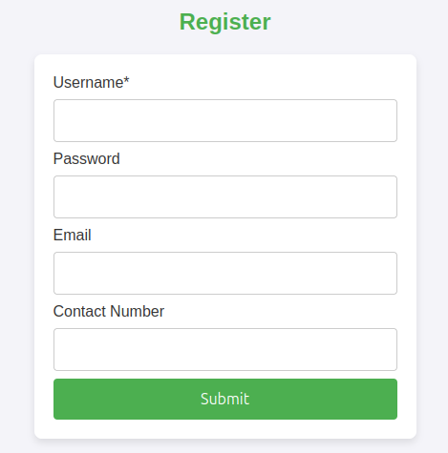

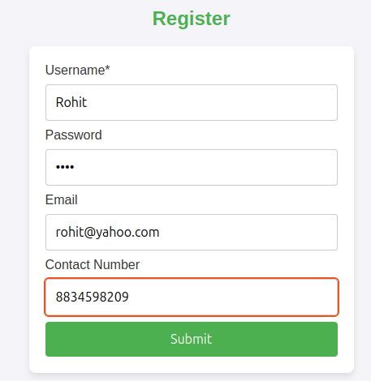

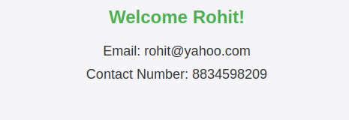

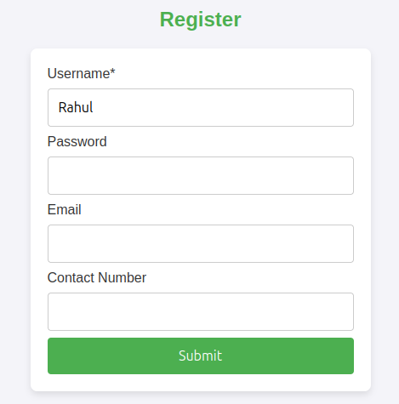

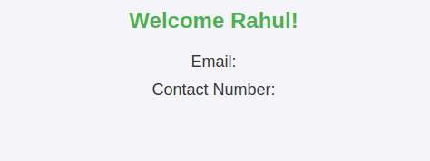

Q2)“How is the book ASP.NET with c# by Vipul Prakashan?” Give the user three
choice: i)Good ii)Satisfactory iii)Bad. Provide a VOTE button. After user votes, present the
result in percentage using labels next to the choices

CODE:

q2/urls.py

from django.contrib import admin
from django.urls import path, include

urlpatterns = [
path('admin/', admin.site.urls),
path('', include('vote.urls')),
]

vote/urls.py

from django.urls import path
from . import views
urlpatterns = [
path('', views.vote_view, name='vote'),
path('results/', views.results_view, name='results'),
]

vote/forms.py

from django import forms

class RegisterForm(forms.Form):
username = forms.CharField(max_length=100, required=True, label="Username")
password = forms.CharField(widget=forms.PasswordInput, required=False, label="Password")
email = forms.EmailField(required=False, label="Email ID")
contact = forms.CharField(max_length=15, required=False, label="Contact Number")

vote/views.py

from django.shortcuts import render
from .models import Choice
def vote_view(request):
choices = Choice.objects.all()
total_votes = sum(choice.votes for choice in choices)
if request.method == 'POST':
choice_id = request.POST.get('choice')
if choice_id:
choice = Choice.objects.get(id=choice_id)
choice.votes += 1
choice.save()
return render(request, 'vote/vote.html', {'choices': choices, 'total_votes': total_votes})
def results_view(request):
choices = Choice.objects.all()
total_votes = sum(choice.votes for choice in choices)
for choice in choices:
if total_votes > 0:
choice.vote_percentage = (choice.votes / total_votes) * 100
else:
choice.vote_percentage = 0
return render(request, 'vote/results.html', {'choices': choices, 'total_votes': total_votes})

results.html

<!DOCTYPE html>
<html>
<head>
<title>Vote Results</title>
</head>
<body>
<h3>Results for ASP.NET with C# by Vipul Prakashan</h3>

<h3>Vote Results:</h3>
<ul>
{% for choice in choices %}
<li>
{{ choice.text }} - {{ choice.votes }} votes
({{ choice.vote_percentage|floatformat:2 }}%)
</li>
{% endfor %}
</ul>

<a href="{% url 'vote' %}">Back to voting</a>
</body>
</html>

vote.html

<!DOCTYPE html>
<html>
<head>
<title>Vote for the Book</title>
</head>
<body>
<h3>How is the book ASP.NET with C# by Vipul Prakashan?</h3>
<form method="post">
{% csrf_token %}
{% for choice in choices %}
<li>
<input type="radio" name="choice" value="{{ choice.id }}" id="choice_{{ choice.id }}">
<label for="choice_{{ choice.id }}">{{ choice.text }}</label>
</li>
{% endfor %}
<button type="submit">VOTE</button>
</form>

{% if total_votes %}
<a href="{% url 'results' %}">See Results</a>
{% endif %}
</body>
</html>

OUTPUT:

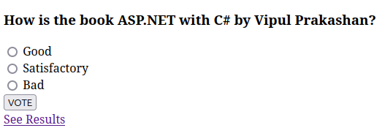

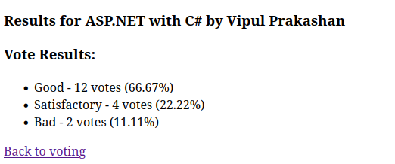

Q3)Create a website with two pages. Page 1 has two TextBoxes (name and total
marks) and one ‘Calculate’ Button as shown in the figure. On clicking the ‘Calculate’
Button, CGPA (total marks/50) along with the name should be displayed in the Page
2. Use Django sessions to store the information.

CODE:

q3/urls.py
from django.urls import path
from . import views

urlpatterns = [
path('', views.home, name='home'),
path('result/', views.result, name='result'),
]

marks/forms.py

from django import forms

class CGPAForm(forms.Form):
name = forms.CharField(max_length=100, label="Name")
total_marks = forms.FloatField(label="Total Marks", min_value=0)

marks/urls.py

from django.urls import path
from . import views

urlpatterns = [
path('', views.home, name='home'),
path('result/', views.result, name='result'),
]

marks/views.py

from django.shortcuts import render, redirect
from .forms import CGPAForm
def home(request):
if request.method == 'POST':
form = CGPAForm(request.POST)
if form.is_valid():
name = form.cleaned_data['name']
total_marks = form.cleaned_data['total_marks']
request.session['name'] = name
request.session['total_marks'] = total_marks
return redirect('result')
else:
form = CGPAForm()
return render(request, 'marks/home.html', {'form': form})
def result(request):
name = request.session.get('name', 'Guest')
total_marks = request.session.get('total_marks', 0)
if total_marks:
cgpa = total_marks / 50
else:
cgpa = 0
return render(request, 'marks/result.html', {'name': name, 'cgpa': cgpa})

home.html

<!DOCTYPE html>
<html lang="en">
<head>
<meta charset="UTF-8">
<meta name="viewport" content="width=device-width, initial-scale=1.0">
<title>CGPA Calculator</title>
<style>
body {
font-family: Arial, sans-serif;
background-color: #f4f4f9;
margin: 0;
padding: 0;
}
.container {
width: 50%;
margin: 50px auto;
padding: 20px;
background-color: white;
box-shadow: 0px 0px 10px rgba(0, 0, 0, 0.1);
border-radius: 8px;
}
h1 {
text-align: center;
color: #333;
}
label {
display: block;
margin-bottom: 8px;
color: #555;
}
input[type="text"], input[type="number"] {
width: 100%;
padding: 10px;
margin-bottom: 20px;
border: 1px solid #ddd;
border-radius: 5px;
}
button {
width: 100%;
padding: 10px;
background-color: #4CAF50;
color: white;
border: none;
border-radius: 5px;
font-size: 16px;
cursor: pointer;
}
button:hover {
background-color: #45a049;
}
.errors {
color: red;
margin-bottom: 20px;
}
.errors ul {
list-style-type: none;
padding: 0;
}
.errors ul li {
margin-bottom: 5px;
}
</style>
</head>
<body>
<div class="container">
<h1>Enter Your Details</h1>
<form method="POST">
{% csrf_token %}
{% if form.errors %}
<div class="errors">
<ul>
{% for field in form %}
{% for error in field.errors %}
<li>{{ error }}</li>
{% endfor %}
{% endfor %}
</ul>
</div>
{% endif %}
{{ form.as_p }}
<button type="submit">Calculate</button>
</form>
</div>
</body>
</html>

result.html

<!DOCTYPE html>
<html lang="en">
<head>
<meta charset="UTF-8">
<meta name="viewport" content="width=device-width, initial-scale=1.0">
<title>CGPA Result</title>
<style>
body {
font-family: Arial, sans-serif;
background-color: #f4f4f9;
margin: 0;
padding: 0;
}
.container {
width: 50%;
margin: 50px auto;
padding: 20px;
background-color: white;
box-shadow: 0px 0px 10px rgba(0, 0, 0, 0.1);
border-radius: 8px;
text-align: center;
}
h1 {
color: #333;
}
p {
font-size: 18px;
color: #555;
}
.success-message {
color: green;
font-weight: bold;
}
.instruction-message {
color: #f44336;
font-weight: bold;
}
</style>
</head>
<body>
<div class="container">
<h1>Result</h1>
<p><strong>Name:</strong> {{ name }}</p>
<p><strong>CGPA:</strong> {{ cgpa }}</p>
{% if name %}
<p class="success-message">Your CGPA has been successfully calculated!</p>
{% else %}
<p class="instruction-message">No data available. Please go back and enter your details.</p>
{% endif %}
</div>
</body>
</html>

OUTPUT:

