Lab8(Home Assignment)

Q1)Create a website with two pages.First page contains:
RadioButton with HP, Nokia, Samsung, Motorola, Apple as options.
CheckBox with Mobile and Laptop as items. TextBox to enter quantity.
There is a button with text as "Produce Bill".
On Clicking Produce Bill button, item should be displayed with total amount on another
page.

CODE:

q1/urls.py

from django.contrib import admin
from django.urls import path, include
urlpatterns = [
path('admin/', admin.site.urls),
path('', include('billing.urls')),
]

billing/urls.py

from django.urls import path
from . import views

urlpatterns = [
path('', views.index, name='index'),
]

billing/forms.py

from django import forms
class BillForm(forms.Form):
brand = forms.ChoiceField(
choices=[('HP', 'HP'), ('Nokia', 'Nokia'), ('Samsung', 'Samsung'),
('Motorola', 'Motorola'), ('Apple', 'Apple')],
widget=forms.RadioSelect,
label="Select Brand"
)
product_type = forms.MultipleChoiceField(
choices=[('Mobile', 'Mobile'), ('Laptop', 'Laptop')],
widget=forms.CheckboxSelectMultiple,
label="Select Product Type"
)
quantity = forms.IntegerField(min_value=1, label="Enter Quantity")

billing/views.py

from django.shortcuts import render
from .forms import BillForm
def index(request):
if request.method == 'POST':
form = BillForm(request.POST)
if form.is_valid():
brand = form.cleaned_data['brand']
product_type = form.cleaned_data['product_type']
quantity = form.cleaned_data['quantity']
price = 0
if brand == 'HP':
price = 1000
elif brand == 'Nokia':
price = 500
elif brand == 'Samsung':
price = 800
elif brand == 'Motorola':
price = 600
elif brand == 'Apple':
price = 1200
total_amount = price * quantity
return render(request, 'billing/bill.html', {
'brand': brand,
'product_type': product_type,
'quantity': quantity,
'total_amount': total_amount,
})
else:
form = BillForm()
return render(request, 'billing/index.html', {'form': form})

bill.html

<!DOCTYPE html>
<html lang="en">
<head>
<meta charset="UTF-8">
<title>Bill</title>
</head>
<body>
<h1>Your Bill</h1>
<p><strong>Brand:</strong> {{ brand }}</p>
<p><strong>Product Type(s):</strong> {{ product_type|join:", " }}</p>
<p><strong>Quantity:</strong> {{ quantity }}</p>
<p><strong>Total Amount:</strong> ${{ total_amount }}</p>
</body>
</html>

index.html

<!DOCTYPE html>
<html lang="en">
<head>
<meta charset="UTF-8">
<title>Billing Form</title>
</head>
<body>
<h1>Select Product Details</h1>
<form method="POST">
{% csrf_token %}
{{ form.as_p }}
<button type="submit">Produce Bill</button>
</form>
</body>
</html>

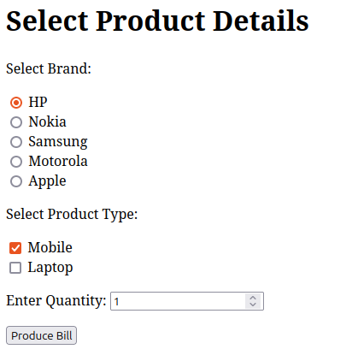
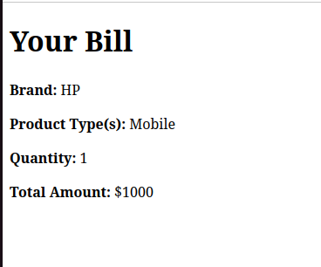
OUTPUT:

Q2)

