LAB 3

Q1)Design the student bio-data form using button, label, textbox, radio button, table and
checkbox using CSS.

CODE:
<!DOCTYPE html>
<html lang="en">
<head>
<meta charset="UTF-8">
<meta name="viewport" content="width=device-width, initial-scale=1.0">
<title>Student Bio-Data Form</title>
<link href="https://cdn.jsdelivr.net/npm/bootstrap@5.3.0-alpha3/dist/css/bootstrap.min.css" rel="stylesheet">
</head>
<body>
<div class="container mt-5 ">
<div class="card border border-primary ">
<div class="card-header text-center bg-primary border border-primary text-white">
<h1>Student Bio-Data Form</h1>
</div>
<div class="card-body">
<form>
<div class="mb-3">
<label for="name" class="form-label">Full Name:</label>
<input type="text" class="form-control border border-primary " id="name" placeholder="Enter your full name">
</div>
<div class="mb-3">
<label for="dob" class="form-label">Date of Birth:</label>
<input type="date" class="form-control border border-primary" id="dob">
</div>
<div class="mb-3">
<label class="form-label">Gender:</label>
<div>
<div class="form-check form-check-inline">
<input class="form-check-input " type="radio" id="male" name="gender" value="Male">
<label class="form-check-label " for="male">Male</label>
</div>
<div class="form-check form-check-inline">
<input class="form-check-input" type="radio" id="female" name="gender" value="Female">
<label class="form-check-label" for="female">Female</label>
</div>
<div class="form-check form-check-inline">
<input class="form-check-input" type="radio" id="other" name="gender" value="Other">
<label class="form-check-label" for="other">Other</label>
</div>
</div>
</div>
<div class="mb-3">
<label for="address" class="form-label">Address:</label>
<textarea class="form-control border border-primary" id="address" rows="3" placeholder="Enter your address"></textarea>
</div>
<div class="mb-3">
<label class="form-label">Languages Known:</label>
<div class="form-check">
<input class="form-check-input" type="checkbox" id="english" value="English">
<label class="form-check-label" for="english">English</label>
</div>
<div class="form-check">
<input class="form-check-input" type="checkbox" id="hindi" value="Hindi">
<label class="form-check-label" for="hindi">Hindi</label>
</div>
<div class="form-check">
<input class="form-check-input" type="checkbox" id="other-language" value="Other">
<label class="form-check-label" for="other-language">Other</label>
</div>
</div>
<div class="mb-3">
<label class="form-label">Educational Qualifications:</label>
<table class="table table-bordered ">
<thead class="table-light">
<tr>
<th>Degree</th>
<th>Year of Passing</th>
<th>Institution</th>
<th>Percentage</th>
</tr>
</thead>
<tbody>
<tr>
<td><input type="text" class="form-control" placeholder="Enter degree"></td>
<td><input type="text" class="form-control" placeholder="Year"></td>
<td><input type="text" class="form-control" placeholder="Institution"></td>
<td><input type="text" class="form-control" placeholder="Percentage"></td>
</tr>
<tr>
<td><input type="text" class="form-control" placeholder="Enter degree"></td>
<td><input type="text" class="form-control" placeholder="Year"></td>
<td><input type="text" class="form-control" placeholder="Institution"></td>
<td><input type="text" class="form-control" placeholder="Percentage"></td>
</tr>
</tbody>
</table>
</div>
<div class="text-center">
<button type="submit" class="btn btn-success me-2">Submit</button>
<button type="reset" class="btn btn-danger">Reset</button>
</div>
</form>
</div>
</div>
</div>

<script src="https://cdn.jsdelivr.net/npm/bootstrap@5.3.0-alpha3/dist/js/bootstrap.bundle.min.js"></script>
</body>
</html>

Output:
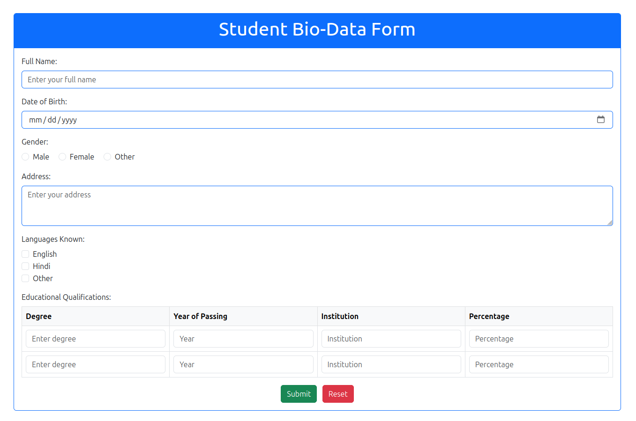

Q2)Design a web page which shows the database oriented CRUD operation. Consider
Employee data using CSS.

CODE:
<!DOCTYPE html>
<html lang="en">
<head>
<meta charset="UTF-8">
<meta name="viewport" content="width=device-width, initial-scale=1.0">
<title>Employee CRUD Operations</title>
<link href="https://cdn.jsdelivr.net/npm/bootstrap@5.3.0-alpha3/dist/css/bootstrap.min.css" rel="stylesheet">
<style>
body {
background-color: #f8f9fa;
}
.card {
margin: 20px;
border-radius: 10px;
box-shadow: 0 4px 8px rgba(0, 0, 0, 0.1);
}
.table-container {
max-height: 400px;
overflow-y: auto;
}
.modal-header {
background-color: #007bff;
color: white;
}
</style>
</head>
<body>
<div class="container mt-5">
<div class="text-center mb-4">
<h1>Employee Data Management</h1>
</div>
<div class="text-end mb-3">
<button class="btn btn-info" data-bs-toggle="modal" data-bs-target="#addEmployeeModal">
Add Employee
</button>
</div>
<div class="card">
<div class="card-header bg-info text-black">
<h4 class="mb-0">Employee Records</h4>
</div>
<div class="card-body table-container">
<table class="table table-striped">
<thead>
<tr>
<th>#</th>
<th>Employee Name</th>
<th>Department</th>
<th>Designation</th>
<th>Actions</th>
</tr>
</thead>
<tbody id="employeeTable">
</tbody>
</table>
</div>
</div>
<div class="modal fade" id="addEmployeeModal" tabindex="-1" aria-labelledby="addEmployeeModalLabel" aria-hidden="true">
<div class="modal-dialog">
<div class="modal-content">
<div class="modal-header">
<h5 class="modal-title " id="addEmployeeModalLabel">Add Employee</h5>
<button type="button" class="btn-close" data-bs-dismiss="modal" aria-label="Close"></button>
</div>
<div class="modal-body">
<form id="employeeForm">
<div class="mb-3 ">
<label for="employeeName" class="form-label ">Employee Name</label>
<input type="text" class="form-control" id="employeeName" placeholder="Enter name">
</div>
<div class="mb-3">
<label for="employeeDepartment" class="form-label">Department</label>
<input type="text" class="form-control" id="employeeDepartment" placeholder="Enter department">
</div>
<div class="mb-3">
<label for="employeeDesignation" class="form-label">Designation</label>
<input type="text" class="form-control" id="employeeDesignation" placeholder="Enter designation">
</div>
</form>
</div>
<div class="modal-footer">
<button type="button" class="btn btn-secondary" data-bs-dismiss="modal">Close</button>
<button type="button" class="btn btn-primary" id="saveEmployee">Save</button>
</div>
</div>
</div>
</div>
</div>

<script src="https://cdn.jsdelivr.net/npm/bootstrap@5.3.0-alpha3/dist/js/bootstrap.bundle.min.js"></script>
<script>
let employeeTable = document.getElementById("employeeTable");
let editIndex = null;

document.getElementById("saveEmployee").addEventListener("click", function () {
const name = document.getElementById("employeeName").value.trim();
const department = document.getElementById("employeeDepartment").value.trim();
const designation = document.getElementById("employeeDesignation").value.trim();

if (!name || !department || !designation) {
alert("All fields are required.");
return;
}

if (editIndex === null) {
const row = document.createElement("tr");
row.innerHTML = `
<td>${employeeTable.rows.length + 1}</td>
<td>${name}</td>
<td>${department}</td>
<td>${designation}</td>
<td>
<button class="btn btn-warning btn-sm me-1 edit-btn">Edit</button>
<button class="btn btn-danger btn-sm delete-btn">Delete</button>
</td>
`;
employeeTable.appendChild(row);
} else {
const row = employeeTable.rows[editIndex];
row.cells[1].textContent = name;
row.cells[2].textContent = department;
row.cells[3].textContent = designation;
editIndex = null;
}
document.getElementById("employeeForm").reset();
const modal = bootstrap.Modal.getInstance(document.getElementById("addEmployeeModal"));
modal.hide();
});
employeeTable.addEventListener("click", function (e) {
if (e.target.classList.contains("edit-btn")) {
const row = e.target.closest("tr");
editIndex = row.rowIndex - 1;
document.getElementById("employeeName").value = row.cells[1].textContent;
document.getElementById("employeeDepartment").value = row.cells[2].textContent;
document.getElementById("employeeDesignation").value = row.cells[3].textContent;
const modal = new bootstrap.Modal(document.getElementById("addEmployeeModal"));
modal.show();
} else if (e.target.classList.contains("delete-btn")) {
const row = e.target.closest("tr");
employeeTable.deleteRow(row.rowIndex - 1);
updateRowNumbers();
}
});
function updateRowNumbers() {
Array.from(employeeTable.rows).forEach((row, index) => {
row.cells[0].textContent = index + 1;
});
}
</script>
</body>
</html>

Output:

Upon clicking on button “Add Employee”
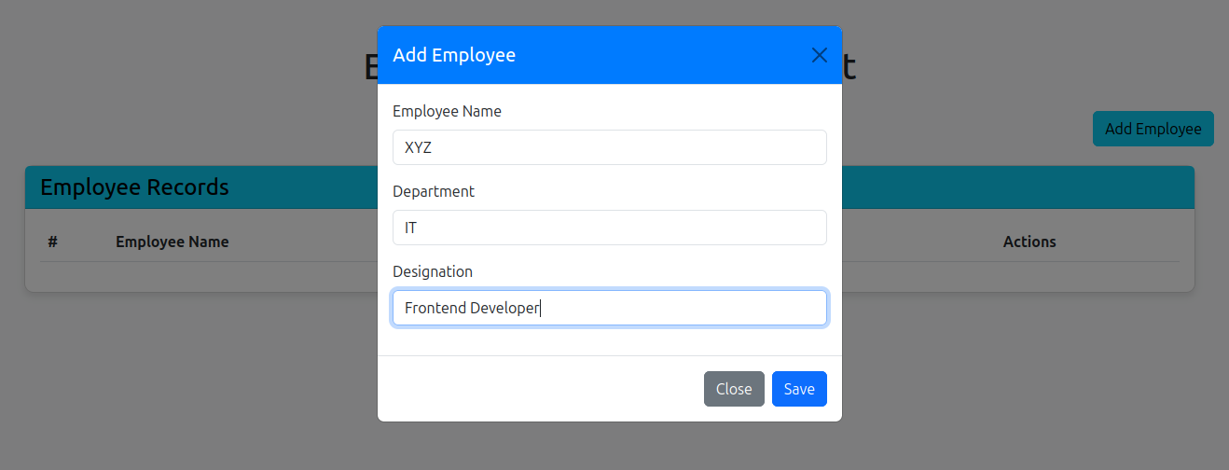
READ operation:

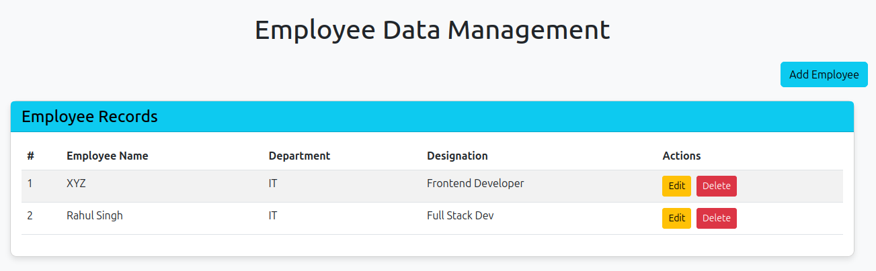

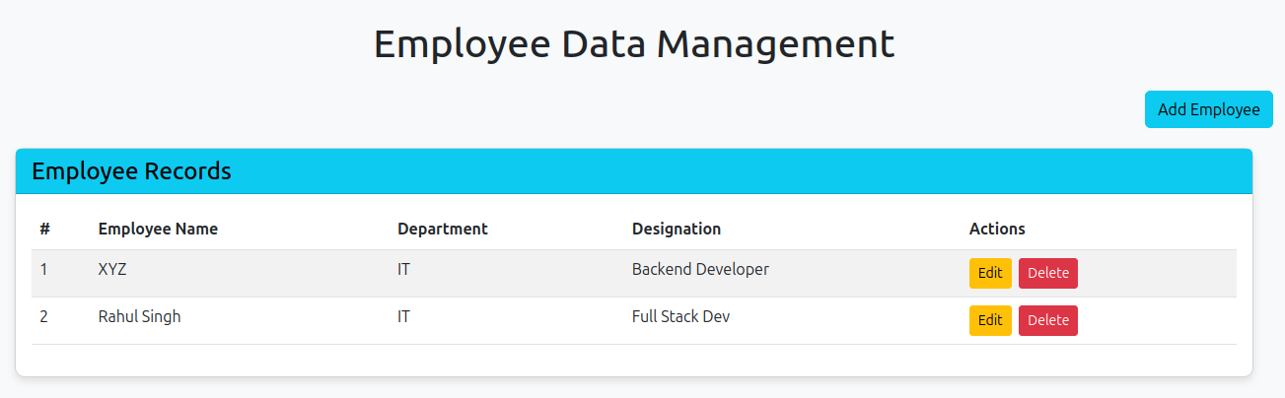
UPDATE operation:

DELETE operation:

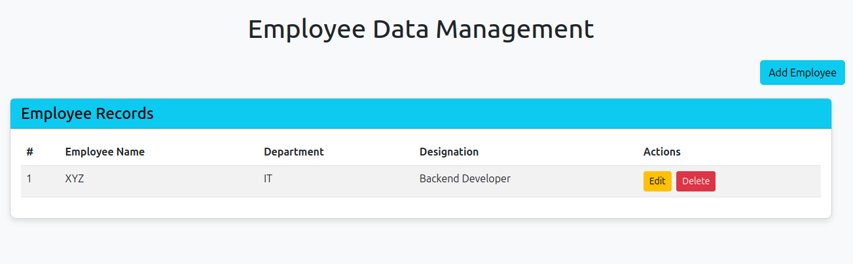

Q3)Create a web page using bootstrap as mentioned. Divide the page in to 2 parts top and
bottom, then divide the bottom into 3 parts and design each top and bottom part using
different input groups, input, badges, buttons and button groups. Make the design more
attractive using bootstrap.

CODE:

<!DOCTYPE html>
<html lang="en">
<head>
<meta charset="UTF-8">
<meta name="viewport" content="width=device-width, initial-scale=1.0">
<title>Q4</title>
<link href="https://cdn.jsdelivr.net/npm/bootstrap@5.3.0/dist/css/bootstrap.min.css" rel="stylesheet">
<style>
body {
background: linear-gradient(to right, #f8f9fa, #e9ecef);
}
.top-section {
background: linear-gradient(135deg, #007bff, #0056b3);
color: white;
border-radius: 10px;
}
.top-section h1 {
font-weight: bold;
}
.top-section .btn-light {
box-shadow: 0px 4px 6px rgba(0, 0, 0, 0.1);
}
.rounded.shadow {
box-shadow: 0px 4px 10px rgba(0, 0, 0, 0.1);
}
.btn-group .btn {
transition: background-color 0.3s ease;
}
.btn-group .btn:hover {
background-color: rgba(0, 0, 0, 0.05);
color: black;
}
.list-group-item {
border: none;
background: #f8f9fa;
}
.list-group-item:hover {
background: #e9ecef;
}
.btn {
transition: all 0.3s ease;
}
.btn:hover {
box-shadow: 0px 4px 6px rgba(0, 0, 0, 0.1);
}
.btn:active {
transform: translateY(0);
box-shadow: none;
}
</style>
</head>
<body>
<div class="container py-5">
<div class="top-section text-center p-5 shadow mb-5">
<h1 class="display-4">Welcome to My Website</h1>
<p class="lead">Your one-stop destination for managing your profile, notifications, and settings.</p>
<div class="input-group mt-4 w-50 mx-auto">
<input type="text" class="form-control" placeholder="Search here...">
<button class="btn btn-light" type="button">Search</button>
</div>
</div>
<div class="row g-5">
<div class="col-md-4">
<div class="p-4 bg-white rounded shadow">
<h3 class="mb-4 text-primary">Profile</h3>
<div class="input-group mb-3">
<span class="input-group-text">Name</span>
<input type="text" class="form-control" placeholder="Enter your name">
</div>
<div class="input-group mb-3">
<span class="input-group-text">Email</span>
<input type="email" class="form-control" placeholder="Email">
</div>
<button class="btn btn-success w-100">Save Profile</button>
</div>
</div>
<div class="col-md-4">
<div class="p-4 bg-white rounded shadow">
<h3 class="mb-4 text-primary">Notifications</h3>
<ul class="list-group">
<li class="list-group-item d-flex justify-content-between align-items-center">
<span><i class="bi bi-envelope-fill"></i> New Message</span>
<span class="badge bg-info text-dark">4</span>
</li>
<li class="list-group-item d-flex justify-content-between align-items-center">
<span><i class="bi bi-list-check"></i> Pending Tasks</span>
<span class="badge bg-warning text-dark">2</span>
</li>
<li class="list-group-item d-flex justify-content-between align-items-center">
<span><i class="bi bi-exclamation-triangle-fill"></i> Overdue</span>
<span class="badge bg-danger">1</span>
</li>
</ul>
<div class="mt-4 text-center">
<button class="btn btn-primary me-2">Mark All as Read</button>
<button class="btn btn-danger">Clear All</button>
</div>
</div>
</div>
<div class="col-md-4">
<div class="p-4 bg-white rounded shadow">
<h3 class="mb-4 text-primary">Settings</h3>
<div class="btn-group w-100 mb-4" role="group">
<button type="button" class="btn btn-outline-primary">Account</button>
<button type="button" class="btn btn-outline-secondary">Privacy</button>
<button type="button" class="btn btn-outline-danger">Security</button>
</div>
<button class="btn btn-success w-100">Apply Settings</button>
</div>
</div>
</div>
</div>

<script src="https://cdn.jsdelivr.net/npm/bootstrap@5.3.0/dist/js/bootstrap.bundle.min.js"></script>
<link rel="stylesheet" href="https://cdnjs.cloudflare.com/ajax/libs/bootstrap-icons/1.9.1/font/bootstrap-icons.min.css">
</body>
</html>

Output:

