LAB 3
HOME ASSIGNMENTS:

Q1)Design an attractive ‘train ticket booking form using different Bootstrap elements.
CODE:
<!DOCTYPE html>
<html lang="en">
<head>
<meta charset="UTF-8">
<meta name="viewport" content="width=device-width, initial-scale=1.0">
<title>Train Ticket Booking Form</title>
<link href="https://cdn.jsdelivr.net/npm/bootstrap@5.3.0/dist/css/bootstrap.min.css" rel="stylesheet">
<style>
body {
background: linear-gradient(135deg, #74ebd5, #9face6);
min-height: 100vh;
display: flex;
align-items: center;
justify-content: center;
}
.form-container {
background: white;
padding: 30px;
border-radius: 15px;
box-shadow: 0 10px 15px rgba(0, 0, 0, 0.4);
width: 100%;
max-width: 600px;
}
.form-header {
text-align: center;
margin-bottom: 20px;
color: #007bff;
}
.btn-primary {
background-color: #007bff;
border: none;
}
.btn-primary:hover {
background-color: #0056b3;
}
.form-footer {
text-align: center;
margin-top: 20px;
}
</style>
</head>
<body>
<div class="container">
<div class="form-container">
<h2 class="form-header">Train Ticket Booking</h2>
<form>
<div class="mb-3">
<label for="name" class="form-label">Full Name</label>
<input type="text" class="form-control border border-primary" id="name" placeholder="Enter your full name" required>
</div>
<div class="mb-3">
<label for="email" class="form-label">Email Address</label>
<input type="email" class="form-control border border-primary" id="email" placeholder="Enter your email" required>
</div>
<div class="mb-3">
<label for="phone" class="form-label">Phone Number</label>
<input type="text" class="form-control border border-primary" id="phone" placeholder="Enter your phone number" required>
</div>
<div class="mb-3">
<label for="source" class="form-label">From</label>
<input type="text" class="form-control border border-primary" id="source" placeholder="Departure station" required>
</div>
<div class="mb-3">
<label for="destination" class="form-label">To</label>
<input type="text" class="form-control border border-primary" id="destination" placeholder="Destination station" required>
</div>
<div class="row">
<div class="col-md-6 mb-3">
<label for="departureDate" class="form-label">Departure Date</label>
<input type="date" class="form-control border border-primary" id="departureDate" required>
</div>
<div class="col-md-6 mb-3">
<label for="class" class="form-label ">Class</label>
<select class="form-select border border-primary" id="class" required>
<option value="">Choose class</option>
<option value="1A">First AC</option>
<option value="2A">Second AC</option>
<option value="3A">Third AC</option>
<option value="SL">Sleeper</option>
</select>
</div>
</div>
<div class="mb-3">
<label for="paymentMethod" class="form-label">Payment Method</label>
<select class="form-select border border-primary" id="paymentMethod" required>
<option value="">Select payment method</option>
<option value="creditCard">Credit Card</option>
<option value="debitCard">Debit Card</option>
<option value="netBanking">Net Banking</option>
<option value="upi">UPI</option>
</select>
</div>
<div class="mb-3">
<label for="additionalInfo" class="form-label">Additional Information</label>
<textarea class="form-control border border-primary" id="additionalInfo" rows="3" placeholder="Enter any additional information"></textarea>
</div>
<div class="d-grid">
<button type="submit" class="btn btn-primary">Book Ticket</button>
</div>
</form>

</div>
</div>

<script src="https://cdn.jsdelivr.net/npm/bootstrap@5.3.0/dist/js/bootstrap.bundle.min.js"></script>
</body>
</html>

Output:

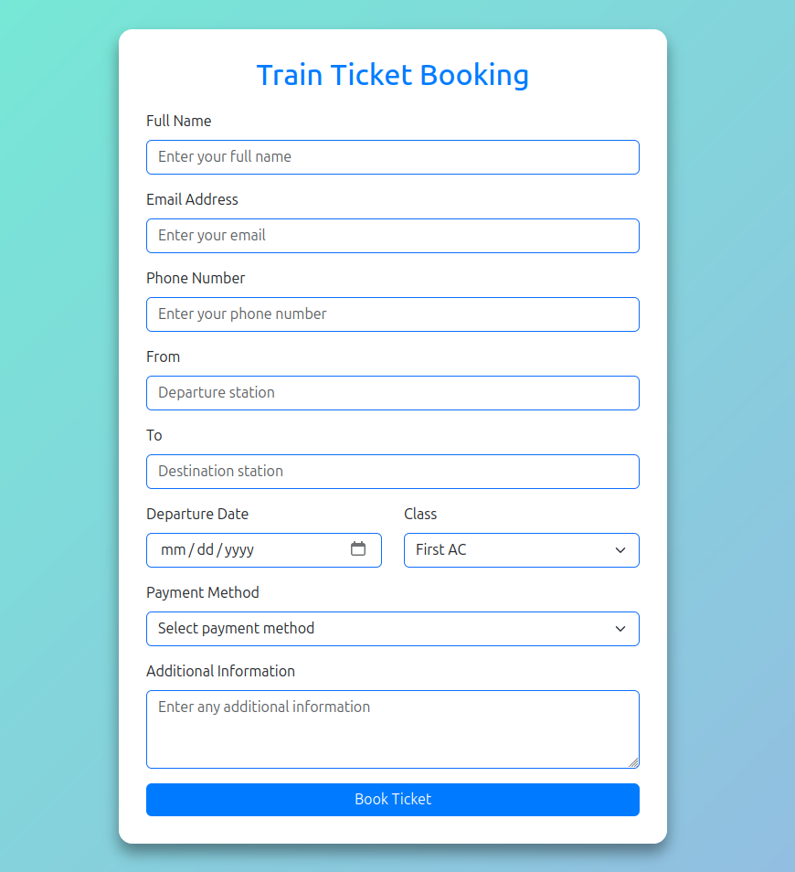

Q2)Design an attractive ‘magazine cover page’ using different bootstrap elements.

CODE:
<!DOCTYPE html>
<html lang="en">
<head>
<meta charset="UTF-8">
<meta name="viewport" content="width=device-width, initial-scale=1.0">
<title>Magazine Cover</title>
<link href="https://cdn.jsdelivr.net/npm/bootstrap@5.3.0/dist/css/bootstrap.min.css" rel="stylesheet">
<style>
body {
background: linear-gradient(135deg, #1a1a1a, #333);
min-height: 100vh;
display: flex;
align-items: center;
justify-content: center;
color: white;
}
.cover-container {
background: #212529;
padding: 40px;
border-radius: 20px;
box-shadow: 0 8px 20px rgba(0, 0, 0, 0.5);
text-align: center;
max-width: 800px;
width: 100%;
}
.cover-header {
font-family: 'Georgia', serif;
color: #f39c12;
text-transform: uppercase;
margin-bottom: 20px;
}
.main-headline {
font-family: 'Impact', sans-serif;
font-size: 48px;
color: #f39c12;
line-height: 1.2;
text-shadow: 2px 2px 5px rgba(0, 0, 0, 0.5);
}
.secondary-text {
font-family: 'Arial', sans-serif;
color: #ffffff;
font-size: 18px;
margin-top: 15px;
margin-bottom: 30px;
}
.features-list {
font-family: 'Verdana', sans-serif;
color: #cdd1d4;
margin: 20px 0;
}
.btn-primary {
background-color: #e74c3c;
border: none;
padding: 10px 20px;
font-size: 18px;
border-radius: 50px;
}
.btn-primary:hover {
background-color: #c0392b;
}
.footer {
margin-top: 30px;
font-size: 14px;
color: #bdc3c7;
}
</style>
</head>
<body>
<div class="cover-container">
<div class="cover-header">Monthly Digest</div>
<h1 class="main-headline">The Future of Tech<br>Innovations in 2025</h1>
<p class="secondary-text">Explore groundbreaking advancements in artificial intelligence, robotics, and beyond. Exclusive insights and interviews from industry leaders.</p>
<div class="features-list">
<h5>Featured Inside:</h5>
<ul class="list-unstyled">
<li>&#8226; The Rise of Quantum Computing</li>
<li>&#8226; Top 10 Gadgets to Watch Out For</li>
<li>&#8226; How AI is Revolutionizing Healthcare</li>
<li>&#8226; Interview with Tesla's New CEO</li>
</ul>
</div>
<div>
<button class="btn btn-primary">Subscribe Now</button>
</div>
<div class="footer">
<p> 2025 Monthly Digest Magazine </p>
</div>
</div>
<script src="https://cdn.jsdelivr.net/npm/bootstrap@5.3.0/dist/js/bootstrap.bundle.min.js"></script>
</body>
</html>

Output:



Q3)Design your class timetable using bootstrap table and carousel.

CODE:

<!DOCTYPE html>
<html lang="en">
<head>
<meta charset="UTF-8">
<meta name="viewport" content="width=device-width, initial-scale=1.0">
<title>Class Timetable</title>
<link href="https://cdn.jsdelivr.net/npm/bootstrap@5.3.0/dist/css/bootstrap.min.css" rel="stylesheet">
</head>
<body>
<div class="container my-4">
<div id="announcementCarousel" class="carousel slide mb-4" data-bs-ride="carousel">
<div class="carousel-inner">
<div class="carousel-item active">
<img src="https://via.placeholder.com/800x300" class="d-block w-100" alt="Announcement 1">
<div class="carousel-caption d-none d-md-block">
<h5>Welcome to the New Semester!</h5>
<p>Check out the latest updates and schedules.</p>
</div>
</div>
<div class="carousel-item">
<img src="https://via.placeholder.com/800x300" class="d-block w-100" alt="Announcement 2">
<div class="carousel-caption d-none d-md-block">
<h5>Exam Schedule Released</h5>
<p>Make sure to prepare for the upcoming exams!</p>
</div>
</div>
<div class="carousel-item">
<img src="https://via.placeholder.com/800x300" class="d-block w-100" alt="Announcement 3">
<div class="carousel-caption d-none d-md-block">
<h5>Annual Sports Day</h5>
<p>Join us for an exciting sports day event on 25th Jan!</p>
</div>
</div>
</div>
<button class="carousel-control-prev" type="button" data-bs-target="#announcementCarousel" data-bs-slide="prev">
<span class="carousel-control-prev-icon" aria-hidden="true"></span>
<span class="visually-hidden">Previous</span>
</button>
<button class="carousel-control-next" type="button" data-bs-target="#announcementCarousel" data-bs-slide="next">
<span class="carousel-control-next-icon" aria-hidden="true"></span>
<span class="visually-hidden">Next</span>
</button>
</div>
<h2 class="text-center mb-4">Class Timetable</h2>
<table class="table table-bordered table-hover text-center">
<thead class="table-dark">
<tr>
<th>Day</th>
<th>8:00 AM - 9:00 AM</th>
<th>9:00 AM - 10:00 AM</th>
<th>10:00 AM - 10:30 AM</th>
<th>10:30 AM - 11:30 AM</th>
<th>11:30 AM - 12:30 PM</th>
<th>12:30 PM - 2:00 PM</th>
<th>2:00 PM - 3:00 PM</th>
</tr>
</thead>
<tbody>
<tr>
<th>Monday</th>
<td>Mathematics</td>
<td>Physics</td>
<td>Break</td>
<td>Chemistry</td>
<td>English</td>
<td>Break</td>
<td>Sports</td>
</tr>
<tr>
<th>Tuesday</th>
<td>Biology</td>
<td>Mathematics</td>
<td>Break</td>
<td>Physics</td>
<td>Chemistry</td>
<td>Break</td>
<td>Arts</td>
</tr>
<tr>
<th>Wednesday</th>
<td>History</td>
<td>Geography</td>
<td>Break</td>
<td>Mathematics</td>
<td>English</td>
<td>Break</td>
<td>Computer Science</td>
</tr>
<tr>
<th>Thursday</th>
<td>Chemistry</td>
<td>Biology</td>
<td>Break</td>
<td>Physics</td>
<td>Mathematics</td>
<td>Break</td>
<td>Music</td>
</tr>
<tr>
<th>Friday</th>
<td>English</td>
<td>History</td>
<td>Break</td>
<td>Geography</td>
<td>Computer Science</td>
<td>Break</td>
<td>Physical Education</td>
</tr>
</tbody>
</table>
</div>
<script src="https://cdn.jsdelivr.net/npm/bootstrap@5.3.0/dist/js/bootstrap.bundle.min.js"></script>
</body>
</html>

Output:

