LAB 7

SOLVED EXERCISE:

Q1)

CODE:

q1/settings.py

INSTALLED_APPS = [
'django.contrib.admin',
'django.contrib.auth',
'django.contrib.contenttypes',
'django.contrib.sessions',
'django.contrib.messages',
'django.contrib.staticfiles',
'myapp',
]

MIDDLEWARE = [
'django.middleware.security.SecurityMiddleware',
'django.contrib.sessions.middleware.SessionMiddleware',
'django.middleware.common.CommonMiddleware',
'django.middleware.csrf.CsrfViewMiddleware',
'django.contrib.auth.middleware.AuthenticationMiddleware',
'django.contrib.messages.middleware.MessageMiddleware',
'django.middleware.clickjacking.XFrameOptionsMiddleware',
]

ROOT_URLCONF = 'myproject.urls'

TEMPLATES = [
{
'BACKEND': 'django.template.backends.django.DjangoTemplates',
'DIRS': [
BASE_DIR / 'templates', # Look in the 'templates' folder under 'myproject'
],
'APP_DIRS': True,
'OPTIONS': {
'context_processors': [
'django.template.context_processors.debug',
'django.template.context_processors.request',
'django.contrib.auth.context_processors.auth',
'django.contrib.messages.context_processors.messages',
],
},
},
]

q1/urls.py

from django.contrib import admin
from django.urls import path, include

urlpatterns = [
path('admin/', admin.site.urls),
path('', include('myapp.urls')),
]

myapp/urls.py

from django.urls import path
from . import views

urlpatterns = [
path('', views.first_page, name='first_page'),
path('second/', views.second_page, name='second_page'),
]

myapp/views.py

from django.shortcuts import render, redirect
def first_page(request):
if request.method == 'POST':
name = request.POST.get('name')
phone = request.POST.get('phone')
request.session['name'] = name
request.session['phone'] = phone
return redirect('second_page')
return render(request, 'firstPage.html')
def second_page(request):
name = request.session.get('name', 'Not Available')
phone = request.session.get('phone', 'Not Available')
return render(request, 'secondPage.html', {
'name': name,
'phone': phone,
})

myapp/templates/firstpage.html

<!DOCTYPE html>
<html lang="en">
<head>
<meta charset="UTF-8">
<meta name="viewport" content="width=device-width, initial-scale=1.0">
<title>First Page</title>
</head>
<body>
<h1>Enter Your Details</h1>
<form method="POST">
{% csrf_token %}
<label for="name">Name</label>
<input type="text" name="name" id="name" required>

<label for="phone">Phone Number</label>
<input type="text" name="phone" id="phone" required>

<button type="submit">Submit</button>
</form>
</body>
</html>

myapp/templates/secondpage.html

<!DOCTYPE html>
<html lang="en">
<head>
<meta charset="UTF-8">
<meta name="viewport" content="width=device-width, initial-scale=1.0">
<title>Second Page</title>
</head>
<body>
<h1>Submitted Details</h1>
<p><strong>Name:</strong> {{ name }}</p>
<p><strong>Phone Number:</strong> {{ phone }}</p>

<a href="/">Back to First Page</a>
</body>
</html>

OUTPUT:

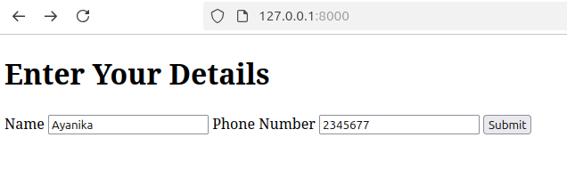

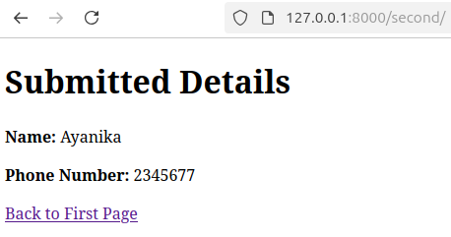

Q2)

CODE

q2/settings.py

INSTALLED_APPS = [
'django.contrib.admin',
'django.contrib.auth',
'django.contrib.contenttypes',
'django.contrib.sessions',
'django.contrib.messages',
'django.contrib.staticfiles',
'myapp',
]

q2/urls.py

from django.contrib import admin
from django.urls import path, include
from django.shortcuts import redirect
urlpatterns = [
path('admin/', admin.site.urls),
path('login/', include('myapp.urls')),
path('dashboard/', include('myapp.urls')),
path('', lambda request: redirect('login')),
]
myapp/urls.py

from django.urls import path
from . import views

urlpatterns = [
path('login/', views.login_view, name='login'),
path('dashboard/', views.dashboard_view, name='dashboard'),
]

myapp/views,py

from django.shortcuts import render, redirect
from django.contrib.auth import authenticate, login
from .forms import LoginForm
def login_view(request):
if request.method == 'POST':
form = LoginForm(request.POST)
if form.is_valid():
username = form.cleaned_data['username']
password = form.cleaned_data['password']
user = authenticate(request, username=username, password=password)
if user is not None:
login(request, user)
return redirect('dashboard')
else:
return render(request, 'login.html', {'form': form, 'error': 'Invalid credentials'})
else:
form = LoginForm()
return render(request, 'login.html', {'form': form})
def dashboard_view(request):
if request.user.is_authenticated:
return render(request, 'dashboard.html')
else:
return redirect('login')

myapp/templates/dashboard.html

<!DOCTYPE html>
<html lang="en">
<head>
<meta charset="UTF-8">
<meta name="viewport" content="width=device-width, initial-scale=1.0">
<title>Dashboard</title>
</head>
<body>
<h1>Welcome to your Dashboard!</h1>
<p>Logged in as: {{ user.username }}</p>
<a href="/logout/">Logout</a>
</body>
</html>

myapp/templates/login.html
<!DOCTYPE html>
<html lang="en">
<head>
<meta charset="UTF-8">
<meta name="viewport" content="width=device-width, initial-scale=1.0">
<title>Login</title>
</head>
<body>
<h1>Login</h1>
<form method="POST">
{% csrf_token %}
{{ form.as_p }}
<button type="submit">Login</button>
</form>
{% if error %}
<p style="color:red;">{{ error }}</p>
{% endif %}
</body>
</html>

OUTPUT
python manage.py createsuperuserer
Username (leave blank to use 'lab4'): Ayanika
Email address: ayanika@gmail.com
Password:
Password (again):
Bypass password validation and create user anyway? [y/N]: y

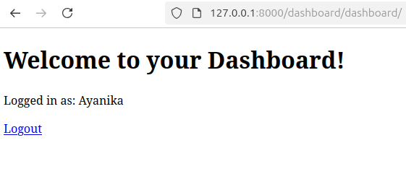

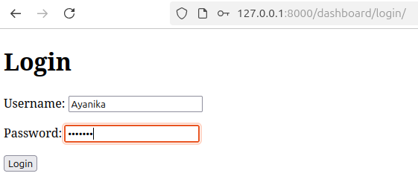

LAB ASSIGNMENTS:
1) Develop a web application using Django framework to demonstrate the transfer of
multiple parameters between web pages. User should be presented with a dropdown
list containing car manufacturers, a text box which takes model name of the
manufacturer and a submit button. On submitting the web page, the user is forwarded
to a new page. This new page should display the selected car manufacturer name and
the model name.

CODE:

q1/settings.py

INSTALLED_APPS = [
'django.contrib.admin',
'django.contrib.auth',
'django.contrib.contenttypes',
'django.contrib.sessions',
'django.contrib.messages',
'django.contrib.staticfiles',
'carapp',
]

MIDDLEWARE = [
'django.middleware.security.SecurityMiddleware',
'django.contrib.sessions.middleware.SessionMiddleware',
'django.middleware.common.CommonMiddleware',
'django.middleware.csrf.CsrfViewMiddleware',
'django.contrib.auth.middleware.AuthenticationMiddleware',
'django.contrib.messages.middleware.MessageMiddleware',
'django.middleware.clickjacking.XFrameOptionsMiddleware',
]

TEMPLATES = [
{
'BACKEND': 'django.template.backends.django.DjangoTemplates',
'DIRS': [
BASE_DIR / 'templates',
],
'APP_DIRS': True,
'OPTIONS': {
'context_processors': [
'django.template.context_processors.debug',
'django.template.context_processors.request',
'django.contrib.auth.context_processors.auth',
'django.contrib.messages.context_processors.messages',
],
},
},
]

q1/urls.py

from django.contrib import admin
from django.urls import path, include
urlpatterns = [
path('admin/', admin.site.urls),
path('', include('carapp.urls')),
]

carapp/urls.py

from django.urls import path
from . import views
urlpatterns = [
path('', views.index_view, name='index'),
path('result/', views.result_view, name='result'),
]

carapp/views.py

from django.shortcuts import render, redirect
from .forms import CarForm
def index_view(request):
if request.method == 'POST':
form = CarForm(request.POST)
if form.is_valid():
manufacturer = form.cleaned_data['manufacturer']
model = form.cleaned_data['model']
return redirect(f'/result/?manufacturer={manufacturer}&model={model}')
else:
form = CarForm()
return render(request, 'carapp/index.html', {'form': form})
def result_view(request):
manufacturer = request.GET.get('manufacturer', 'No manufacturer selected')
model = request.GET.get('model', 'No model provided')
return render(request, 'carapp/result.html', {
'manufacturer': manufacturer,
'model': model
})

carapp/templates/index.html

<html>
<body>
<h1>Select Your Car</h1>
<form method="POST">
{% csrf_token %}
{{ form.as_p }}
<button type="submit">Submit</button>
</form>
</body>
</html>

carapp/templates/result.html

<html>
<body>
<h1>Car Selection</h1>
<p>You selected the car manufacturer: <strong>{{ manufacturer }}</strong></p>
<p>And the model: <strong>{{ model }}</strong></p>
</body>
</html>

OUTPUT:
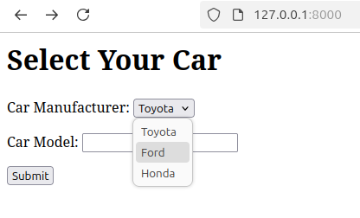

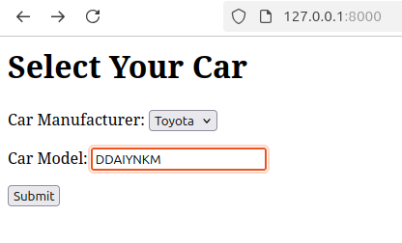

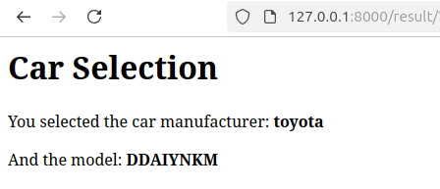

Q2)Create a page firstPage.html with two TextBoxes [Name, Roll], DropDownList
[Subjects], and a button. Create another page secondPage.html with a label and a
button. When the user clicks the button in first Page, he should be sent to the second
page and display the contents passed from first page in the label. The button in second
page should navigate the user back to firstPage. Use Django sessions to transfer
information.

CODE:

q2/settings.py

INSTALLED_APPS = [
'django.contrib.admin',
'django.contrib.auth',
'django.contrib.contenttypes',
'django.contrib.sessions',
'django.contrib.messages',
'django.contrib.staticfiles',
'myapp',
]
MIDDLEWARE = [
'django.middleware.security.SecurityMiddleware',
'django.contrib.sessions.middleware.SessionMiddleware',
'django.middleware.common.CommonMiddleware',
'django.middleware.csrf.CsrfViewMiddleware',
'django.contrib.auth.middleware.AuthenticationMiddleware',
'django.contrib.messages.middleware.MessageMiddleware',
'django.middleware.clickjacking.XFrameOptionsMiddleware',
]
SESSION_ENGINE = 'django.contrib.sessions.backends.db'
ROOT_URLCONF = 'myproject.urls'
TEMPLATES = [
{
'BACKEND': 'django.template.backends.django.DjangoTemplates',
'DIRS': [
BASE_DIR / 'templates',
],
'APP_DIRS': True,
'OPTIONS': {
'context_processors': [
'django.template.context_processors.debug',
'django.template.context_processors.request',
'django.contrib.auth.context_processors.auth',
'django.contrib.messages.context_processors.messages',
],
},
},
]

q2/urls.py

from django.contrib import admin
from django.urls import path, include
urlpatterns = [
path('admin/', admin.site.urls),
path('', include('myapp.urls')),
]

myapp/urls.py

from django.urls import path
from . import views

urlpatterns = [
path('', views.first_page, name='first_page'),
path('second/', views.second_page, name='second_page'),
]

myapp/views.py

from django.shortcuts import render, redirect
from django.http import HttpResponse
def first_page(request):
if request.method == 'POST':
name = request.POST.get('name')
roll = request.POST.get('roll')
subject = request.POST.get('subject')
request.session['name'] = name
request.session['roll'] = roll
request.session['subject'] = subject
return redirect('second_page')
return render(request, 'firstPage.html')
def second_page(request):
name = request.session.get('name', '')
roll = request.session.get('roll', '')
subject = request.session.get('subject', '')
return render(request, 'secondPage.html', {
'name': name,
'roll': roll,
'subject': subject
})

myapp/templates/firstpage.html

<!DOCTYPE html>
<html lang="en">
<head>
<meta charset="UTF-8">
<meta name="viewport" content="width=device-width, initial-scale=1.0">
<title>First Page</title>
<style>
body {
font-family: Arial, sans-serif;
background-color: #f4f7fc;
margin: 0;
padding: 0;
display: flex;
justify-content: center;
align-items: center;
height: 100vh;
}

.container {
background-color: #ffffff;
border-radius: 8px;
box-shadow: 0 4px 12px rgba(0, 0, 0, 0.1);
padding: 20px;
width: 350px;
text-align: center;
}

h1 {
color: #333;
margin-bottom: 20px;
font-size: 24px;
}

label {
margin-bottom: 8px;
font-weight: bold;
color: #333;
}

input[type="text"], select {
padding: 10px;
margin-bottom: 15px;
border: 1px solid #ccc;
border-radius: 5px;
font-size: 16px;
width: 100%;
}

button {
padding: 10px;
background-color: #4CAF50;
color: white;
border: none;
border-radius: 5px;
font-size: 16px;
cursor: pointer;
transition: background-color 0.3s;
width: 100%;
}

button:hover {
background-color: #45a049;
}
</style>
</head>
<body>
<div class="container">
<h1>Enter Your Details</h1>
<form method="POST">
{% csrf_token %}
<label for="name">Name</label>
<input type="text" name="name" id="name" required>

<label for="roll">Roll Number</label>
<input type="text" name="roll" id="roll" required>
<label for="subject">Subject</label>
<select name="subject" id="subject" required>
<option value="Maths">Maths</option>
<option value="Science">Science</option>
<option value="English">English</option>
</select>
<button type="submit">Submit</button>
</form>
</div>
</body>
</html>

myapp/templates/secondpage.html

<!DOCTYPE html>
<html lang="en">
<head>
<meta charset="UTF-8">
<meta name="viewport" content="width=device-width, initial-scale=1.0">
<title>Second Page</title>
<style>
body {
font-family: Arial, sans-serif;
background-color: #f4f7fc;
margin: 0;
padding: 0;
display: flex;
justify-content: center;
align-items: center;
height: 100vh;
}

.container {
background-color: #ffffff;
border-radius: 8px;
box-shadow: 0 4px 12px rgba(0, 0, 0, 0.1);
padding: 20px;
width: 350px;
text-align: center;
}

h1 {
color: #333;
margin-bottom: 20px;
font-size: 24px;
}

p {
font-size: 18px;
margin: 10px 0;
color: #333;
}

.result {
font-size: 18px;
font-weight: bold;
color: #4CAF50;
}

.back-btn {
padding: 10px 20px;
background-color: #4CAF50;
color: white;
border: none;
border-radius: 5px;
font-size: 16px;
cursor: pointer;
text-decoration: none;
display: inline-block;
margin-top: 20px;
transition: background-color 0.3s;
}

.back-btn:hover {
background-color: #45a049;
}
</style>
</head>
<body>
<div class="container">
<h1>Submitted Details</h1>
<p><span class="result">Name:</span> {{ name }}</p>
<p><span class="result">Roll Number:</span> {{ roll }}</p>
<p><span class="result">Subject:</span> {{ subject }}</p>
<a href="/" class="back-btn">Back to First Page</a>
</div>
</body>
</html>

OUTPUT:

