
UNIVERSITY OF ENGINEERING
TECHNOLOGY MARDAN
Lab Task 2
NAME : Faisal Shinwari
DEPT : SOFTWARE
SUB TO : SIR Hamayun
SEM : 6th SEMESTER
SUB : WE Lab

Task No 1 :
Html Code :
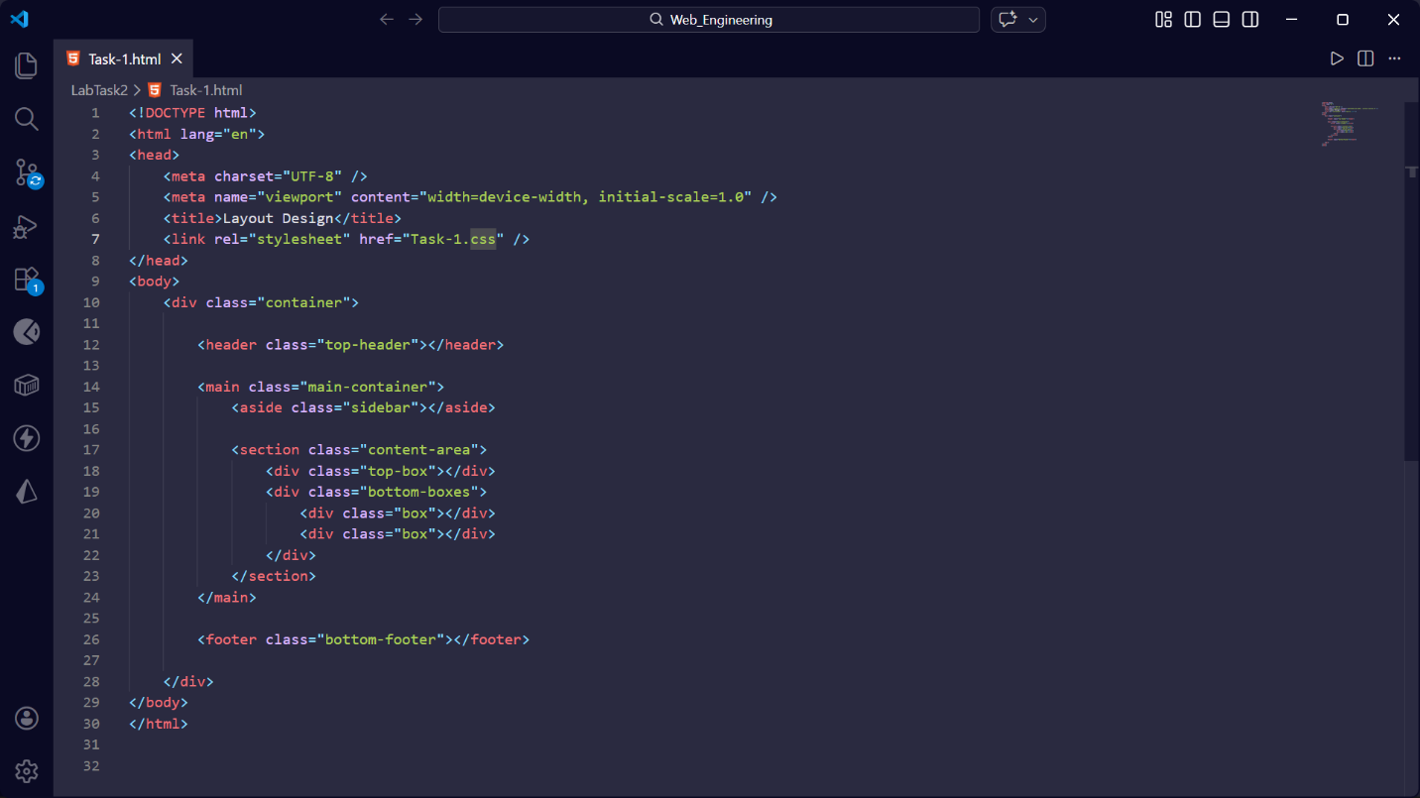
Css Code :
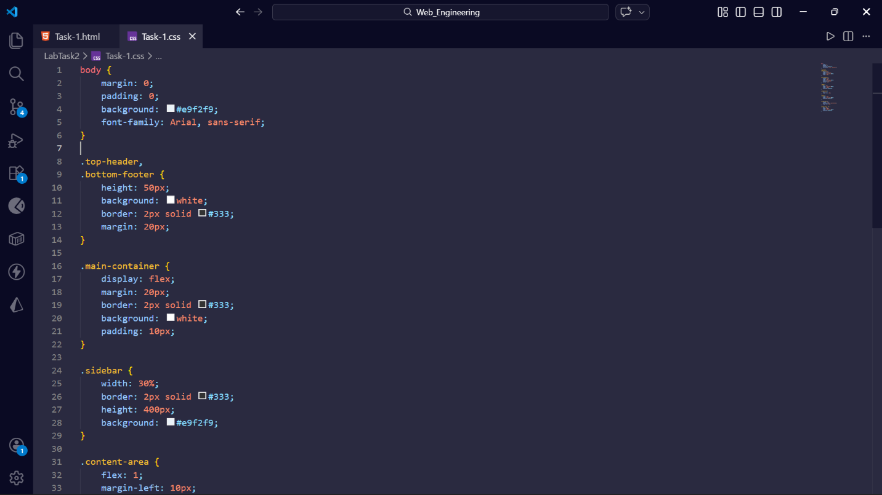

Output :
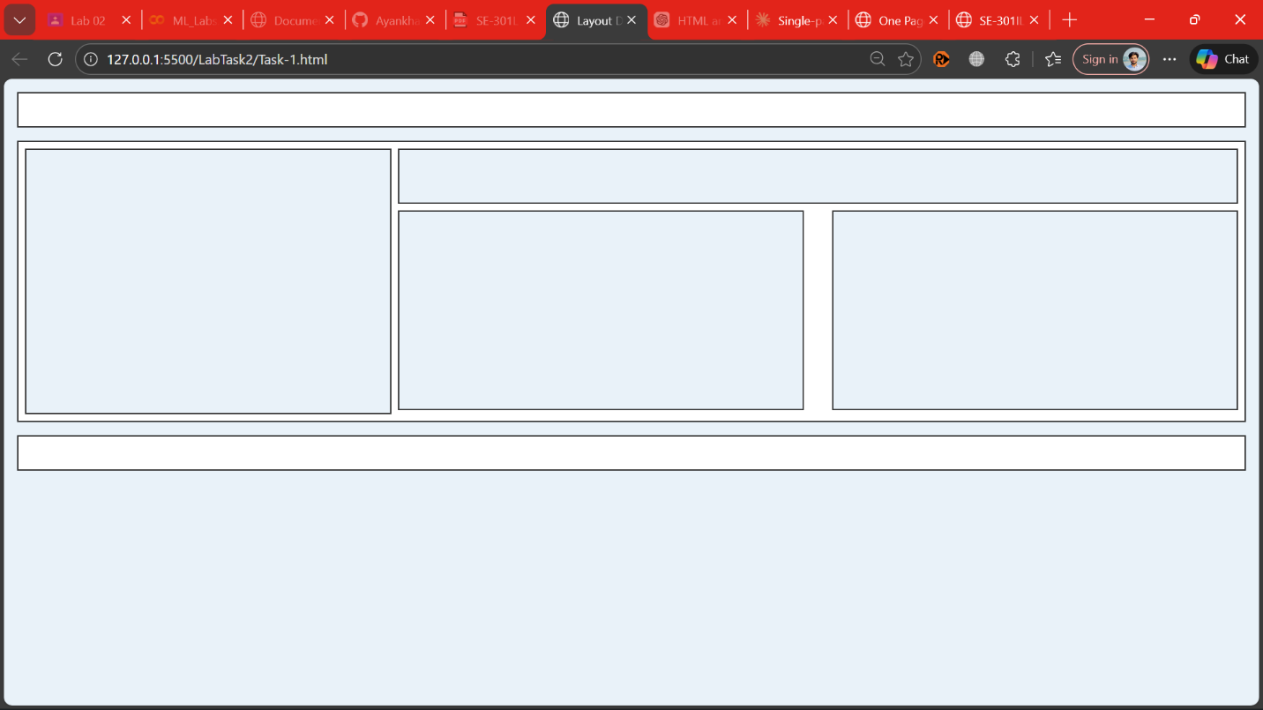

Task No 2 :
Html Code :
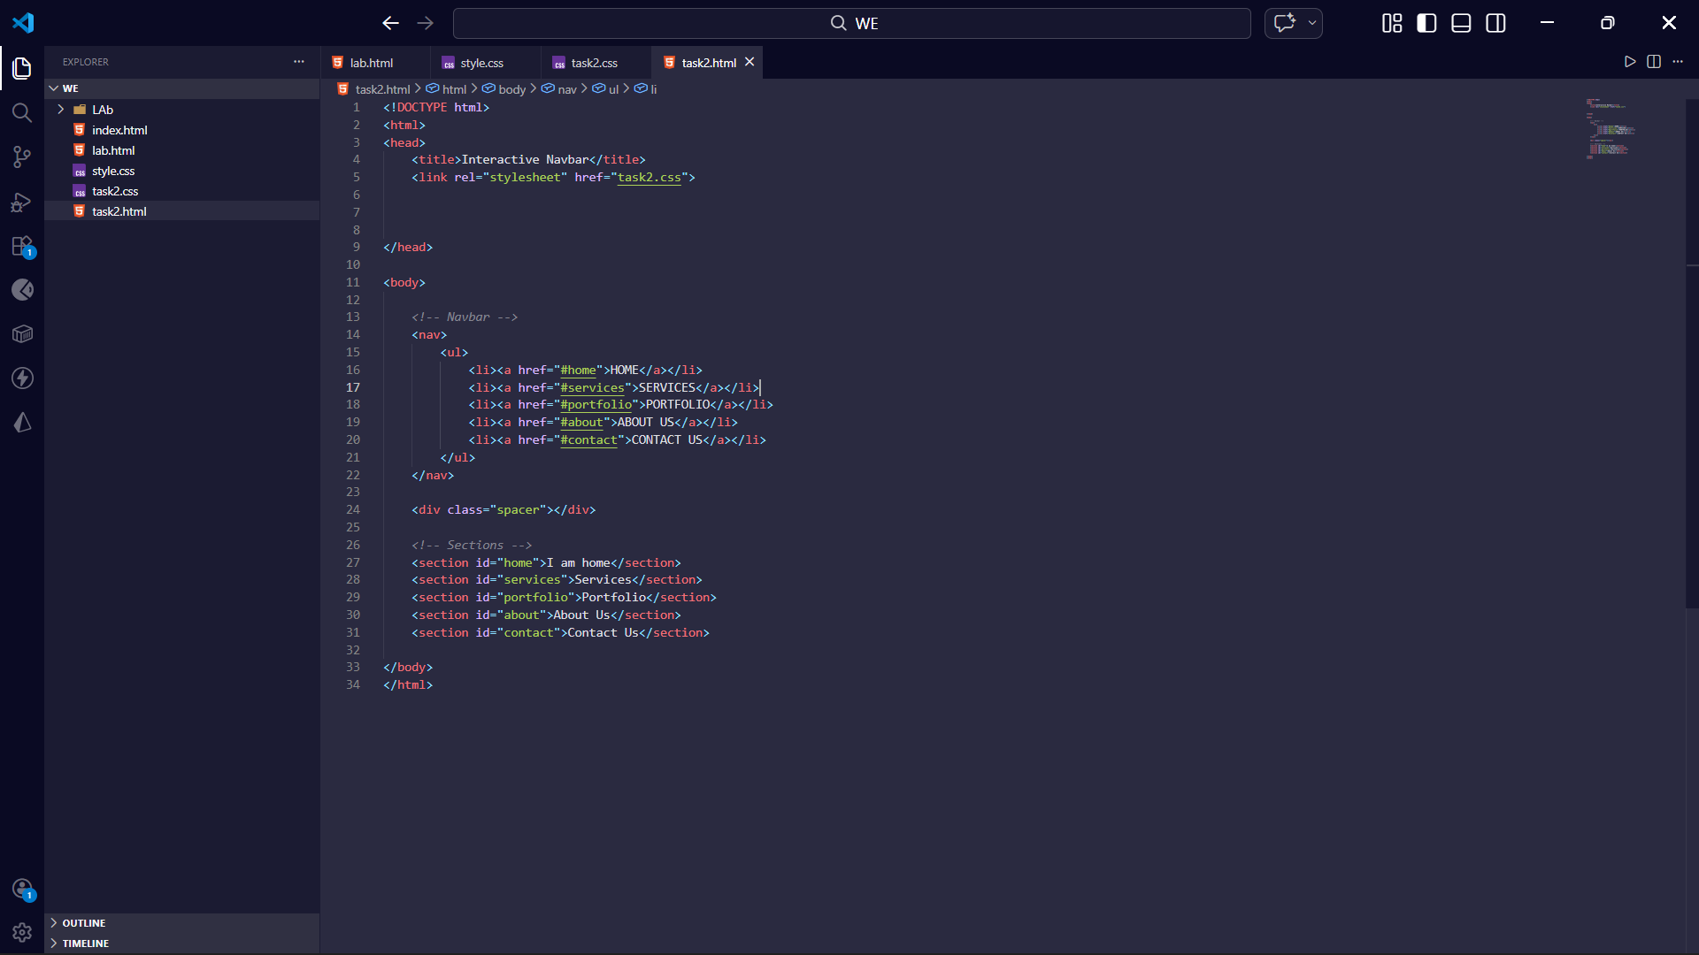
Css Code :
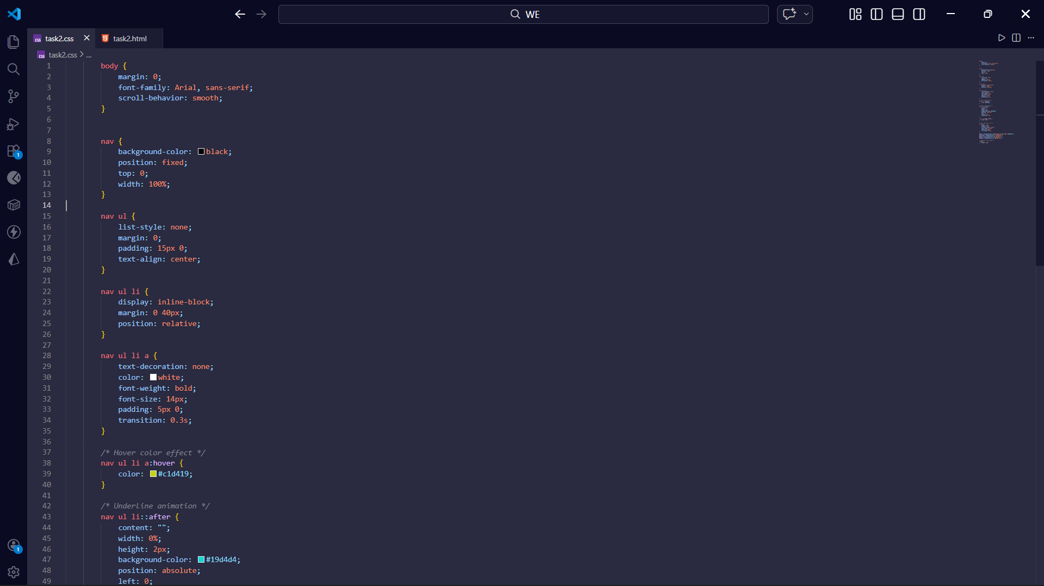

Output :
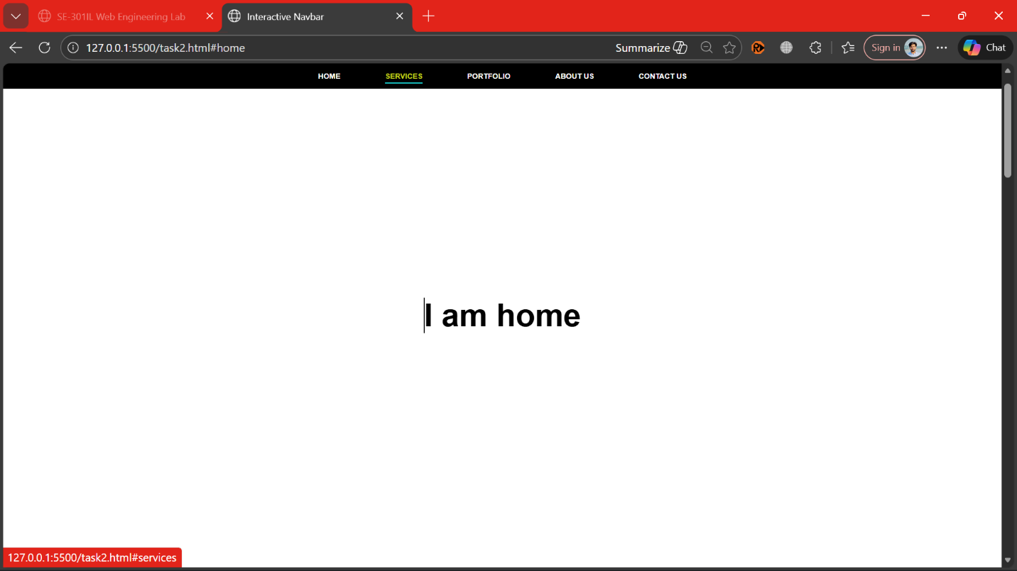

Task No 3 :
Html Code :
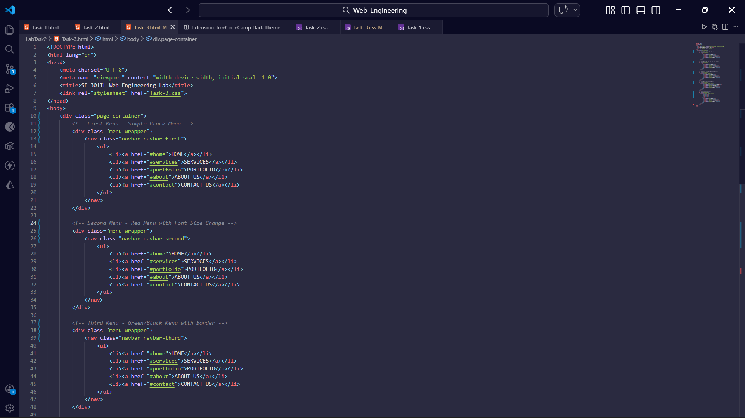
Css Code :
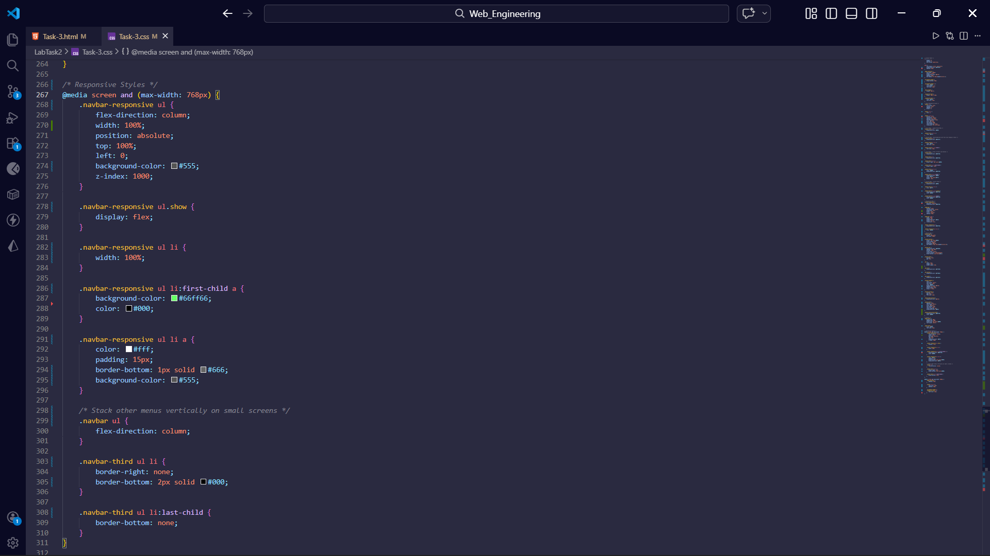

Output :

