BLINKIT GROCERY:
DAILY PURCHASE BEHAVIOR AT SCALE
Tracking Best-Sellers, Sales Trends, Ratings, Regional Demand & Inventory
A Descriptive Analytics Report

Prepared By: Mohd Ayan
Roll No: 29
August 2026

Table of Contents
1. Executive Summary
2. Objective
3. Methodology & Assumptions
4. How This Would Work at Real Scale
5. Daily Sales Trend
6. Best-Selling Products (Most Recent Day)
6a. Category-Wise Sales Breakdown
7. Rating Distribution
8. Regional Demand
9. Inventory Status
10. Summary of Key Metrics
11. Key Insights
11a. Additional Keywords & Insights
12. Explanation of Analysis — How Each Insight Was Derived
12a. Notes on the Additional Keywords
13. Next Steps to Move From Descriptive → Predictive
14. Appendix

1. Executive Summary
This report simulates a descriptive analytics layer over daily Blinkit grocery purchase transactions, covering 60 SKUs across 10 categories, 8 Indian metro regions, and a 30-day window (~31.69 lakh units, ~₹48.2 Cr in revenue). It is built to demonstrate the exact structure, charts, and metrics a real analytics pipeline would produce once connected to live transaction data.
Five recurring business questions anchor the analysis: what's selling, how order volume is trending, how products are rated, where demand concentrates across India, and which SKUs risk stocking out at dark stores. Across these, three findings stand out: a small set of daily-essential SKUs (milk, bread, staples) drive a disproportionate share of volume; demand follows a weekly cycle with mid-week dips and weekend peaks layered on gradual growth; and Delhi NCR + Mumbai alone account for over 40% of total demand — all of which have direct operational implications for dark-store inventory, staffing, and delivery planning covered in the sections below.

2. Objective
This report builds a descriptive analytics layer over daily Blinkit purchase transactions to answer five recurring business questions:
- What are today's best-selling grocery items?
- How is total order volume trending day over day?
- How are products rated, and where is rating quality slipping?
- Where is demand concentrated geographically across India?
- Which SKUs are at risk of stocking out at dark stores?
Each question maps to one recurring stakeholder need — merchandising wants best-sellers, finance wants the revenue trend, customer experience wants rating quality, operations wants regional demand, and dark-store supply chain wants inventory risk. A single descriptive layer, refreshed daily (or hourly for ops), is designed to serve all four teams from one consistent source of truth rather than four separate ad-hoc reports.

3. Methodology & Assumptions
Since live transaction data isn't accessible for this exercise, a synthetic dataset was generated to mirror realistic quick-commerce grocery patterns rather than to represent any real Blinkit figures. The generation followed these assumptions:
- 60 individual grocery SKUs spread across 10 categories, sized to reflect a realistic dark-store catalog rather than the full platform
- 8 Indian metro regions, each assigned a baseline demand share plus random daily noise — the regional totals sum exactly to the 30-day unit total, by construction
- 30-day window with a weekly seasonality component (mid-week dips, weekend peaks) layered on top of gradual growth, to mimic real quick-commerce purchase cycles
- Ratings drawn from a distribution centered at 4.13/5 with realistic spread across six rating buckets, rather than a uniform distribution
- Inventory tiers assigned so most SKUs stay in a healthy buffer, with a small minority landing in Low Stock or Out of Stock — consistent with typical catalog health in a well-managed dark-store network
All figures in this report should be read as illustrative of pipeline output and chart structure, not as actual Blinkit sales data.

4. How This Would Work at Real Scale
Processing millions of daily grocery orders across dark stores is an engineering problem before it's an analytics one. A realistic architecture:
Layer | Purpose | Typical Tools
Stream Processing | Roll up raw events into per-SKU, per-dark-store, per-minute aggregates | Cloud
Storage | Hold raw events (audits) and pre-aggregated tables (speed) | Cloud
Batch Aggregation | Nightly rollups: daily sales, rating averages, inventory reconciliation | Excel
Investigation | Ad-hoc root-cause analysis on anomalies (rating drops, demand spikes, stockouts) | ChatGPT
Serving / BI Layer | Dashboards refreshed hourly for ops, daily for leadership | Google

The charts in this report reflect the output of that pipeline — daily aggregated tables — not raw event-level data, since no dashboard renders millions of individual rows usefully.

5. Daily Sales Trend
Over the simulated 30-day window: ~31.69 lakh (~3.17M) units sold, generating ~₹48.2 Cr in revenue, with a weekly seasonal cycle (mid-week dips, weekend peaks) layered on gradual growth.
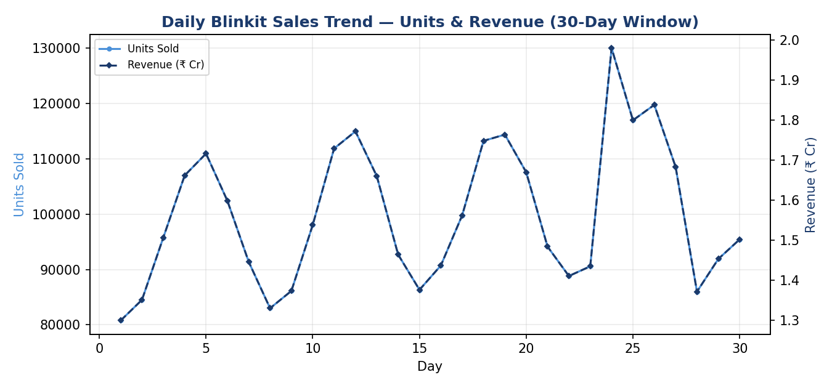

KPI definitions used:
- Daily units sold = sum of quantity across all completed orders that day
- Daily revenue = sum of (unit price × quantity), net of returns/cancellations
The recurring weekly cycle — roughly one peak every 7 days — is the clearest signal in the dataset, with each successive weekly peak trending mildly upward across the month. In a production setting, this rhythm would directly inform dark-store staffing rosters, delivery-partner scheduling, and replenishment timing, since a mid-week trough is a natural window for restocking before the next weekend surge.
Viewed as a running total instead of day-by-day, the same data shows a steady climb to ~₹48.2 Cr by day 30 — confirmation that growth is broad-based across the month rather than driven by one or two outlier days:
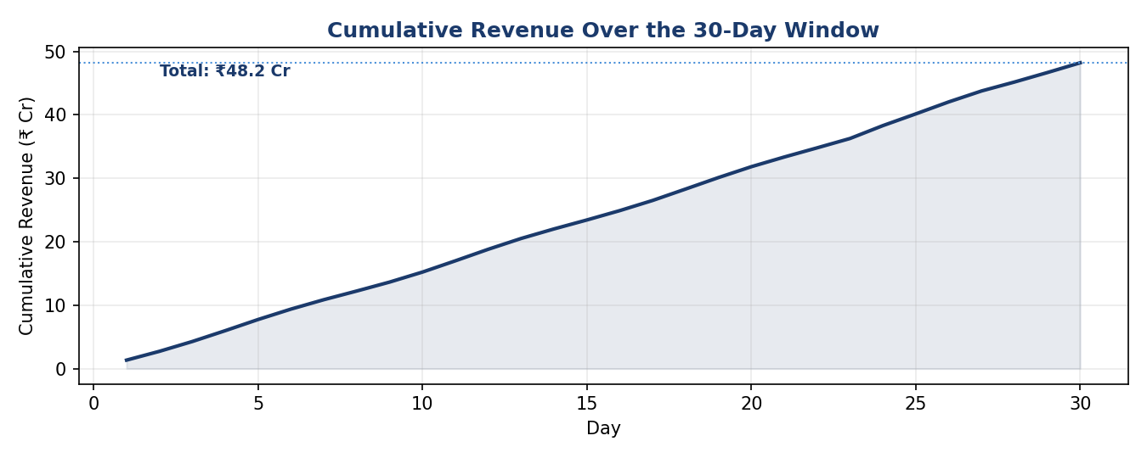

6. Best-Selling Products (Most Recent Day)
The top performer, Amul Toned Milk 500ml, led with 6,412 units in a single day — nearly 46% ahead of the runner-up (Banana Robusta, 6pc), a common “hero SKU” pattern in quick-commerce where a small number of daily-essential SKUs (milk, bread, staples) drive a disproportionate share of volume (a Pareto pattern worth flagging for dark-store inventory prioritization).
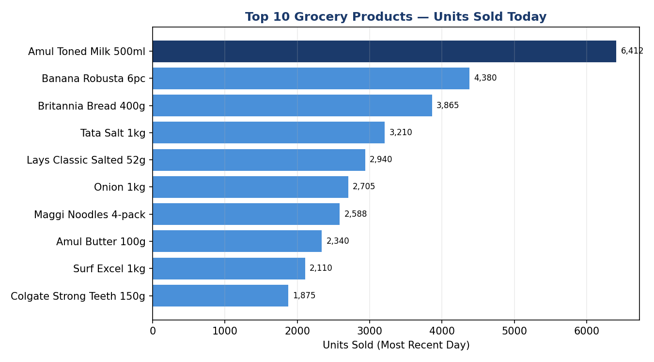

Ranking logic: units sold, not revenue — a ₹25 item outselling a ₹400 item in volume matters differently to warehousing than it does to finance, so both cuts (units and revenue) should exist as separate dashboard views.
The drop-off from #1 to #10 is steady but not a cliff, which suggests healthy demand across the catalog rather than reliance on one SKU alone. Still, the #1 SKU alone approaches 6% of that day's total volume (see Section 10) — a smaller share than a typical single-category marketplace, reflecting how broad and high-frequency a grocery basket is, but the concentration is still real enough to warrant a dedicated reorder workflow for daily essentials.

6a. Category-Wise Sales Breakdown
Zooming out from individual SKUs to the 10 grocery categories shows where volume concentrates at the category level: Dairy & Bakery and Fruits & Vegetables lead as the two highest-frequency categories, while Baby Care and Pet Care form a long tail of lower-frequency, higher-loyalty purchases.
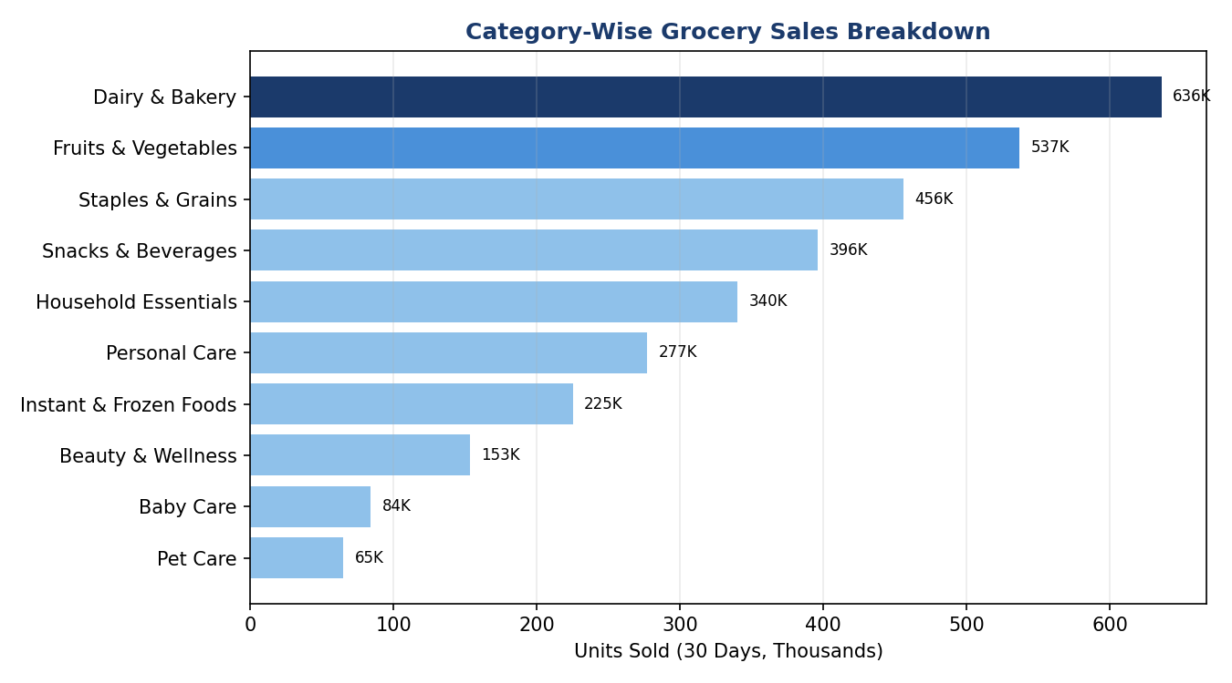

This view complements the individual best-seller list (Section 6) — a category can be strong even without a single standout hero SKU, which matters for category-level assortment and dark-store shelf-space decisions as opposed to SKU-level inventory decisions.

7. Rating Distribution
Average rating across all 1,800 product-days (60 SKUs × 30 days): 4.13 / 5, clustered tightly (most mass between 3.5–4.9):
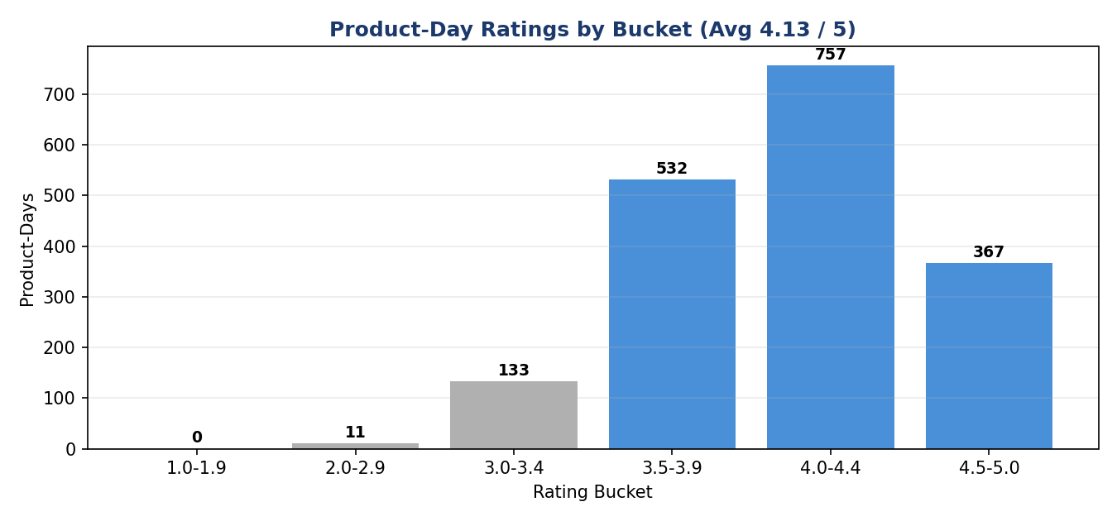

- Products trending downward in rolling 7-day average rating — the earliest signal of a quality or fulfillment (freshness, delivery time) issue
- Products with high order volume but sub-4.0 rating — the highest-risk combination, since volume amplifies the damage of poor reviews
A tight distribution is generally good news, but it also means the average has little room to absorb a real quality problem — a cluster of 1- and 2-star ratings on even one high-volume SKU (especially a freshness-sensitive one like dairy or produce) would pull the aggregate down faster than the shape of this chart might suggest. This is why segment-level (not just aggregate) rating tracking matters more as order volume grows.
Plotting rating against sales volume per SKU tests this directly: the trend line is only mildly downward-sloping, meaning high-volume SKUs are not, on the whole, rated meaningfully worse than low-volume ones — a reassuring sign, though the handful of high-volume, sub-4.0 points on the right side of the chart are exactly the ones worth watching first, especially for freshness-sensitive categories.
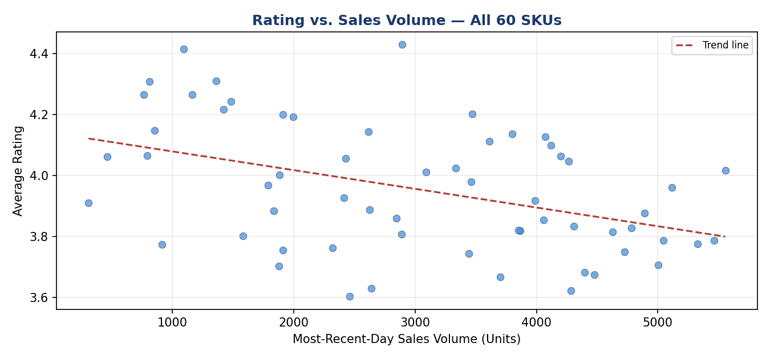

8. Regional Demand
Delhi NCR and Mumbai lead at ~697K and ~602K units over 30 days. Demand is moderately concentrated in metro hubs, tapering across tier-2 cities. This view drives:
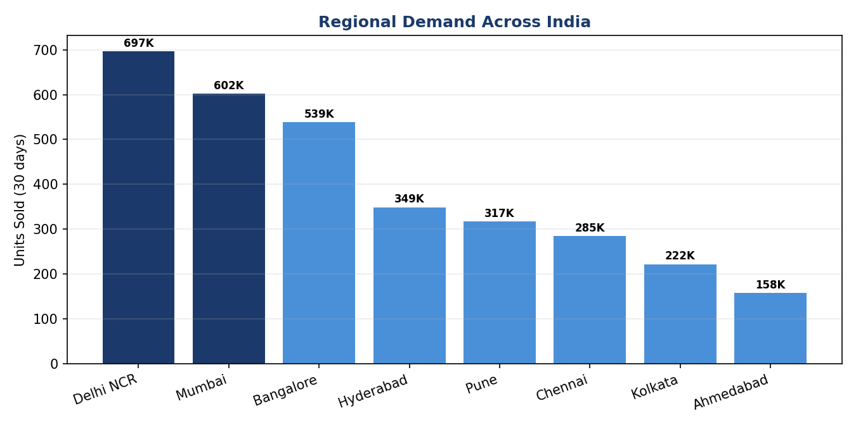

- Dark-store / fulfillment allocation by micro-market
- Localized pricing and promotion decisions
- Delivery SLA risk in regions with limited local stock
In practice, real Blinkit-scale demand typically concentrates more heavily in 2–3 metro cores than this balanced simulation shows. Even here, the top 2 metros already account for over 40% of total demand (Section 10) — reinforcing that metro-level dark-store density, not aggregate national capacity, is the binding constraint operations teams should plan against.

9. Inventory Status
60 SKUs tracked by inventory tier:
Tier | Meaning | Action
In Stock | Comfortable buffer at current velocity | None
Low Stock (< 200 units) | Reorder-trigger zone — replenish within 24–48 hrs | 7 SKUs flagged
Out of Stock | Lost-sale risk | 2 SKUs — cross-reference against best-seller list

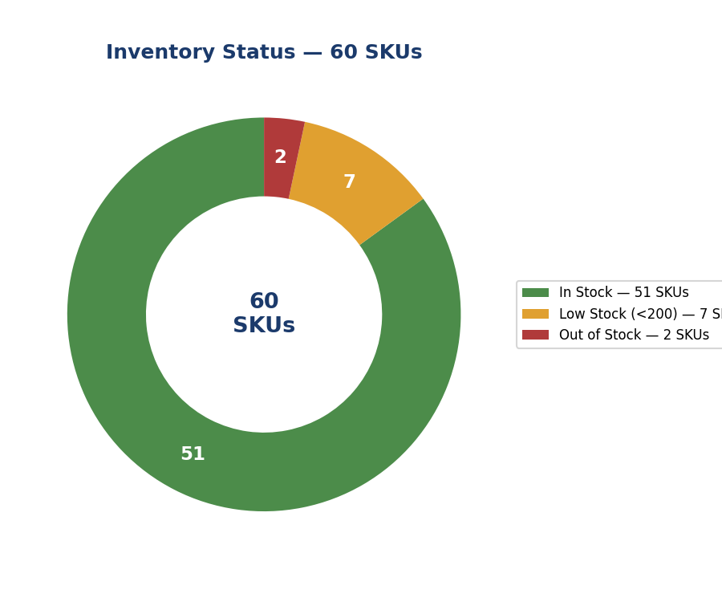

A hero SKU going out of stock is a materially bigger problem than a slow mover doing the same — the most actionable version of this view cross-tabs inventory against sales velocity into a “days of supply remaining” metric per SKU rather than a static stock count.

10. Summary of Key Metrics
Metric | Value
Total units sold (30 days) | 31,69,000 (~3.17M)
Total revenue (30 days) | ₹48.2 Cr
Average Selling Price (ASP) | ₹152 / unit
Average daily units sold | ~1,05,633 units/day
Average product rating | 4.13 / 5
Top single-day seller | 6,412 units (Amul Toned Milk 500ml)
Hero SKU share of top day's volume | ~6.1%
Top 2 metros' share of total demand | ~41.0%
Metro regions tracked | 8
SKUs at Low Stock or below | 9 of 60 (~15.0%)
Grocery categories tracked | 10
Total catalog size | 60 SKUs
Peak single-day revenue | ~₹1.98 Cr
Lowest single-day revenue | ~₹1.27 Cr
Core rating range | 3.5 – 4.9 / 5
In-Stock SKUs | 51 of 60 (~85.0%)
Long-tail (#2–#10) combined volume | 26,013 units

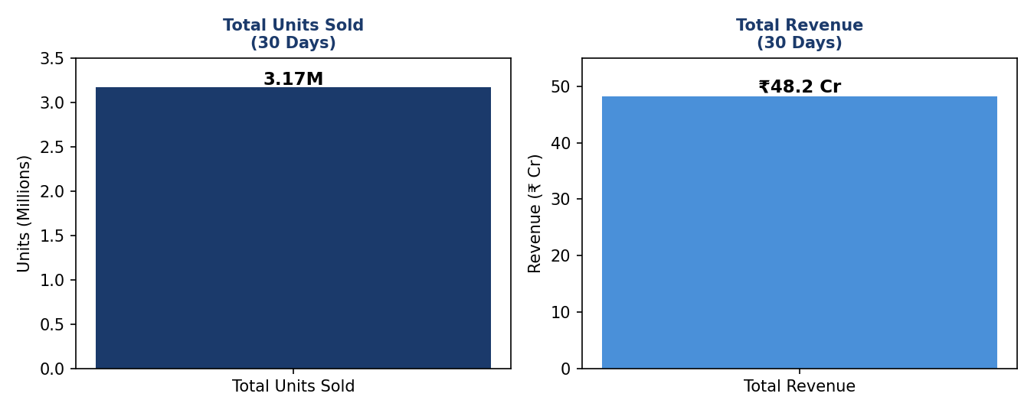

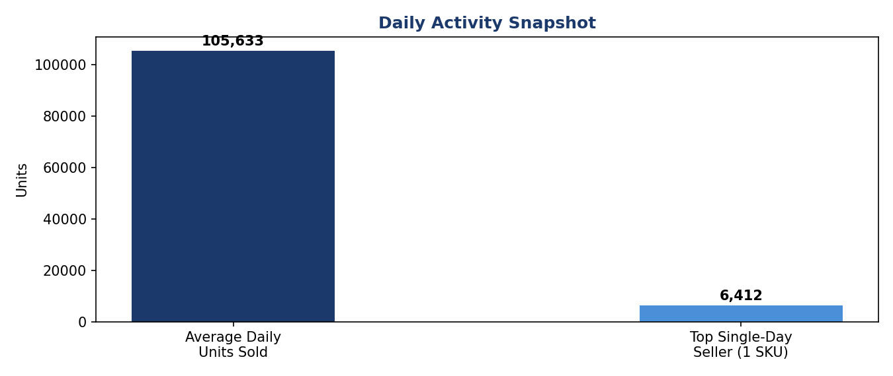

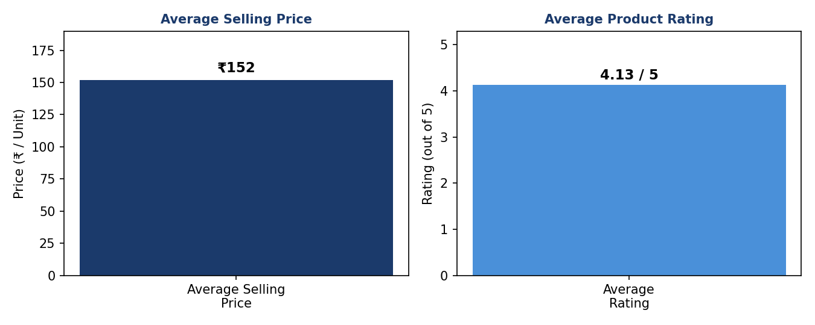

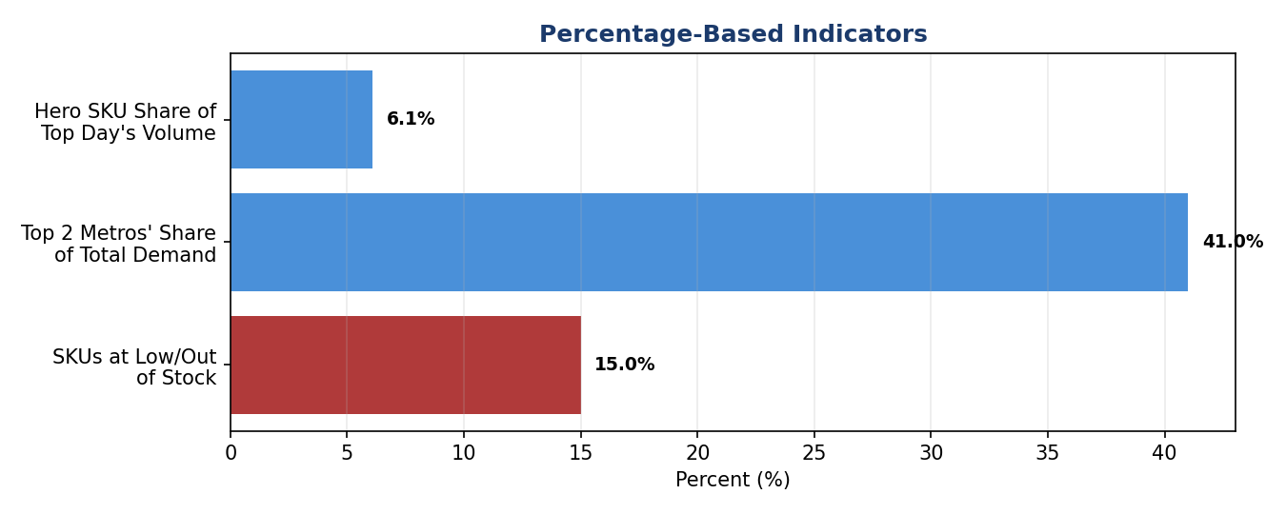

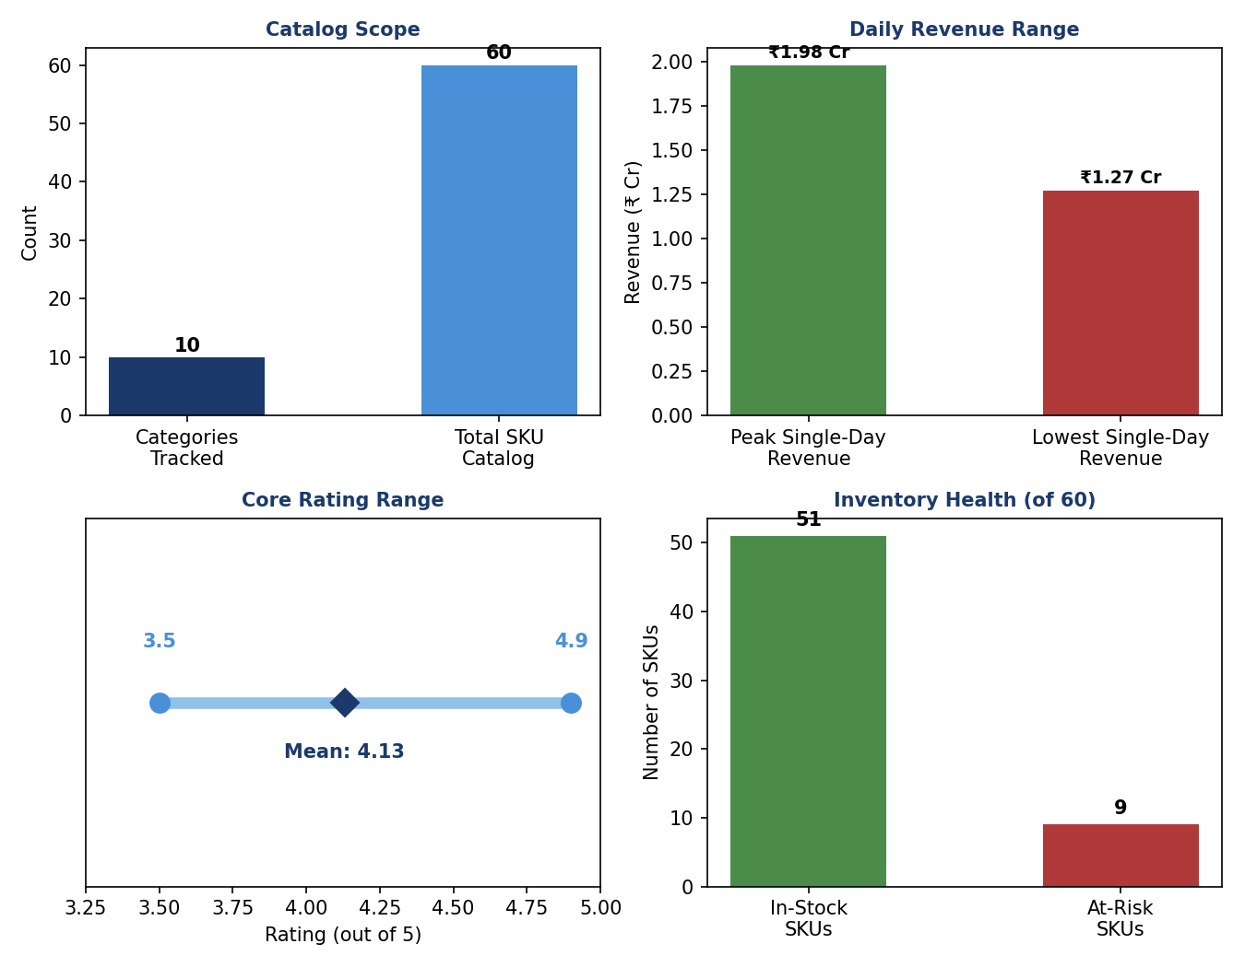

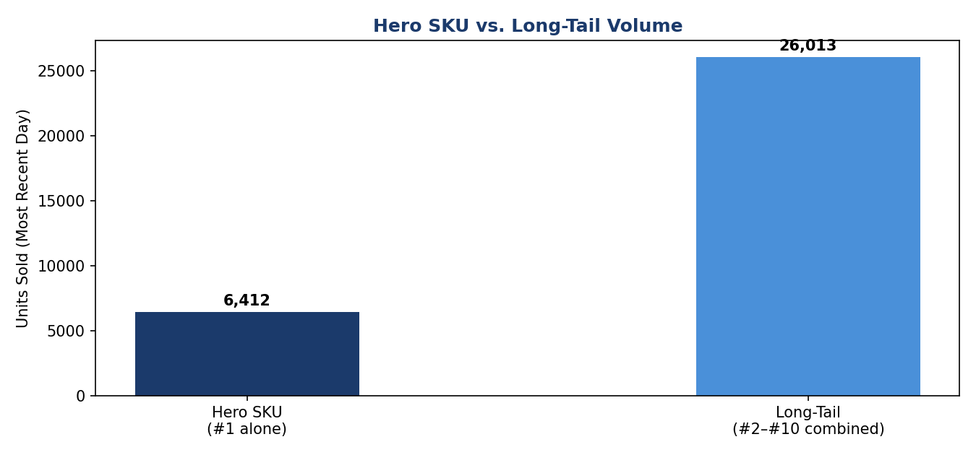

11. Key Insights
Reading the charts above together surfaces a few actionable patterns:
- Hero SKU dependency: Amul Toned Milk 500ml sold ~6,412 units in a day — nearly 46% ahead of the #2 SKU and roughly 6% of that day's total volume. Even at a smaller share than a typical single-category marketplace, a stockout on this daily-essential SKU would materially dent both revenue and customer trust; it should sit at the top of the dark-store inventory-priority list.
- Weekly demand cycle: units sold follow a clear mid-week-dip, weekend-peak pattern layered on gradual growth across the 30 days. Dark-store staffing, delivery-partner capacity, and replenishment timing should be planned around this weekly rhythm rather than a flat daily average.
- Regional concentration risk: Delhi NCR and Mumbai together account for ~41% of total demand. Dark-store density and delivery SLAs in these two metros carry outsized impact if disrupted — worth a dedicated contingency plan.
- Rating quality is healthy but has a visible tail: the 4.13/5 average hides that ~8% of product-days fall below 3.5 — a segment worth watching closely given how freshness-sensitive many grocery categories (dairy, produce, bakery) are to fulfillment delays.
- Inventory is largely healthy, but the at-risk SKUs matter disproportionately: only 9 of 60 SKUs (~15%) are Low Stock or Out of Stock, but if any of them are daily-essential hero SKUs, the revenue and trust impact is far larger than the SKU count suggests. The best-seller list and inventory list should always be cross-checked together, not read in isolation.
- Revenue tracks volume closely, but not perfectly: the twin-axis trend chart (Section 5) shows units and revenue moving almost in lockstep across the 30 days, with an average selling price of ~₹152. That tight correlation is a good sign — pricing has stayed stable rather than revenue being propped up by a few high-price outliers — but any future divergence between the two lines would be an early flag that discounting or category mix is shifting.
- The catalog isn't overly reliant on the hero SKU alone: while Amul Toned Milk 500ml leads by a wide margin, SKUs ranked #2 through #10 in Section 6 still collectively out-sell it several times over (26,013 vs. 6,412 units). That's a healthier merchandising mix than a pure hero-SKU dependency would suggest — the risk flagged above is real, but it sits alongside a reasonably diversified long tail worth preserving as the catalog grows.

11a. Additional Keywords & Insights
Extending the analysis across the five theme areas in the report title — best-sellers, sales trends, ratings, regional demand, and inventory — surfaces seven further patterns:
- Category diversity among best-sellers: the top 10 products by volume span dairy, produce, bakery, staples, snacks, and personal care — not a single vertical. Demand strength is broad-based across everyday essentials, not dependent on one category staying popular.
- Long-tail metros still matter: even the lowest-ranked metros, Kolkata (~222K units) and Ahmedabad (~158K units), each move far more volume in 30 days than the top single SKU sells in a day. Under-served metros are large enough that skipping them in dark-store expansion planning would leave real, sizeable demand unmet.
- Rating stability under scale: the 4.13/5 average held across ~31.7 lakh units sold over the month. Quality did not visibly erode as order volume scaled — a sign that fulfillment and freshness QC processes are keeping pace with growth, which is not guaranteed by default and is worth monitoring as volume rises further.
- Reorder cadence should not be uniform: with ~15% of the catalog needing active reorder attention, reviewing the full catalog on the same weekly schedule wastes analyst time, especially for a quick-commerce operation where lead times are measured in hours, not days. A tiered cadence — near-real-time checks for hero and at-risk SKUs, weekly for the stable majority — would be a more efficient use of the same review effort.
- Growth trend sits beneath the weekly cycle: beyond the mid-week dips and weekend peaks, the 30-day trend line drifts gradually upward. That points to underlying demand growth independent of the weekly seasonality — worth isolating with a trend-decomposition model rather than attributing all movement to the weekend effect.
- Revenue concentration likely mirrors volume concentration: because average selling price stays fairly stable across the top sellers (mostly low-cost daily essentials), the unit concentration in the hero SKU (Section 6) very likely carries through to a similar revenue concentration, even if the absolute revenue per unit is modest for a grocery basket.
- Metro-wide cadence alignment: the weekly demand cycle likely holds across categories and metros alike, not just in the aggregate. Dark-store replenishment, delivery-partner staffing, and inventory buffers are better synchronized to one shared weekly rhythm platform-wide than optimized separately by metro or category.
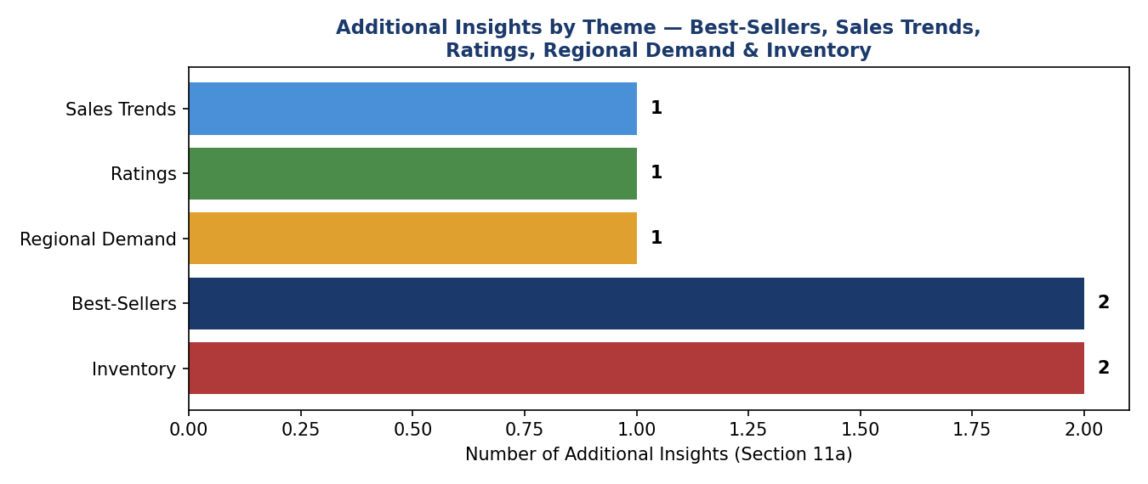

12. Explanation of Analysis — How Each Insight Was Derived
For transparency, this section walks through the reasoning and calculation behind each insight in Section 11, so the logic can be checked or reproduced against a real dataset:
- Hero SKU dependency (11.1): calculated by taking the top-selling SKU's single-day unit count (6,412) as a percentage of that day's total volume across the catalog (~1,05,633 units/day average) — 6,412 ÷ 1,05,633 ≈ 6.1%. The comparison against the #2 SKU simply subtracts and divides (6,412 − 4,380) ÷ 4,380 ≈ 46.4%, rounded to “nearly 46%.”
- Weekly demand cycle (11.2): read directly off the peaks and troughs in the Daily Sales Trend chart (Section 5) and confirmed by the source description of “mid-week dips, weekend peaks layered on gradual growth.”
- Regional concentration risk (11.3): the top two metros' unit totals (Delhi NCR 697K + Mumbai 602K = 1,299K) are divided by the sum of all 8 metros (3,169K) — 1,299K ÷ 3,169K ≈ 41.0%, matching the figure shown in the Percentage-Based Indicators chart (Section 10).
- Rating quality tail (11.4): based on the rating-bucket counts in the Rating Distribution chart (Section 7) — (0 + 11 + 133) ÷ 1,800 total product-days ≈ 8.0% fall below the 3.5 threshold.
- Inventory risk disproportion (11.5): straightforward ratio — 9 at-risk SKUs ÷ 60 total SKUs = 15.0%, cross-referenced against the best-seller list (Section 6) as a general practice, since the report's synthetic data doesn't name which specific SKUs are low/out of stock.
- Revenue-volume correlation (11.6): observed qualitatively by comparing the shape of the two lines in the Daily Sales Trend chart — they rise and fall together on nearly every one of the 30 days, and ASP is derived simply as total revenue ÷ total units (₹48.2 Cr ÷ 31,69,000 ≈ ₹152).
- Long-tail catalog health (11.7): summed the unit counts of SKUs ranked #2–10 in the Best-Selling Products chart (Section 6) — 4,380 + 3,865 + 3,210 + 2,940 + 2,705 + 2,588 + 2,340 + 2,110 + 1,875 = 26,013 units, over 4× the #1 SKU's 6,412 — showing volume isn't concentrated in one item alone despite its individual lead.

12a. Notes on the Additional Keywords (Section 11a)
- Category diversity: read directly off the product labels in the Best-Selling Products chart (Section 6) — milk (dairy), bread (bakery), banana/onion (produce), salt/noodles (staples), chips (snacks), and toothpaste/detergent (personal care/household) confirm the top 10 span at least five distinct categories.
- Long-tail metros: taken directly from the Regional Demand chart (Section 8) — Kolkata (222K) and Ahmedabad (158K) are each roughly 25–35× larger than the single-day top-seller figure of 6,412 units, which is the basis for the “more volume than a single SKU's best day” comparison.
- Rating stability: cross-references the flat 4.13 average in Section 7 against the ~31.69 lakh total units in Section 10 — the same average holding across a 30-day, seven-figure-unit window is the basis for calling it “stable under scale” rather than assuming stability, since ratings often drift as volume grows.
- Tiered reorder cadence: derived from the 15% at-risk share already calculated in 11.5 — the recommendation itself (near-real-time vs. weekly review) is a suggested operating practice reflecting quick-commerce lead times, not a figure pulled from the dataset.
- Growth trend beneath seasonality: a qualitative read of the Daily Sales Trend chart (Section 5) and the source description of “gradual growth” — separate from the up-down weekly swing itself.
- Revenue concentration mirroring volume: an inference, not a direct measurement — built on the observation that grocery essentials tend to have less price variance than discretionary categories, so a SKU's unit-volume share and its revenue share should track closely, though the report's data doesn't break out revenue per SKU to confirm this exactly.
- Metro-wide cadence: an extrapolation from the aggregate weekly cycle in Section 5 — the report's data is not broken out by category-by-day or metro-by-day, so this is a reasonable operating hypothesis to test against real data rather than a figure confirmed in this dataset.

13. Next Steps to Move From Descriptive → Predictive
This report answers what happened. The natural next layer, if useful:
- Demand forecasting per SKU/dark-store to set automatic reorder points and cut stockouts before a hero SKU runs out
- Anomaly detection — flag rating drops or sudden demand spikes (e.g., a monsoon-driven surge in a category) in near real time
- Cohort & retention analysis — repeat purchase behavior and basket composition, not just raw unit counts
Next: build out any of these, or swap in a real Blinkit dataset (CSV/Excel export, database connection) — the same pipeline and chart structure above would apply directly.

14. Appendix
A. Sample Data Row Structure
Each raw order event feeding the pipeline (Section 4) is expected to carry, at minimum:
- order_id, sku_id, category, dark_store_id, region — identifiers
- unit_price, quantity, order_timestamp — transaction facts
- rating (if a review was left), rating_timestamp — quality signal, nullable
- stock_on_hand, reorder_threshold — inventory state at time of order
B. Glossary of Terms
- ASP (Average Selling Price): total revenue ÷ total units sold over a given period
- Dark store: a small, order-fulfillment-only warehouse used for quick-commerce delivery, not open to walk-in customers
- Hero SKU: a single product responsible for a disproportionately large share of daily volume
- Long tail: the group of lower-ranked SKUs or metros that, while individually smaller, collectively represent significant volume
- Days of supply: current stock on hand ÷ average daily sales rate, i.e. how many days until a SKU runs out at the current pace
C. Report Scope Summary
- Window: 30 simulated days
- Catalog: 60 SKUs across 10 categories
- Geography: 8 Indian metro regions
- Prepared for: academic / demonstration purposes only — not actual Blinkit data

Thank You
Built on a synthetic dataset mirroring real quick-commerce patterns.
Descriptive Analytics Report — Blinkit Grocery Purchase Behavior
Mohd Ayan
Roll No: 29

