Digital Image Processing Project Report

## Submitted To:

Dr. Devanjali Relan

## Submitted By:

G.K.N Kireet – 1800153C202

# **Brain Tumour Detection using Deep Learning and Pseudo Color Transformation.**

# Abstract

In this project, we modelled a Convolutional Neural Network to classify a brain magnetic resonance image (MRI) as an image containing a brain tumour or not containing a brain tumour. The key concept in this method is the usage of pseudo color transformation methods to pre-process the training image data such as to increase the color density in the grey levels in an attempt to increase the accuracy of the Neural Network. Experiments demonstrate that the method can successfully achieve Brain Tumour Detection in Magnetic Resonance Images of a brain.

# Motivation for the Project

Brain Tumours are one of the deadliest kinds of tumours a human can be affected with. This makes it very important to detect whether a person has a brain tumour or not. This detection process is often difficult to do manually and requires a lot of expertise. This is where good algorithms for detecting brain tumours arise. But, considering how important it is and the fact that false classifications by a algorithm can often lead to the death of the patient, it becomes very crucial that the detection algorithm we use needs to be as accurate as possible. So, we were motivated to try and produce a detection algorithm which has a good accuracy.

# Problem Solved by our project

We created a Convolutional Neural Network and trained it on brain tumour images in order to create a model which can be used to detect brain tumours with as much accuracy as possible. We also made a comparison of using normal grey scale images and using pseudo color transformed images

# Project Details

For our project, we used the brain tumour images dataset from Kaggle. We first used pseudo color transformation on our dataset to convert the grey scale images to rgb color space. This process was automated using python, the code for which is in the source files(transformer.py). After transforming our dataset, we started preparing our dataset for creating our Neural Network.

We used Image Data Augmentation to change the properties of the training dataset like image resolution, rotation, scale.

After Data Augmentation, each image undergoes a feature detection process using filters/kernel/ feature detectors to detect multiple features in the image which is the core of convolutional neural network. These features are the ones which are used to decide whether an image contains a brain tumour or not.

After Feature Detection, we use pooling to extract the important data from the feature maps. This reduces the number of input variables in our Neural Network.

After pooling we use a method called flattening to convert the multidimensional image array into a unidimensional array which makes it easier to send the values as the input to the Neural Network.

By using the values in the unidimensional array as the input for our neural network, we create an artificial neural network and train it using the training dataset to create a model which can be used to predict if an MRI contains a brain tumour or not.

We tested our model with the original grey scale dataset and then the transformed dataset to compare the results. We have noticed that pseudo color transformation of the input dataset led to a more accurate CNN model.

The Below is the results from the Neural Network created using the grey scale images as our training data. The Model ended up having an accuracy of 0.9463 on the training set and 0.9 on the test set

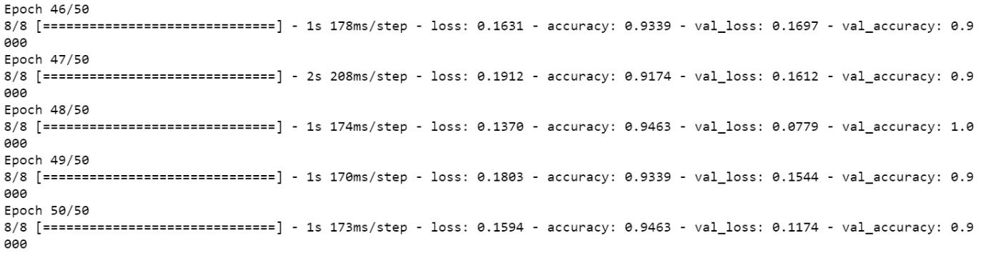

The Below is the results from the Neural Network created using the transformed images as our training data. The model resulted in an accuracy of 0.9876 on the training set. 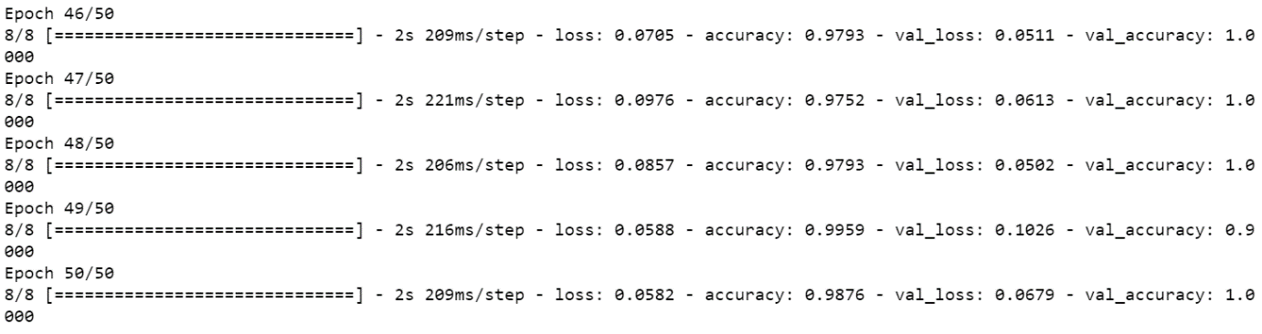

Due to the limited size of the training set, overfitting could have crept in while training the models. But it is still enough to indicate the superiority of using a pseudo color transformed image as the training data to create a Brain Tumour Detection algorithm over using a normal grey scale image.

# Existing State of art

There are a lot of deep learning models which are used to classify a magnetic resonance image as having a brain tumour or not. Each model has its own hyper parameters used and their own image pre-processing methods used. These various variables lead to models with different accuracies.

# Technical Features

The two core features of our project consist of image pre-processing and convolutional neural network modelling.

A good CNN model can be generated only when the image pre-processing stage is done carefully and ignoring this stage can lead to a Neural Network with very bad accuracies on the test dataset.

# Block Diagram

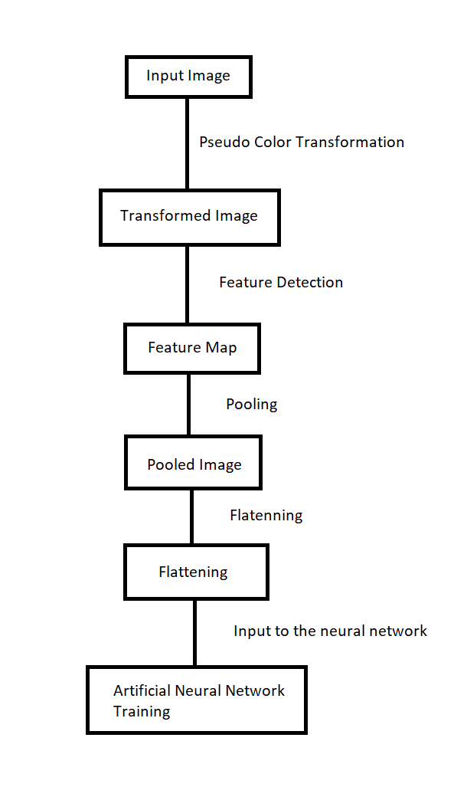

# Hardware and Software used

We used python programming language to implement our project. For ease of use, we used Jupyter Notebook as the programming environment.

For image pre-processing, we used keras image processing library and open cv python.

For creating our Neural Network, we used TensorFlow python library.

# New Features

We implemented a new way of image pre-processing on the dataset to train our Neural Network on. The usage of pseudo color transformation is something which is ignored because of not enough theory that says that it leads to a better model. But in practical use, we noticed that increasing the density of image grey levels by using pseudo color transformation indeed results in a better Brain Tumour Detection algorithm.

# Alternate ways to implement

The other ways to implement our project would be

* Usage of various other hyper parameters to tune the Neural network.
* Using different algorithms to do pseudo color transformation of the image
* Using a bigger dataset to train the Neural Network
* Using different types of neural network to create the model

It wouldn’t be difficult for someone else to implement our project in an alternative way because the core concept behind our project is not something which cannot be recreated by someone else. But it would be difficult for them to gain the same results as us because the accuracy of the model also depends on the dataset being used and the hyper parameters using while training the Neural Network

# Project Status

The project is successfully built and tested. It was implemented by Kireet Gannavarapu and Ganni Venkata Satya Pranav during November 2020.

# Idea Origin

While reading a research paper on brain tumour segmentation, I came across a paper which did brain tumour segmentation using color based k means clustering algorithm. The paper demonstrated that pseudo color transformation of an image leads to a better segmentation algorithm. This made me wonder if it is true for Brain Tumour Detection using Deep Learning as well.

# Product use scenario

This brain tumour detection algorithm can be used in hospitals to quickly classify whether patients have brain tumour or not. With a huge dataset which can be used to train the model and make it better, it would be quite useful for detecting Brain Tumours.

# References

* Dataset - <https://www.kaggle.com/navoneel/brain-mri-images-for-brain-tumor-detection>
* OpenCV - <https://pypi.org/project/opencv-python/>
* TensorFlow - <https://pypi.org/project/tensorflow/>
* Brain Tumour Detection using color based K-Means Clustering Segmentation - <https://ieeexplore.ieee.org/abstract/document/4457697>