*P. infestans* Index of Assocation and Minimum Spanning Network Analysis

Zhian N. Kamvar

July 10, 2016

# Introduction

In this analysis, I am analyzing 86 samples of *Phytophthora infestans* from North America and South America genotyped at 11 microsattelite loci. Note, that some of these samples appear to be triploid. I will be asessing clonality by calculating the standardized index of association (${\overline{r}}_{d}$) (Agapow and Burt 2001) and showing population structure by creating a minimum spanning network from Bruvo's genetic distance (Bruvo et al. 2004).

I used the R package *poppr* version 2.2.0 to perform the analysis, The minimum spanning network was constructed with *igraph* version 1.0.1, The figures were constructed with *ggplot2* version 2.1.0.

To read in the data, I used read.genalex() function from *poppr*, specifying a ploidy of "3". Because Bruvo's distance requires knowledge of repeat lengths, I supplied them for each locus and then ensured that they were consistent with the *poppr* function fix_replen().

# Index of Assocation

I used the function poppr() to calculate the index of assocation for both North American and South American populations, this was done for total populations and clone-corrected at the country level. To assess significance, alleles were shuffled at each locus independently 999 times.

Total Data Set

|  |  |  |  |  |  |  |  |  |  |  |
| --- | --- | --- | --- | --- | --- | --- | --- | --- | --- | --- |
| Pop | N | MLG | eMLG | SE | Hexp | Ia | p.Ia | rbarD | p.rD | File |
| South America | 38 | 29 | 29.00 | 0.00 | 0.51 | 2.87 | 0.00 | 0.34 | 0.00 | pinf |
| North America | 48 | 43 | 34.45 | 0.99 | 0.50 | 0.22 | 0.01 | 0.02 | 0.01 | pinf |

Clone Corrected Data

|  |  |  |  |  |  |  |  |  |  |  |
| --- | --- | --- | --- | --- | --- | --- | --- | --- | --- | --- |
| Pop | N | MLG | eMLG | SE | Hexp | Ia | p.Ia | rbarD | p.rD | File |
| South America | 29 | 29 | 29 | 0 | 0.52 | 2.63 | 0.0 | 0.31 | 0.00 | pinf |
| North America | 43 | 43 | 29 | NaN | 0.51 | 0.08 | 0.2 | 0.01 | 0.19 | pinf |

The results show that there is no evidence for linkage in the North American population while there is significant linkage in the South American population for the clone-corrected data set, suggesting a mainly sexual mode of reproduction for the North American population. I then used the *ggplot2* package to plot the results of the randomization procedure on the clone-corrected data as a histogram.

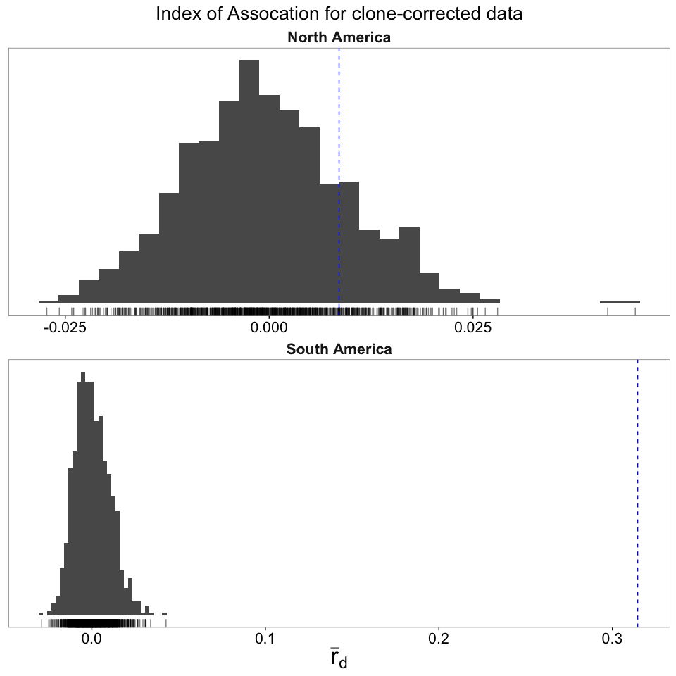

# Minimum Spanning Network

To display the diversity of the population, I used the packages *poppr* and *igraph* to construct a minimum spanning network from Bruvo's distance using a genome addition model (Bruvo et al. 2004). This was initially constructed visually using the function imsn() and then the code from the "Command" tab was copied and pasted to reproduce the plot. Before plotting, population was set to Country.

In the plot, nodes represent multilocus genotypes, whose sizes are scaled relative to the number of samples in each. Node colors represent population membership and thicker, darker-shaded lines represent closer genetic connections between nodes.

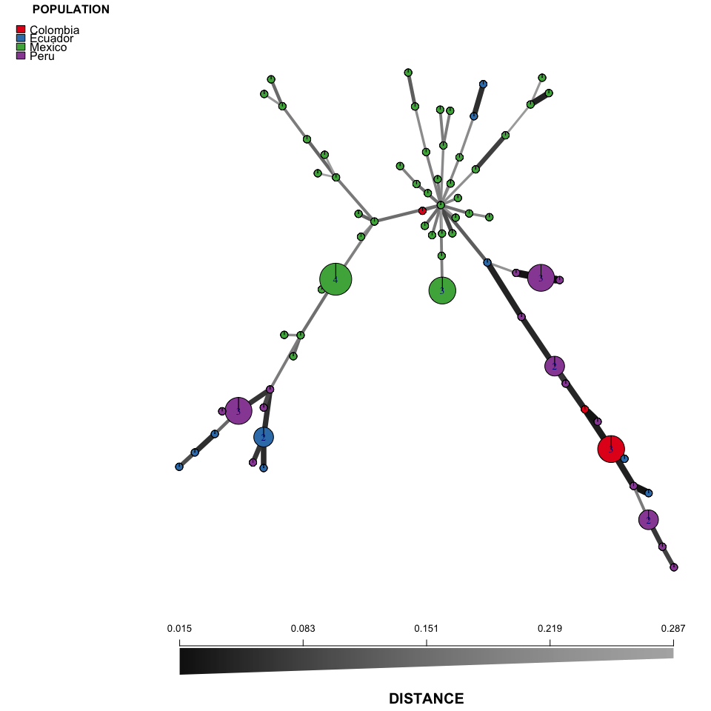

# R environment

The following packages were used in this analysis.

## Session info ---------------------------------------------------------------------------------------

## setting value   
## version R version 3.3.1 (2016-06-21)  
## system x86_64, darwin13.4.0   
## ui X11   
## language (EN)   
## collate en_US.UTF-8   
## tz America/Los_Angeles   
## date 2016-07-11

## Packages -------------------------------------------------------------------------------------------

## package * version date source   
## ade4 * 1.7-4 2016-03-01 CRAN (R 3.2.3)   
## adegenet * 2.0.1 2016-02-15 CRAN (R 3.3.0)   
## ape 3.5 2016-05-24 CRAN (R 3.3.0)   
## assertthat 0.1 2013-12-06 CRAN (R 3.2.0)   
## boot 1.3-18 2016-02-23 CRAN (R 3.2.3)   
## cluster 2.0.4 2016-04-18 CRAN (R 3.3.0)   
## coda 0.18-1 2015-10-16 CRAN (R 3.2.0)   
## colorspace 1.2-6 2015-03-11 CRAN (R 3.2.0)   
## DBI 0.4-1 2016-05-08 CRAN (R 3.3.0)   
## deldir 0.1-12 2016-03-06 CRAN (R 3.2.4)   
## devtools 1.12.0 2016-06-24 CRAN (R 3.3.0)   
## digest 0.6.9 2016-01-08 CRAN (R 3.2.3)   
## dplyr 0.5.0 2016-06-24 CRAN (R 3.3.0)   
## evaluate 0.9 2016-04-29 CRAN (R 3.2.5)   
## fastmatch 1.0-4 2012-01-21 CRAN (R 3.2.0)   
## formatR 1.4 2016-05-09 CRAN (R 3.3.0)   
## gdata 2.17.0 2015-07-04 CRAN (R 3.2.0)   
## ggplot2 * 2.1.0 2016-03-01 CRAN (R 3.3.0)   
## gmodels 2.16.2 2015-07-22 CRAN (R 3.2.0)   
## gtable 0.2.0 2016-02-26 CRAN (R 3.2.3)   
## gtools 3.5.0 2015-05-29 CRAN (R 3.2.0)   
## highr 0.6 2016-05-09 CRAN (R 3.3.0)   
## htmltools 0.3.5 2016-03-21 CRAN (R 3.2.4)   
## httpuv 1.3.3 2015-08-04 CRAN (R 3.2.0)   
## igraph 1.0.1 2015-06-26 CRAN (R 3.2.0)   
## knitr 1.13 2016-05-09 CRAN (R 3.3.0)   
## labeling 0.3 2014-08-23 CRAN (R 3.2.0)   
## lattice 0.20-33 2015-07-14 CRAN (R 3.2.0)   
## LearnBayes 2.15 2014-05-29 CRAN (R 3.2.0)   
## magrittr 1.5 2014-11-22 CRAN (R 3.2.0)   
## MASS 7.3-45 2015-11-10 CRAN (R 3.2.2)   
## Matrix 1.2-6 2016-05-02 CRAN (R 3.3.0)   
## memoise 1.0.0 2016-01-29 CRAN (R 3.2.3)   
## mgcv 1.8-12 2016-03-03 CRAN (R 3.2.4)   
## mime 0.4 2015-09-03 CRAN (R 3.2.0)   
## munsell 0.4.3 2016-02-13 CRAN (R 3.2.3)   
## nlme 3.1-128 2016-05-10 CRAN (R 3.3.0)   
## nnls 1.4 2012-03-19 CRAN (R 3.2.0)   
## pegas 0.9 2016-04-16 CRAN (R 3.2.5)   
## permute 0.9-0 2016-01-24 CRAN (R 3.2.3)   
## phangorn 2.0.3 2016-05-01 CRAN (R 3.2.5)   
## plyr 1.8.4 2016-06-08 CRAN (R 3.3.0)   
## poppr * 2.2.0 2016-06-13 CRAN (R 3.3.0)   
## quadprog 1.5-5 2013-04-17 CRAN (R 3.2.0)   
## R6 2.1.2 2016-01-26 CRAN (R 3.2.3)   
## RColorBrewer * 1.1-2 2014-12-07 CRAN (R 3.2.0)   
## Rcpp 0.12.5 2016-05-14 CRAN (R 3.3.0)   
## reshape2 1.4.1 2014-12-06 CRAN (R 3.2.0)   
## rmarkdown 0.9.6.14 2016-07-12 Github (rstudio/rmarkdown@bc331f2)  
## scales 0.4.0 2016-02-26 CRAN (R 3.2.3)   
## seqinr 3.1-5 2016-06-08 CRAN (R 3.3.0)   
## shiny 0.13.2.9004 2016-06-23 Github (rstudio/shiny@bf52075)   
## sp 1.2-3 2016-04-14 CRAN (R 3.3.0)   
## spdep 0.6-5 2016-06-02 CRAN (R 3.3.0)   
## stringi 1.1.1 2016-05-27 CRAN (R 3.3.0)   
## stringr 1.0.0 2015-04-30 CRAN (R 3.2.0)   
## tibble 1.1 2016-07-04 CRAN (R 3.3.0)   
## vegan 2.3-5 2016-04-09 CRAN (R 3.2.4)   
## withr 1.0.2 2016-06-20 cran (@1.0.2)   
## xtable 1.8-2 2016-02-05 CRAN (R 3.2.3)   
## yaml 2.1.13 2014-06-12 CRAN (R 3.2.0)

# References

Agapow, Paul-Michael, and Austin Burt. 2001. “Indices of Multilocus Linkage Disequilibrium.” *Molecular Ecology Notes* 1 (1-2). Wiley Online Library: 101–2.

Bruvo, Ružica, Nicolaas K Michiels, Thomas G D’Souza, and Hinrich Schulenburg. 2004. “A Simple Method for the Calculation of Microsatellite Genotype Distances Irrespective of Ploidy Level.” *Molecular Ecology* 13 (7). Wiley Online Library: 2101–6.