AIM: : Log Monitoring & Analysis

STEP 1: Understand log types

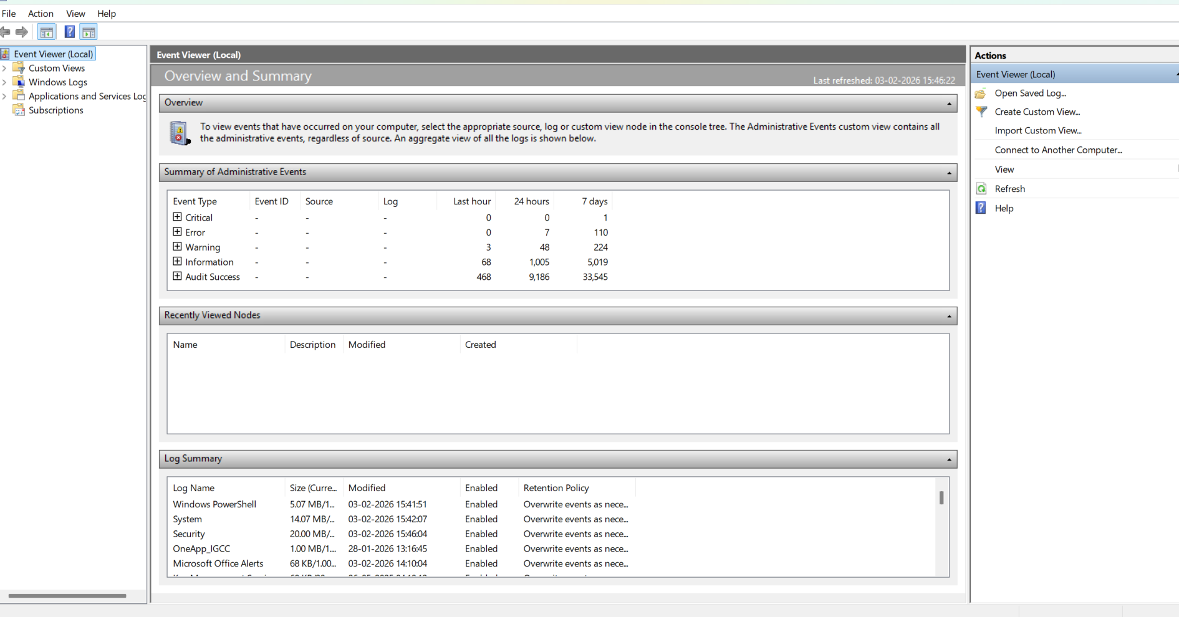

Use Event Viewer:
- Security → logons, failures, privilege use
- System → system startup, service failures
- Application → app errors
STEP 2: .Analyze authentication logs.
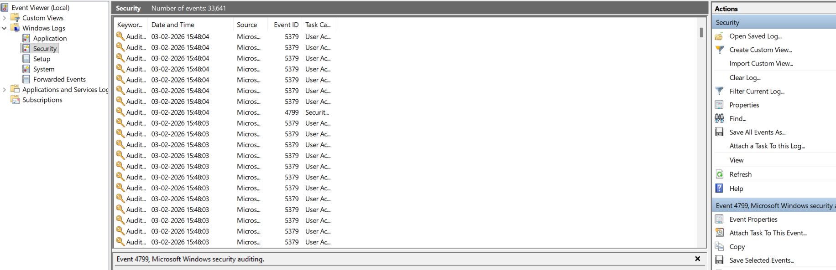

These logs contain:
- Logins
- Failed logins
- Admin activity

STEP 3: Generate Logs

We need real data.
Generate failed login logs:
- Lock your PC (Windows + L)
- Enter wrong password 3–5 times
- Log in successfully once
This creates:
- Event ID 4625 → Failed login
- Event ID 4624 → Successful login
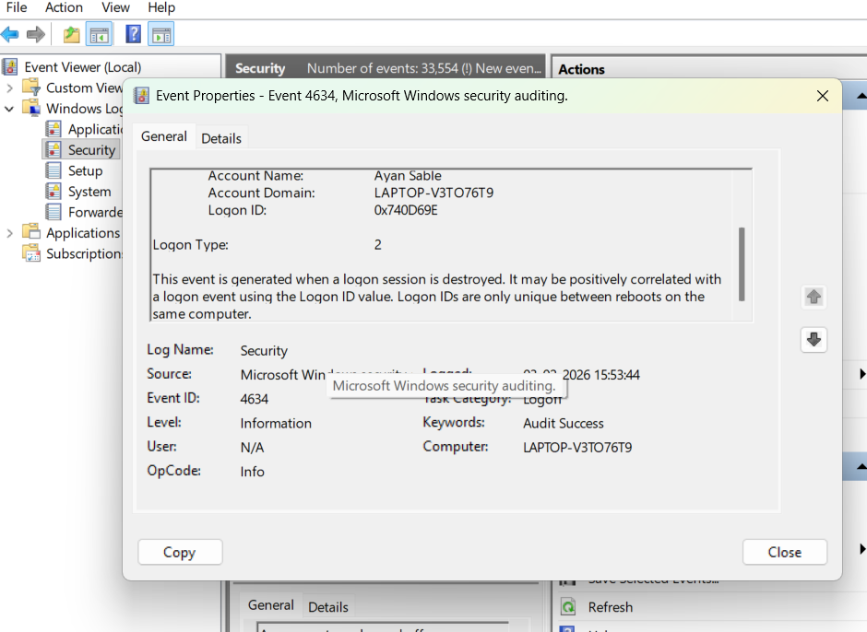
STEP 4: Detect anomalies.
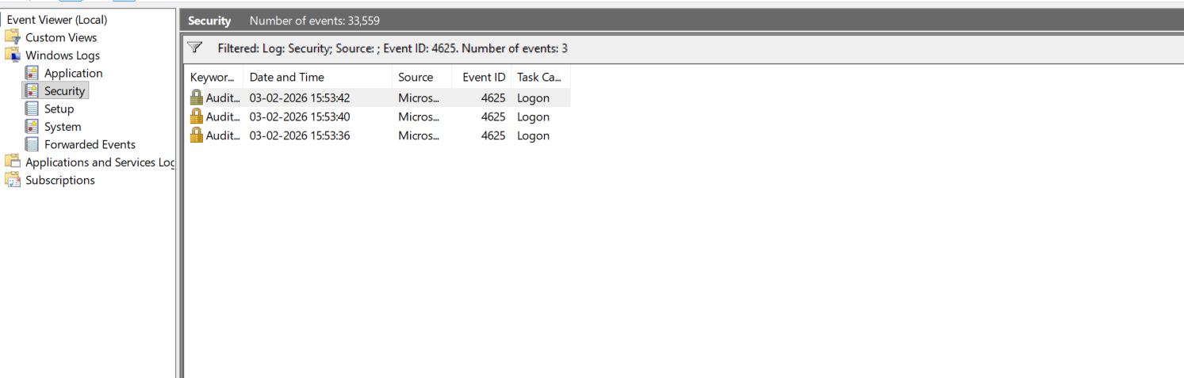

STEP 5: CORRELATE EVENTS
WHAT THIS MEANS
Connecting related logs to see the full attack story.

HOW
Failed → Successful Login
index=main EventCode=4625 OR EventCode=4624
| sort _time
📌 Pattern:
4625 → 4625 → 4624

@@EXAMPLE:
Date: 03-02-2026
System: Windows 10
Log Source: Security Logs
Anomaly Detected: Multiple failed logins
Events: Event ID 4625
Evidence: 6 failed attempts for user "admin"
Impact: Possible brute-force attack
Recommendation: Lock account, enable MFA

