AIM: Secure API Testing & Authorization Validation
Step 1: Understand the API You’re Testing
Before touching any tool, do this first:
- Read the API documentation
- Identify:
  - Base URL (e.g., /api/v1/users)
  - Available endpoints
  - HTTP methods used (GET, POST, PUT, DELETE)
  - Authentication type (API key, Bearer token, OAuth, etc.)

Step 2: Choose Your Tool
Use one primary tool and know at least one alternative.
- Primary: Postman

Step 3:download

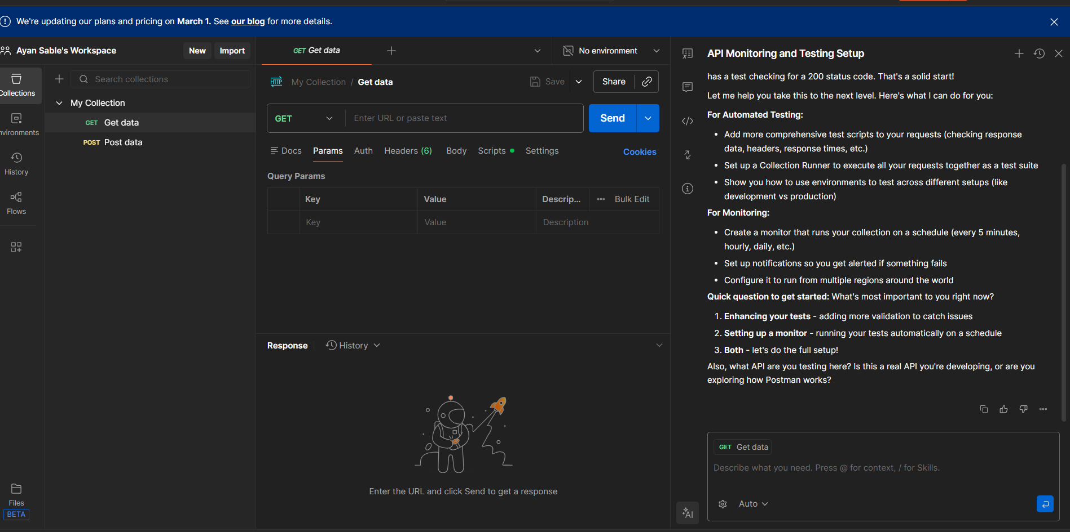

Step 4: • Select GET
• Enter URL:
https://jsonplaceholder.typicode.com/posts/1

