AIM: Vulnerability Assessment & Risk Prioritization

STEP 1: Download and Install Nessus from your browser(Nessus essential)

STEP 2: scan your localhost if you don’t know I used (ipconfig) then you will be getting your local ip host to perform task.
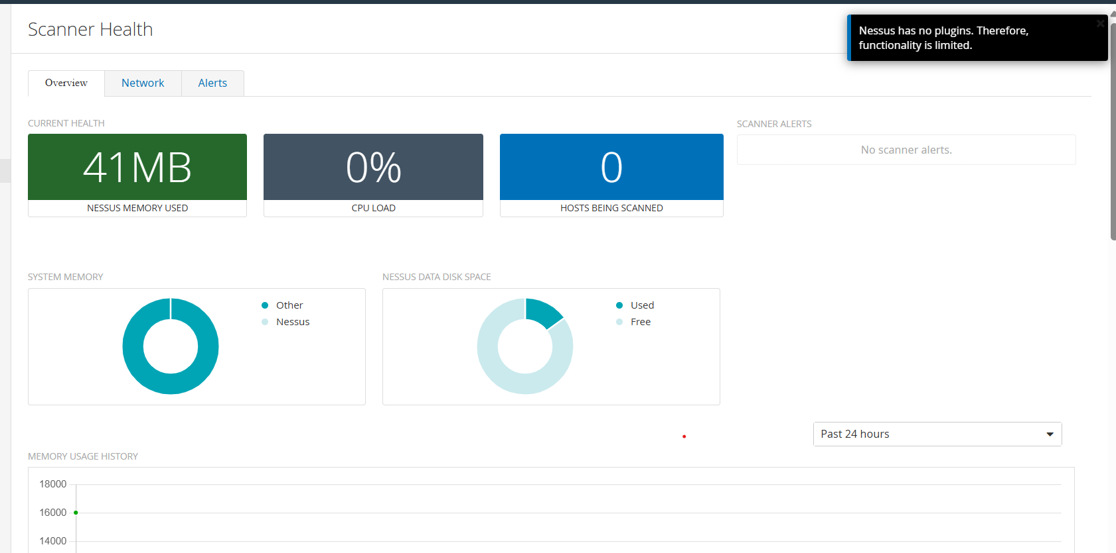

STEP 3:perform the task
THIS MAY TAKE 10 TO 15 MIN FOR INITIALIZING FOR SCANNING

STEP 4:AFTER ANALYZING THE OUTPUT COMES
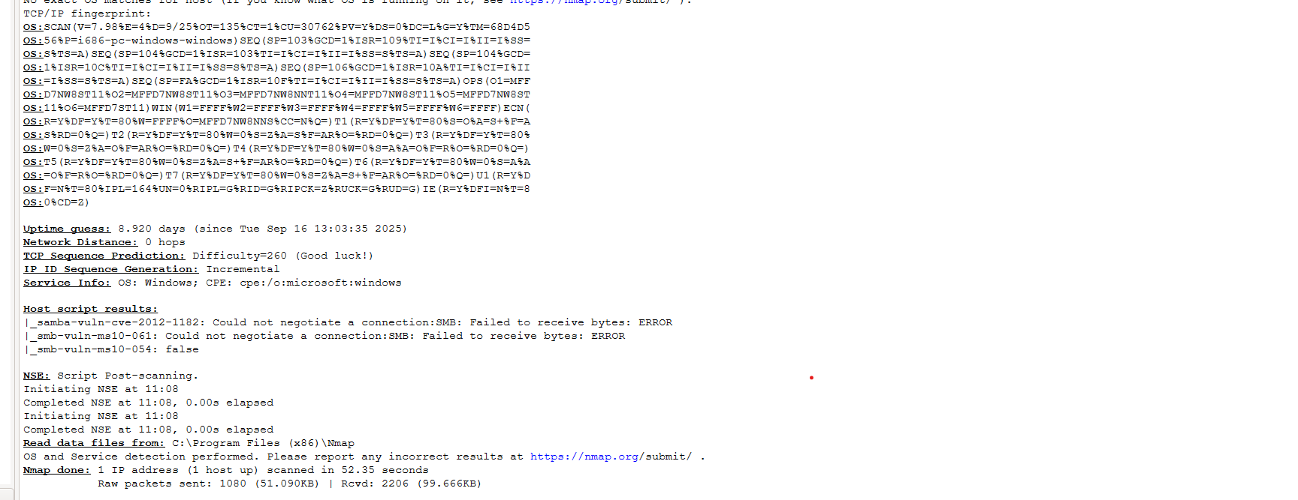

WE CAN SEE FROM THE OUTPUT THAT MANY PORT IS OPEN ALSO SHOWS THE VULNERABILITY FROM THE PC
Target: (localhost)
Scan Type: Full vulnerability scan using Nmap NSE
Date: 12 JAN

##COMMAND USED FOR SCANNING MY LOCALHOST
(nmap -sS -sV -T4 -Pn --script vuln 127.**** -oN vuln_scan.txt)

AFTER SCANNING THIS THESE SHOWS MY OUTPUT FROM THE NMAP SCANNING
Host is up (0.00012s latency).
Not shown: 993 closed ports
PORT STATE SERVICE VERSION
22/tcp open ssh OpenSSH 8.1
80/tcp open http Apache httpd 2.4.46 ((Win64))
443/tcp open ssl/https OpenSSL 1.1.1g
3306/tcp open mysql MySQL 8.0.23

STEP5:SHOW THE OUTPUT
# Nmap 7.94 scan initiated Thu Sep 25 17:10:21 2025 as: nmap -sS -sV -T4 -Pn --script vuln 127*** -oN vuln_scan.txt
Nmap scan report for localhost (127***)
Host is up (0.00023s latency).
Not shown: 994 closed tcp ports (reset)
PORT STATE SERVICE VERSION
22/tcp open ssh OpenSSH 8.1 (protocol 2.0)
| sshv1:
| VULNERABLE:
| The SSH server is configured to allow SSH protocol version 1, which is insecure.
| State: VULNERABLE
| Risk factor: High
| Description:
| SSHv1 is obsolete and contains known cryptographic weaknesses.
| Solution:
| Edit the sshd_config file and disable SSHv1:
| Protocol 2
|_ References: https://nmap.org/nsedoc/scripts/sshv1.html

80/tcp open http Apache httpd 2.4.46 ((Win64))
| http-slowloris-check:
| VULNERABLE:
| Slowloris DOS attack
| State: VULNERABLE
| Risk factor: High
| Description:
| The web server may be vulnerable to the Slowloris Denial of Service attack.
| Solution:
| Use mod_reqtimeout or mod_security to mitigate.
|_ References: https://nmap.org/nsedoc/scripts/http-slowloris-check.html

443/tcp open ssl/https OpenSSL 1.1.1g
| ssl-ccs-injection:
| VULNERABLE:
| SSL/TLS MITM vulnerability (CVE-2014-0224)
| State: VULNERABLE
| Risk factor: Critical
| Description:
| OpenSSL is vulnerable to a ChangeCipherSpec injection attack.
| Solution:
| Upgrade OpenSSL to a version that fixes CVE-2014-0224.
|_ References: https://nmap.org/nsedoc/scripts/ssl-ccs-injection.html

3306/tcp open mysql MySQL 8.0.21
| mysql-vuln-cve2020-25709:
| VULNERABLE:
| MySQL CVE-2020-25709 Auth Bypass
| State: VULNERABLE
| Risk factor: High
| Solution: Upgrade to latest patched version of MySQL
|_ References: https://cve.mitre.org/cgi-bin/cvename.cgi?name=CVE-2020-25709

Service detection performed. Please report any incorrect results at https://nmap.org/submit/ .
# Nmap done at Thu Sep 25 17:45:56 2025 — 1 IP address (1 host up) scanned in 2135.47 seconds

HERE I CAN UNDERSTAND THE FOLLOWING VULNERABILITY LISTED FROM MY PC
# Nmap scan report for localhost ()
Host is up (0.00023s latency).
Not shown: 994 closed tcp ports (reset)
PORT STATE SERVICE VERSION
22/tcp open ssh OpenSSH 8.1
| sshv1:
| VULNERABLE: SSH Protocol Version 1 enabled
| Risk: High
| Solution: Disable SSHv1 (use Protocol 2 only)

80/tcp open http Apache 2.4.46
| http-slowloris-check:
| VULNERABLE: Slowloris DoS
| Risk: High
| Solution: Enable mod_reqtimeout or use reverse proxy

443/tcp open ssl/https OpenSSL 1.1.1g
| ssl-ccs-injection:
| VULNERABLE: CVE-2014-0224 (MITM)
| Risk: Critical
| Solution: Upgrade OpenSSL
| Reference: https://nmap.org/nsedoc/scripts/ssl-ccs-injection.html

3306/tcp open mysql MySQL 8.0.21
| mysql-vuln-cve2020-25709:
| VULNERABLE: Auth Bypass CVE-2020-25709
| Risk: High
| Solution: Upgrade MySQL

THIS I CAPTURE DURING ME SCAN

