Aim: : Incident Response & Security Breach Simulation

Step 1: Simulate a Basic Security Incident

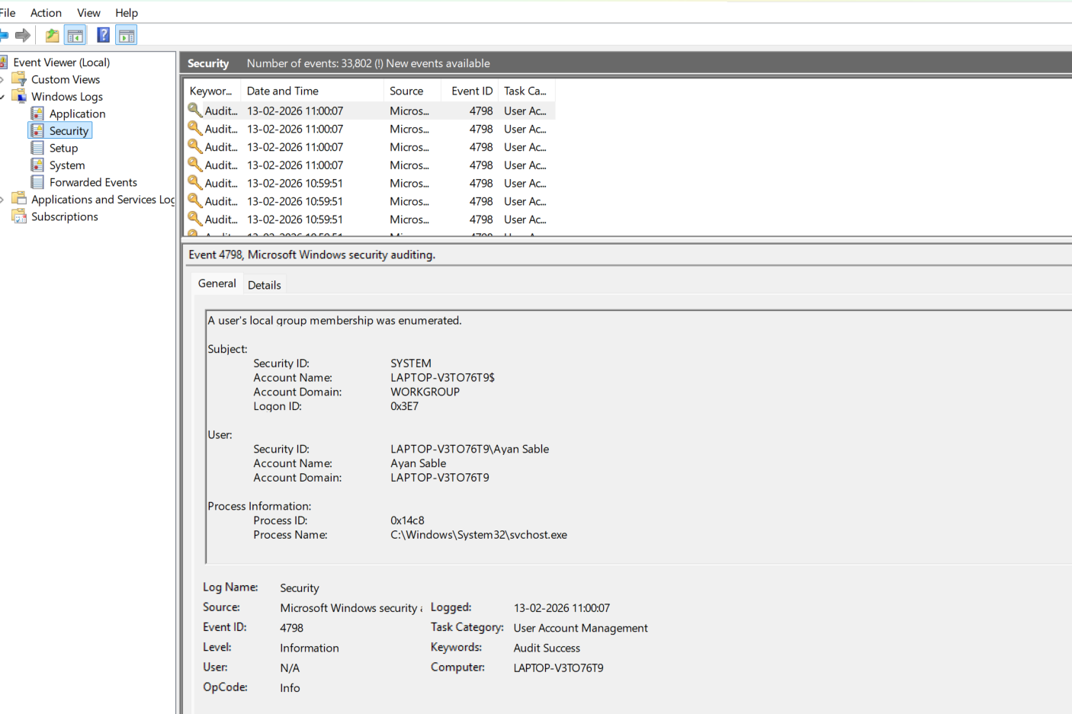

Meaning

4624 | Successful Login

4625 | Failed Login

4672 | Admin privileges assigned

- STEP 2: Identify Suspicious Activity (Log Analysis)
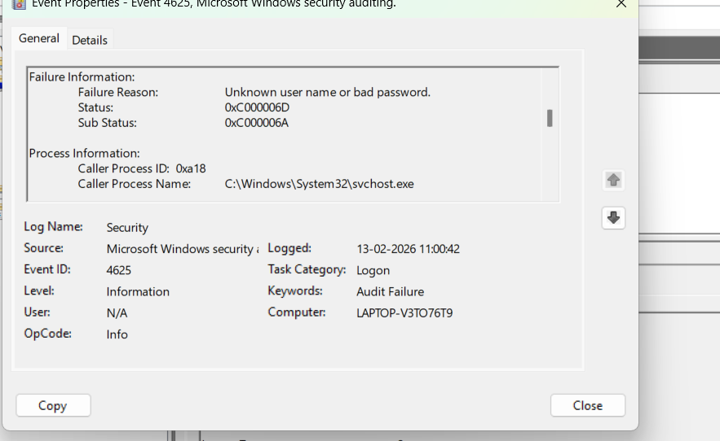

- Many failed attempts
- Same account
- Same IP
- Within short time
👉 That indicates suspicious activity.

STEP 3: Classify the Incident
Attack Type: Brute Force Attempt
Target: Local User Account
Severity: Medium (No successful login)
If attacker succeeds → Severity = High

STEP 4: Contain the Incident

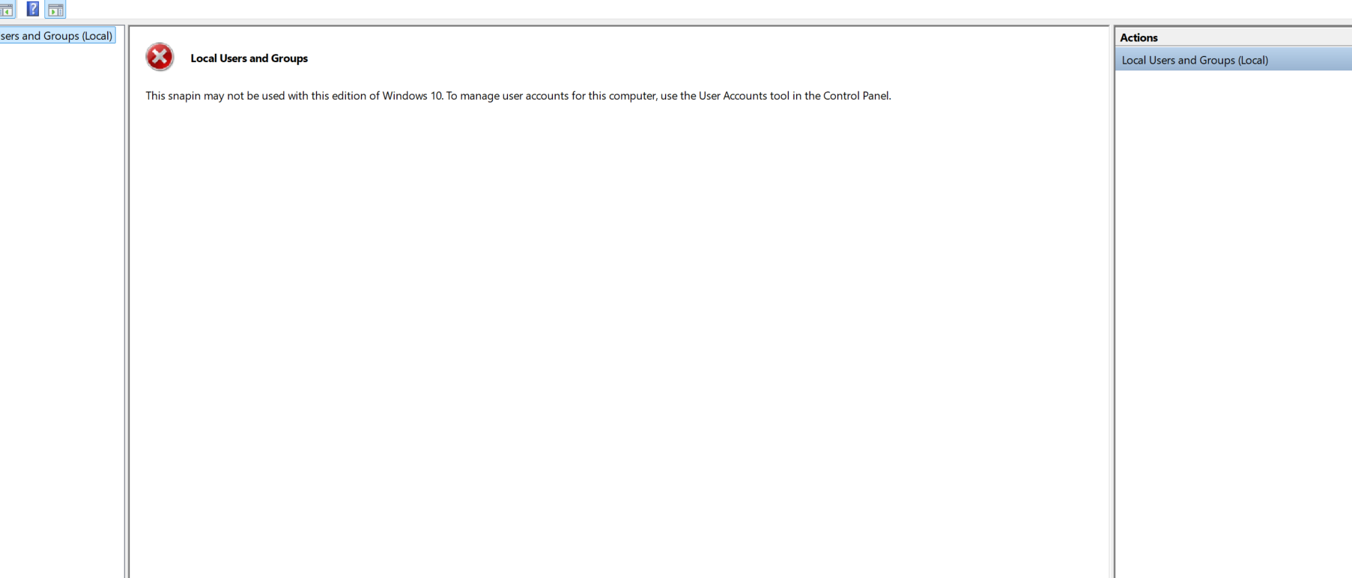

- Set:
  - Threshold: 5 attempts
  - Lockout duration: 15 minutes
Click Apply.
STEP 5: Remove Threat & Fix Root Cause
✔ Change password
✔ Enforce strong password policy
✔ Run Windows Defender scan
✔ Remove unknown users
✔ Update Windows

STEP 6: Restore System to Secure State
✔ Re-enable legitimate account
✔ Confirm no new failed attempts
✔ Monitor logs for 10–15 minutes
✔ Restart system if needed

STEP 7: Document the Incident
Create a report like this:

📝 Incident Timeline Example
Time | Event
10:00 AM | Multiple failed login attempts detected
10:05 AM | Event ID 4625 identified
10:10 AM | Account disabled
10:15 AM | Password reset
10:20 AM | Account lockout policy enabled

Root Cause
Weak password and no account lockout policy.

Actions Taken
- Account disabled
- Password changed
- Lockout policy configured

STEP 8: Recommend Preventive Improvements
🔒 Security Recommendations
- Enable Account Lockout Policy
- Use Strong Password Policy
- Enable Multi-Factor Authentication
- Regular log monitoring
- Enable Windows Firewall
- Keep system updated
- Use centralized logging tools
- Use incident tracking tools like

