AIM : : Networking Basics for Cyber Security.

STEP 1: 1. Basic Networking Concepts (Simple Language)
IP Address
- An IP address is a unique number given to each device on a network.
- Example: 192.168.1.1
- Used to identify devices.
MAC Address
- A MAC address is a physical address of a network device.
- It is fixed and unique for every device.
- Example: 00:1A:2B:3C:4D:5E
DNS (Domain Name System)
- DNS converts website names into IP addresses.
- Example: google.com → 142.250.xxx.xxx
TCP (Transmission Control Protocol)
- Reliable and connection-based protocol.
- Used for web browsing, emails, file transfer.
UDP (User Datagram Protocol)
- Fast but not reliable.
- Used for video streaming, online games.

STEP 2:LIVE NETWORK CAPTURE.

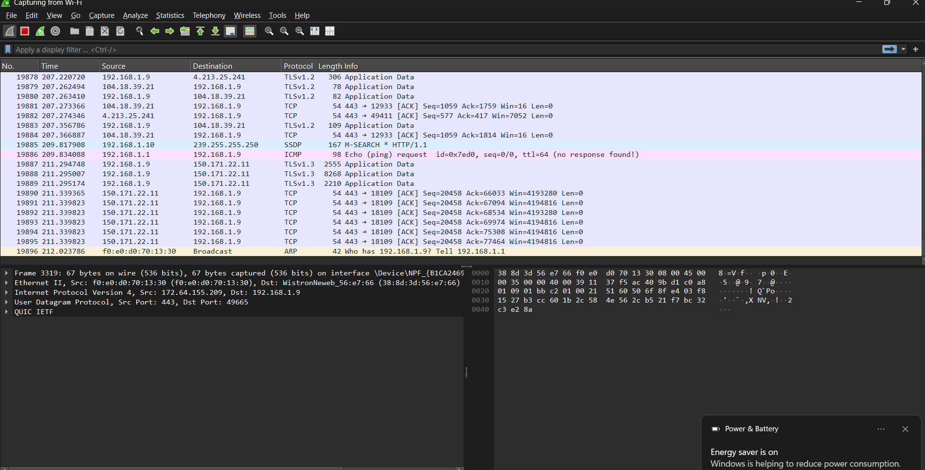

STEP 3: Filtering Packets by Protocol
Protocol | Filter Used
HTTP | http
DNS | dns
TCP | tcp
UDP | udp
These filters help in analyzing specific traffic.

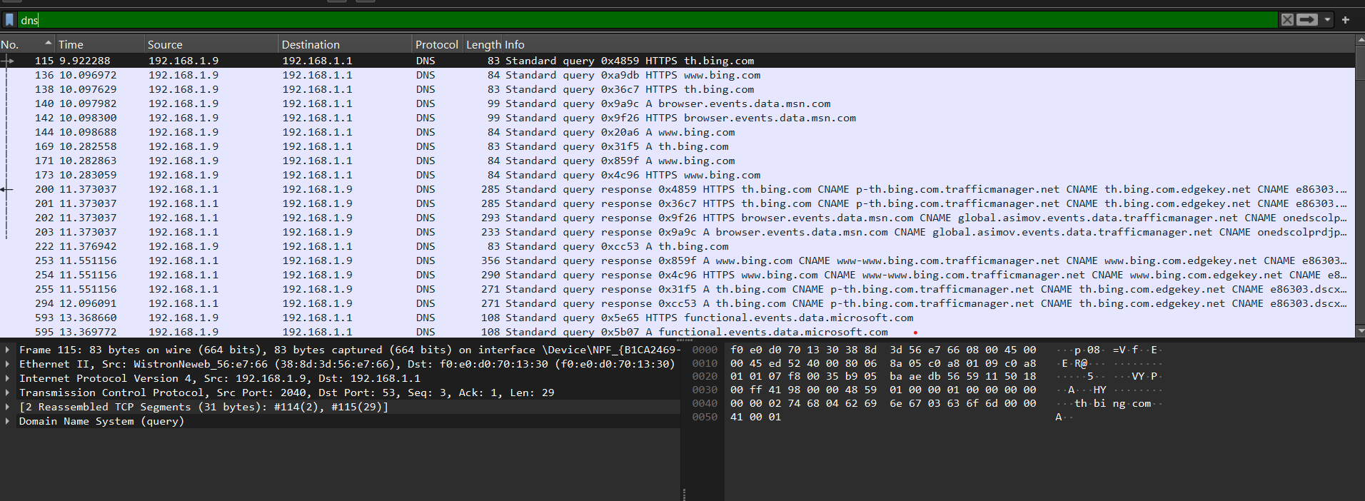

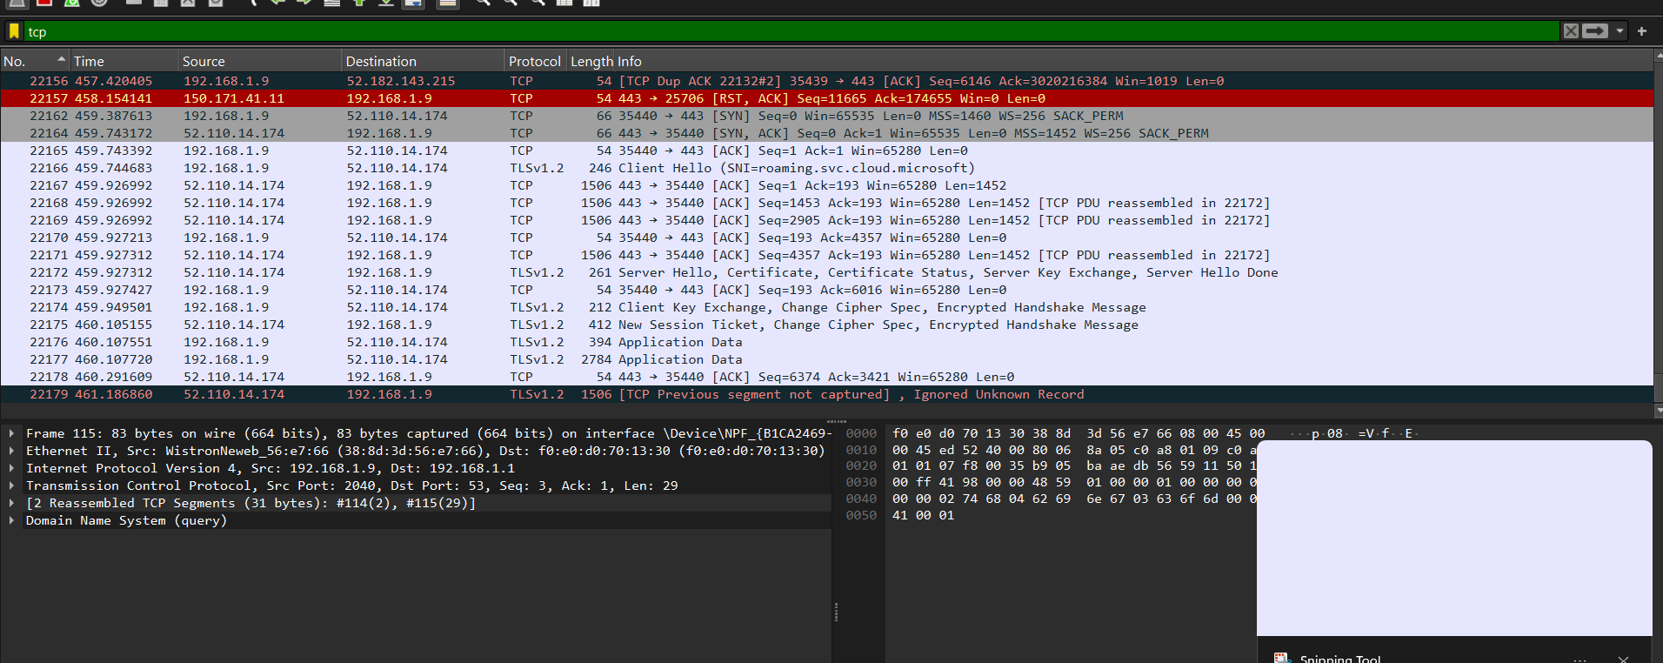

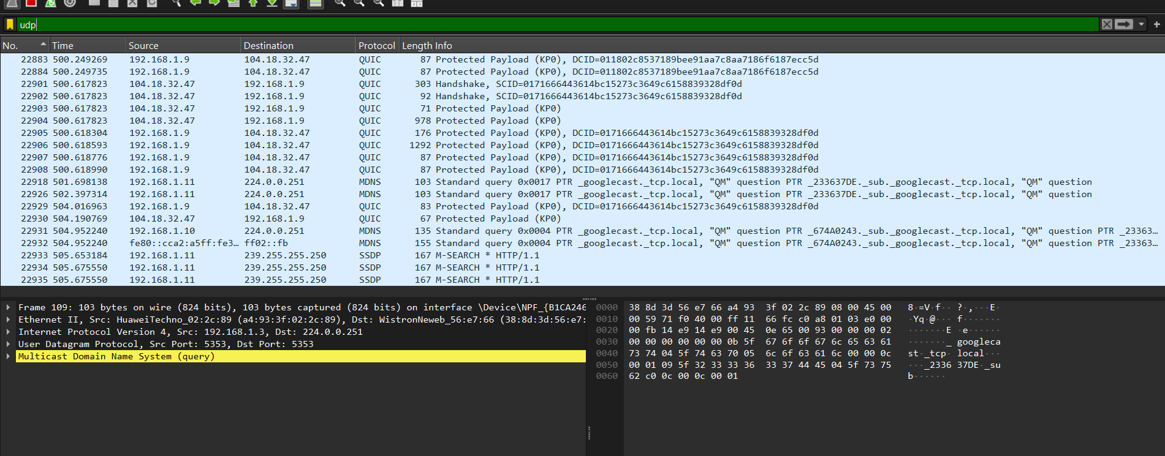

STEP 4: Observing TCP Three-Way Handshake

The TCP connection is established in three steps:
- SYN – Client requests connection
- SYN-ACK – Server accepts request
- ACK – Client confirms connection

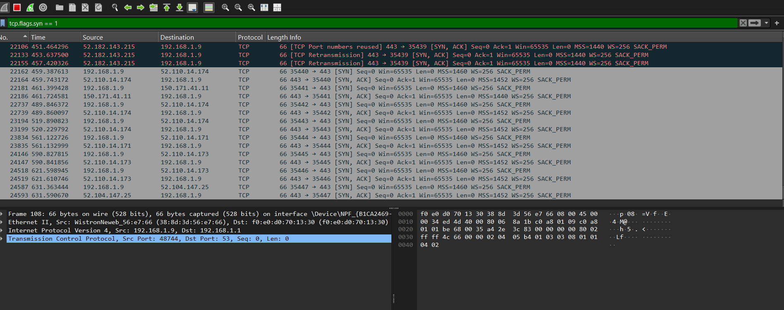

STEP 5: Plain-Text vs Encrypted Traffic
Plain-Text Traffic
- HTTP traffic shows readable data.
- Example: URLs, form data.
Encrypted Traffic
- HTTPS traffic is encrypted.
- Data cannot be read.
- Appears as random characters.

STEP 6: Observations
- Wireshark captures real-time network traffic.
- DNS converts website names into IP addresses.
- TCP ensures reliable communication.
- Three-way handshake is required to start TCP communication.
- HTTP traffic is readable, HTTPS traffic is encrypted.
- Packet filters help in easy analysis.

