AIM: Malware Types & Behavior Analysis (Basic)
STEP 1: : Upload Hashes to VirusTotal

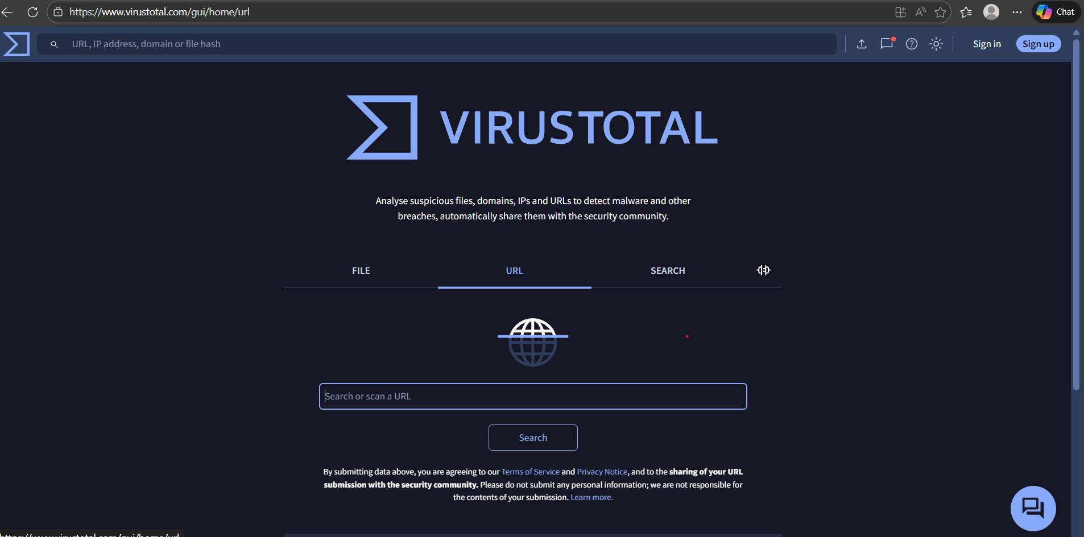

STEP 2:UPLOAD ON SOFTWARE
(44d88612fea8a8f36de82e1278abb02f)
PASTE AND SEE THE RESULT.

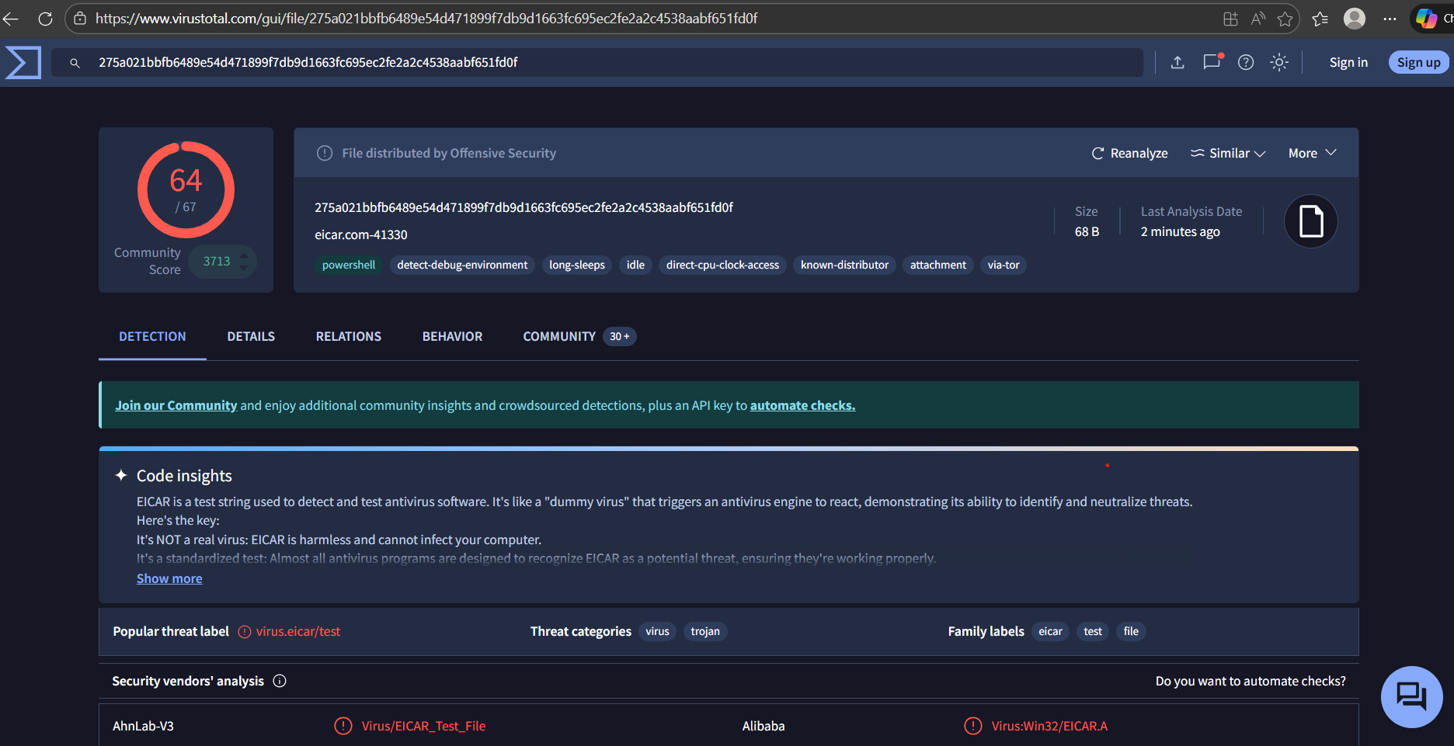

VirusTotal will show:
- Detection results from 60+ antivirus engines
- File details
- Behavior analysis
Always note scan date, hash, and file type.
STEP 3: Analyze Detection Reports
Focus on these key sections:
1. Detection Ratio
Example:
45 / 70 engines detected this file as malicious
- Higher ratio → Higher confidence malware
2. Malware Labels
Look for names like:
- Trojan.Generic
- Ransom.Win32
- Worm.AutoRun
Different AV engines may use different names — focus on the common pattern.
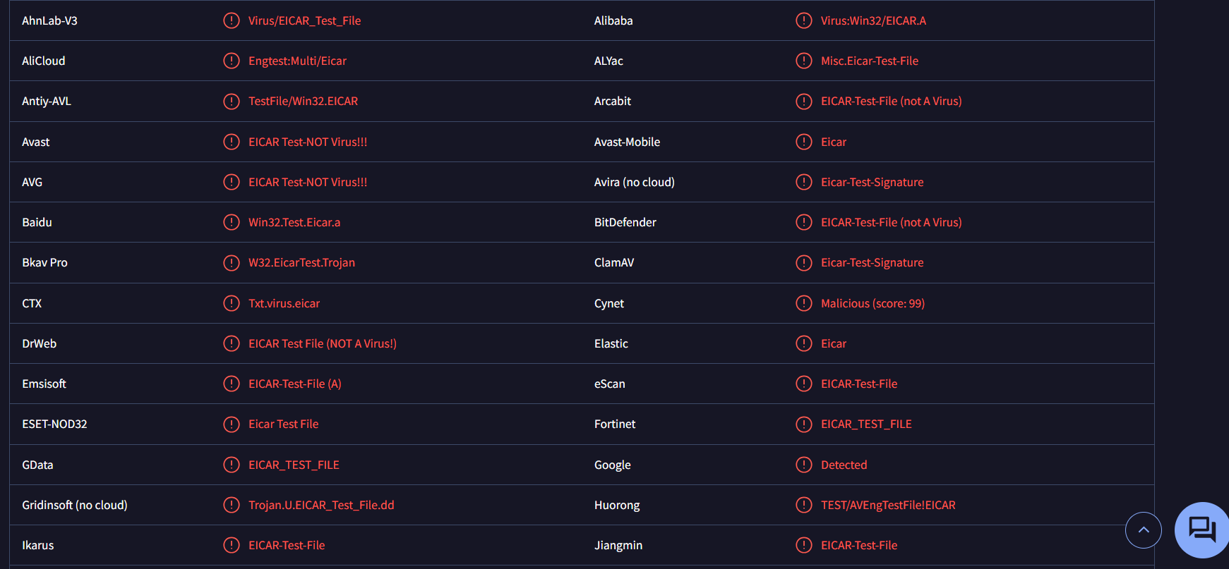
STEP 4: Observe Behavior Indicators

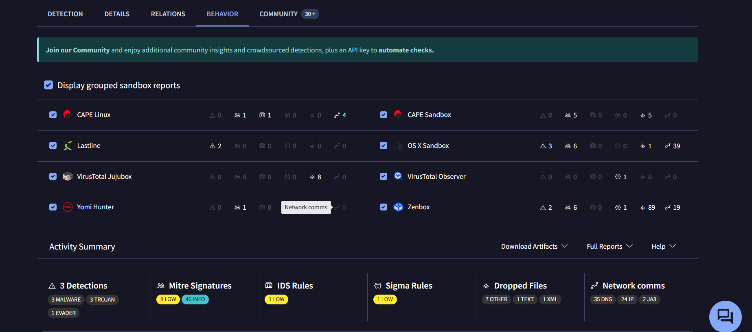
AFTER CLICKING YOU WILL SEE THE BEHAVIOUR AND SEE THE INFECTED IP OR RULE AND MALWARE

Behavior is more reliable than detection names.

STEP 5: Identify Prevention Methods
Based on your analysis, suggest defenses:
Common Prevention Techniques:
- Antivirus & EDR solutions
- Email filtering
- Regular OS updates
- User awareness training
- Network firewall rules
- Disable macros by default
Always link prevention to observed behavior.

STEP 6: Learn How Malware Spreads
Identify the propagation method from reports:
- Email phishing
- Infected downloads
- Network exploitation
- Removable media (USB)
VirusTotal clues:
- File name patterns
- Embedded URLs
- Dropped files

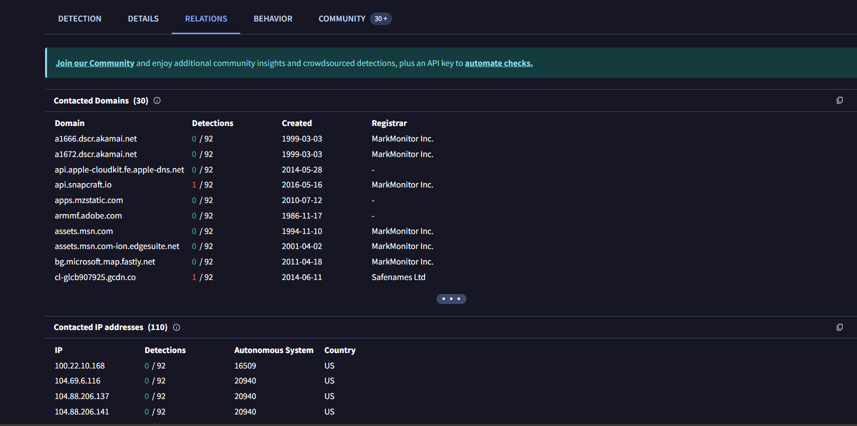

STEP 7: SummarY
- Malware is malicious software designed to harm systems.
- A virus needs user action; a worm spreads automatically.
- Ransomware encrypts files and demands payment.
- Malware spreads via emails, downloads, networks, and USB devices.
- Prevention includes antivirus, updates, backups, and user awareness.

