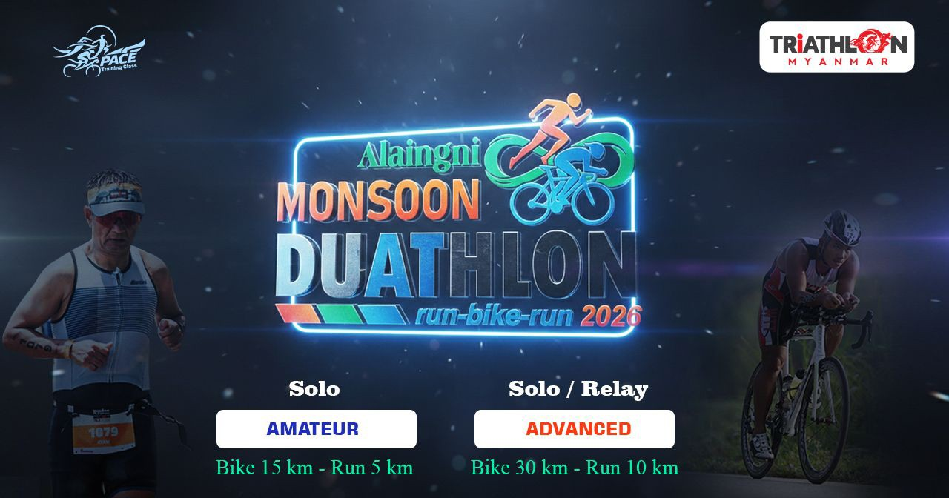

Dear Participant,
Thank you very much for your interest in participating in the Alaingni Monsoon Duathlon 2026. Based on the personal information provided in your registration form, we have noted that you will be under 18 years of age on the day of the race. Therefore, a parent or legal guardian is required to carefully read and sign the consent form below. You must bring the signed form and submit it to the organizers without fail on the day you collect your race kit and other materials.

Parent/Guardian Consent and Indemnity Form

Event Name: Alaingni Monsoon Duathlon 2026
Date of Event: 24 May 2026 (Sunday)

1. Participant (Minor) Details
- Full Name: _________________________________________________
- Date of Birth: _________________ Age on Race Day: _________
- Race Category: (Amateur Solo, Advanced Solo and Advanced Relay) __________________
2. Parent / Guardian Details
- Full Name: _________________________________________________
- Relationship to Minor: _______________________________________
- NRIC / Passport No: _________________________________________
- Phone Number: _____________________________________________
3. Consent and Medical Declaration
I, the undersigned, being the parent/legal guardian of the participant named above, hereby:
- Consent: Grant permission for my child/ward to participate in the aforementioned event.
- Health Status: Certify that my child/ward is in good health and physically capable of participating in a running event.
- Rules: Agree that my child/ward will abide by all official rules and regulations set by the organizers.
4. Indemnity and Waiver of Liability
- Acknowledgement of Risk: Acknowledge that participating in the Alaingni Monsoon Duathlon 2026 (the "Event") involves inherent risks, including but not limited to physical injury, exhaustion, or accidents.
- Release of Liability: Agree to release, waive, and hold harmless the event organizers, sponsors, and officials from any liability for injury, loss, or damage arising from participation.
- Medical Treatment: Authorize the organizers to seek and provide emergency medical treatment for my child/ward if required during the event.
5. Signature
- Parent/Guardian Signature: ___________________________________
- Date: __________________________

